**湖北服务开通与网络激活系统晨检**

**版本变更历史**

|  |  |  |  |
| --- | --- | --- | --- |
| **时间** | **版本** | **描述** | **作者** |
| 2013.02.11 | V1.0 | 创建，规划目录，编写章节 | 刘锐钦、程波 |
| 2014.03.05 | V3.0 | 在“四、检查 服务开通派单积压”增加“事件池派单稽核”和“事件池异常稽核”脚本，增加输出结果判断说明； | 程波 |
| 2014.03.23 | V3.1 | 在一、二中加入网络激活部分； | 程波 |
|  |  |  |  |
|  |  |  |  |
|  |  |  |  |
|  |  |  |  |
|  |  |  |  |
|  |  |  |  |
|  |  |  |  |
|  |  |  |  |
|  |  |  |  |
|  |  |  |  |

**一、生产库锁表情况核查**

--1.1需要核查的数据库

①.武电服务开通数据库(SPS_DEV)

②.16个本地网服务开通数据库(BDWSPS)

③.网络激活数据库(inas)

--1.2核查重点：

--查锁语句：输出无结果为正常

SELECT */*+ rule */*

lpad(' ', decode(l.xidusn, 0, 3, 0)) || l.oracle_username,

logon_time,o.owner,o.object_name,o.object_type,s.sid,s.serial#,s.OSUSER,

s.MACHINE,s.TERMINAL,s.USERNAME,SECONDS_IN_WAIT

FROM v$locked_object l, dba_objects o, v$session s

WHERE l.object_id = o.object_id and s.username in('BDWSPS','SPS_DEV','INAS') AND l.session_id = s.sid and s.status<> 'KILLED' and seconds_in_wait> 60

ORDER BY seconds_in_wait DESC;

--1.3分析及处理方法：

主要关注seconds_in_wait> 60 和user_name，可以通过下面2个SQL稽核出来的语句直接执行即可，也可以通过上面的语句查出对应的sid和serial通过下面的语句执行杀掉。

--单个杀锁语句：

alter system kill session '1014,25770';

--批量杀锁语句: 输出无结果为正常

--①.16个本地网服务开通

select 'alter system kill session ''' || s.sid || ',' || s.serial# || '''' || ';'

from v$locked_object l, dba_objects o, v$session s

where s.username = 'BDWSPS'

AND l.object_id = o.object_id

AND l.session_id = s.sid

And s.status<> 'KILLED'

AND s.seconds_in_wait>60

order by s.seconds_in_wait DESC;

--②.武电服务开通：

select 'alter system kill session ''' || s.sid || ',' || s.serial# || '''' || ';'

from v$locked_object l, dba_objects o, v$session s

where s.username = 'SPS_DEV'

AND l.object_id = o.object_id

AND l.session_id = s.sid

And s.status<> 'KILLED'

AND s.seconds_in_wait>60

order by s.seconds_in_wait DESC;

--③.网络激活：

select 'alter system kill session ''' || s.sid || ',' || s.serial# || '''' || ';'

from v$locked_object l, dba_objects o, v$session s

where s.username = 'INAS'

AND l.object_id = o.object_id

AND l.session_id = s.sid

and s.status<> 'KILLED'

AND s.seconds_in_wait>60

order by s.seconds_in_wait DESC;

**二、检查失效存储和包**

--①.16个本地网服务开通: 输出无结果为正常

SELECT b.owner,b.object_name, b.status, b.object_type

FROM dba_objects b

WHERE b.owner = 'BDWSPS'

And b.object_type in ('PROCEDURE', 'PACKAGE BODY')

And b.status = 'INVALID';

批量编译：

*--存在失效的存储过程批量执行编译*

SELECT 'ALTER PROCEDURE ' || b.owner|| '.' || b.object_name || ' COMPILE;' AS s

FROM dba_objects b

WHERE b.object_type = 'PROCEDURE'

AND b.status = 'INVALID'

AND b.owner = 'BDWSPS';

*--存在失效的包批量执行编译*

SELECT 'ALTER PACKAGE ' || b.owner|| '.' || b.object_name || ' COMPILE;' AS s

FROM dba_objects b

WHERE b.object_type in('PACKAGE','PACKAGE BODY')

AND b.status = 'INVALID'

AND b.owner = 'BDWSPS';

--②.武电服务开通：输出无结果为正常

SELECT b.owner,b.object_name, b.status, b.object_type

FROM dba_objects b

WHERE b.owner = 'SPS_DEV'

And b.object_type in ('PROCEDURE', 'PACKAGE BODY')

And b.status = 'INVALID';

批量编译：

*--存在失效的存储过程批量执行编译*

SELECT 'ALTER PROCEDURE ' || b.owner|| '.' || b.object_name || ' COMPILE;' AS s

FROM dba_objects b

WHERE b.object_type = 'PROCEDURE'

AND b.status = 'INVALID'

AND b.owner = 'SPS_DEV';

*--存在失效的包批量执行编译*

SELECT 'ALTER PACKAGE ' || b.owner|| '.' || b.object_name || ' COMPILE;' AS s

FROM dba_objects b

WHERE b.object_type in('PACKAGE','PACKAGE BODY')

AND b.status = 'INVALID'

AND b.owner = 'SPS_DEV';

--③.网络激活：输出无结果为正常

SELECT b.owner,b.object_name, b.status, b.object_type

FROM dba_objects b

WHERE b.owner = 'INAS'

And b.object_type in ('PROCEDURE', 'PACKAGE BODY')

And b.status = 'INVALID';

批量编译：

*--存在失效的存储过程批量执行编译*

SELECT 'ALTER PROCEDURE ' || b.owner|| '.' || b.object_name || ' COMPILE;' AS s

FROM dba_objects b

WHERE b.object_type = 'PROCEDURE'

AND b.status = 'INVALID'

AND b.owner = 'INAS';

*--存在失效的包批量执行编译*

SELECT 'ALTER PACKAGE ' || b.owner|| '.' || b.object_name || ' COMPILE;' AS s

FROM dba_objects b

WHERE b.object_type in('PACKAGE','PACKAGE BODY')

AND b.status = 'INVALID'

AND b.owner = 'INAS';

**三、检查本地网华为大区SHLR\ENIP\AG工单是否积压**

--①.16个本地网: 输出单条结果集小于100为正常

select COUNT(*),

b.name,

decode(WORK_ITEM_TYPE,

'SW6201',

'SHLR',

'SW3301',

'ENIP',

'SW3309',

'AG')

from spjk_table@sps_to_jk a,local_net b

where a.work_item_type in ('SW3301', 'SW3309', 'SW6201')

and a.STS = 'D'

and a.local_net_id = b.local_net_id

GROUP BY b.name, a.WORK_ITEM_TYPE

order by count(*) desc;

--1.可能问题一：

--AG接口

华为分三个片区。襄樊，宜昌，荆州。

襄樊片区包括：林区，十堰，随州,襄樊，孝感; 133.3.76.26/root/xfcc1234，大唐可重启；

宜昌片区包括：宜昌，恩施；荆门;10.38.129.59 /root/ngn@hbycsf，大唐不可重启，RTX联系宜昌邹鹏；

荆州片区包括：仙桃,天门,荆州,潜江;10.38.0.34 /root/ngnqazwsx，大唐不可重启，RTX联系荆州孟超；

如有压单请根据本地网去对应大区重启相应服务。

--2.可能问题二：

--AG接口

在195接口机上地址参数是否有全角冒号存在，如果有则修改为半角冒号。

select b.*,b.rowid from spjk_para b where b.spjk_id in (select a.spjk_id

from spjk_table a

where a.work_item_type in ('SW3301', 'SW3309', 'SW6201')

and a.STS = 'D')

and (b.para_value like '%：%' or b.para_value_old like '%：%');

--3.可能问题三

--SHLR接口

根据稽核量的本地网核查是否有在一个时间段里批量的欠费停开机工单，如果集中在某一时间并且有减少，正常；不用处理；

select to_char(create_time, 'yyyy-mm-dd hh24:mi'),count(*) from spjk_table a

where a.local_net_id = 1003 and a.sts in('P')

and a.create_time >= TO_DATE('2014-4-1 08:00:00', 'yyyy-mm-dd hh24:mi:ss') and a.step_id ='SP6201A'

group by rollup(to_char(create_time, 'yyyy-mm-dd hh24:mi'))

order by to_char(create_time, 'yyyy-mm-dd hh24:mi');

--4.可能问题四

其它平台，如黄石的小灵通预付费平台一直不处理，就会出现积压，直接在spjk_table.sts状态改为C状态；

**四、检查服务开通派单积压**

--①.16个本地网

--环节派单积压稽核，输出数字小于100，并且存在不断的变化为正常；

select COUNT(*)

from bdwsps.wo a

where a.work_mode = 'A'

AND A.RUN_STS = 'D'

AND A.REASGN_COUNT = '0'

AND BUSI_STS IN ('N', 'I')

AND A.FAIL_REASON_ID IS NULL

AND EXISTS(

select 1 from bdwsps.so b

where b.local_net_id = a.local_net_id

and b.so_nbr = a.so_nbr and B.STS= 'A'

and b.SO_LOCK_STS = 'N');

--事件池派单稽核，输出数字小于100，并且存在不断的变化为正常，无派单积压；

select count(*) from bdwsps.t_ms_event_pool C where c.except_times = '0';

--事件池异常稽核，输出数字小于100，并且不存在50条上以相同错误的工单为正常；存在50条上以相同错误的工单及时报流程组和开通研发定位；

delete from bdwsps.t_ms_event_pool c where c.except_times <> '0'

and c.except_reason = '配置错误--找不到转换后处理 ma_transaction_id=10300815';

commit;

select except_times,c.except_reason,c.*,Rowid from bdwsps.t_ms_event_pool C where c.except_times <> '0' order by c.except_reason,c.EVENT_TIME;

--②.武电：

--环节派单积压稽核，输出数字小于100，并且存在不断的变化为正常；

select COUNT(*)

from sps_dev.wo a

where a.work_mode = 'A'

AND A.RUN_STS = 'D'

AND A.REASGN_COUNT = '0'

AND BUSI_STS IN ('N', 'I')

AND A.FAIL_REASON_ID IS NULL

AND EXISTS(

select 1 from sps_dev.so b

where b.local_net_id = a.local_net_id

and b.so_nbr = a.so_nbr and B.STS= 'A'

and b.SO_LOCK_STS = 'N');

--事件池派单稽核，输出数字小于100，并且存在不断的变化为正常，无派单积压；

select count(*) from sps_dev.t_ms_event_pool C where c.except_times = '0';

--事件池异常稽核，输出数字小于100，并且不存在50条上以相同错误的工单为正常；存在50条上以相同错误的工单及时报流程组和开通研发定位；

delete from sps_dev.t_ms_event_pool c where c.except_times <> '0'

and c.except_reason = '配置错误--找不到转换后处理 ma_transaction_id=10300815';

commit;

select except_times,c.except_reason,c.*,Rowid from sps_dev.t_ms_event_pool C where c.except_times <> '0' order by c.except_reason,c.EVENT_TIME;

--“环节派单积压稽核”和“事件池派单稽核”的解决办法：

如有压单请对应重启服务开通TIMER， TIMER路径见最新的“服务开通命令脚本X.xls”脚本文档，分别对应“武电生产环境命令脚本”SHEET页、“全省六版生产环境命令脚本”SHEET页中的TIMER操作说明部分。

重启完成后，对以上SQL进行再次执行，输出数字小于100，并且存在不断的变化为正常。

**五、检查激活服务是否异常**

**--**输出无结果为正常

select *

from tserviceruninfo@TO_INAS_171 a

where a.dtupdatetime>sysdate - (1 / (24 * 60))

and a.vcexitinfo like '%退出原因%'

如果结果集不为空则需要执行下面的SQL：

select *

from spjk_table

where sts = 'D'

AND DATA_ROUTE = 'NAS'

And busi_type<>'BS'

order by spjk_id;

处理办法：

将上述结果集中第一条纪录放到下列SQL中核实参数是否在特殊字符，通常情况下是因为特殊字符导致激活无法向网元发单，导致服务异常。

select * from spjk_para where spjk_ordeR_id in(

select spjk_order_id from spjk_order where spjk_id = 10237033559);

例如下图中的客户名称：

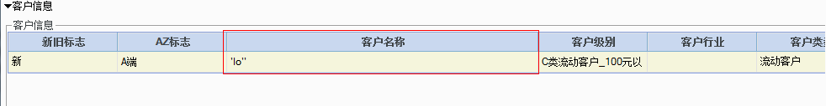

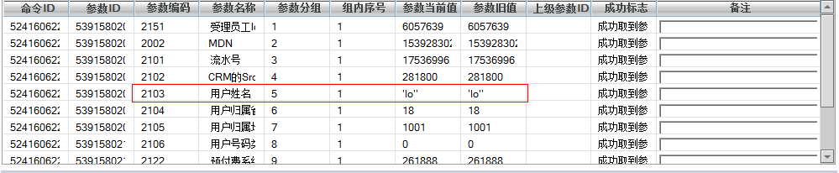

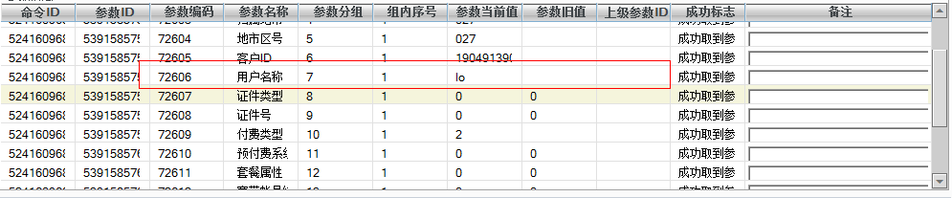

序列最小的工单出现异常，需要核实指令中参数是否存在异常字符。找到出现异常的工单第一步先将工单SPJK_TABLE状态设置成F状态，保证激活服务找不到此工单；第二步与局方核实此工单如何处理，是同步修正用户名称，还是撤单，通常情况是我们手工修正参数中信息重发接口。

**六、检查停复机是否积压**

--①.16个本地网：输出无结果为正常

select (select count(*)

from BDWSPS.jk_history_ss1

where sts = 'M'

and remarks like '%生成命令和参数到全局临时表时发生异常%'

and block_date>sysdate - 1) +

(select count(*)

From BDWSPS.jk_history_ss2

Where sts = 'M'

and remarks like '%生成命令和参数到全局临时表时发生异常%'

and block_date>sysdate - 1)

from dual;

当结果集大于0时，则说明有失效存储，需要我们先停掉TIMER，重新编译失效存储，再启TIMER，最后把状态为M的更新为D状态。

更新SQL：

Update BDWSPS.jk_history_ss1

Set sts = 'D'

Where sts = 'M'

and remarks like '%生成命令和参数到全局临时表时发生异常%'

and block_date > trunc(sysdate - 1/2);

update BDWSPS.jk_history_ss2

set sts = 'D'

where sts = 'M'

and remarks like '%生成命令和参数到全局临时表时发生异常%'

and block_date > trunc(sysdate - 1/2);

update BDWSPS.jk_history_ss1 ta set ta.backfill_flag_num=99

WHERE 1 = 1 and ta.remarks like '%ORA-%' and ta.backfill_flag_num=4 and block_date> trunc(sysdate - 1/2);

update BDWSPS.jk_history_ss2 ta set ta.backfill_flag_num=99

WHERE 1 = 1 and ta.remarks like '%ORA-%' and ta.backfill_flag_num=4 and block_date> trunc(sysdate - 1/2);

--②.武电：输出无结果为正常

select (select count(*)

from SPS_DEV.jk_history_ss1

where sts = 'M'

and remarks like '%生成命令和参数到全局临时表时发生异常%'

and block_date>sysdate - 1) +

(select count(*)

From SPS_DEV.jk_history_ss2

Where sts = 'M'

and remarks like '%生成命令和参数到全局临时表时发生异常%'

and block_date>sysdate - 1)

from dual;

更新SQL：

Update SPS_DEV.jk_history_ss1

Set sts = 'D'

where sts = 'M'

and remarks like '%生成命令和参数到全局临时表时发生异常%'

andblock_date> trunc(sysdate - 1/2);

update SPS_DEV.jk_history_ss2

set sts = 'D'

where sts = 'M'

and remarks like '%生成命令和参数到全局临时表时发生异常%'

andblock_date> trunc(sysdate - 1/2);

update SPS_DEV.jk_history_ss1 ta set ta.backfill_flag_num=99

WHERE 1 = 1 and ta.remarks like '%ORA-%' and ta.backfill_flag_num=4 and block_date> trunc(sysdate - 1/2);

update SPS_DEV.jk_history_ss2 ta set ta.backfill_flag_num=99

WHERE 1 = 1 and ta.remarks like '%ORA-%' and ta.backfill_flag_num=4 and block_date> trunc(sysdate - 1/2);