扩容前首先查询确认表空间磁盘情况：

# su - grid

$ asmcmd

ASMCMD> lsdg

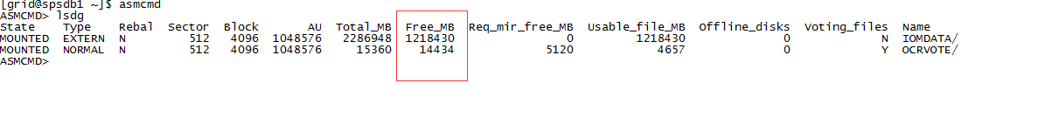

确认空间的空间足够，再添加表空间。

添加方法：

$ su - oracle oracle用户

$ sqlplus / as sysdba 进入数据库

SQL> set linesize 200

SQL> set pagesize 300

SQL> col used% for a20

SQL> col FILE_NAME for a60

查询表空间Sql:

select t.status,

t.file_name,

t.tablespace_name,

t.file_id,

t.relative_fno,

t.total,

(total - free) as "used",

round(100 * (1 - (free / total)), 3) || '%' as "used",

autoextensible

from (select status,

file_name,

tablespace_name,

file_id,

relative_fno,

bytes / 1024 / 1024 / 1024 total,

autoextensible

from dba_data_files) t

left join (select file_id, sum(bytes / 1024 / 1024/ 1024) free

from dba_free_space

group by file_id) f on (t.file_id = f.file_id)

order by tablespace_name, round(100 * (1 - (free / total)), 3) desc;

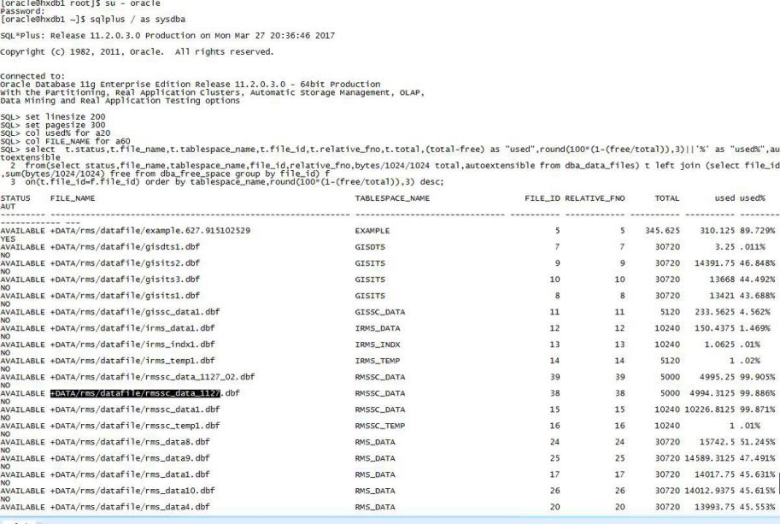

找出需要扩容的表空间，根据文件名向后加下标进行扩容。

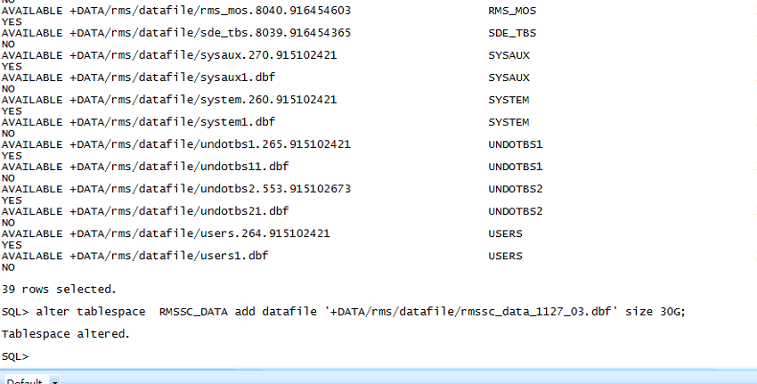

扩数据文件

alter tablespace RMSSC_DATA add datafile '+DATA/rms/datafile/rmssc_data_1127_03.dbf' size 30G;

alter tablespace IOM_DATA add datafile '+IOMDATA/iom/datafile/iomdata14.dbf' size 30G;

alter tablespace SPS_DATA add datafile '+DATA/sps/datafile/sps_data11.dbf' size 30G;

数据库TEMP临时表空间：

查询表空间使用大小：

select *

from (Select a.tablespace_name,

to_char(a.bytes / 1024 / 1024, '99,999.999') total_bytes,

to_char(b.bytes / 1024 / 1024, '99,999.999') free_bytes,

to_char(a.bytes / 1024 / 1024 - b.bytes / 1024 / 1024,

'99,999.999') use_bytes,

to_char((1 - b.bytes / a.bytes) * 100, '99.99') || '%' use

from (select tablespace_name, sum(bytes) bytes

from dba_data_files

group by tablespace_name) a,

(select tablespace_name, sum(bytes) bytes

from dba_free_space

group by tablespace_name) b

where a.tablespace_name = b.tablespace_name

union all

select c.tablespace_name,

to_char(c.bytes / 1024 / 1024, '99,999.999') total_bytes,

to_char((c.bytes - d.bytes_used) / 1024 / 1024, '99,999.999') free_bytes,

to_char(d.bytes_used / 1024 / 1024, '99,999.999') use_bytes,

to_char(d.bytes_used * 100 / c.bytes, '99.99') || '%' use

from (select tablespace_name, sum(bytes) bytes

from dba_temp_files

group by tablespace_name) c,

(select tablespace_name, sum(bytes_cached) bytes_used

from v$temp_extent_pool

group by tablespace_name) d

where c.tablespace_name = d.tablespace_name)

order by tablespace_name;

查询是否扩展

select d.file_name,d.tablespace_name,d.autoextensible from dba_temp_files d;

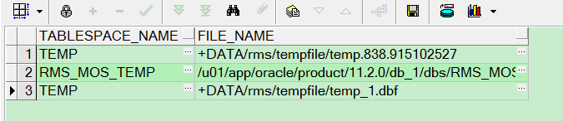

获得TEMP表空间情况，增加表空间：

alter tablespace TEMP add tempfile '+DATA/rms/tempfile/temp_1.dbf' size 10G;