Reflection2
- Objective & Validation Metrics

Evaluation Objective
The objective of this evaluation was to determine whether the revised SKY XR prototype addressed the main usability problems identified during the first prototype evaluation.The first evaluation showed that participants often needed verbal explanations to discover the Ancestor Item Interface, understand the interaction controls, obtain an item and equip the mask. Participants also reported uncertainty about item states, inconsistent feedback, and camera movement that interrupted the interaction.
In response, the revised prototype introduced:
- clearer contextual guidance and interaction cues;
- stronger visual affordances for interactive objects;
- more consistent controls across the three tasks;
- clearer feedback after obtaining and equipping the mask;
- improved camera positioning and movement behaviour.
The evaluation focused on whether these changes helped participants complete the following tasks independently:
T1: Find and open the Ancestor Item Interface.
T2: Obtain the mask from the Ancestor Tree.
T3: Put on the obtained mask.

Research Questions
- RQ1: Can participants discover and understand the Ancestor Item Interface without direct facilitator instruction?
- RQ2: Can participants obtain the mask and correctly understand where it is and what state it is in?
- RQ3: Can participants equip the mask and recognise that the action has been completed successfully?
- RQ4: Do the revised guidance, camera behaviour and interaction feedback support independent task completion and a satisfactory experience?

Research Methods
I used task-based usability testing to see how participants completed the main tasks in our prototype. During the testing, participants were asked to think aloud while we observed and recorded their actions, comments, and any difficulties they experienced. After completing the tasks, participants filled out a short questionnaire to share their feedback on the usability and overall experience.

2. Results
Five participants completed the three tasks. For T1, the clarity of the Ancestor Item Interface received an average score of 4.6/5, while its discoverability scored 4.0/5. This suggests that participants understood the interface after opening it, but some new players had difficulty finding it independently.
For T2, both the ease of obtaining the mask and the clarity of feedback received an average score of 4.0/5. Most participants completed the task, but three were unsure whether the mask had only been selected or had already been obtained.
T3 achieved the strongest results. The ease of putting on the mask scored 4.6/5, while the clarity of the confirmation feedback scored 4.4/5. All participants recognised that the mask had been equipped through the change in the character’s appearance.
The overall satisfaction score was 4.8/5, showing that participants generally had a positive experience. However, the think-aloud data also identified problems with interface discoverability, item status feedback, camera movement and guidance for new players.

3. Analysis & Insights

3.1. Areas of the Prototype That Still Need Improvement
First, the entrance to the Ancestor Item Interface should be more noticeable. Although the average rating for understanding the purpose of the interface was 4.6/5, its discoverability received only 4.0/5, with three participants giving a rating of 4 or 5. This suggests that new players may still have difficulty finding the interface independently.
Second, the feedback after obtaining an item needs to be clearer. Although both questionnaire items for T2 received an average score of 4.0/5, three participants were unsure whether the mask had only been selected or had already been obtained. This shows that the differences between selecting, obtaining and storing an item are not clearly communicated. The prototype could include a more noticeable collection animation, a longer confirmation message, a sound effect and a clear indication of where the item has been stored.
Finally, the camera movement and guidance for new players should be improved. P02 and P04 reported that the camera did not always behave as expected. Sudden camera movements should be reduced, and short instructions could appear when the player first approaches an Ancestor or selects an item. T3 produced the strongest results, showing that the direct visual change to the character is effective and should also be applied to other interactions.

3.2. Why These Problems Were Not Identified in Reflection 1
These problems were not fully identified in Reflection 1 because the original testing scope was too broad. It covered the Ancestor interface, item interactions, throwing, the virtual keyboard and camera controls at the same time. As a result, there was not enough time to examine the complete item collection process in detail.
The Ancestor function was also incomplete during the first test. Participants could not continuously complete the full process of “T1: open the interface—T2: obtain the mask—T3: wear the mask.” Therefore, the confusion between selecting and obtaining an item was not clearly observed. Participants also received direct instructions about the required keys and actions. This helped them complete the tasks, but it hid problems related to discoverability and independent use.
The tutor also noted that the original testing plan was presented more like a checklist and did not include a clear data-recording method. Completion time, assistance, errors and participants’ immediate thoughts were not recorded consistently. Reflection 1 therefore focused mainly on whether the functions worked and whether participants liked the overall concept, rather than examining why they hesitated or how their previous game and VR experience affected their performance.
4.Evaluation of Aims
The main aim of this test was to understand whether participants could independently find the Ancestor Item Interface, obtain the mask and successfully put it on. The results show that participants could generally complete the main interaction process, although some parts did not fully meet the design aims.
For T1, most participants understood the purpose of the interface after opening it, with an average score of 4.6/5. However, its discoverability scored only 4.0/5. Some participants without previous experience of Sky needed more time or guidance to find the entrance. Therefore, this aim was only partly achieved.
T2 was also partly successful. Most participants could obtain the mask, and both related questions received an average score of 4.0/5. However, three participants were unsure whether the mask had only been selected or had already been obtained. This means that the interaction could be completed, but the feedback was not clear enough.
T3 produced the best results. The ease of putting on the mask scored 4.6/5, while the clarity of the feedback scored 4.4/5. All participants could recognise that the mask had been equipped by looking at the change in the character’s appearance. Therefore, this aim was mostly achieved.
Overall, the current prototype supports the complete item interaction process, especially the mask-wearing stage. However, the entrance to the Ancestor Item Interface and the feedback after obtaining an item still need to be improved so that new players can complete the tasks more independently.
5.Concept Iteration
Based on the results of this test, I will make several improvements to the prototype.
First, I will make the entrance to the Ancestor Item Interface more noticeable. Some new players needed more time or extra guidance to find it. Therefore, when players approach the Ancestor, the system will show a clearer highlight and a short interaction prompt. This should help players discover the interface independently, even if they have no previous experience with Sky.
Second, I will improve the feedback after obtaining an item. Three participants were unsure whether the mask had only been selected or had already been obtained. To address this issue, the next version will include a clearer collection animation, a confirmation sound and a short message such as “Mask Obtained.” It will also show the mask moving from the Ancestor Tree into the player’s collection.
The mask-wearing interaction will mainly remain the same because it achieved the best results during testing. Participants could recognise that the mask had been successfully equipped through the change in the character’s appearance. A short message or sound could also be added to provide stronger confirmation.
Finally, I will reduce unexpected camera movements and provide simple instructions for players using the Ancestor Item Interface for the first time. These changes should make the whole item interaction process easier to discover and understand, while helping new players complete the tasks more independently.
6. Reflection & Next Steps
Through this test, I found that the prototype can support the basic item interaction process, but it is still not clear enough for new players. For example, P02, who had no previous experience with Sky or VR, needed more time to find the Ancestor Item Interface and was unsure whether to click, hold or drag the item. This suggests that the current design partly depends on the player’s previous gaming experience. In the next version, I will add a clearer highlight and a simple interaction prompt when the player approaches the Ancestor. This should help first-time players find and open the interface independently.
When obtaining the mask, P01 and P05 were unsure whether it had only been selected or had already been obtained. P03 noticed a short delay after the interaction, while P01 felt that the confirmation message disappeared too quickly. These findings suggest that the main problem is not whether the function works, but whether the system clearly communicates the result. I will add a more noticeable collection animation, a confirmation sound and a short “Mask Obtained” message. The message will also remain visible for longer so that players have enough time to understand what has happened.
P02 and P04 also reported that the camera did not always move as expected. Sudden changes in viewpoint may reduce the player’s sense of control and immersion. I will therefore keep the camera more stable when the player approaches the Ancestor and make any automatic movement smoother. In comparison, T3 produced the strongest results. All participants recognised that the mask had been equipped through the change in the character’s appearance. This shows that direct visual feedback is effective and could also be applied to the item collection process.
Based on these findings, the next iteration will focus on four specific parts. The first is the entrance to the Ancestor Item Interface, which will use clearer highlighting and an approach prompt. The second is the mask collection process, which should clearly separate the selected, obtained and stored states. The third is the system feedback, including the timing of animations, sounds and text messages. The fourth is the camera control, which should reduce sudden changes in direction and provide a more stable view. The mask-wearing interaction already works well, so the visible change to the character will be kept with an additional short confirmation message.
After making these changes, I will conduct another usability test using the same three tasks. I will examine whether participants need fewer prompts, hesitate less and complete the process more independently. The next test will also use a consistent recording sheet to document task completion, errors, assistance and important think-aloud comments. Participants with different levels of Sky and VR experience will be included again to check whether the updated design works for both experienced players and first-time users.

APPENDIX
Thinking Aloud Appendix

P01 Think Aloud
00:00 — T1 Finding the interface
Okay, this looks like an ancestor from Sky. I think I need to move closer first.
I can see a symbol near the character. It looks interactive, so I will try it.
Yes, this is the item interface. The layout is familiar to me, and I can understand that it is used to get items from the ancestor.
00:25 — T3 Obtaining the mask
I can see the mask in the interface. I will select it.
The mask has disappeared from the tree. I think I have obtained it, but the change happened quite quickly.
I expected the mask to move directly into my hand. I can see that something has changed, but I need a moment to understand where the item is now.
Okay, I think it is available for me to use.
01:00 — T4 Equipping the mask
I will try the same interaction to put it on.
Yes, now the mask is on my character. I can see the visual change, and I also heard a short sound.
This part is clear. I know the action has finished successfully.
01:25 — Final comment
Overall, it feels simple and easy to understand. The only part I would improve is the feedback after taking the mask. It could stay on screen slightly longer.

P02 Think Aloud
00:00 — T1 Finding the interface
I have not played Sky before, so I am not sure what this character does.
Maybe I need to walk closer to the person. The camera is moving a little differently from what I expected.
I can see something highlighted. Maybe that means I can interact with it.
I will try this button. Okay, an interface has opened. I think it shows items connected to this character.
00:40 — T3 Obtaining the mask
I can see the mask, but I am not sure how to take it.
Do I click it, hold it or drag it? I will try clicking first.
It is selected, but I do not know if that means I already have it.
I will try holding it. Okay, the mask is not on the tree now. I think I have taken it, but I would like a clearer message.
01:25 — T4 Equipping the mask
Now I need to wear it. Maybe I should select it again.
I can see it on the character now. That probably means it is equipped.
This step is easier than taking the mask because the result is more visible.
01:55 — Final comment
I understand the process now, but at the beginning I needed more guidance. A short instruction about how to take the mask would help new players.

P03 Think Aloud
00:00 — T1 Finding the interface
I will move towards the ancestor. The visual marker makes it look interactive.
I can open the interface here. Yes, this seems to be the ancestor’s item menu. The purpose is clear.
00:20 — T3 Obtaining the mask
The mask is available, so I will select it.
Now it moves away from the tree, and the interface has changed. I understand that the item has been obtained.
The response is quite clear. There is a small delay after the selection, but it is not a major problem.
00:50 — T4 Equipping the mask
I will use the mask now.
Yes, the character model has changed, and I heard a confirmation sound. The feedback tells me that the mask is equipped.
I do not need another instruction because the result is clear.
01:15 — Final comment
The whole sequence is understandable. The feedback is the strongest part because I can tell when each action has finished. I would only reduce the small delay after selecting the mask.

P04 Think Aloud
00:00 — T1 Finding the interface
I am looking around for something connected to the ancestor.
There is an interaction symbol near the character. I think this is the correct place.
The camera angle changed when I moved closer, but I can still see the target.
The interface is open now. It looks like a menu for choosing an item.
00:35 — T3 Obtaining the mask
I can see the mask, so I will select it.
The highlight helps me understand which object I can use.
Now the mask has changed position. I think I have obtained it because it is no longer shown in the same place.
01:00 — T4 Equipping the mask
I will try to put it on.
The mask is on the character’s face now. The visual result is easy to see.
I am fairly sure it is finished, although a stronger confirmation message could make it clearer.
01:25 — Final comment
Equipping the mask was the simplest part. The camera worked well most of the time, but when I stood close to the ancestor, I expected it to stay directly behind the character.

P05 Think Aloud
00:00 — T1 Finding the interface
I recognise the ancestor interaction, and the entrance is easy to notice.
I will move closer and open it. This is clearly the item interface.
The layout makes sense because it follows the general style of Sky.
00:25 — T3 Obtaining the mask
I will select the mask.
The item has changed position, but I am not immediately sure if it is only selected or already obtained.
The interface has also changed, so I think the extraction is complete. A short status message would make this more obvious.
00:55 — T4 Equipping the mask
Now I will put it on.
Yes, the mask appears on the character, and the interface shows that it is equipped.
This is clear. The controls are consistent with the previous action, so the complete process feels connected.
01:20 — Final comment
The flow works well overall. I would keep the current controls but add stronger confirmation after obtaining the mask, so the player can clearly separate selection, obtaining and equipping.

Questionnaire results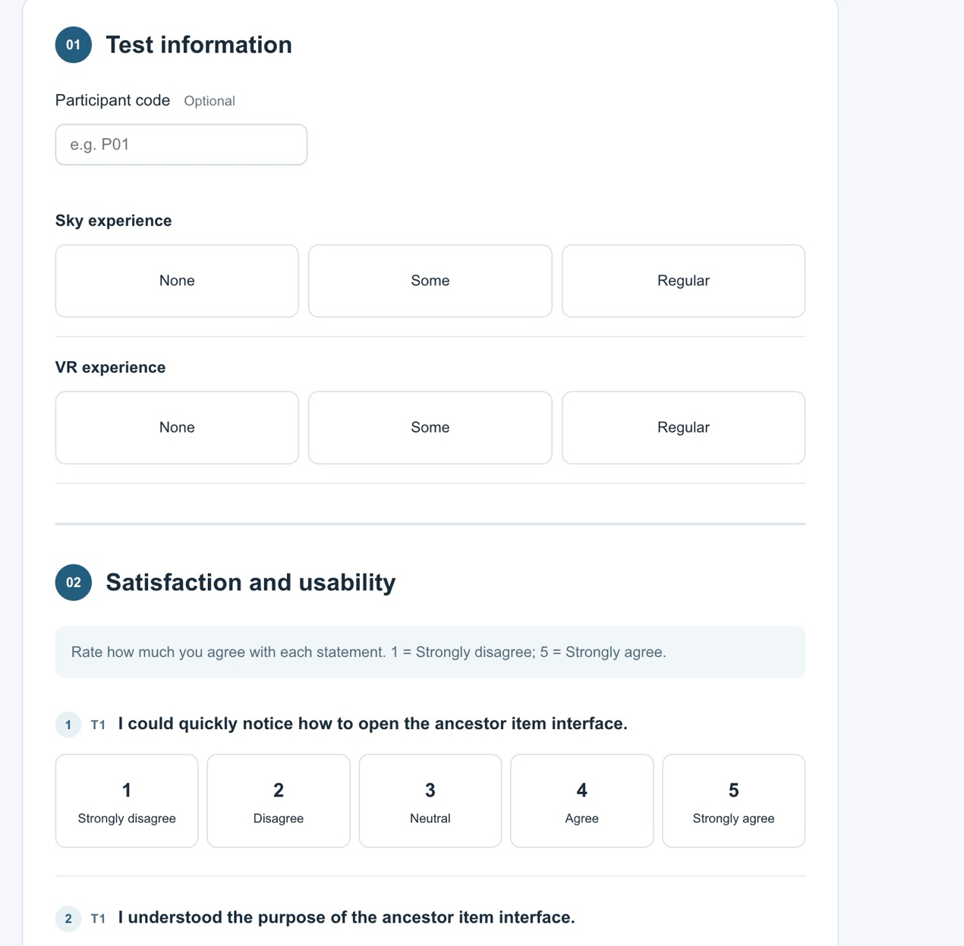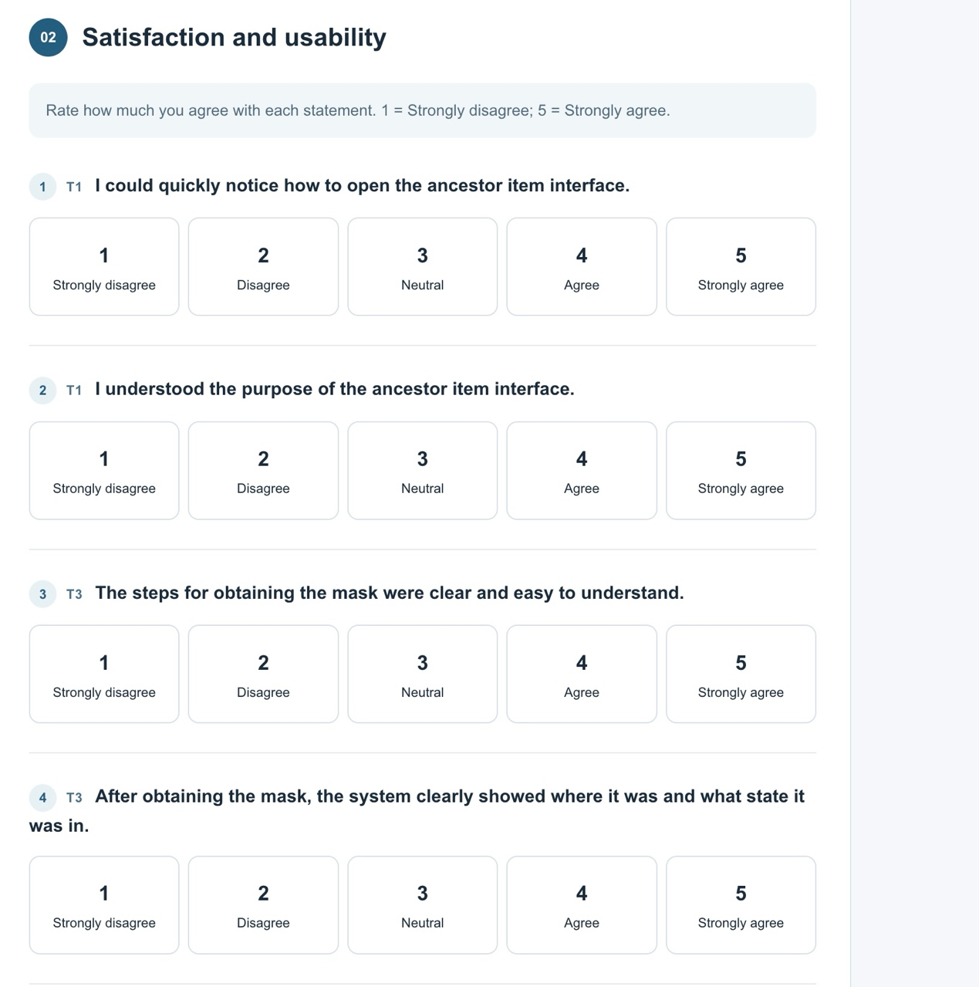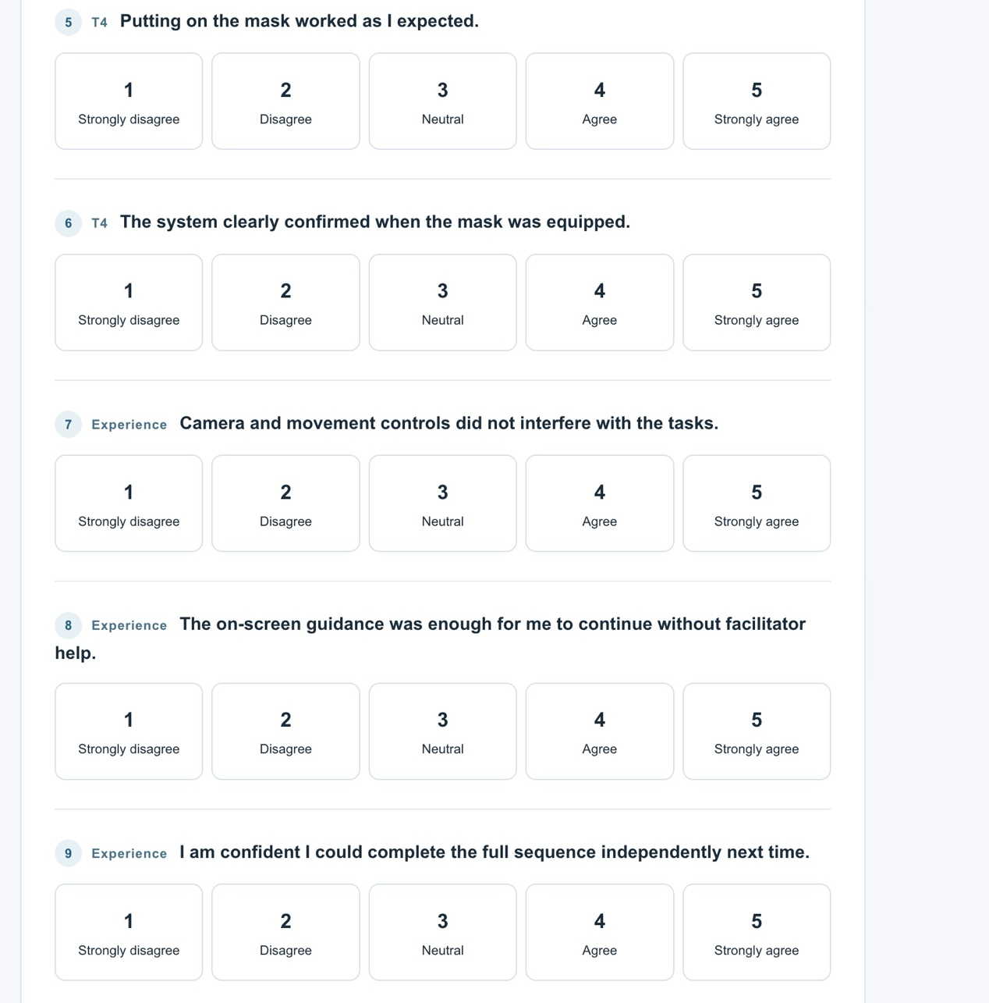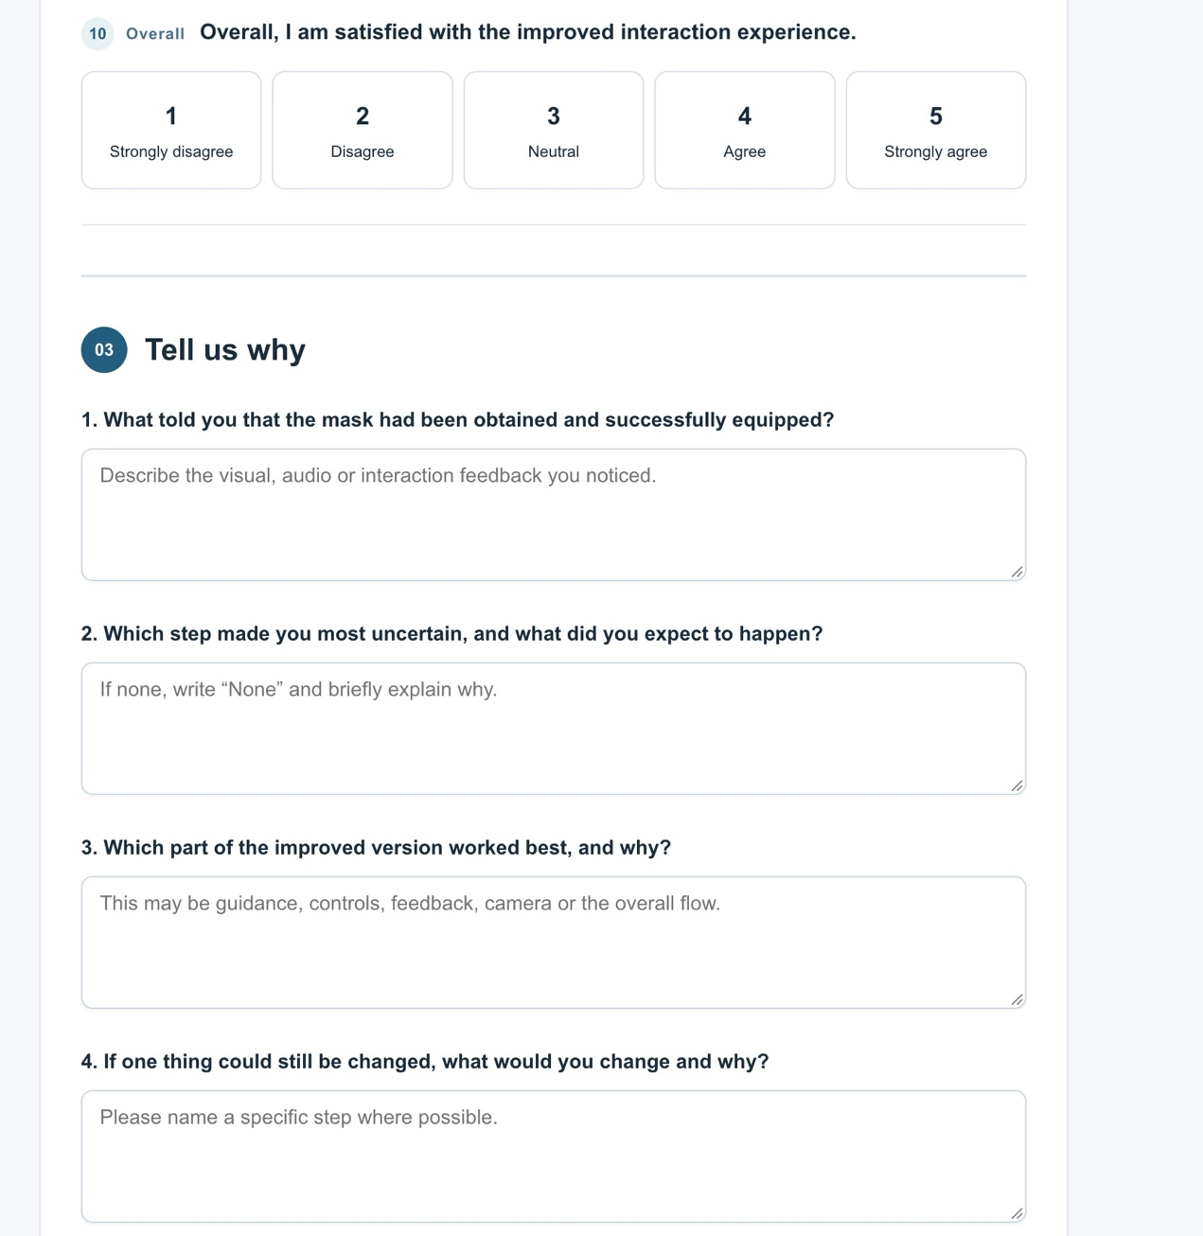

SKY XR Improved Prototype Survey Results

1 Dataset overview
Participant | Sky experience | VR experience | Submitted
P01 | Regular | Some | 2026-10-02
P02 | None | None | 2026-10-02
P03 | Some | Regular | 2026-10-03
P04 | None | Some | 2026-10-03
P05 | Regular | Regular | 2026-10-03

2 Rating summary
Measure | Mean | Median | Ratings 4–5 | Range
T1 Interface discovery | 4.0 | 4.0 | 3/5 | 3–5
T1 Purpose clarity | 4.6 | 5.0 | 5/5 | 4–5
T2 Obtaining the mask | 4.0 | 4.0 | 4/5 | 3–5
T2 Obtaining feedback | 4.0 | 4.0 | 4/5 | 3–5
T3 Wearing the mask | 4.6 | 5.0 | 5/5 | 4–5
T3 Equip feedback | 4.4 | 5.0 | 4/5 | 3–5
Camera and movement | 4.0 | 4.0 | 4/5 | 3–5
On-screen guidance | 4.0 | 4.0 | 4/5 | 3–5
Independent confidence | 4.2 | 4.0 | 4/5 | 3–5
Overall satisfaction | 4.8 | 5.0 | 5/5 | 4–5

3 Descriptive observations
- The highest average rating was Overall satisfaction (4.8/5).
- The lowest average rating was T1 Interface discovery (4.0/5).
- Written responses most often referred to interaction guidance, feedback after obtaining the mask, camera positioning and confirmation of the equipped state.

4 Complete individual responses

P01
Sky experience: Regular | VR experience: Some | Submitted: 2026-10-07 06:35:25.585 UTC
Rating item | Score
T1 Interface discovery | 5/5
T1 Purpose clarity | 5/5
T2 Obtaining the mask | 4/5
T2 Obtaining feedback | 4/5
T3 Wearing the mask | 5/5
T3 Equip feedback | 5/5
Camera and movement | 4/5
On-screen guidance | 4/5
Independent confidence | 3/5
Overall satisfaction | 5/5

Written responses
What indicated that the mask had been obtained and equipped?
The mask disappeared from the tree and appeared on my character. I also noticed a short sound and a visual change, so I knew it was equipped.
Which step caused uncertainty, and what was expected?
I was only a little unsure when taking the mask from the tree. I expected it to move directly into my hand.
Which part worked best, and why?
Putting on the mask worked best. The action was simple and the result was easy to see.
What should still be changed, and why?
I would make the feedback after obtaining the mask slightly stronger, because the change was quite quick.

P02
Sky experience: None | VR experience: None | Submitted: 2026-10-07 06:36:23.168 UTC
Rating item | Score
T1 Interface discovery | 3/5
T1 Purpose clarity | 4/5
T2 Obtaining the mask | 3/5
T2 Obtaining feedback | 3/5
T3 Wearing the mask | 4/5
T3 Equip feedback | 4/5
Camera and movement | 3/5
On-screen guidance | 3/5
Independent confidence | 4/5
Overall satisfaction | 4/5

Written responses
What indicated that the mask had been obtained and equipped?
The mask was no longer on the tree, and later I could see it on the character. This helped me understand that the action was successful.
Which step caused uncertainty, and what was expected?
Obtaining the mask was the most uncertain step. I was not sure if I needed to click, hold or drag it. I expected a clearer instruction.
Which part worked best, and why?
The highlighting of interactive objects was helpful. It showed me which object I could use.
What should still be changed, and why?
I would add a short instruction before taking the mask. This would help new players who do not know the controls.

P03
Sky experience: Some | VR experience: Regular | Submitted: 2026-10-07 06:37:22.007 UTC
Rating item | Score
T1 Interface discovery | 4/5
T1 Purpose clarity | 5/5
T2 Obtaining the mask | 4/5
T2 Obtaining feedback | 5/5
T3 Wearing the mask | 5/5
T3 Equip feedback | 5/5
Camera and movement | 4/5
On-screen guidance | 5/5
Independent confidence | 5/5
Overall satisfaction | 5/5

Written responses
What indicated that the mask had been obtained and equipped?
I saw the mask move from the tree and the interface changed. When I equipped it, the character model changed and I heard a confirmation sound.
Which step caused uncertainty, and what was expected?
There was no major uncertain step. The visual guidance made the process understandable.
Which part worked best, and why?
The system feedback worked best. I could understand when each action was completed without asking the facilitator.
What should still be changed, and why?
I would reduce the small delay after selecting the mask. The interaction would feel more responsive.

P04
Sky experience: None | VR experience: Some | Submitted: 2026-10-07 06:38:16.388 UTC
Rating item | Score
T1 Interface discovery | 3/5
T1 Purpose clarity | 4/5
T2 Obtaining the mask | 4/5
T2 Obtaining feedback | 4/5
T3 Wearing the mask | 4/5
T3 Equip feedback | 3/5
Camera and movement | 5/5
On-screen guidance | 4/5
Independent confidence | 4/5
Overall satisfaction | 5/5

Written responses
What indicated that the mask had been obtained and equipped?
The mask appeared on the character’s face. The visual change was clear, so I knew I had finished the task.
Which step caused uncertainty, and what was expected?
I was slightly uncertain when standing close to the ancestor because the camera angle changed. I expected the camera to stay behind the character.
Which part worked best, and why?
Equipping the mask was the clearest part. It only required one simple action and gave clear feedback.
What should still be changed, and why?
I would make the camera automatically face the important object. This could make the interaction more comfortable.

P05
Sky experience: Regular | VR experience: Regular | Submitted: 2026-10-07 06:39:17.226 UTC
Rating item | Score
T1 Interface discovery | 5/5
T1 Purpose clarity | 5/5
T2 Obtaining the mask | 5/5
T2 Obtaining feedback | 4/5
T3 Wearing the mask | 5/5
T3 Equip feedback | 5/5
Camera and movement | 4/5
On-screen guidance | 4/5
Independent confidence | 5/5
Overall satisfaction | 5/5

Written responses
What indicated that the mask had been obtained and equipped?
The item changed position after I selected it. When I put it on, I could see the mask on the character and the interface showed that it was equipped.
Which step caused uncertainty, and what was expected?
For a short moment, I was not sure whether the mask was only selected or already obtained. I expected a clearer status message.
Which part worked best, and why?
The complete task flow worked well. The three tasks felt connected and the controls were consistent.
What should still be changed, and why?
I would add a more visible confirmation after obtaining the mask. This would make the item state easier to understand.

