Assignment 2: Factory Method and Abstract Factory
Student: Zhuldyz
Group: SE-2522
GitHub link: [вставь ссылку]
Introduction: This application demonstrates the use of Factory Method and Abstract Factory patterns in a logistics system. Factory Method is responsible for transport creation, while Abstract Factory ensures consistent UI families across platforms.

UML Diagrams
- Factory Method
Product: Transport (interface)
Concrete Products: Truck, Ship
Creator: Logistics (abstract class with createTransport() and planDelivery())
Concrete Creators: RoadLogistics, SeaLogistics

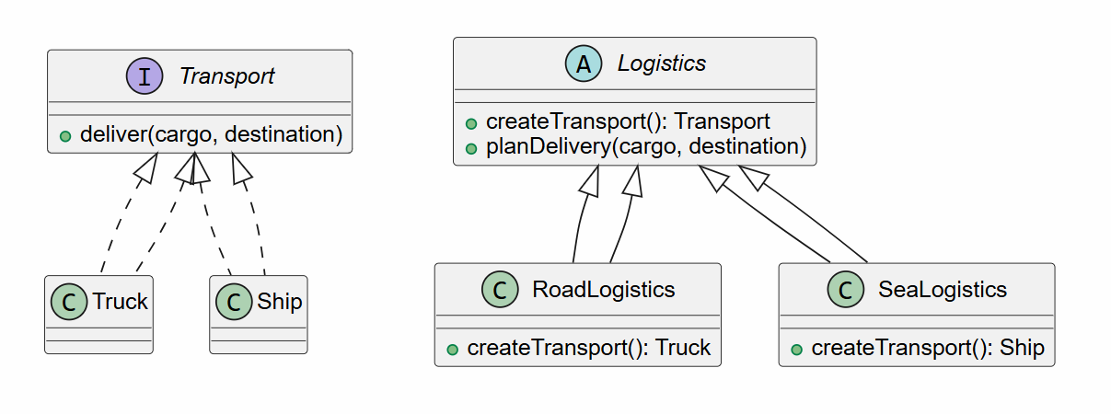
- Abstract Factory
Abstract Products: Button, Checkbox
Concrete Products: WindowsButton, MacOSButton, WindowsCheckbox, MacOSCheckbox
Abstract Factory: GUIFactory (with createButton() and createCheckbox())
Concrete Factories: WindowsFactory, MacOSFactory
Client: DeliveryApplication (uses injected GUIFactory + Logistics)
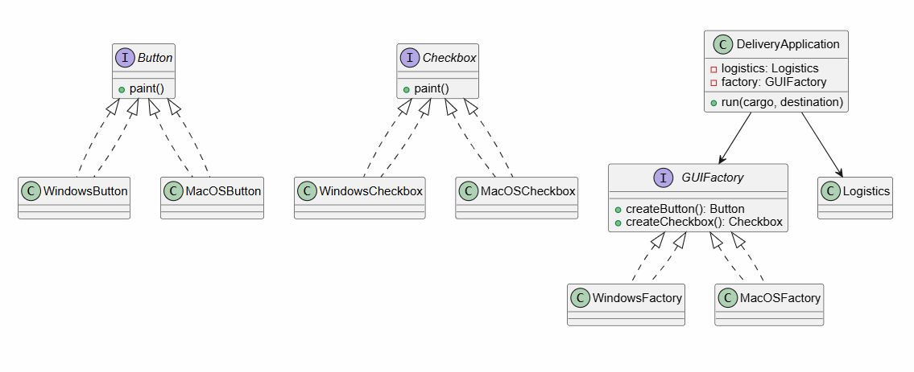
Clean Code Evidence:
- Meaningful names — RoadLogistics, SeaLogistics clearly identify their roles.
class RoadLogistics extends Logistics {
@Override
Transport createTransport() {
return new Truck();
}
}
- Small methods — planDelivery() and createTransport() have single responsibilities.
void planDelivery(String cargo, String destination) {
Transport transport = createTransport();
transport.deliver(cargo, destination);
}
- Avoid duplication — delivery workflow centralized in Logistics.
- Data abstraction — client uses Transport, Button, Checkbox interfaces.
- Encapsulation — methods hide internal implementation details.

Verification Result:
- ROAD + WINDOWS → Truck delivery; Windows button and checkbox.
- SEA + WINDOWS → Ship delivery; Windows button and checkbox.
- ROAD + MACOS → Truck delivery; MacOS button and checkbox.
- SEA + MACOS → Ship delivery; MacOS button and checkbox.
- Unsupported delivery mode → Clear validation message.
- Unsupported platform → Clear validation message.
- Missing output →

Design Reflection
- New transport: Add a new class implementing Transport and a corresponding Logistics subclass. Client code remains unchanged.
- New UI family: Implement a new factory (e.g., LinuxFactory) with matching products. The client continues to use the abstract factory interface.
- New UI product type (e.g., TextField): Define a new interface and implement it in each family. The client can use the new product without modifying existing logic.

Summary:
The Factory Method solves the problem of creating transport objects via subclass overrides, while Abstract Factory ensures platform consistency by producing related UI components. Together they provide modularity, extensibility, and clean architecture. Adding new transports or UI families requires minimal changes thanks to abstraction.

References:
- Freeman & Robson, Head First Design Patterns
- Robert C. Martin, Clean Code
- Lecture 2: Factory Method and Abstract Factory

