Assignment #4 — Facade Pattern
Online Order Processing (Option B)
Student: Yelbayeva Zhuldyz Group: SE-2522
GitHub: https://github.com/zhuldyzyelbayeva-spec/Assignment-4-Facade-Pattern.git

1. Introduction
I chose an online store as my example. When someone places an order, the program has to check the stock, take payment, arrange delivery and send a confirmation. These are different jobs, and doing all of them in Main would make the code hard to read. The Facade pattern helps by giving Main one simple method: placeOrder(cart, customer). The OrderFacade class takes care of the other steps.
This is a small demo, not a real online shop. Payments, delivery and notifications are simulated in Java. There is no database or real payment system.

2. UML class diagram
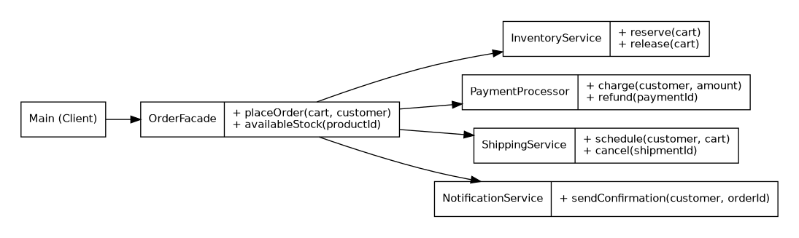
Main uses OrderFacade. OrderFacade works with four services: InventoryService, PaymentProcessor, ShippingService and NotificationService. Cart and Customer store the order details. The services do not depend on OrderFacade, so they can also be used separately.

3. How the program works
- 1. Main creates an OrderFacade and passes a cart and customer to placeOrder().
- 2. InventoryService checks and reserves the products.
- 3. PaymentProcessor checks the payment.
- 4. ShippingService creates a shipment.
- 5. NotificationService sends a confirmation.
- 6. If a step fails, OrderFacade tries to undo completed steps in reverse order.
For example, if the payment is declined, the reserved books go back into stock. If shipping fails after payment, the program tries to refund the payment and release the books. If notification fails, it also tries to cancel the shipment.

4. Five Clean Code principles

4.1 Clear names
Before: doIt(a, b);
After: orders.placeOrder(cart, customer);
The second version is easier to understand. I can see what the method does without reading its implementation.

4.2 One responsibility per class
Before: Main checks stock, processes payment and sends emails.
After: payments.charge(customer, cart.total());
PaymentProcessor handles payment, InventoryService handles stock and ShippingService handles delivery. OrderFacade only puts the steps together.

4.3 Hide unnecessary details
Before: inventory.reserve(cart); payments.charge(customer, cart.total()); shipping.schedule(customer, cart);
After: orders.placeOrder(cart, customer);
Main does not need to know which service runs first or what to do if a later step fails.

4.4 Small, focused methods
Before: one large method updates stock, validates payment and builds delivery details.
After: inventory.reserve(cart);
The reserve method only checks and changes stock. This makes it easier to test and change.

4.5 Handle errors properly
Before: catch (Exception e) { }
After: payments.refund(paymentId); inventory.release(cart);
Ignoring an error can leave the stock or payment in the wrong state. In OrderFacade, a failed order triggers cleanup. Cleanup errors are kept as suppressed exceptions, so the original error is not lost.

5. Testing
I tested a successful order, a declined payment, a shipping failure and a notification failure. The test checks that the stock goes down after a successful order and returns to the previous value when an order fails. It also checks that failed orders do not use up order numbers. Run FacadeTest to see ALL TESTS PASSED.

6. Conclusion
The Facade pattern makes the client code shorter and simpler. Main only calls OrderFacade instead of managing four services. OrderFacade hides the order of operations and the rollback steps. At the same time, the service classes are still public and can be used directly when needed. This demo has limits: the data is stored in memory, and the rollback is best-effort, not a real database transaction.

7. GitHub repository
Repository link: https://github.com/zhuldyzyelbayeva-spec/Assignment-4-Facade-Pattern.git

