Individual Project Report: HTML & CSS Basics
Course: Web Technologies Frontend
Student: Zhuldyz Yelbayeva
Group: SE-2522
Astana IT University
1. Objective
The primary objective of this assignment was to design, structure, and style a fully responsive personal webpage from scratch using semantic HTML5 and an external CSS stylesheet. The project focused on mastering core web development concepts, including document structure, typography, the CSS box model, custom selectors, form implementation, and clean layout design without relying on external frameworks like Bootstrap.
2. Description of Tasks and Implementation
Part 1: Building the HTML Page
- Project Setup & Document Structure:
I initialized a structured project workspace containing an index.html file, an external style.css stylesheet, and an images folder. The HTML document was configured with the standard HTML5 doctype, correct language attributes (lang="en"), UTF-8 character encoding, and the exact required page title: "My First Webpage".
- Semantic Layout & Introduction:
The webpage was organized into distinct semantic landmarks: <header>, <main>, <section>, and <footer>. Using hierarchical headings (<h1>, <h2>, <h3>), I introduced myself as a 2nd-year Software Engineering student at Astana IT University and provided a brief overview of my academic background and interests.
- Lists, Multimedia, and Links:
I implemented an ordered list (<ol>) detailing my core hobbies (3D modeling in Blender, Framer UI design, and algorithmic problem-solving) and an unordered list (<ul>) featuring my favorite websites with active external links (target="_blank"). A personal avatar image was successfully integrated using a relative path with descriptive alternative text for accessibility.
- Navigation & Interactive Elements:
A custom site navigation bar was built using anchor links pointing to respective section IDs (#about-me, #hobbies, #schedule, #contact) to allow smooth in-page jumping. Additionally, a styled action button labeled "Click Me" was added.
- Class Schedule Table:
I organized my academic schedule into a structured HTML table (<table>) featuring three clear columns: Subject, Day, and Time, utilizing proper table header (<th>) and data (<td>) cells.
- Mood Paragraph:
To add a personal touch, I included a specialized mood paragraph styled with an accent border and background tint, featuring expressive emojis that render correctly across modern browsers.
- Interactive Contact Form:
A functional form was constructed containing a text input for the user's name, an email input, a native color picker input for favorite colors, and a submission button. Each input was properly paired with a descriptive <label> element.
Part 2: Styling with CSS
- External Stylesheet & Selector Strategy:
An external stylesheet (style.css) was linked inside the <head> of the document. I successfully demonstrated all four core CSS selector types:
  - Element selectors (e.g., body, p, h1) for foundational typography and resets.
  - Class selectors (e.g., .profile-card, .action-btn, .mood-paragraph) for reusable component styling.
  - ID selectors (e.g., #about-me) to uniquely target specific sections.
  - Descendant selectors (e.g., .site-nav a) to style nested elements cleanly.
- Typography & Visual Design:
I selected a clean, professional font family (Arial) with optimized font sizes, weights, and line heights (1.6) to ensure maximum readability. Headings and body texts were visually contrasted, and text links were styled with custom hover effects and text-decoration removal.
- Color Palette & Backgrounds:
A cohesive, modern color scheme was chosen (combining deep slate blues #2c3e50, clean white backgrounds, and a vibrant teal accent #1abc9c) to maintain a professional aesthetic and high contrast.
- Box Model, Sizing, and Layout:
I utilized CSS properties like margin, padding, border, max-widths, and border-radius to properly space, group, and structure content boxes without clipping or overflowing.
- Interactive States & Accessibility:
The navigation links and buttons were enhanced with smooth :hover and :focus state transitions to improve usability and keyboard accessibility. Images were styled with object-fitting, custom borders, and rounded corners to maintain visual proportions.
3. Screenshots of the Result
(Note: Insert your screenshots here with labels)
- Figure 1: Header, Navigation, and "About Me" Section
[Insert Screenshot Here]
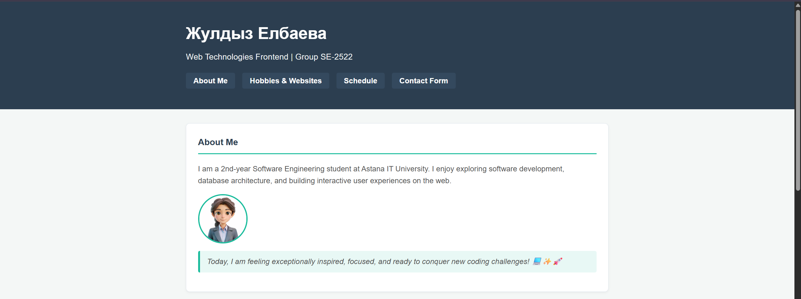
- Figure 2: Hobbies List, Favorite Websites, and Action Button
[Insert Screenshot Here]
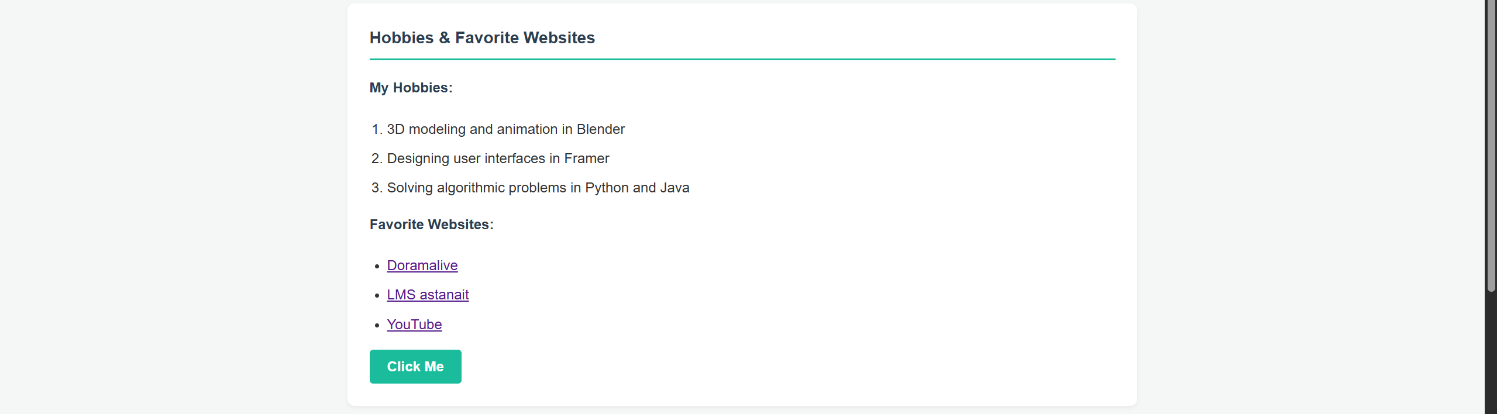
- Figure 3: Class Schedule Table and Mood Paragraph
[Insert Screenshot Here]

- Figure 4: Contact Form and Footer
[Insert Screenshot Here]
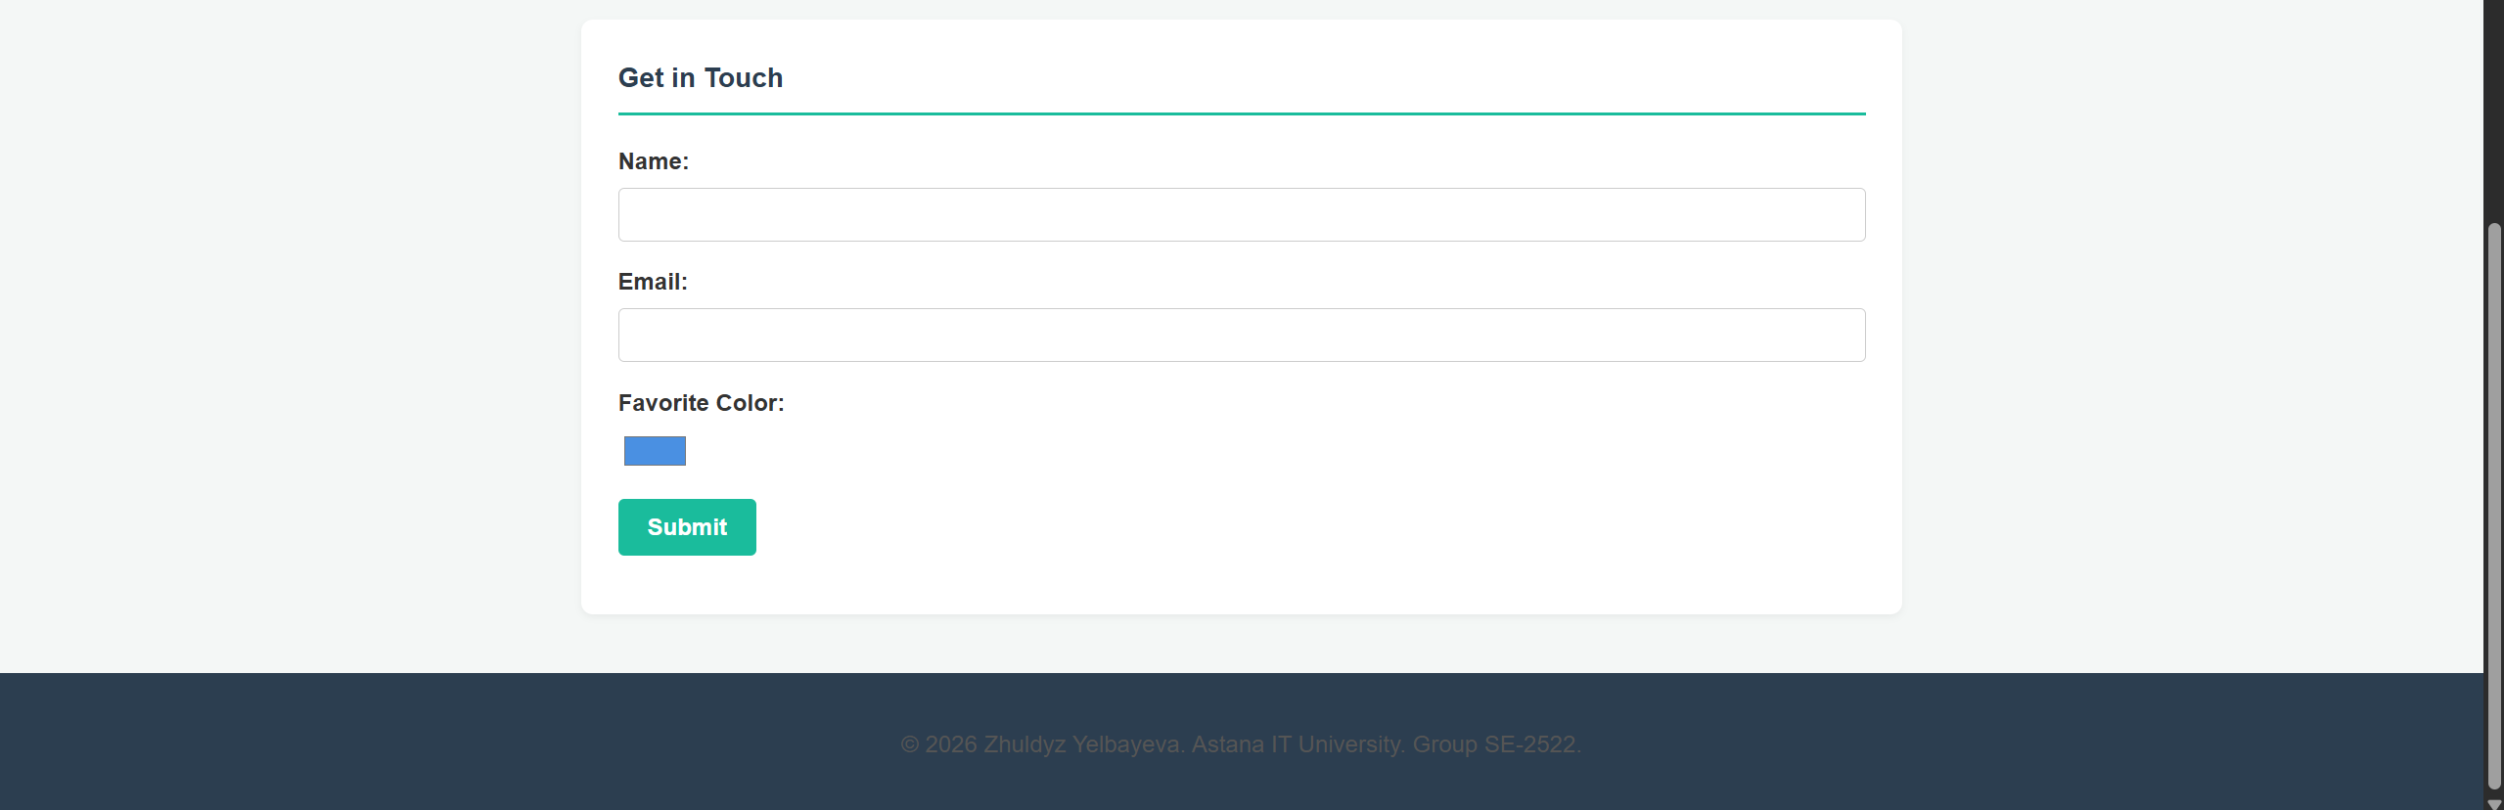
4. Live Preview / Published URL
You can view the live, published version of the webpage here:
👉 [Insert your GitHub Pages / Vercel URL here]
5. Summary and Reflection
Working on this project was a rewarding experience that bridged theoretical web design concepts with practical implementation. I deepened my understanding of semantic HTML5 structure, the nuances of the CSS box model, and how to write clean, maintainable code using modular CSS selectors. Organizing everything from scratch without UI frameworks helped me gain solid control over layout spacing, typography, and form styling. I am fully prepared to defend this project, explain my technical choices, and demonstrate live debugging if necessary.

