Assignment #2
Student: Zhuldyz Yelbayeva
Group: SE-2522

Objective
The purpose of this assignment is to apply Flexbox and CSS Grid to create modern, responsive layouts. The project demonstrates alignment, spacing, grid areas, equal-height cards, image galleries, hover effects, and a combined portfolio layout.

Part 1 — Flexbox

Task 0. Navigation Bar
Created a header with a logo on the left and navigation links on the right. The header uses display: flex, justify-content: space-between, and align-items: center. The navigation links use Flexbox gap for consistent spacing. Navigation bar built with Flexbox (`display: flex; justify-content: space-between;`).
Screen:
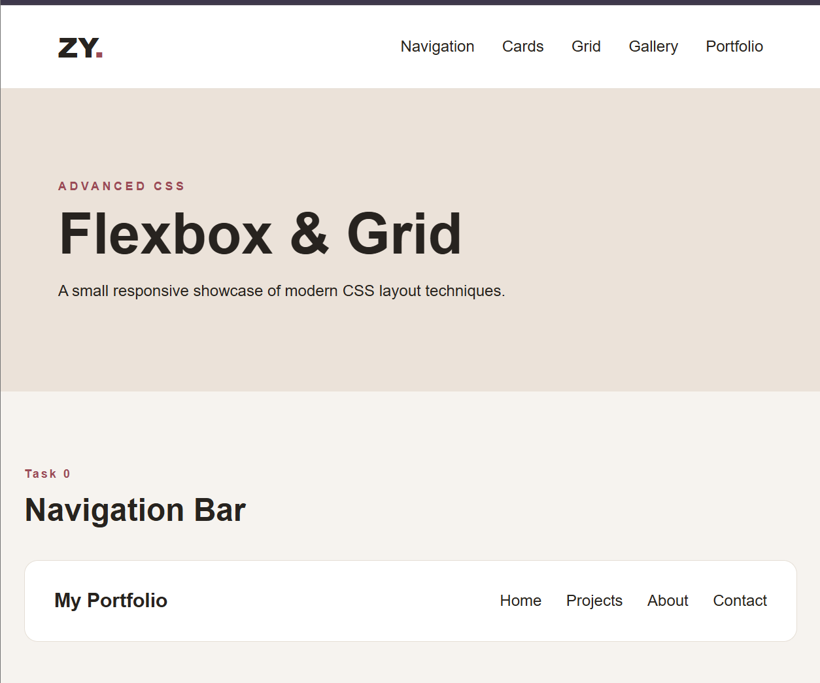

Task 1. Card Row
Created three cards containing an image, title, text, and button. The cards use display: flex and align-items: stretch so they have equal height. A gap separates the cards, and a hover effect lifts the selected card and changes its shadow. Card row using Flexbox for equal height and hover effects.
Screen:
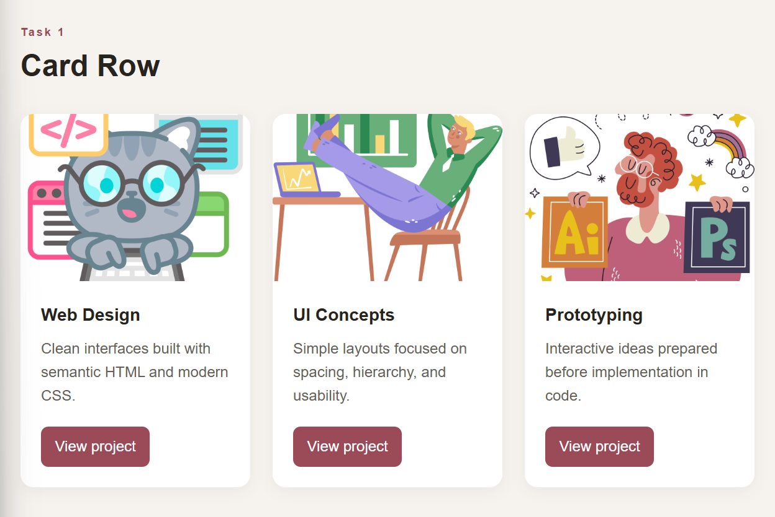

Part 2 — Grid System

Task 2. Page Layout with Grid Areas
Created a four-section layout with header, sidebar, main content, and footer. The parent uses CSS Grid with named areas: header spans the top, sidebar is on the left, main content is on the right, and footer spans the bottom. Page layout created with CSS Grid and named areas.
Screen:
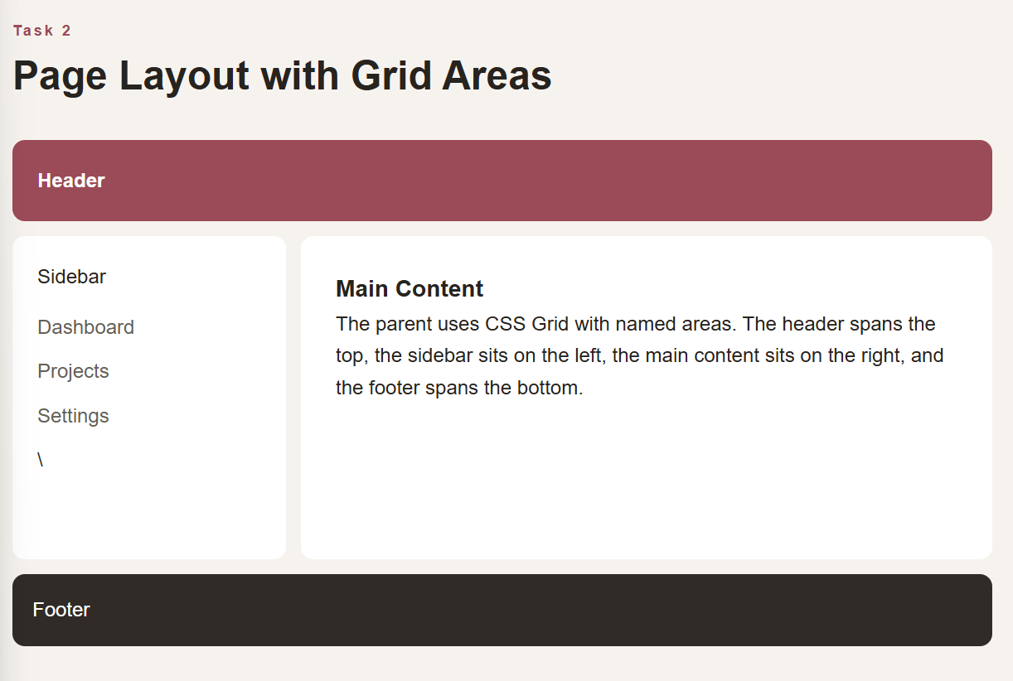
Task 3. Image Gallery
Created a gallery with nine images. The gallery uses a three-column CSS Grid with equal-width columns and consistent gaps. Each image has a hover zoom effect and a caption overlay. Image gallery with Grid, hover zoom and captions.
Screen:
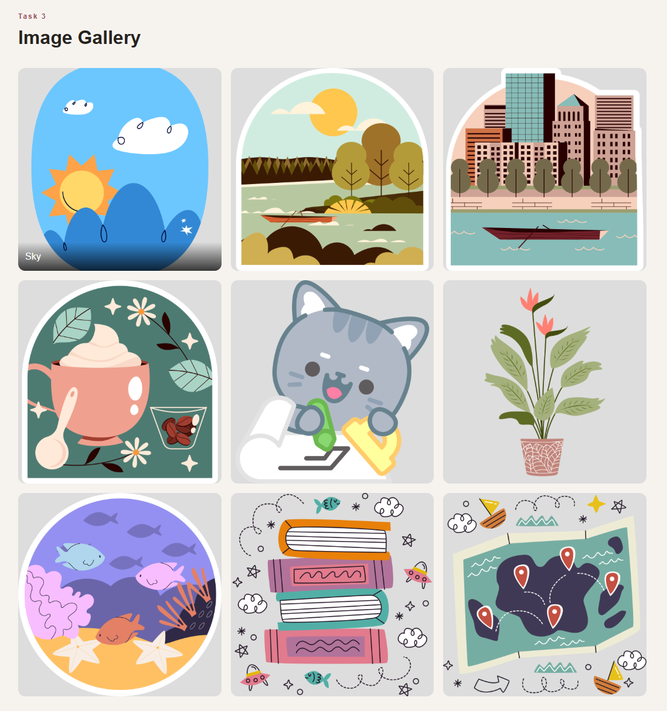

Part 3 — Combining Flexbox & Grid

Task 4. Portfolio Page
Created a portfolio structure containing a header, projects area, information sidebar, and footer. Flexbox is used for the header navigation and inside project cards. CSS Grid is used for the main two-column structure. The footer spans the complete portfolio width. Portfolio page combining Flexbox (projects) and Grid (main layout).
Screen:
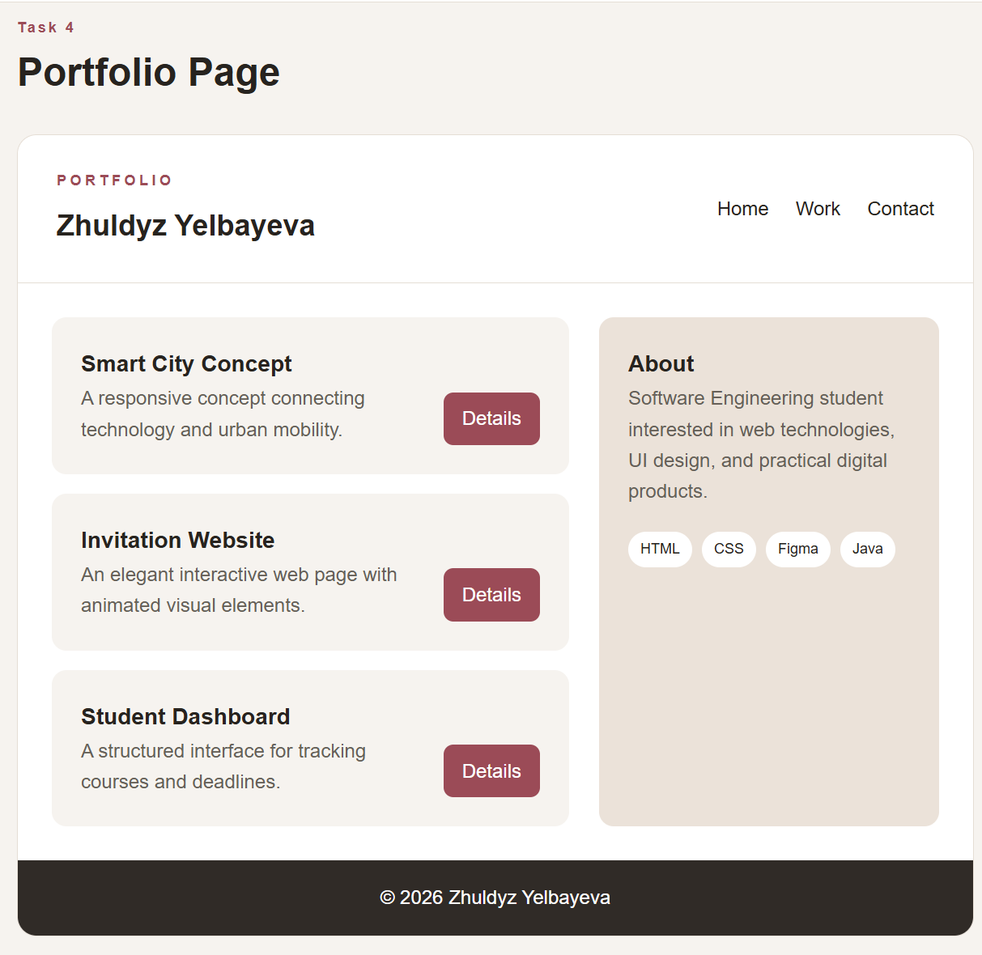
Responsive Design
A media query is included for smaller screens. Navigation wraps, cards change from a row to a column, the Grid layout becomes a single column, the gallery changes to two columns, and the portfolio main section becomes one column.

Code Structure
- index.html — all assignment tasks and semantic page structure
- style.css — Flexbox, Grid, hover effects, spacing, and responsive rules
- images/ — local SVG placeholder images used by the gallery and cards
- README.md — short project description and run instructions

Summary of Work Process
First, I created the HTML structure for all five tasks. Then I styled the navigation and cards with Flexbox, using alignment, gap, and flexible sizing. After that, I created Grid layouts with explicit columns, rows, and named grid areas. I added hover effects to cards and gallery images. Finally, I combined Flexbox and Grid in the portfolio page and added responsive rules for smaller screens. The project does not require an external CSS framework.

How to Run
Open index.html in a modern web browser. The project has no build step or package installation.

