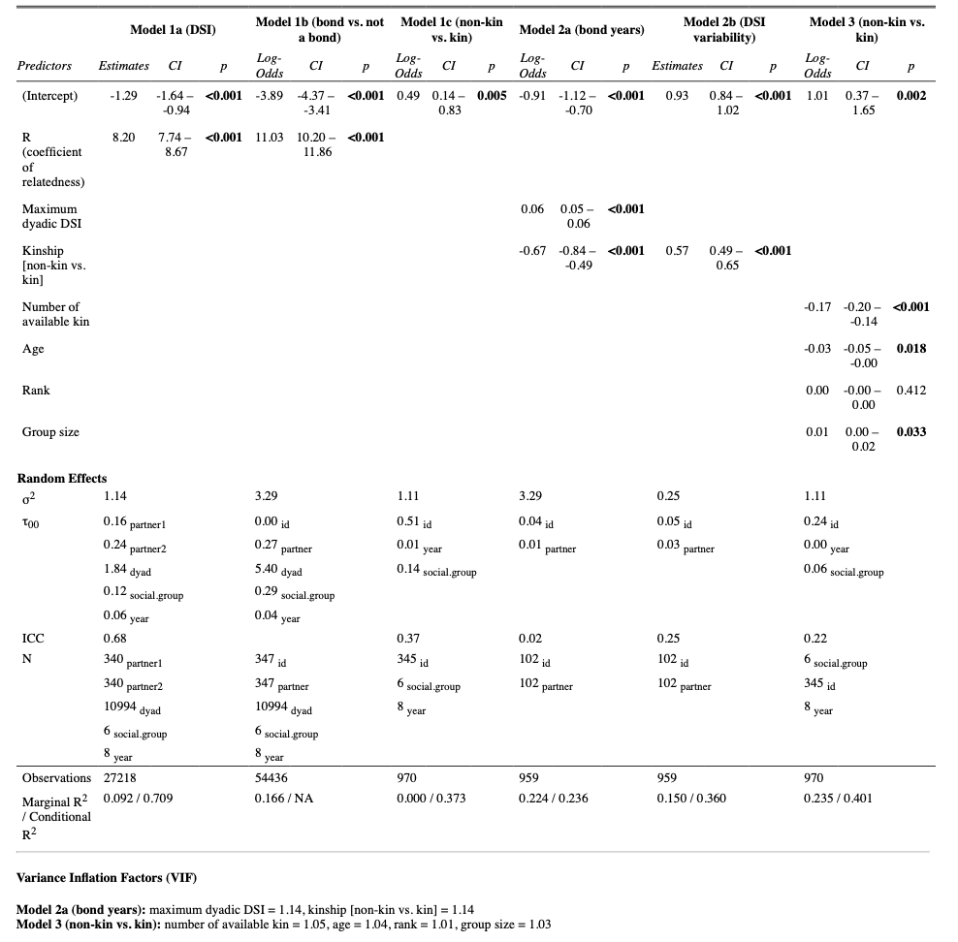
Table S1. A summary of parameters and results of all six statistical models performed in this study.

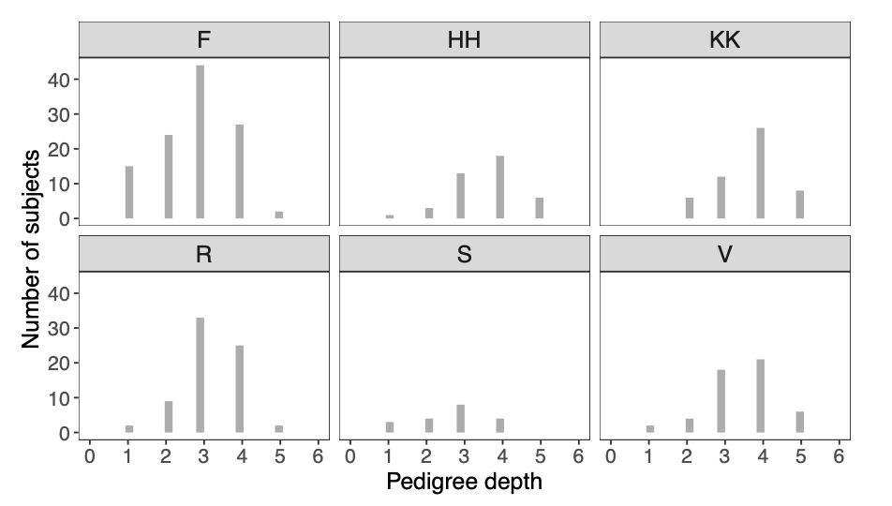
Figure S1. Distribution of pedigree depth for the 347 subjects from the six social groups.

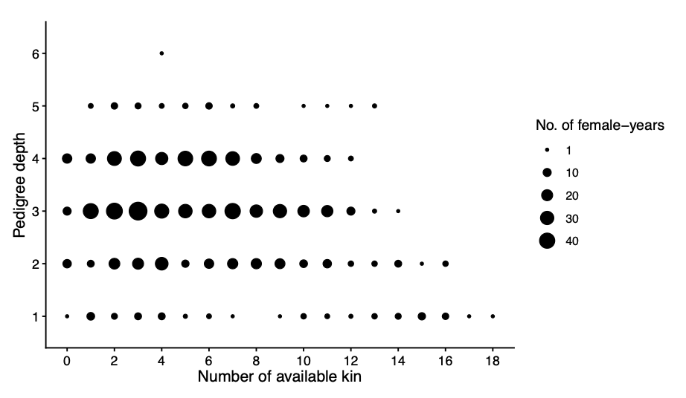
Figure S2. Number of available kin as a function of pedigree depth. Although some of the subjects have few available kin, this was not caused by a lack of information on their pedigree.

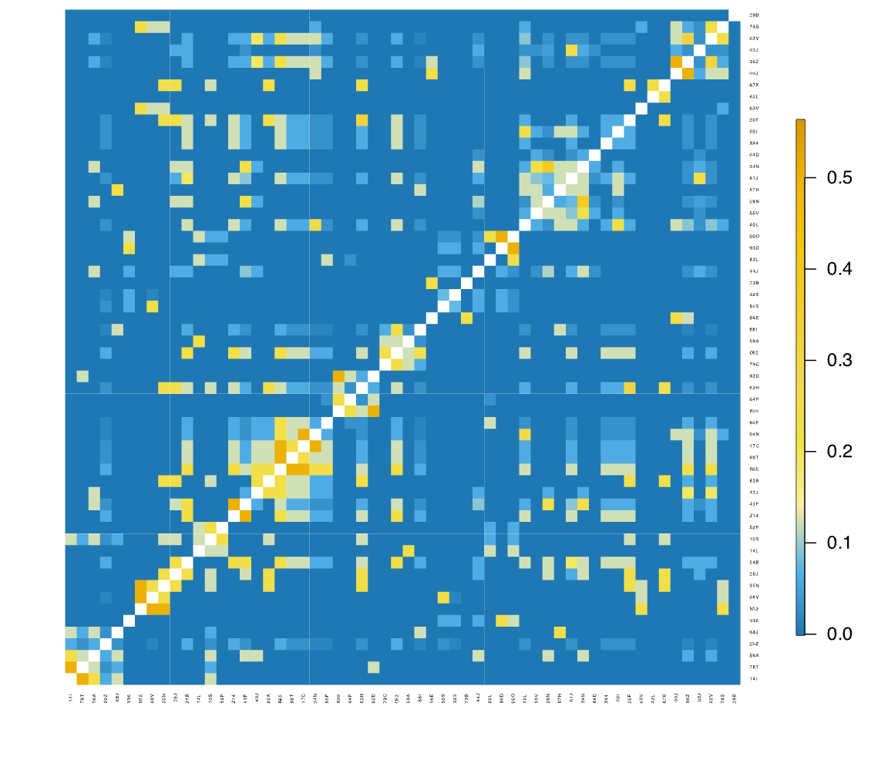Figure S3. Relatedness coefficient (r) between adult female subjects in the group-year F2010.
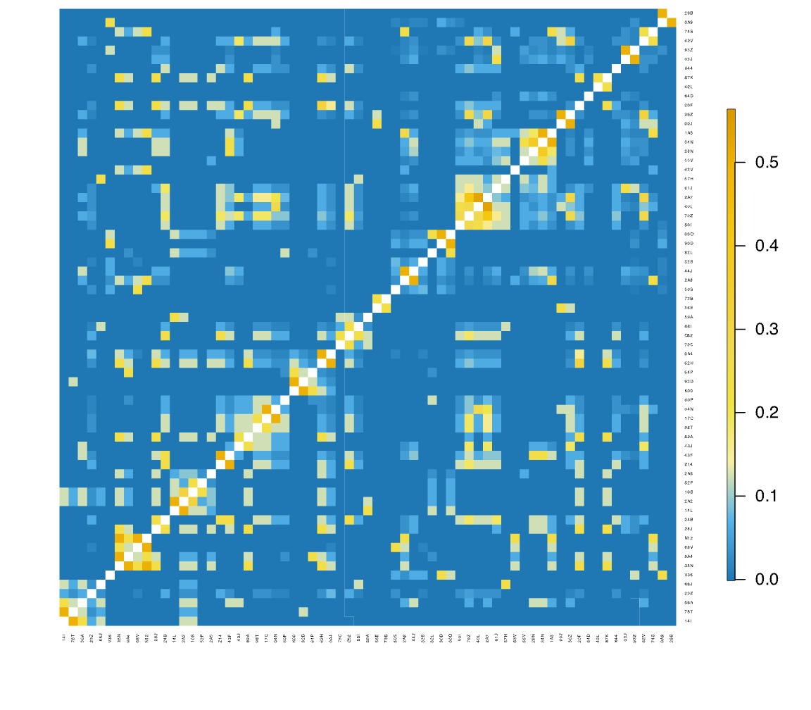
Figure S4. Relatedness coefficient (r) between adult female subjects in the group-year F2011.

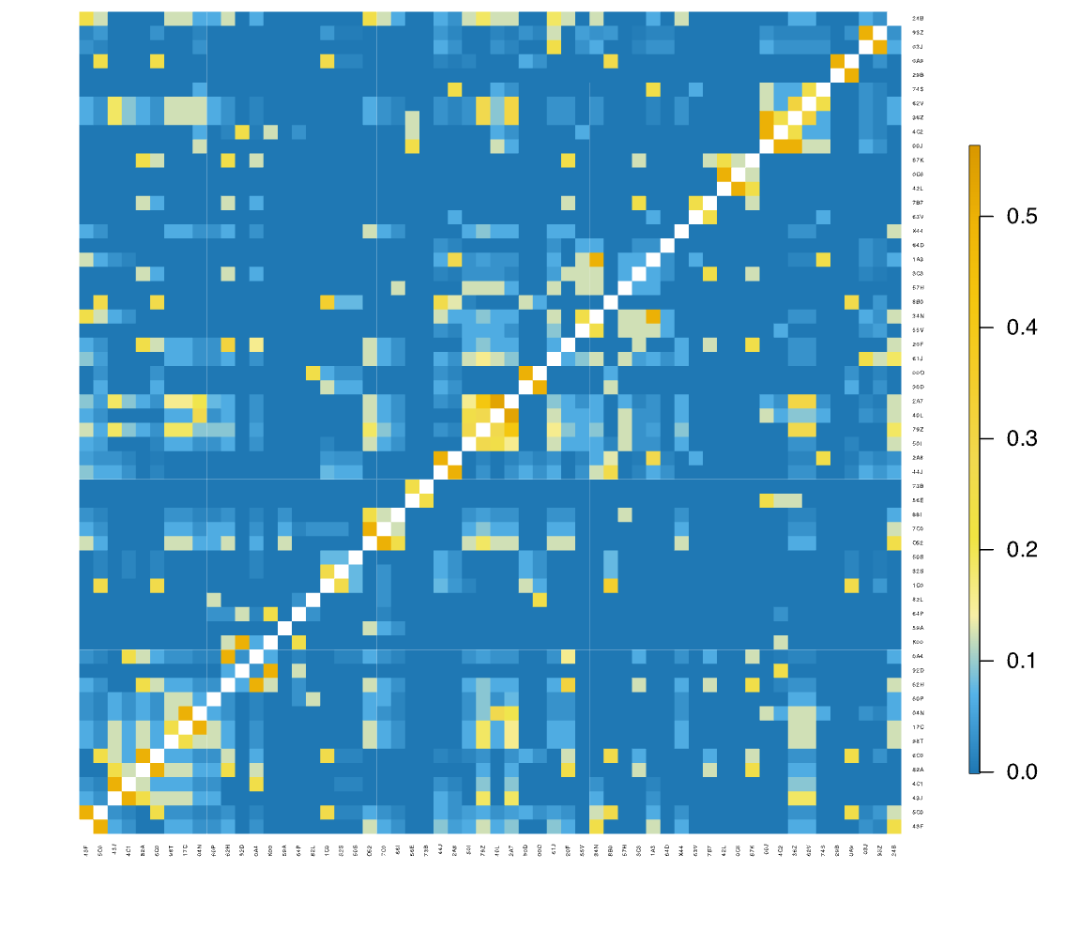
Figure S5. Relatedness coefficient (r) between adult female subjects in the group-year F2012.

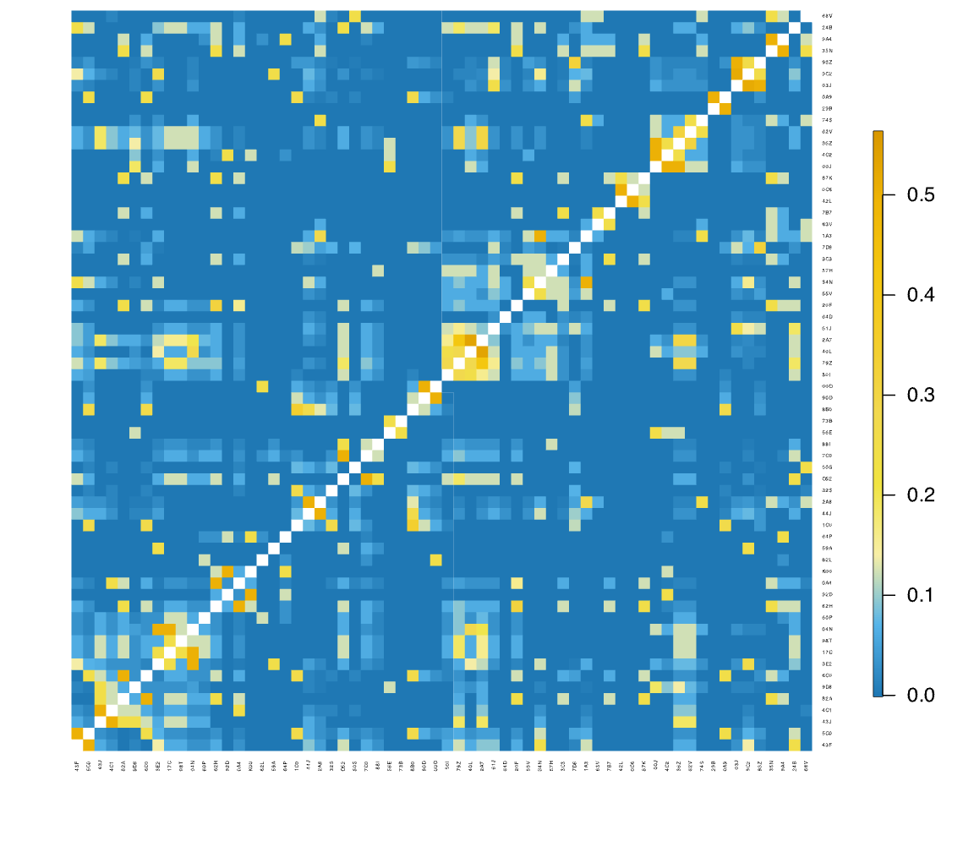
Figure S6. Relatedness coefficient (r) between adult female subjects in the group-year F2013.

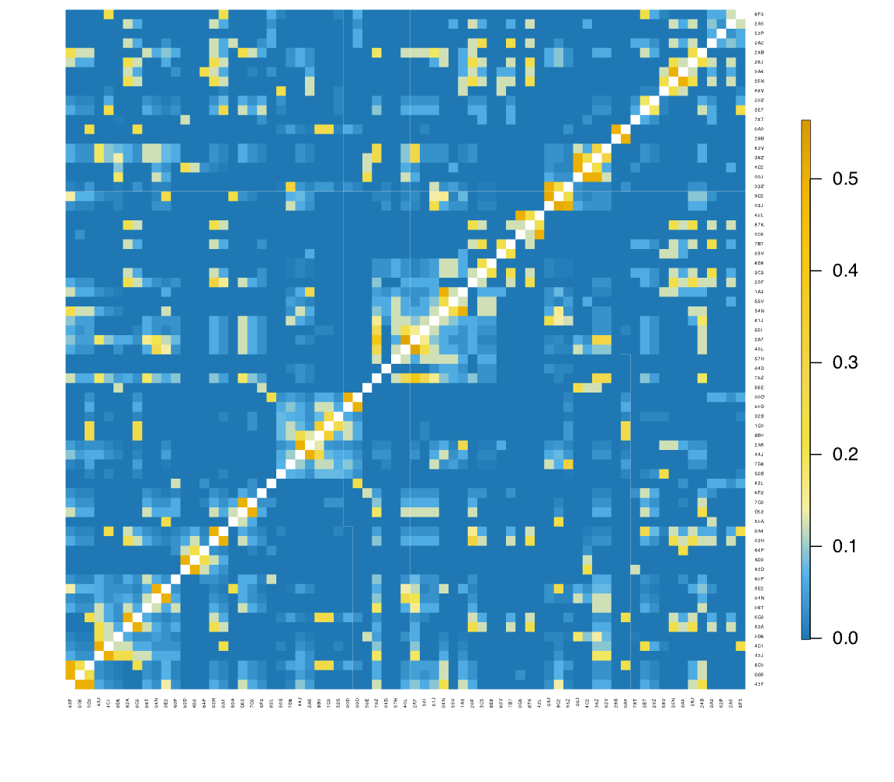
Figure S7. Relatedness coefficient (r) between adult female subjects in the group-year F2014.

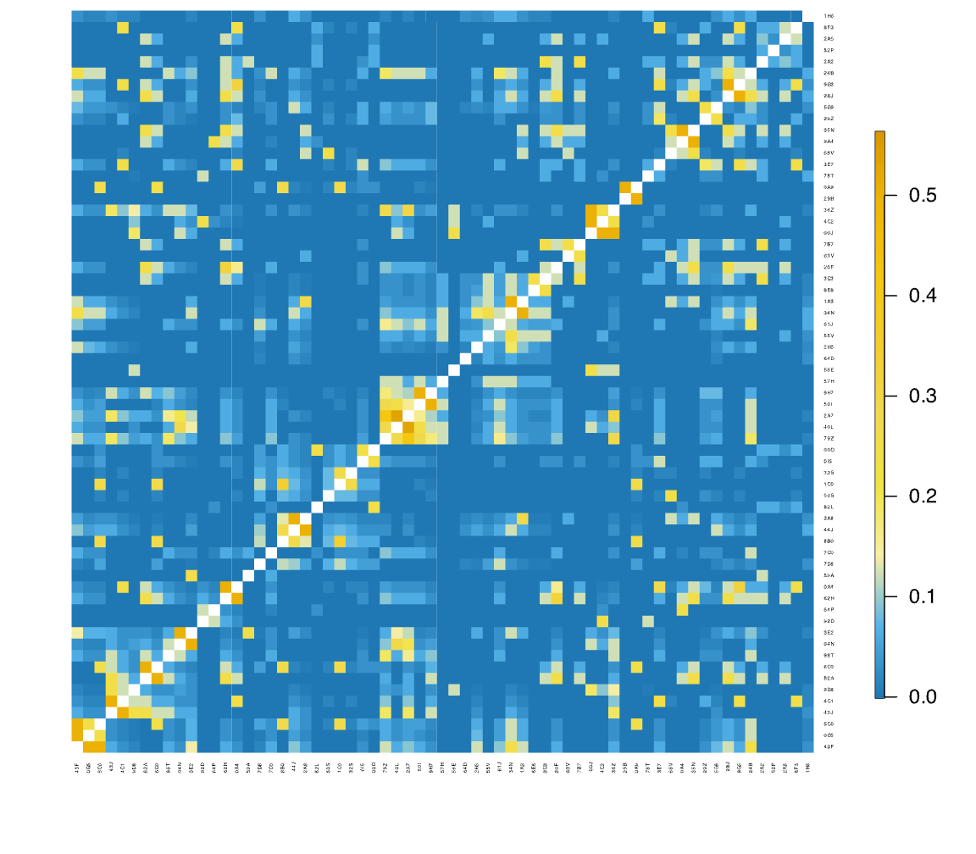
Figure S8. Relatedness coefficient (r) between adult female subjects in the group-year F2015.

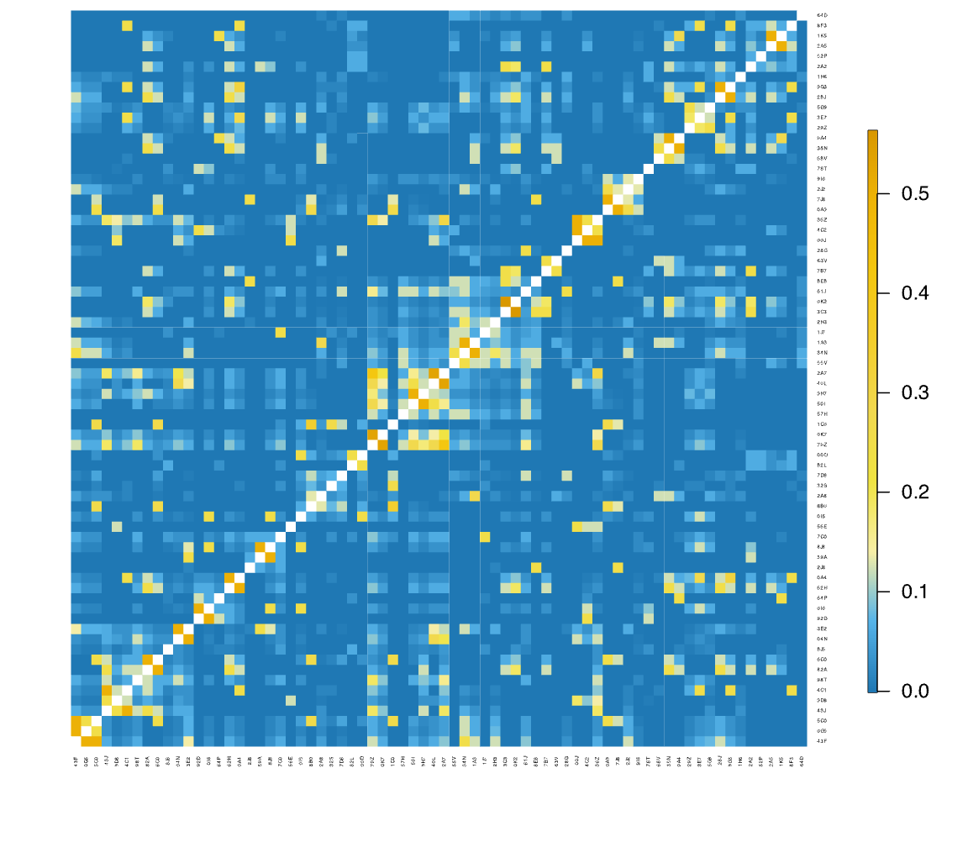
Figure S9. Relatedness coefficient (r) between adult female subjects in the group-year F2016.

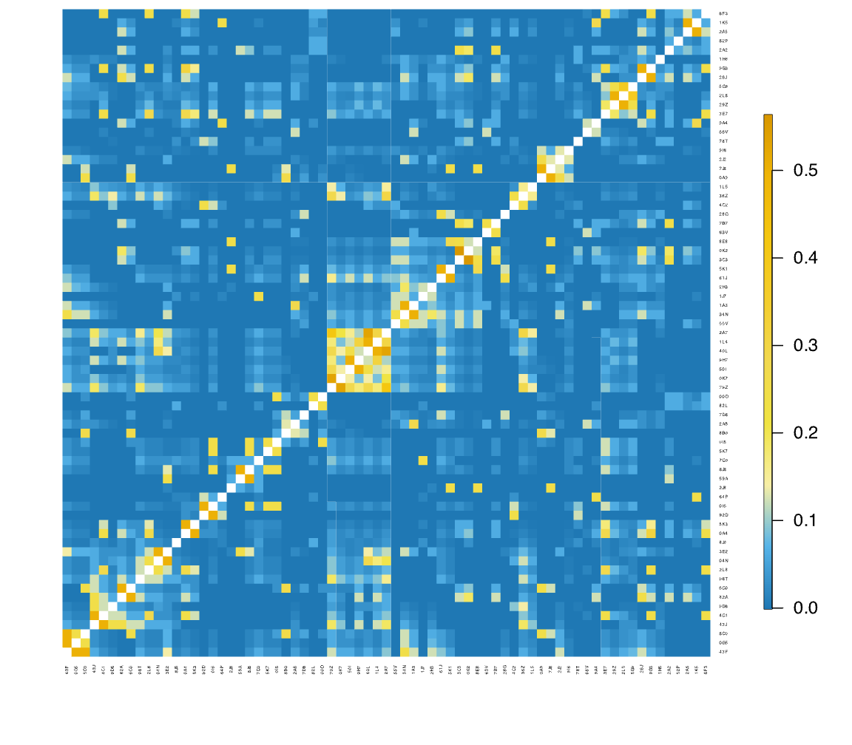
Figure S10. Relatedness coefficient (r) between adult female subjects in the group-year F2017.

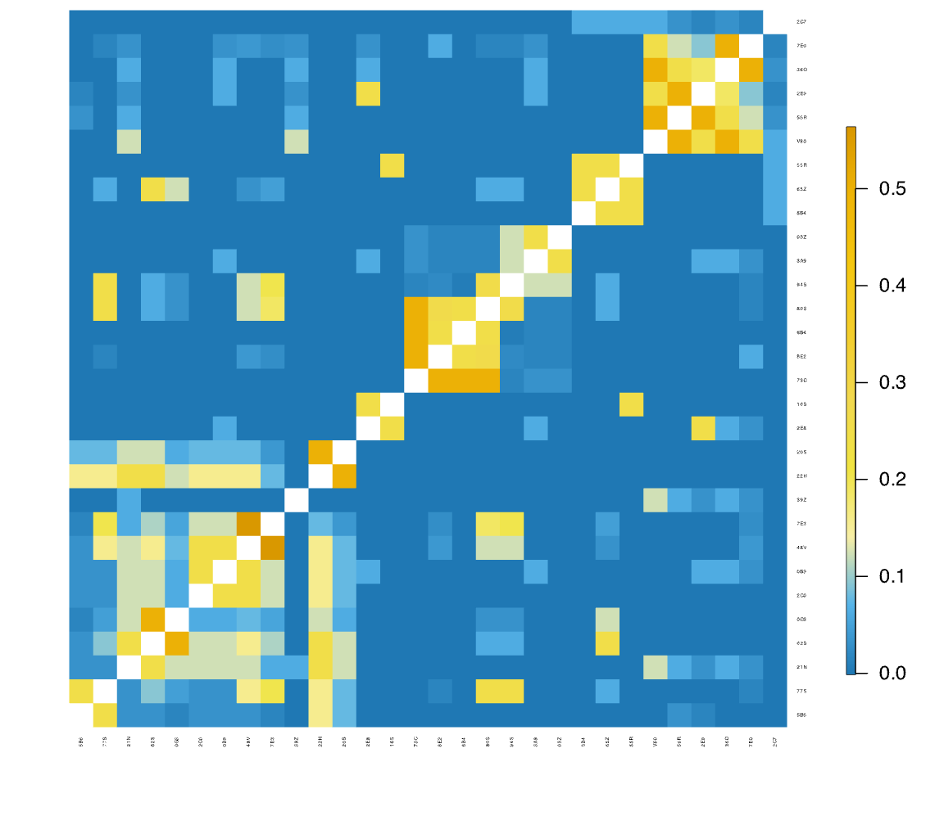
Figure S11. Relatedness coefficient (r) between adult female subjects in the group-year HH2014.

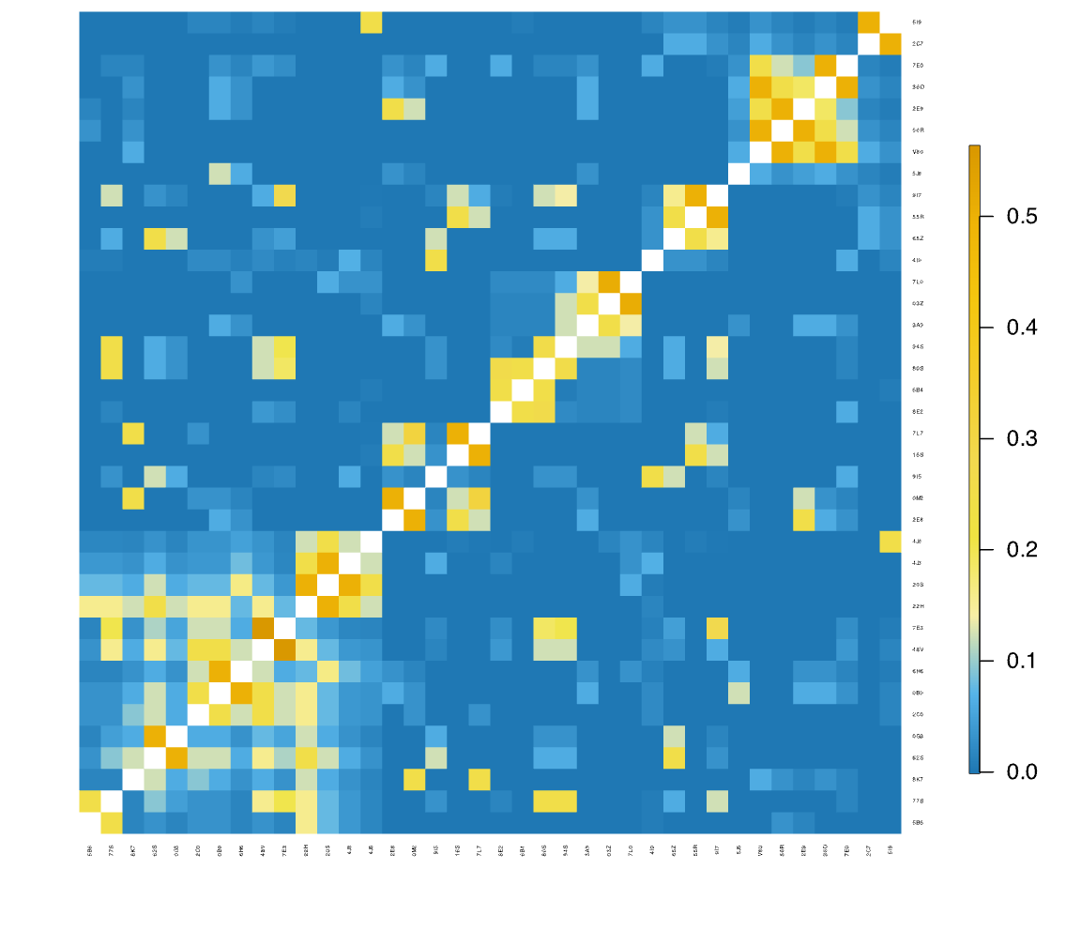
Figure S12. Relatedness coefficient (r) between adult female subjects in the group-year HH2016.

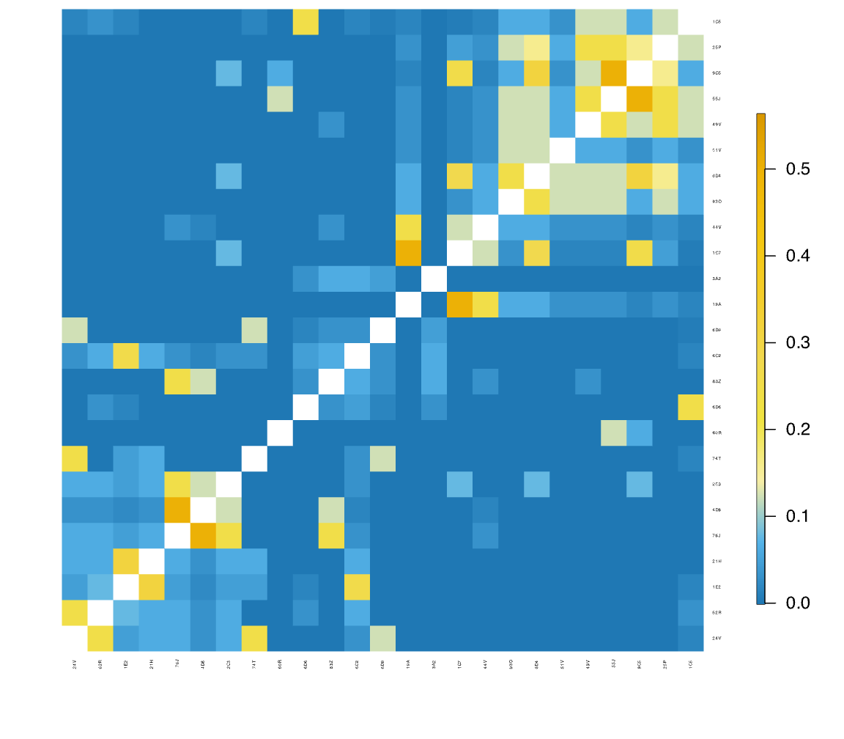
Figure S13. Relatedness coefficient (r) between adult female subjects in the group-year KK2013.

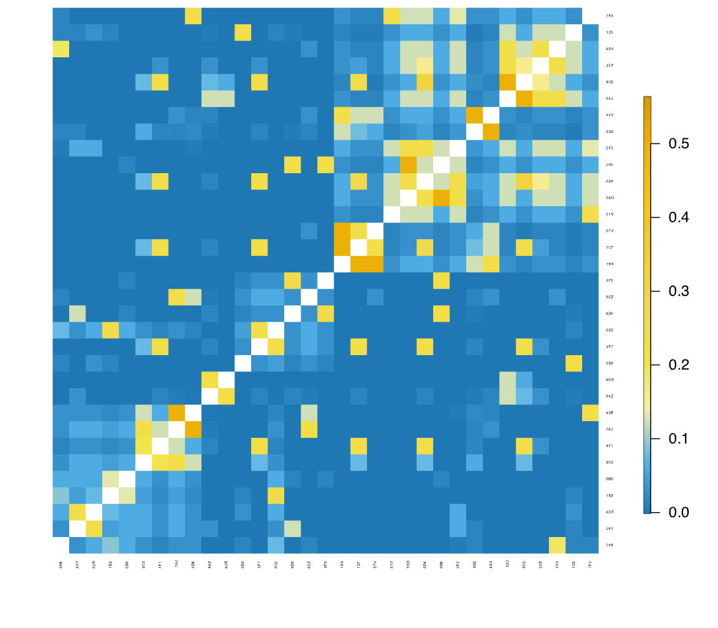
Figure S14. Relatedness coefficient (r) between adult female subjects in the group-year KK2015.

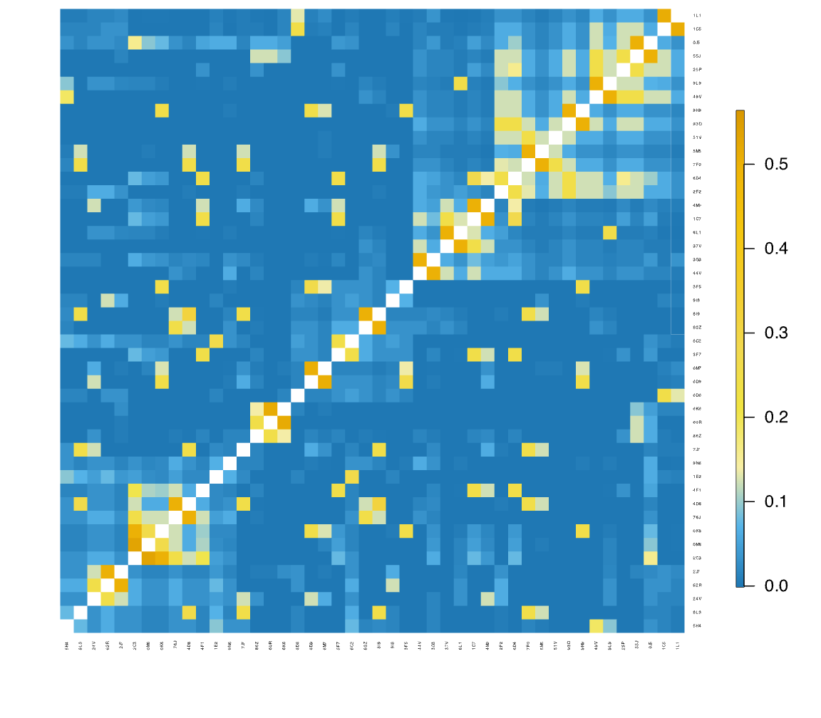
Figure S15. Relatedness coefficient (r) between adult female subjects in the group-year KK2017.

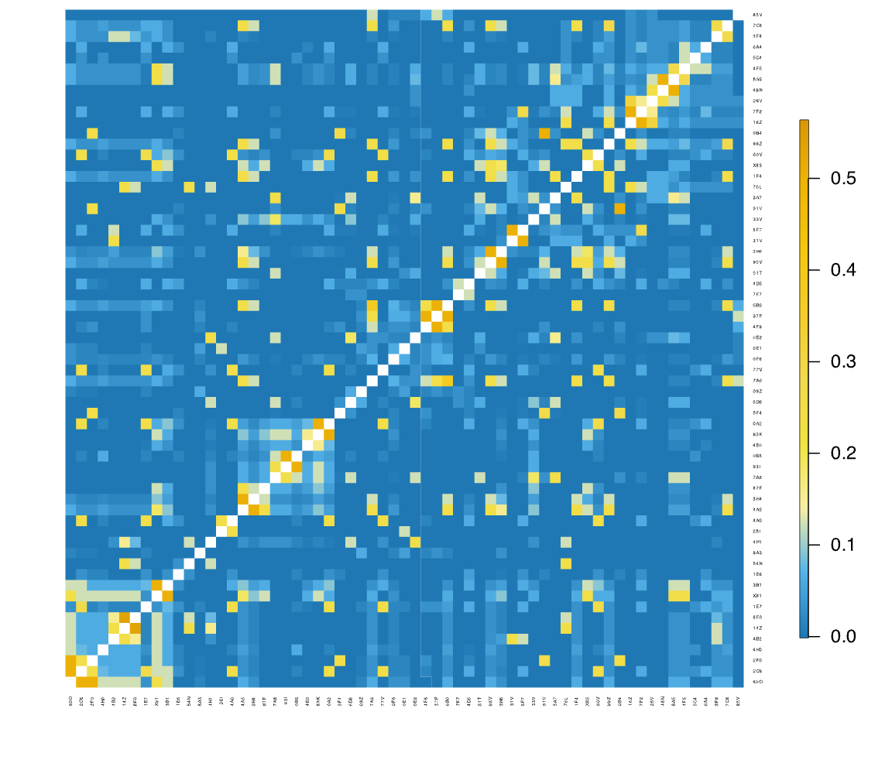
Figure S16. Relatedness coefficient (r) between adult female subjects in the group-year R2015.

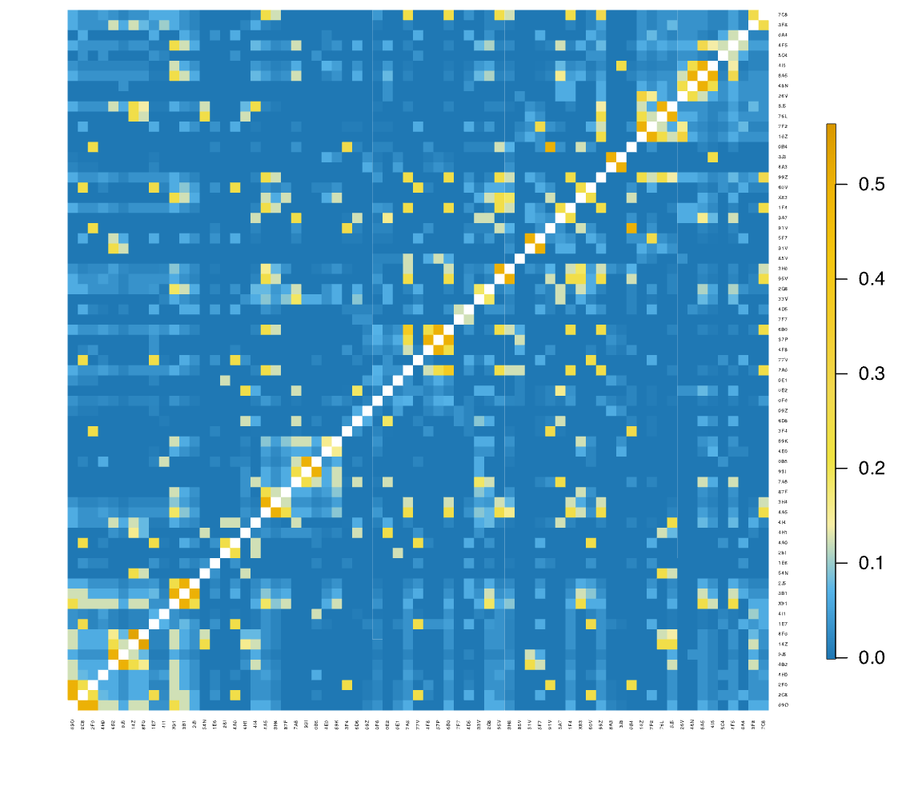
Figure S17. Relatedness coefficient (r) between adult female subjects in the group-year R2016.

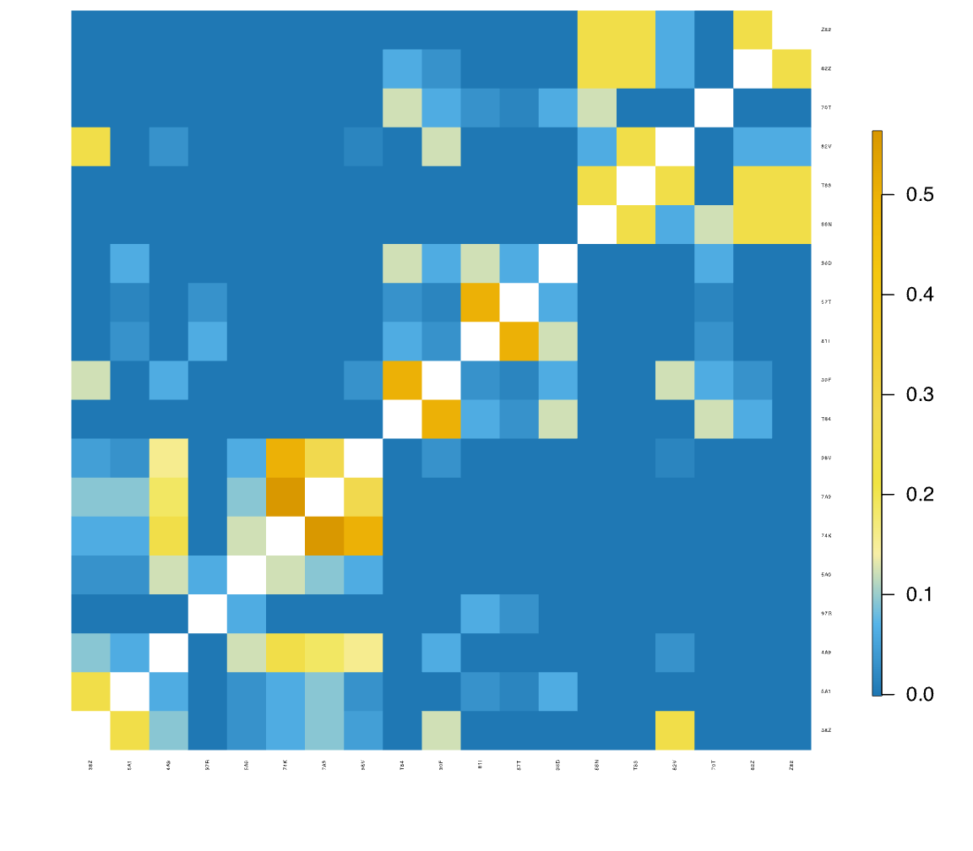
Figure S18. Relatedness coefficient (r) between adult female subjects in the group-year S2011.

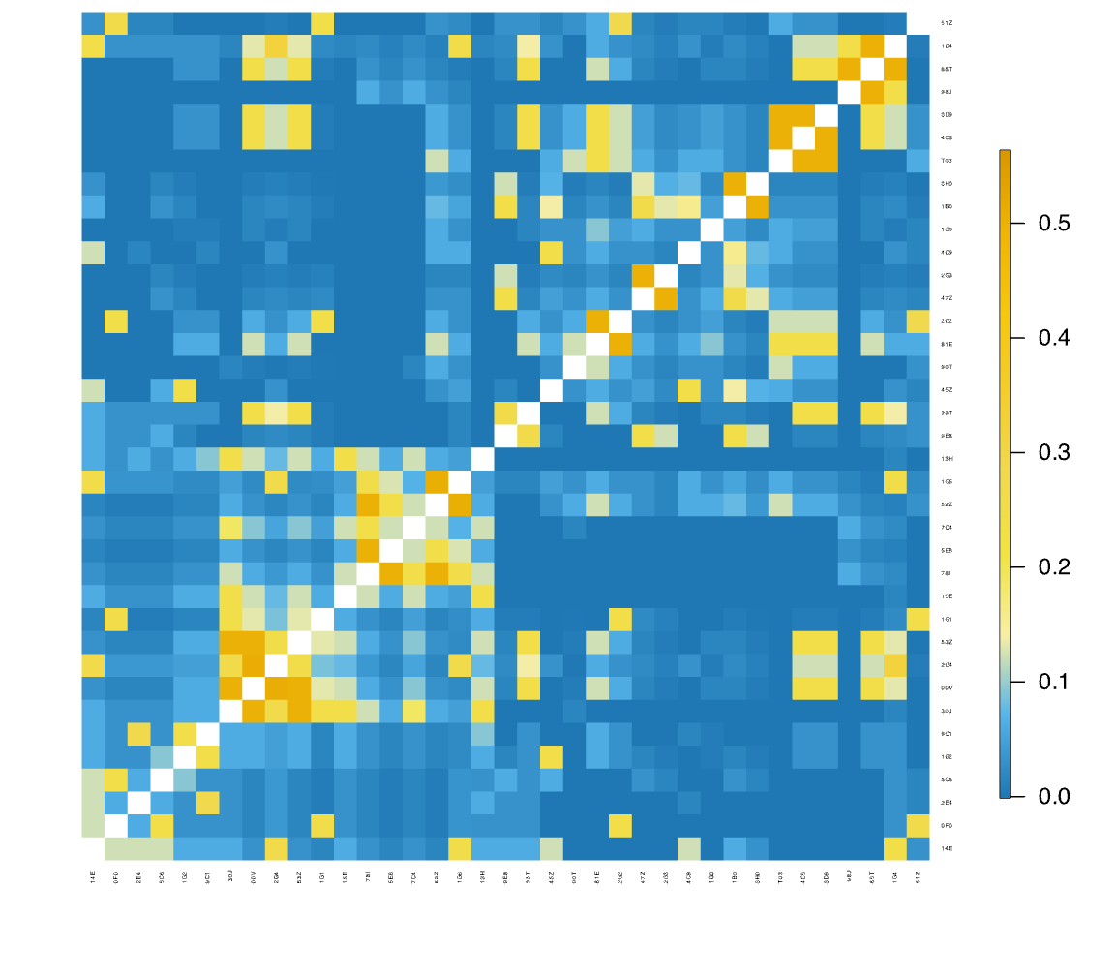
Figure S19. Relatedness coefficient (r) between adult female subjects in the group-year V2015.

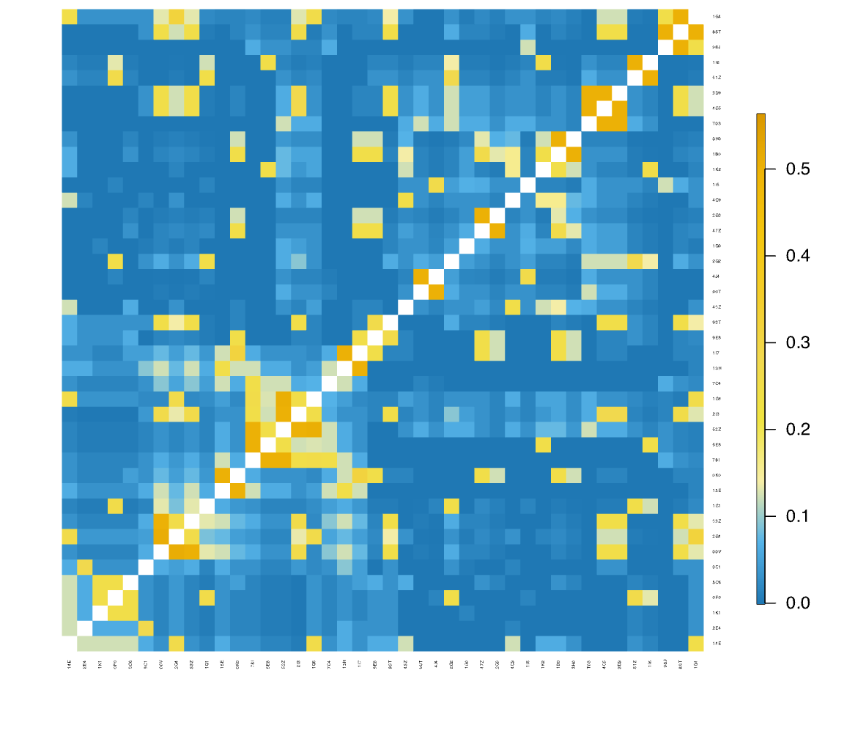
Figure S20. Relatedness coefficient (r) between adult female subjects in the group-year V2016.

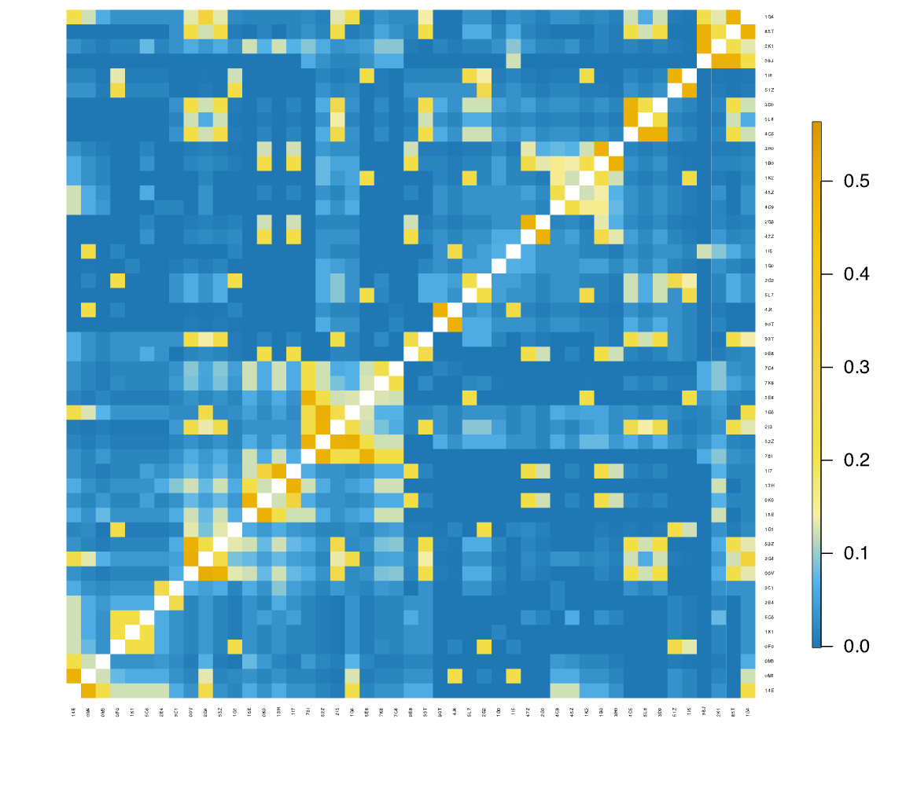
Figure S21. Relatedness coefficient (r) between adult female subjects in the group-year V2017.

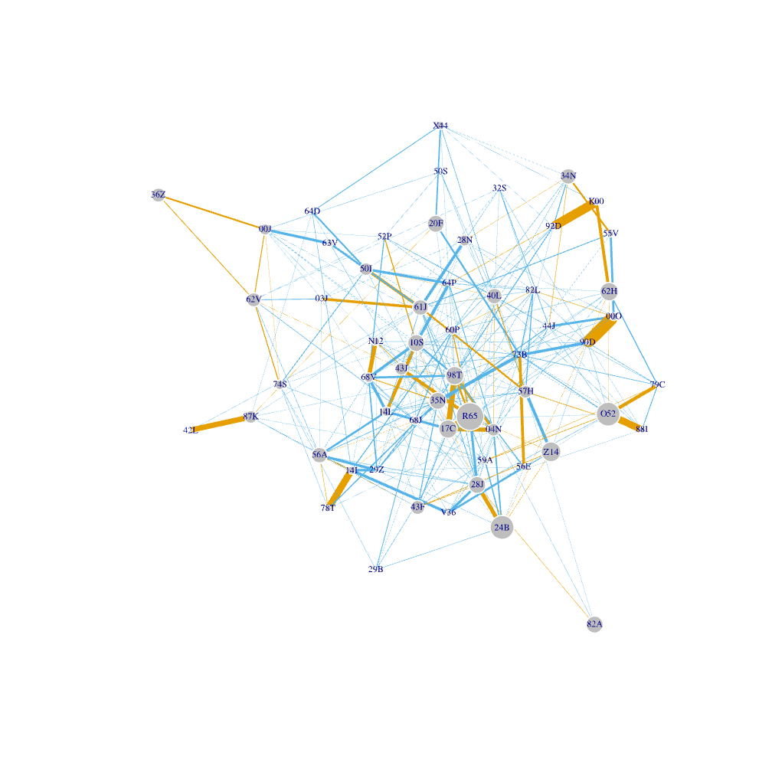
Figure S22. Social network of F2010. The subjects had 0−18 adult female kin groupmates.

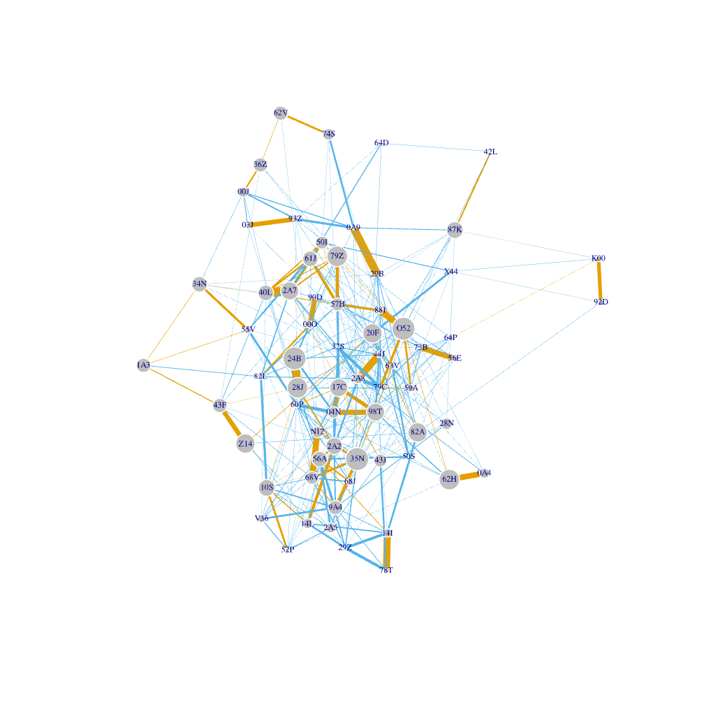
Figure S23. Social network of F2011. The subjects had 0−16 adult female kin groupmates.

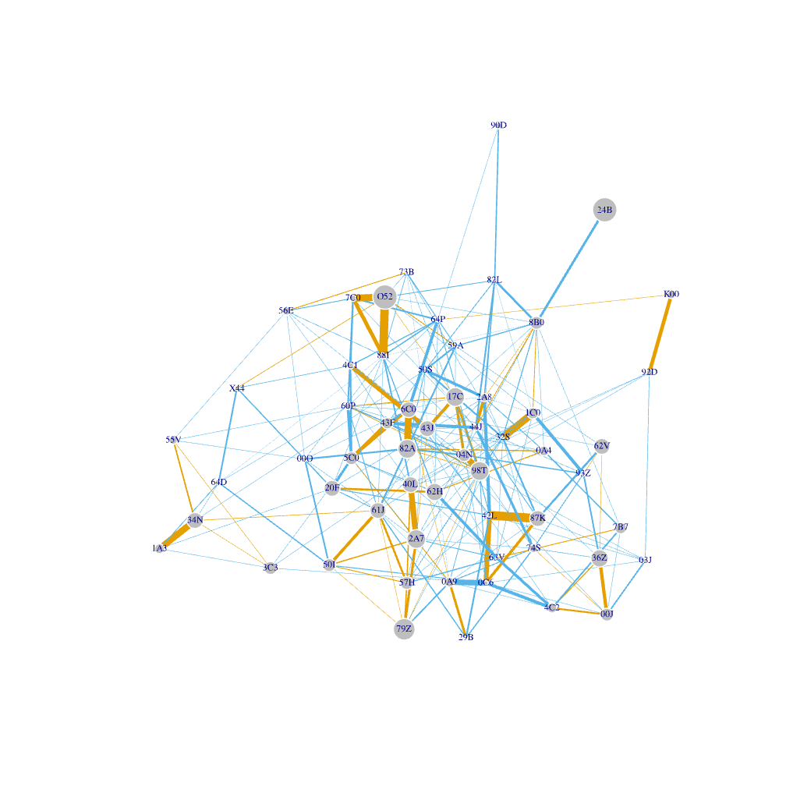
Figure S24. Social network of F2012. The subjects had 0−15 adult female kin groupmates.

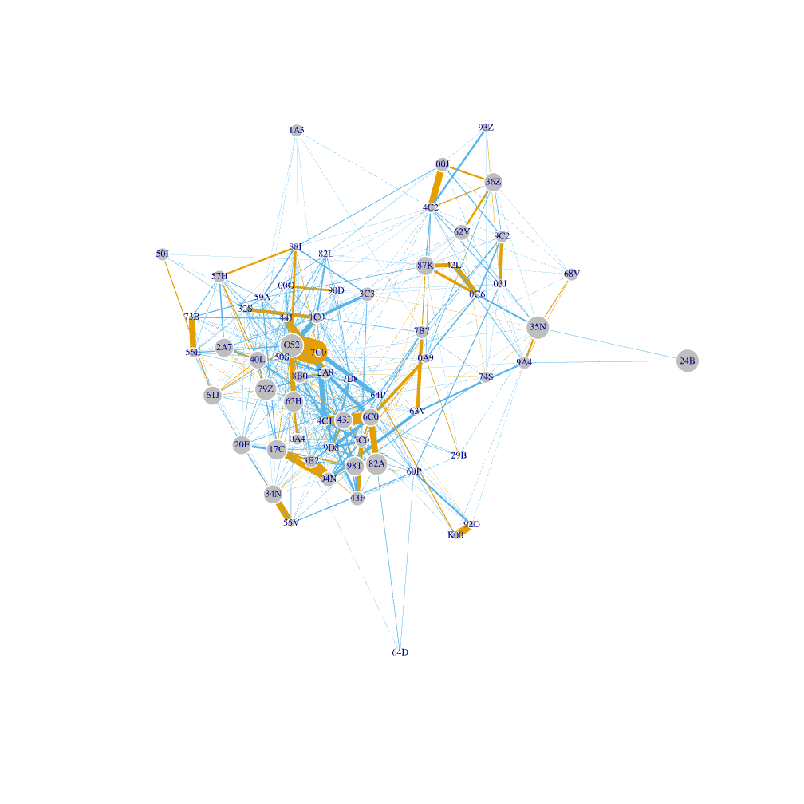
Figure S25. Social network of F2013. The subjects had 0−14 adult female kin groupmates.

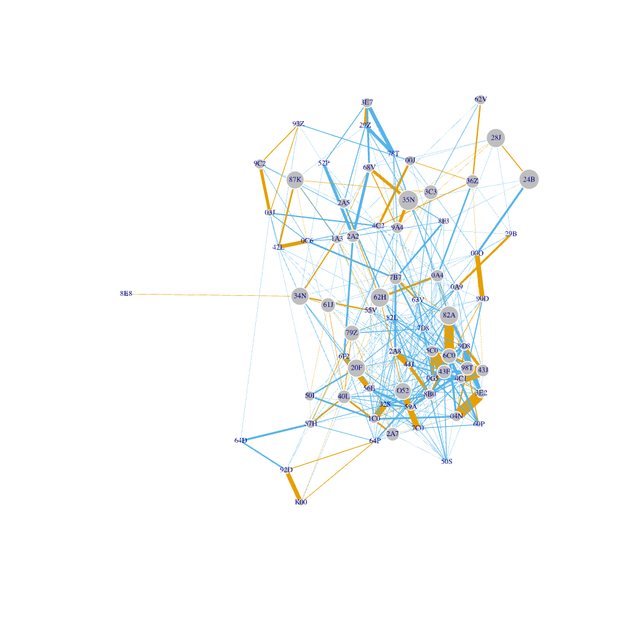
Figure S26. Social network of F2014. The subjects had 0−16 adult female kin groupmates.

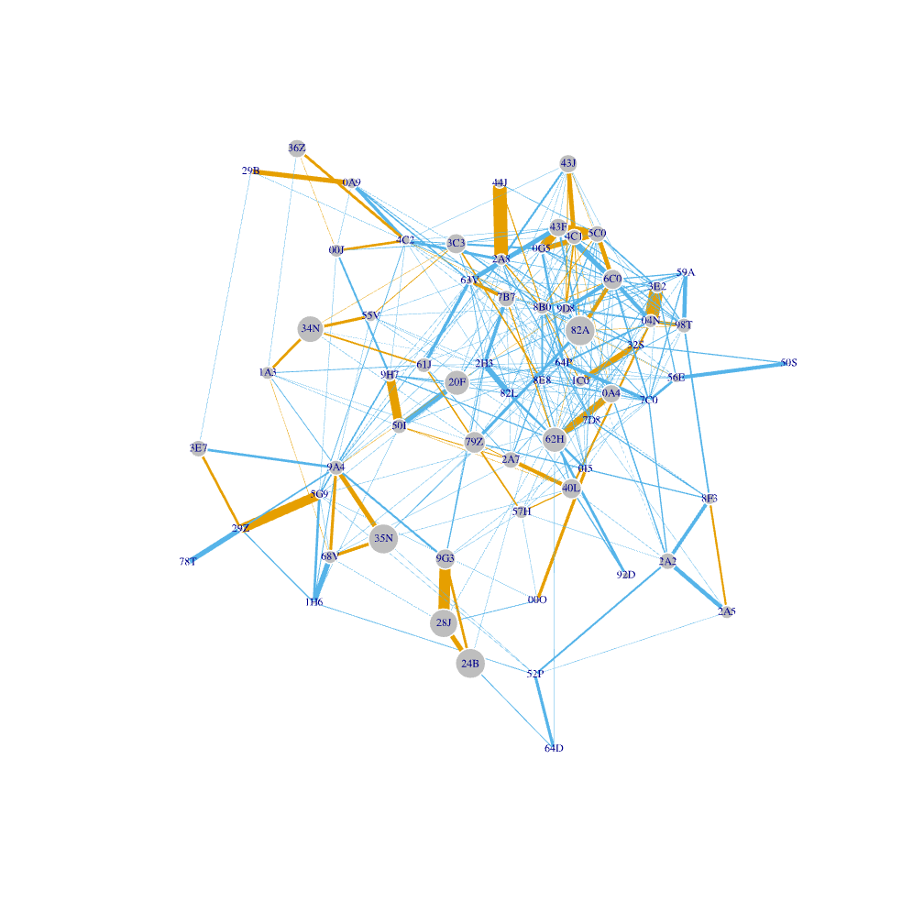
Figure S27. Social network of F2015. The subjects had 0−16 adult female kin groupmates.

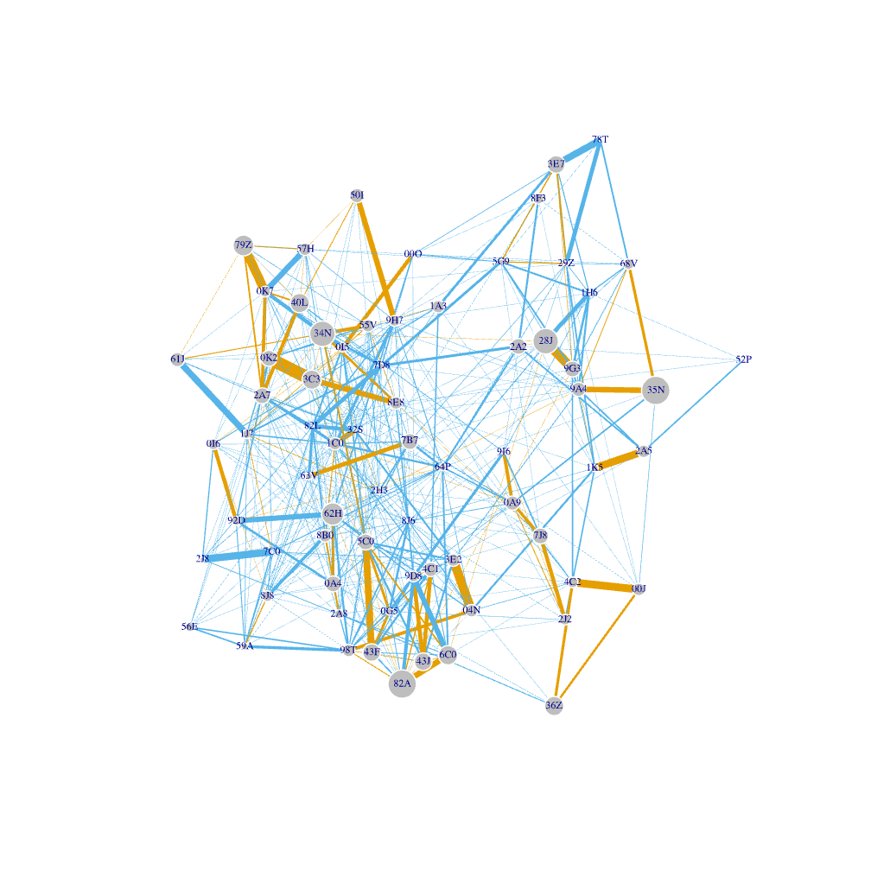
Figure S28. Social network of F2016. The subjects had 0−16 adult female kin groupmates.

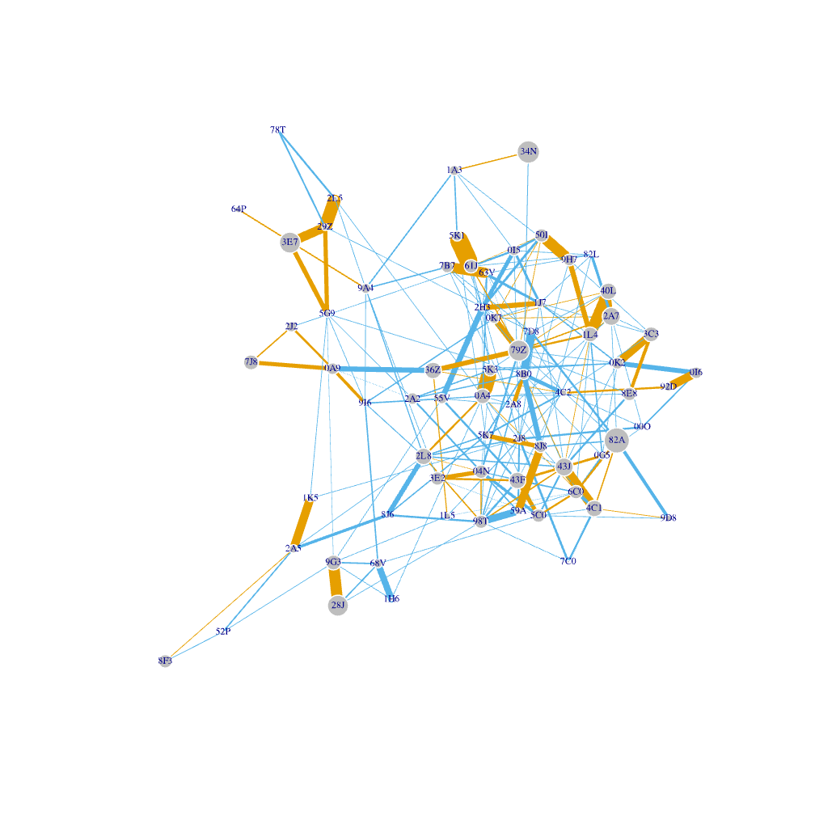
Figure S29. Social network of F2017. The subjects had 0−15 adult female kin groupmates.

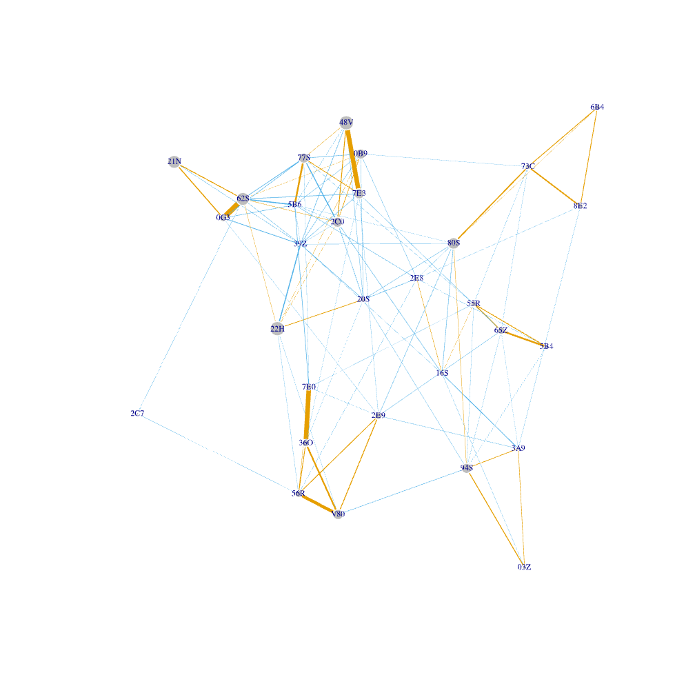
Figure S30. Social network of HH2014. The subjects had 0−9 adult female kin groupmates.
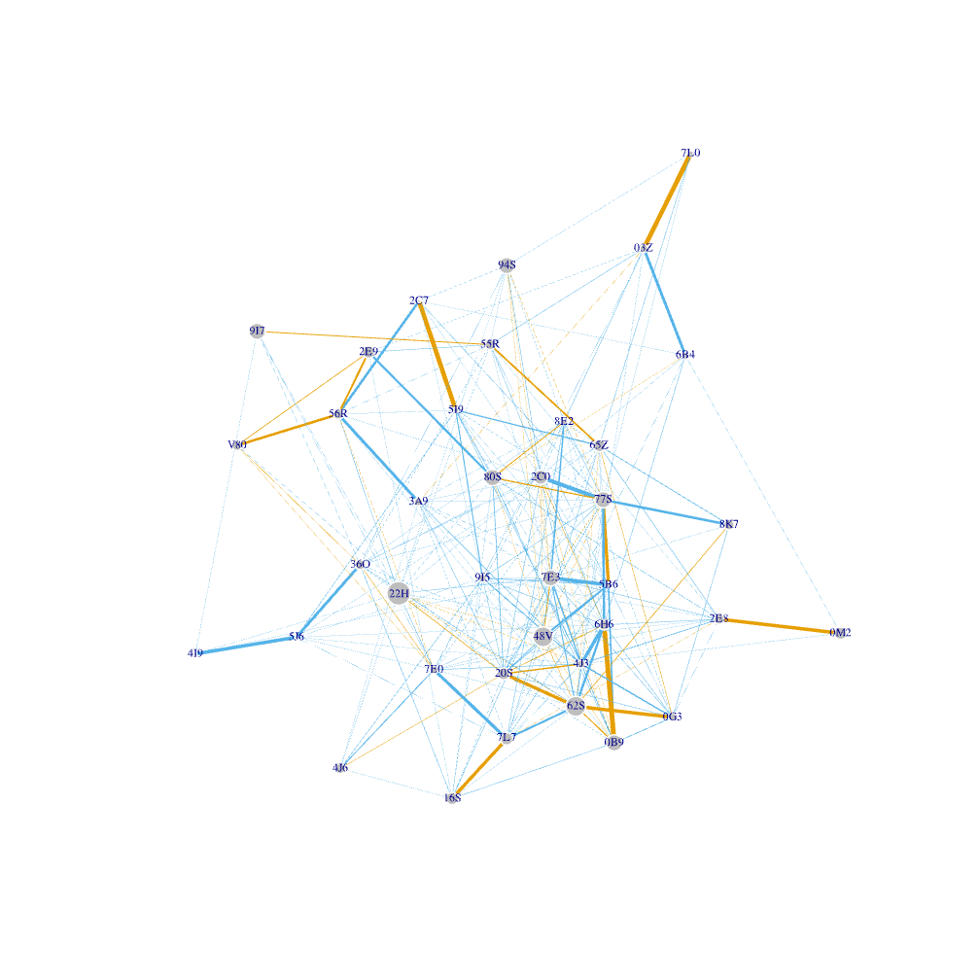

Figure S31. Social network of HH2016. The subjects had 1−11 adult female kin groupmates.

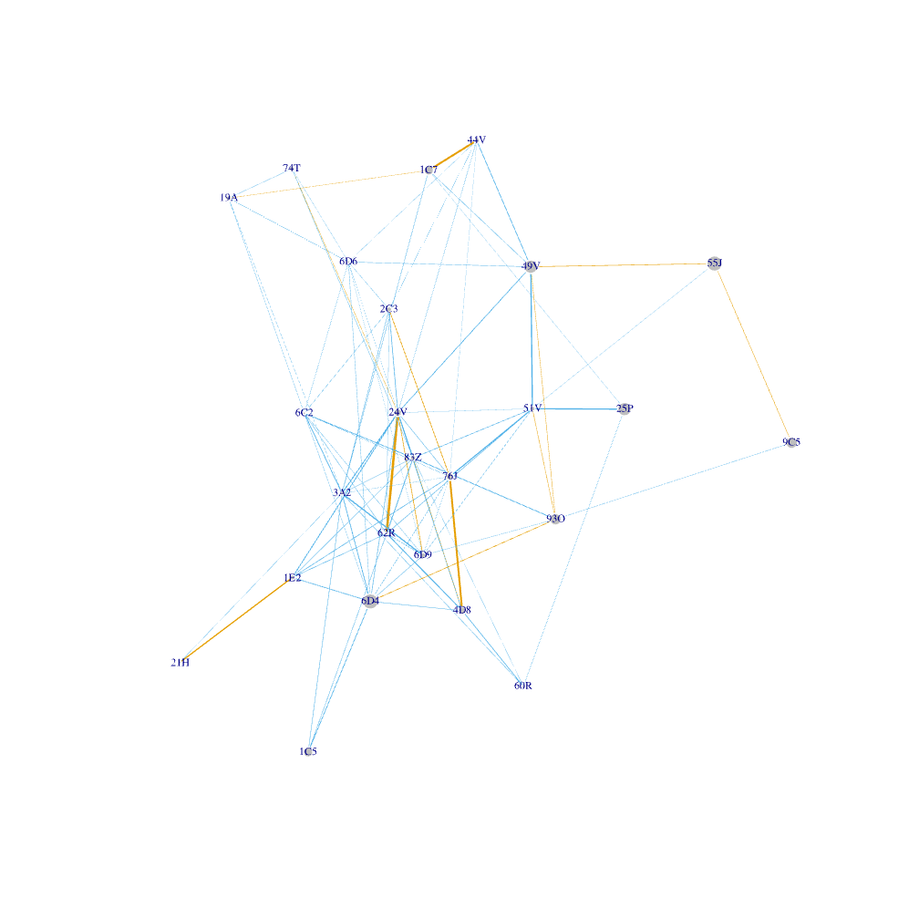
Figure S32. Social network of KK2013. The subjects had 0−7 adult female kin groupmates.

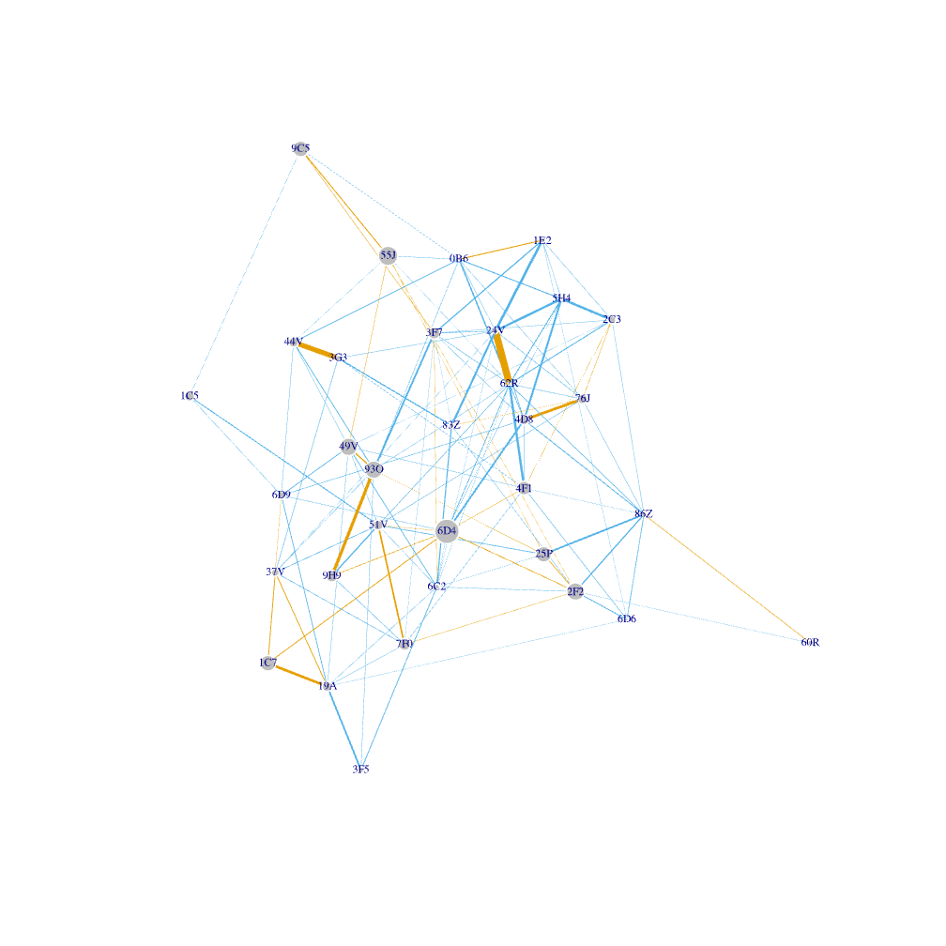
Figure S33. Social network of KK2015. The subjects had 1−12 adult female kin groupmates.

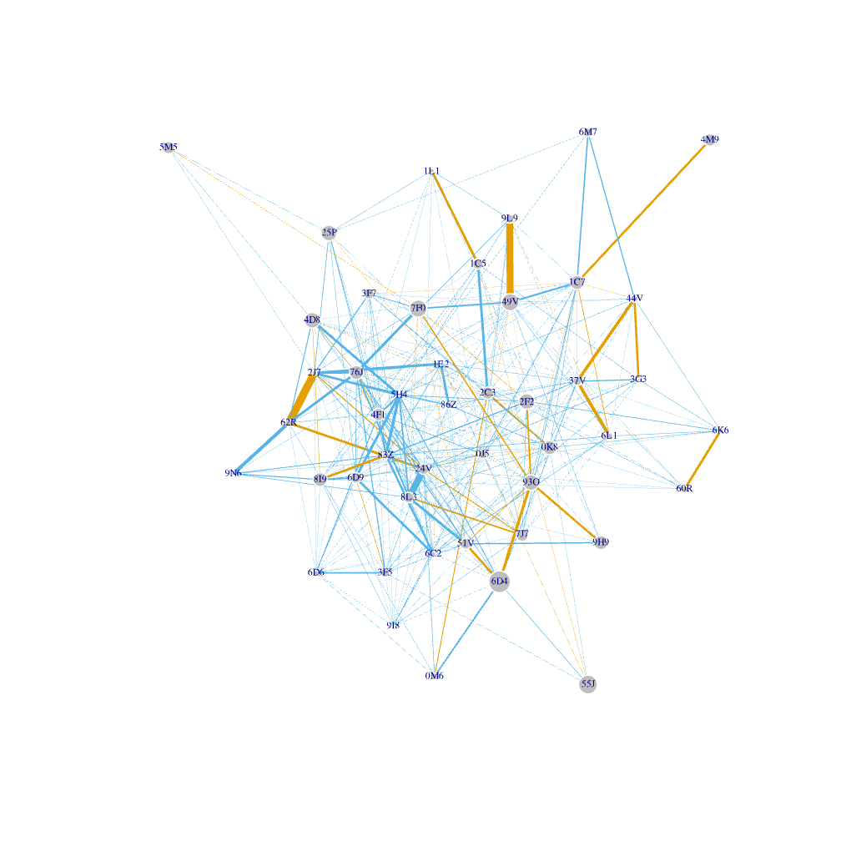
Figure S34. Social network of KK2017. The subjects had 0−12 adult female kin groupmates.

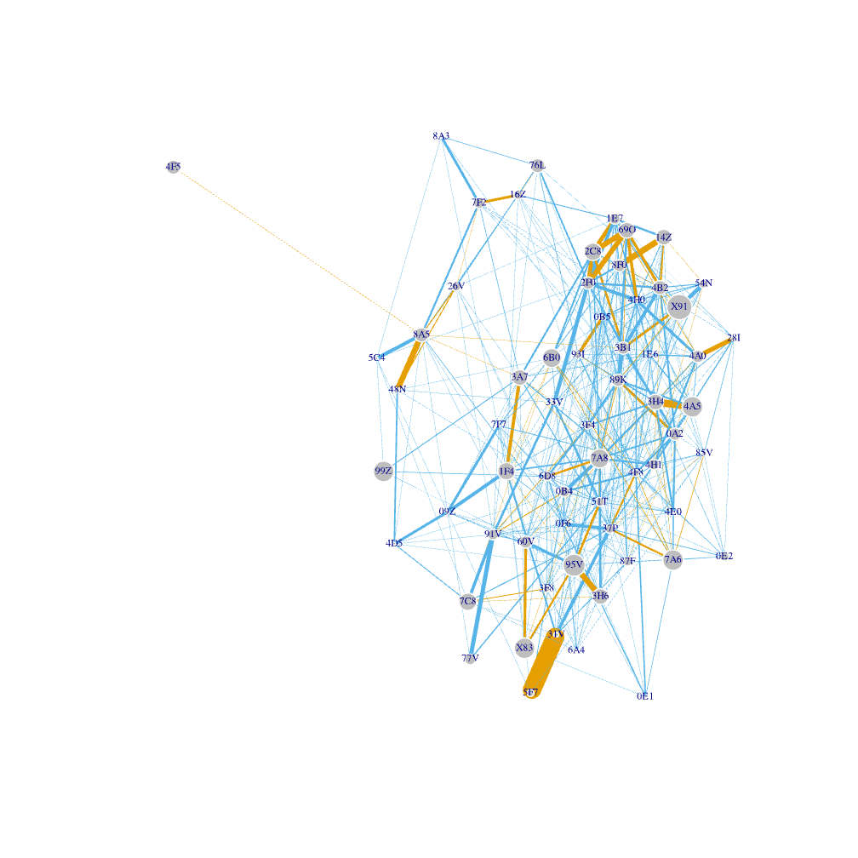
Figure S35. Social network of R2015. The subjects had 0−14 adult female kin groupmates.

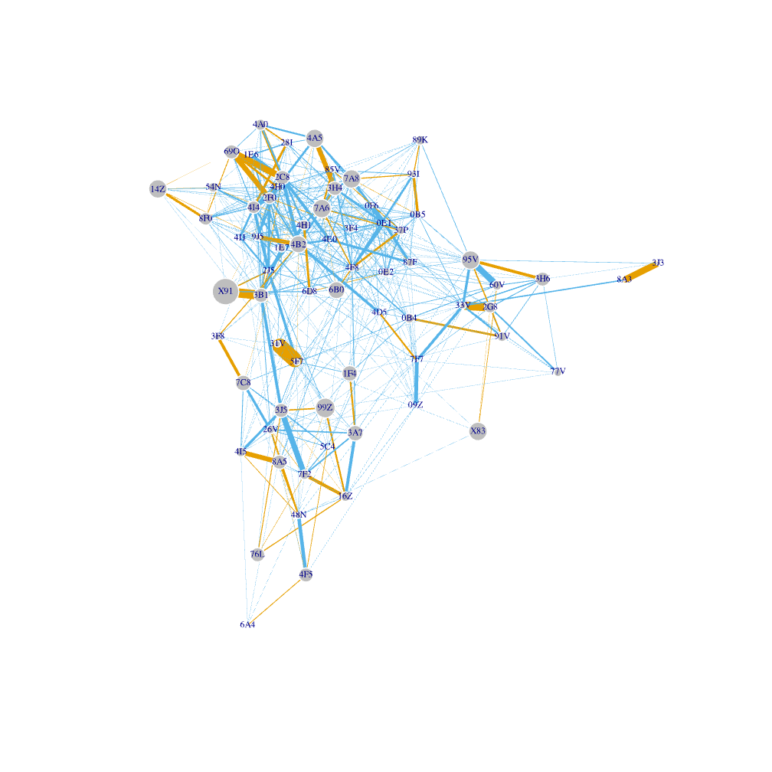
Figure S36. Social network of R2016. The subjects had 0−17 adult female kin groupmates.

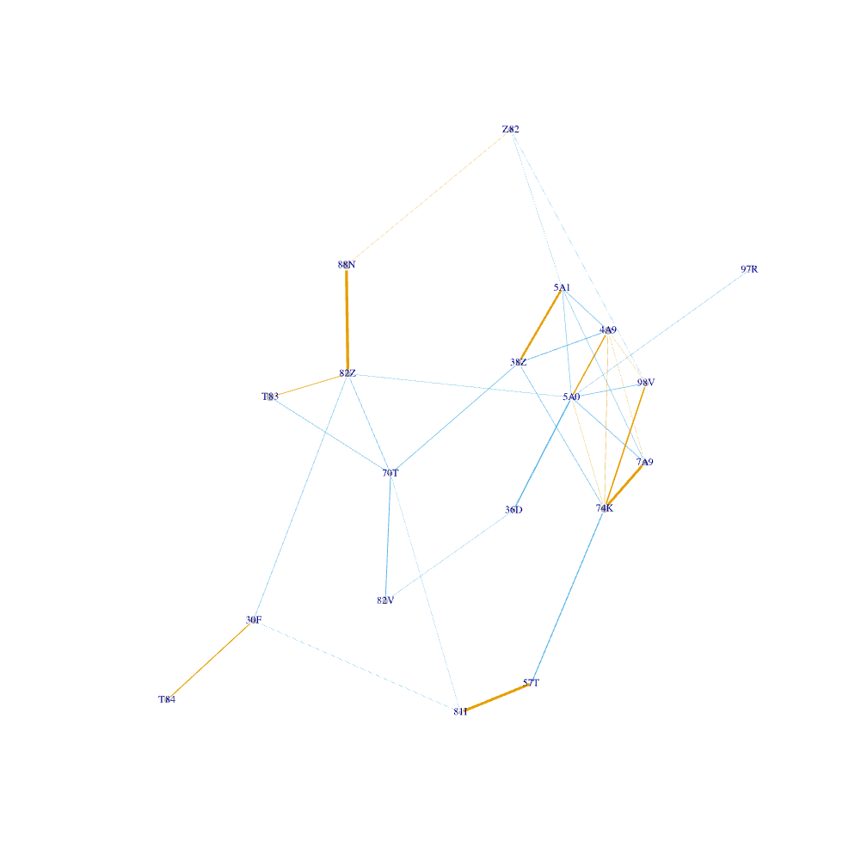
Figure S37. Social network of S2011. The subjects had 0−4 adult female kin groupmates.

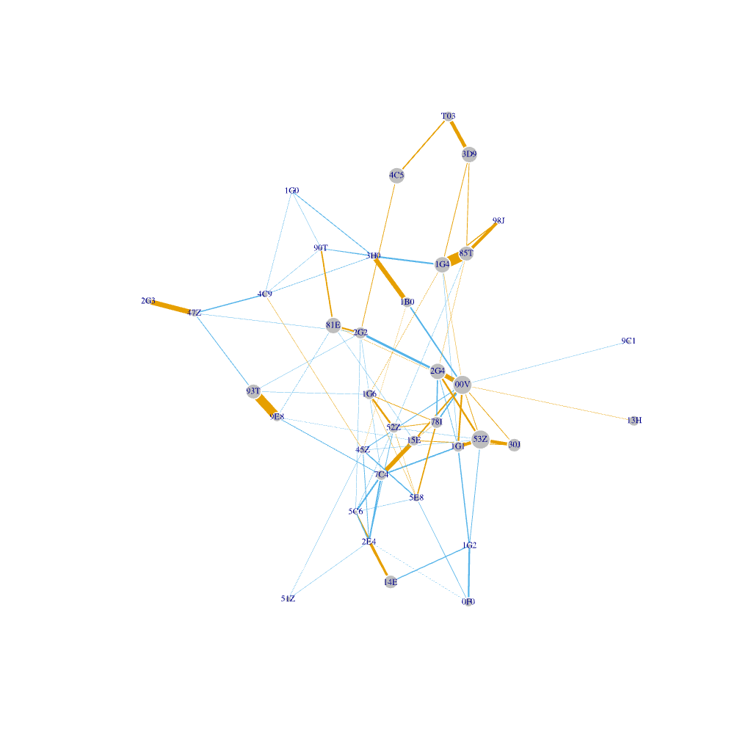
Figure S38. Social network of V2015. The subjects had 0−12 adult female kin groupmates.

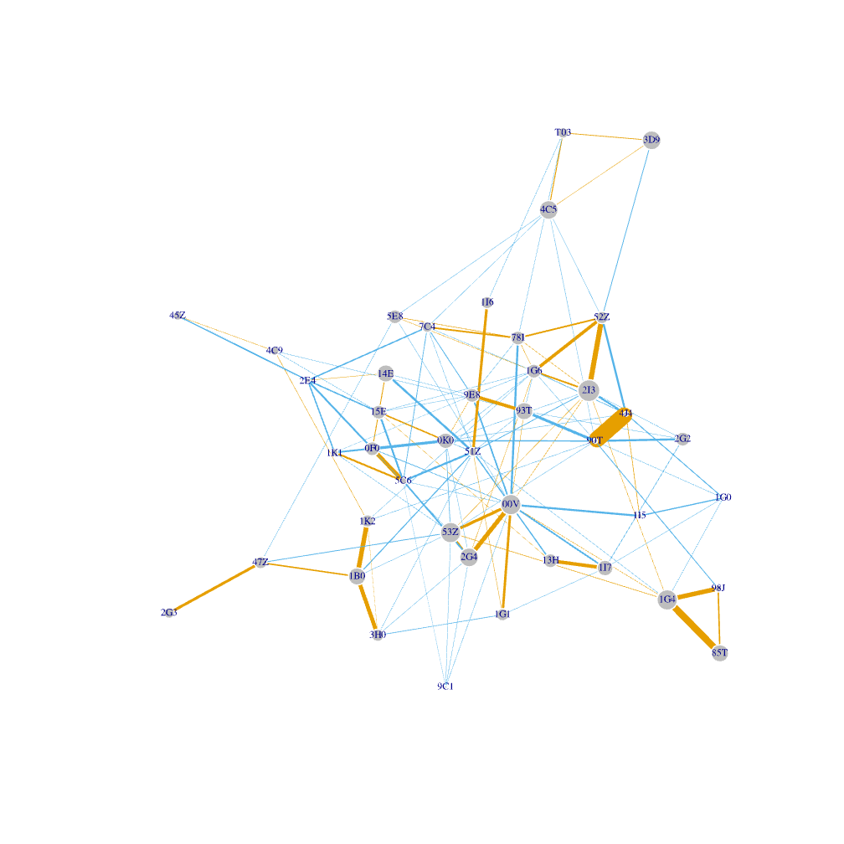
Figure S39. Social network of V2016. The subjects had 0−12 adult female kin groupmates.

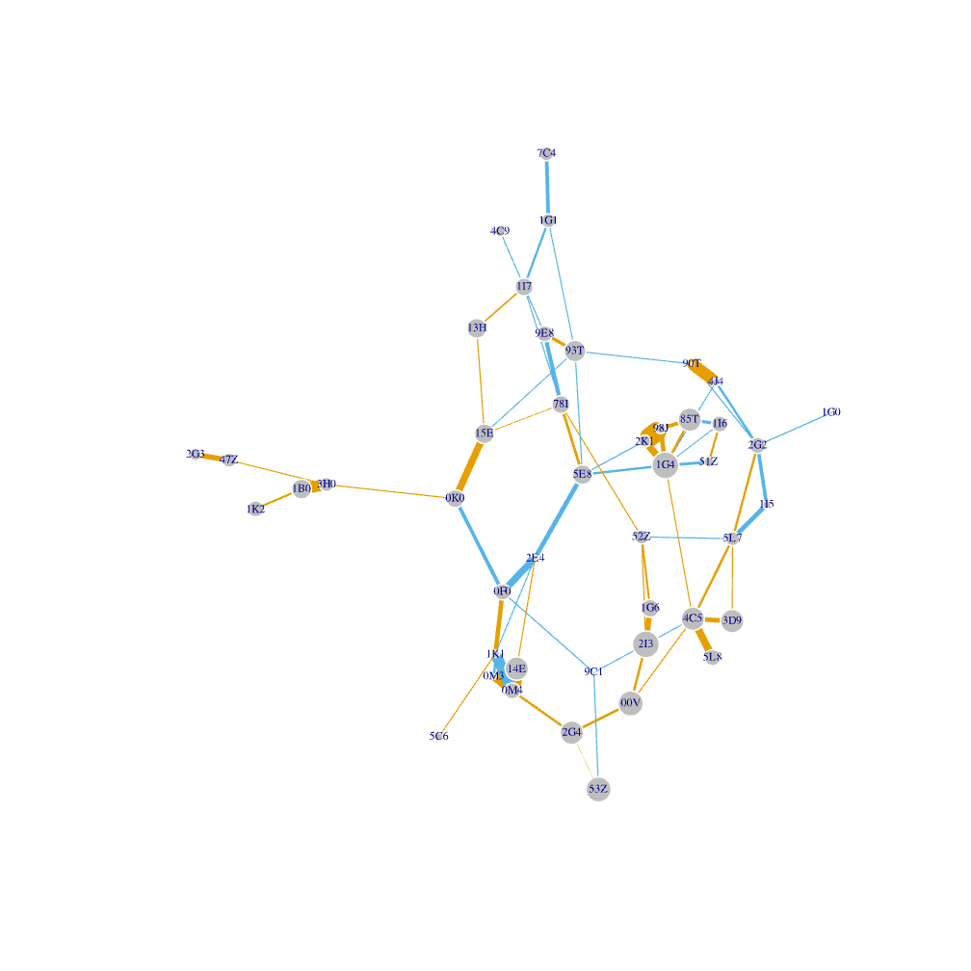
Figure S40. Social network of V2017. The subjects had 0−13 adult female kin groupmates.

