City block







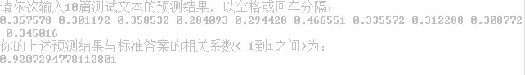



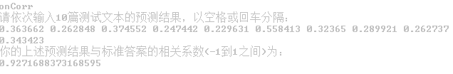

Cut=4;cityclock+weight

