中山大学移动信息工程学院 2013 级软件工程专业（2015学年秋季学期）

**《数据库系统原理》期中试题答案（A 卷）**

（考试形式： 开卷 考试时间：2 小时）

**《中山大学授予学士学位工作细则》第六条**

警 示

**考 试 作 弊 不 授 予 学 士 学 位**

**方向： 姓名： 学号：**

**Problem 1 Multiple Choices (20 points)**

Note: There may be more than one correct answer for some questions.

1. (4 points) Which operation is **not** a basic operation in relation algebra? **D**
2. Selection
3. Projection
4. Cross-production
5. **Intersection**
6. (4 points) How many attributes can a candidate key has? **C**

A. 0 B. 1 **C. 1 or many** D. Not restricted.

1. (4 points) Which of the following is a trivial functional dependency? **AD**

**A. (Sno, Cname, Grade) —> (Cname, Grade)**

B. (Sno, Cname) —> (Cname, Grade)

C. (Sno, Cname) —> (Sname, Grade)

**D. (Sno, Sname) —> Sname**

1. (4 points) A relation R has attributes A, B, C, D, E, F. Suppose there are FDs: AB->C, BC->AD, D->E, CF->B. Which of the following is the closure for {A, B}? **B**

A. {A, B, C, D, E, F}

**B. {A, B, C, D, E}**

C. {A, B, C}

D. {A, B, D, E}

1. (4 points) A relation has **only** one ? **C**

A. Candidate key.

B. Foreign key.

**C. Primary key.**

D. Super key.

**Problem 2 ER Diagram (20 points)**

A travel agency wants to keep track of its travel routes and schedules. Answer the questions according to the following description:

1. Each travel route has a route number, a departure city and a destination city.
2. For each travel route, there is a schedule, which records the departure time of it.
3. For each departure time of each route, a vehicle and a tour guide will be assigned.
4. A tour guide has an ID, a name and an email address.
5. A vehicle is identified by its license number. The database also records the type and capacity of each vehicle.
6. Draw an ER diagram for the database. (10 points)

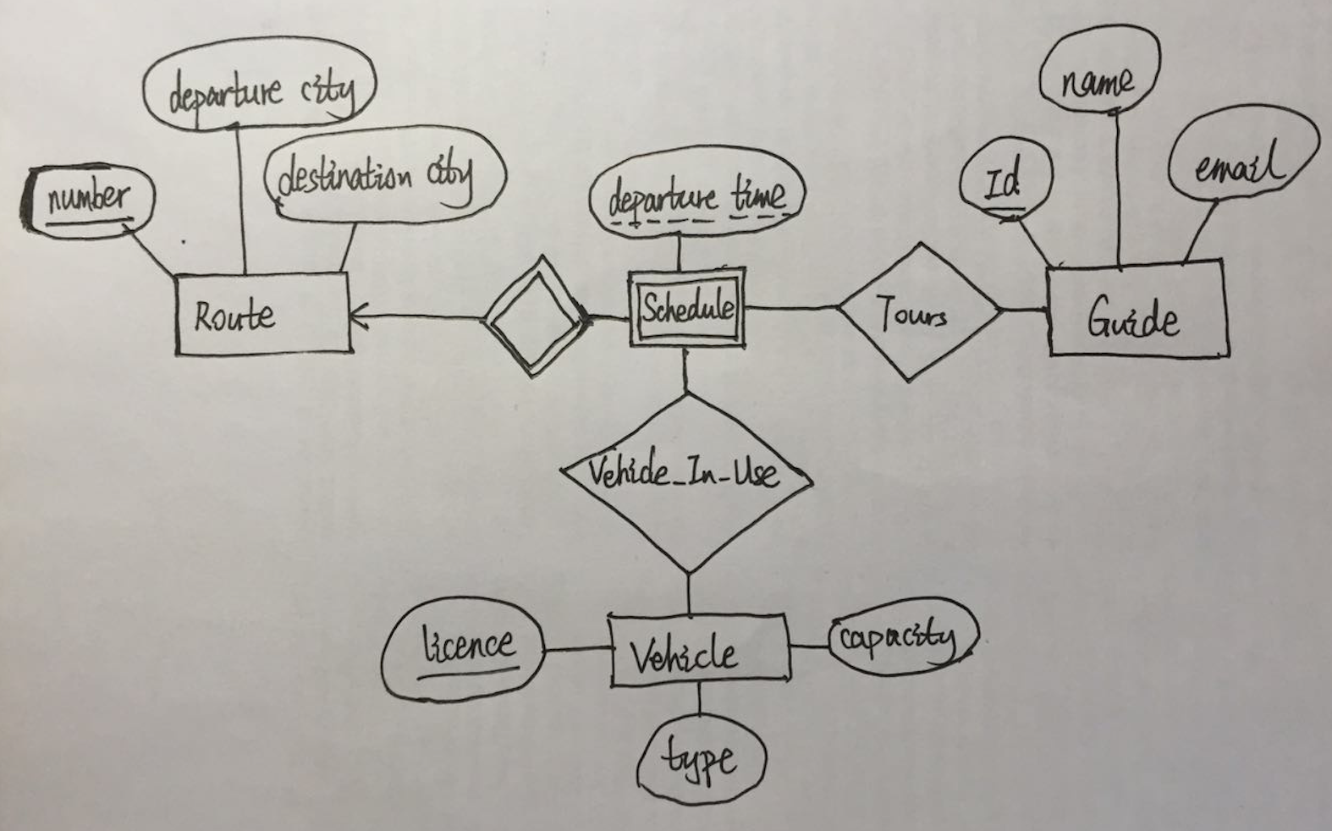

1. Translate the ER diagram into a relation schema, **underline** the primary keys. **Specify** clearly whether a schema is obtained from an entity, a weak entity or a relationship. (10 points)

**Entity:**

**Route (number, departure city, destination city)**

**Vehicle (licence, type, capacity)**

**Guide (Id, name, email)**

**Weak entity:**

**Schedule (number, departure time)**

**Relationship:**

**Tours (number, departure time, Id)**

**Vehicle_In_Use (number, departure time, licence)**

**Problem 3 Functional Dependencies and Normalization (30 points)**

(3.1) Given a relation R (A, B, C, D, E, G, K) with the FDs: F = {AB->C, B->DE, C->G, G->A}, Identify all the candidate keys for R. Briefly explain the reason. (6 points)

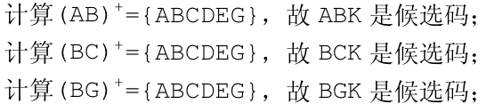

(3.2) There is a relation R (A, B, C, D, E) with the FDs: F = {ABC->DE, BC->D, D->E}. Answer the following questions: (9 points)

(a) Identify all the candidate keys for R. Briefly explain the reason.

**ABC is the candidate key.**

(b) Is R a BCNF relation? Give your reasons.

No, it is not a BCNF. For example, Consider the FD: G->A, G doesn’t contain a key.

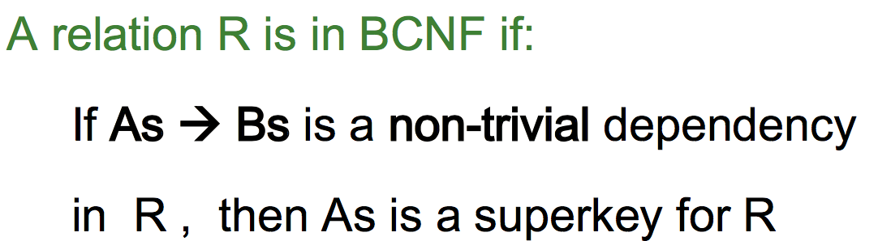

(c) If you think it is not a BCNF relation, then please decompose it to BCNF and show your detailed steps.

**First decompose it to R1 (A, B, C) and R2 (B, C, D, E). There is no nontrivial FD in R1. So let’s check R2. In R2, (B, C) is the candidate key. The FD of R2 is {(B, C)->D, D->E}. Let’s decompose R2 to R21 (B, C, D) and R22 (D, E). Now you can see that R1, R21, R22 satisfy the requirement for BCNF. The result is R1, R21 and R22.**

(3.3) Consider the relation R (V, W, X, Y, Z) with functional dependencies {Z → Y, Y → Z, X → Y, X → V, V W → X}. (9 points)

(a) List the possible keys for relation R based on the functional dependencies above.

**{V, W}, {X, W}**

1. Show the closure for attribute X given the functional dependencies above.

**X+ = {X, V, Y, Z}**

(c) Suppose that relation R is decomposed into two relations, R1(V, W, X) and R2(X, Y, Z). Is this decomposition a lossless decomposition? Explain your answer.

**Yes, it is lossless. To be lossless the attributes in common between the two relations must functionally determine all the attributes in one of the two relations. The only attribute in common is X and it functionally determines all the attributes in R2.**

(3.4) You are given the table below for a relation R (A, B, C, D, E). You do not know the functional dependencies for this relation. (6 points)

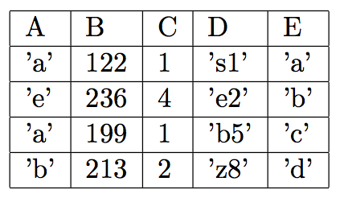

Suppose this relation is decomposed into the following two tables: R1 (A, B, C, D) and R2 (A, C, E). Is this decomposition lossless? Explain your reasoning.

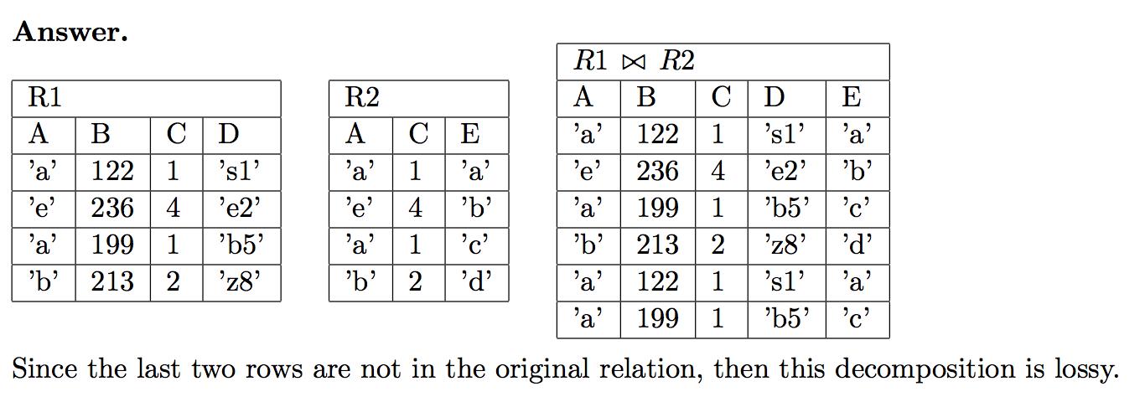

图片有误，最后两个数据为(a,122,1,s1,c)与(a,199,1,b5,a)

**Problem 4 Relational Algebra and SQL (30 points)**

Suppose there is a database which has the following 3 relational tables:

DRIVERS (**DID**, DNAME, SEX, ADDRESS)

CARS (**CID**, BRAND, COLOR)

ORDERS (***DID, CID***, QUANTITY, ORDER-YEAR)

ASSUMPTIONS:

Keys are underlined and foreign keys are in *italics*.

Express the following queries in (a) to (e) using **both** the **relational algebra (RA)** and **SQL** expressions.

1. Find all drivers’ DNAME whose SEX is “FEMALE” (4 points)

Algebra:

ΠDNAME(σSEX=“FEMALE”(DRIVERS))

SQL:

SELECT D.DNAME FROM DRIVERS D WHERE D.SEX = “FEMALE”

1. Find all FEMALE drivers’ DNAME whose ADDRESS is “SYSU” (4 points)

Algebra:

ΠDNAME(σSEX=“FEMALE”∧ADDRESS=”SYSU” (DRIVERS))

SQL:

SELECT D.DNAME FROM DRIVERS D WHERE D.SEX = “FEMALE” AND D. ADDRESS = “SYSU”

1. Find the DNAME of drivers who have not bought any car. (6 points)

Algebra:

ΠDNAME (DRIVERS −−DRIVERS▷◁ORDERS)

SQL:

SELECT D.DNAME FROM DRIVERS D

WHERE NOT EXISTS (

SELECT *

FROM ORDERS

WHERE D.DID = ORDERS.DID)

1. Find the DNAME of drivers who have bought a RED car of which the BRAND is “BMW”. (8 points)

Algebra:

ΠDNAME(σCOLOR=“RED”∧BRAND=”BMW”(DRIVERS▷◁ORDERS▷◁CARS))

SQL:

SELECT D.DNAME

FROM DRIVERS D, ORDERS O, CARS C

WHERE C.COLOR = “RED” AND C.BRAND = “BMW” AND O.CID = C.CID AND O.DID = D.DID

1. Find the ADDRESS of drivers who have bought RED cars after the year 2012. (8 points)

Algebra:

ΠADDRESS(σCOLOR=“RED”∧ORDERYEAR>2012(DRIVERS▷◁ORDERS▷◁CARS))

SQL:

SELECT D.ADDRESS

FROM DRIVERS D, ORDERS O, CARS C

WHERE C.COLOR = “RED” AND O.ORDER-YEAR > 2012 AND O.CID = C.CID AND O.DID = D.DID