The Battle of Neighborhoods
Meng Yu
March 22, 2019
1. Introduction
1.1 Background
Jinan and Qingdao are the two largest cities in China's Shandong province. There are many similarities and differences between the two cities. To be specific, Jinan is the provincial capital city with a long history and culture and a convenient high-speed rail transportation network. Qingdao is a coastal open city with a better environment and climate, a huge port, developed foreign trade, tourism and financial industries. Jinan and Qingdao have long been a hot topic of discussion. This paper hopes to make an intuitive demonstration of the differences between the two cities through the data science method taught in the course. The following is the basic situation of jinan and Qingdao.
Table 1. Basic situation of Jinan and Qingdao
 | Jinan | Qingdao
Prefecture-level area | 10244km² | 11067km²
Population | 7321200 | 9290500
GDP | ￥886.2 billion | ￥1256.1 billion
Human Development Index | 0.811 | 0.822
Position | 36.38N 117.01E | 36.5N 120.2E

1.2 Problem
This paper will collect data from Foursquare, list the number of venues owned by each borough of Jinan and Qingdao, and compare them with charts. In addition, they are classified by k-means clustering method, and these clusters are displayed on the map.
1.3 Interest
For those interested in urban governance, this article may be useful to them. The geographical differences between the two cities can be found through the study of the urban boroughs and the venues around the neighborhoods. For those who wish to settle down in a certain city or a certain area of a certain city, it can also provide reference value for them.
2. Data acquisition and cleaning
2.1 Data sources
There are 12 boroughs and 161 neighborhoods in Jinan, and 10 boroughs and 133 neighborhoods in Qingdao. These can be found on their respective government websites. To get their location, I used the open API provided by Autonavi, a Chinese mapping and geographic information service. The venues near each neighborhood is available through Foursquare's free API. In order to create a choropleth map, I use a json download service provided by Aliyun.
For example, Jinan’s complete borough and neighborhoods can be found at:
http://www.jinan.gov.cn/col/col24699/index.html
And the Autonavi service:
https://lbs.amap.com/
And the Aliyun geo json download site:
http://datav.aliyun.com/tools/atlas/
2.2 Data cleaning
Fortunately, I was able to get the data I wanted from Foursquare, Autonavi, and Aliyun. The data is very neat, with no missing values and no outliers. I simply took this data in Python and wrote it to a local CSV file so that I could call it at any time. For details you can examine the complete code in my jupyter notebook. Therefore, there is no special data cleaning required.
2.3 Feature selection
As I said earlier, after getting the data I wanted in Python, I stored it in a local CSV file. This prevents me from rerunning the program every time I get this data. This saves time.
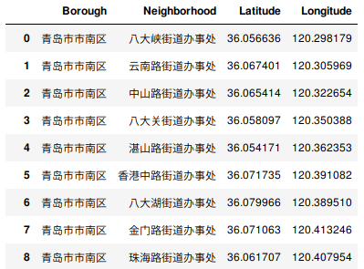
The df_qingdao_geo.csv and df_jinan_geo.csv stores the latitude and longitude of each neighborhood.

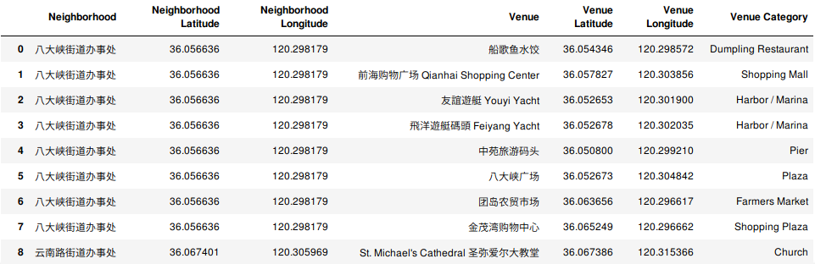
The qingdao_venues.csv and jinan_venues.csv stores the venue, vanue latitude, venue longitude and venue category.
3. Exploratory Data Analysis
3.1 Descriptive statistics
According to Foursquare, there are 458 venues in Jinan and 297 venues in Qingdao. For Jinan, shizhong borough and lixia borough have more venues, while for Qingdao, shinan borough and shibei borough have most venues. This is much the same as our experience. Because Jinan shizhong, lixia boroughs and Qingdao shinan, shibei boroughs are the most populous and prosperous areas. At the same time, we can find that, in terms of the number of venues, regional differences are relatively small in Jinan, while large in Qingdao.
Because matplotlib can not display Chinese very well, I used plotly for Python to generate the chart below.
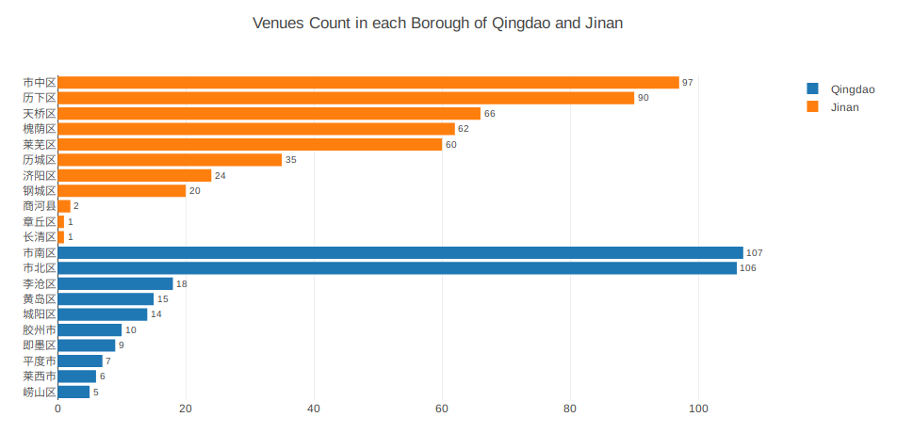
Figure 1. Venues count in each borough of Jinan and Qingdao
I continue to check the types of venues that have the most venues respectively in Jinan and Qingdao. As you can see, the most venues in both cities are hotels, Chinese restaurants and shopping mall. At the same time, Jinan has more movie theater , soccer fields and basketball stadium.
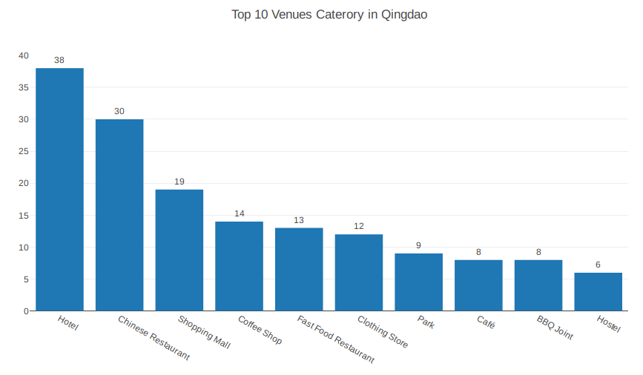
Figure 2. Top 10 venues category in Qingdao

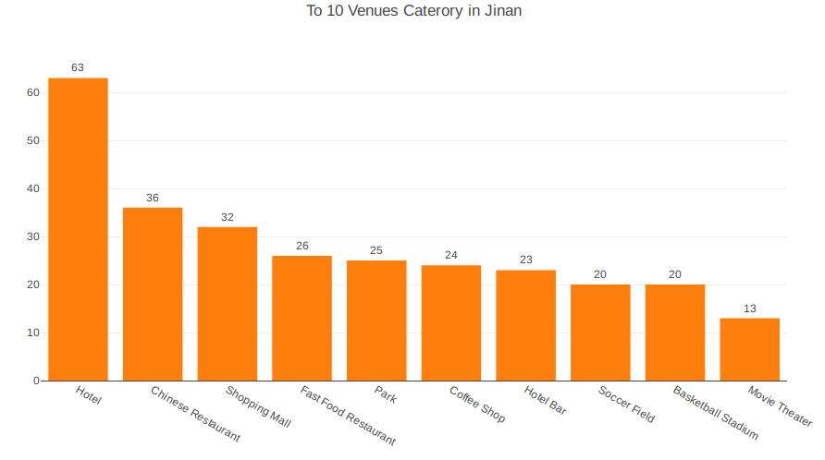
Figure 3. Top 10 venues category in Jinan
3.2 K-means Cluster
In order to find the best k value in K-means cluster, I use elbow method. In general, it is helpful to determine the appropriate value of k by drawing the broken line graph of k and SSE. If you're at a point where SSE goes down very fast from the beginning, and then it goes down very slowly after that point, then this is the appropriate k value. However, sometimes this trend is not so obvious, so it is difficult to judge the value of k. At this point, it is necessary to combine the practical meaning of the problem to choose an appropriate value of k. Here, for the clustering of venues in Qingdao, I selected k = 6.
Similarly, I also used elbow method in the process of clustering venues in Jinan. Unfortunately, the downward trend of SSE is also less pronounced. Well, it looks like k=4 is a good value, and for convenience I chose k=4.
For data preprocessing, I directly adopted the method of course teaching. Finally, the 1st to 10th venues were obtained for each community in each city. The code is available on the jupyter notebook.
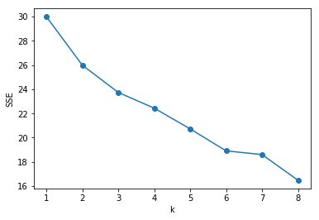
Figure 4. Elbow method for K-means cluster of Qingdao venues

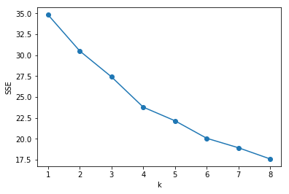
Figure 5. Elbow method for K-means cluster of Jinan venues
Finally, I have obtained the results of clustering venues in Jinan and Qingdao. The sample number of each cluster is as follows.

Table 2. Counts in each cluster in Jinan and Qingdao
 | Cluster 1 | Cluster 2 | Cluster 3 | Cluster 4 | Cluster 5 | Cluster 6
Jinan | 26 | 12 | 56 | 5 | NA | NA
Qingdao | 5 | 6 | 41 | 2 | 9 | 2

3.3 Visualizing Geospatial Data
I chose to display the results of k-means clustering on the map. Different colors of each point in the map represent different clustering. For each Borough, the more venues in the region, the closer the color is to red; while the fewer venues in the region, the closer to yellow.
As we have seen, venues in each city cluster in their own city centres. Specifically, venues are clustered in shinan borough and shibei borough, while in Jinan, venues are clustered in shizhong borough and lixia borough.
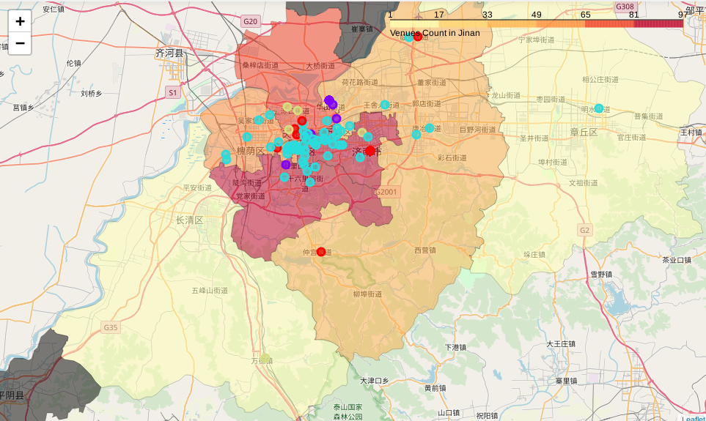
Figure 6. Choropleth and cluster map of Jinan

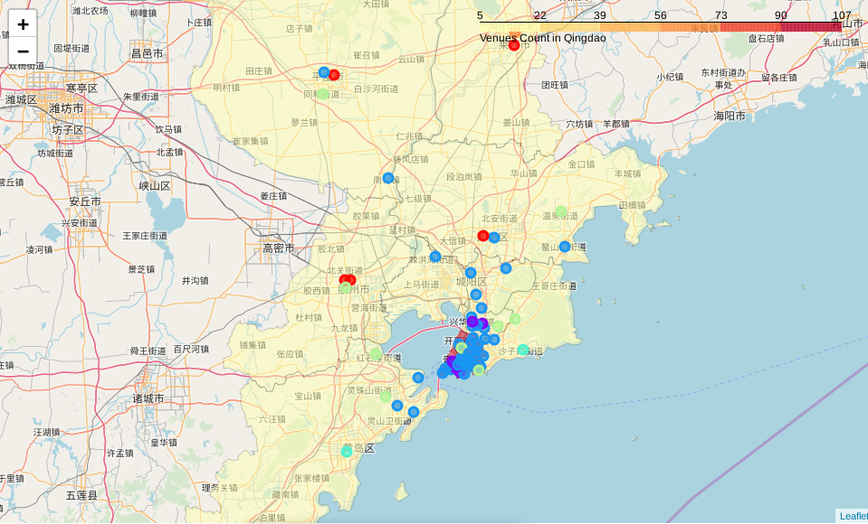
Figure 7. Choropleth and cluster map of Qingdao
4. Conclusions
In this study, I collected Foursquare data of Jinan and Qingdao. Finally, I found that Jinan have more venues, and the differences between boroughs are small. However, Qingdao has fewer venues, with great differences among boroughs. Venues in both cities are concentrated in their respective city centres.
5. Future Directions
There is a gap between my research and people's experience in the real world. Generally speaking, people tend to think that Qingdao is more prosperous, with more population and more venues. Also, laoshan borough, located in a busy area, should have more venues. I think this is because Foursquare, as a foreign service, cannot fully reflect the actual situation in China. In addition, the results of clustering based on k-means are not ideal, which need to be improved in the future.

