Safety-Constrained Deep Reinforcement Learning for Cost-Optimal Dynamic Compressor Dispatch under Time-of-Use Electricity Prices
Table of Contents

Safety-Constrained Deep Reinforcement Learning for Cost-Optimal Dynamic Compressor Dispatch under Time-of-Use Electricity Prices
(Working title — preliminary working draft. All numbers are real, from a reduced-scale run of run_experiments.py; see the integrity note under the abstract.)

Abstract
Electric-driven compressor stations let gas transmission operators shift compression work in time, using the pipeline’s own line-pack as a short-term energy buffer to exploit time-of-use (TOU) electricity tariffs. Realising this flexibility online is hard: the dispatch must respect strongly nonlinear compressor characteristics and a tight operating envelope (speed limits, surge/choke) while reacting to uncertain demand and price. Existing deep-reinforcement-learning (DRL) work on gas networks either optimises a steady-state single-step decision or abstracts the gas side to algebraic constraints, so the coupling between detailed compressor physics and economic, dynamic dispatch is left open. We formulate the problem as a 24-hour constrained Markov decision process (CMDP) over a dynamic line-pack model with TOU pricing, embedding the paper-style centrifugal-compressor maps (adiabatic head, head/efficiency polynomials) and the full operating envelope as state-dependent constraints, and we release a single-source-of-truth physics implementation shared by the environment and the planning baselines. A central finding concerns how the action is realised: because the compressor’s feasible set is disconnected (off, or on above a state-dependent minimum speed), a continuous policy otherwise persistently commands the infeasible “dead band” and incurs ≈6 envelope violation-hours per day regardless of training budget. Realising dead-band commands as the unit staying off makes the action map onto the feasible set and turns the problem tractable: every trained agent then reaches zero envelope violations. We benchmark a rule-based heuristic, a genetic algorithm (GA), a dynamic-programming (DP) reference, a receding-horizon MPC, and four DRL agents (SAC, TD3, PPO, and a Lagrangian / constrained SAC) on a common objective. With feasibility secured, the model-based optimisers (GA, DP, MPC) are near-optimal (24-h cost ≈5.4); model-free DRL is feasible and far cheaper to deploy but pays a cost premium (≈2–3× the optimum). Among DRL agents, constraint-aware SAC is the most reliable — lower 24-h cost and markedly lower seed variance than vanilla penalty-reward SAC, with the tightest terminal-inventory compliance. Learned policies act in ≈5 ms — ≈200× faster than the MPC feedback law and ≈2300× faster than the GA — and, trained under noise, stay the most feasible across perturbed demand/price scenarios (≈0 vs 0.5–1.3 violation-hours for the grid-DP/MPC/GA). Crucially, distilling the MPC controller into a millisecond MLP (behavioral cloning + DAgger) closes the cost premium: it matches — indeed slightly undercuts — the MPC cost (5.13 ± 0.4 vs 5.38) at near-feasibility (≈0.4 violation-hours) and ≈2.5 ms (≈430× faster than the MPC law), showing that the effective route to a fast near-optimal feasible controller here is to distill a model-based controller, not to train model-free RL from scratch. The contributions are the physics-faithful CMDP formulation, the feasibility-aware action realisation that makes DRL tractable here, the constraint-aware method, the distillation result, and a fair, reproducible benchmark that quantifies both the promise (feasibility + real-time latency) and the limits (from-scratch RL’s cost premium) of learned control for line-pack economic dispatch. We validate on three topologies — a gun-barrel element, a branched benchmark, and a sub-network with native pipe geometry from the real GasLib-40 instance — and find the core results (feasibility-aware action realisation, feasible from-scratch DRL, MPC distillation) transfer; on the GasLib-40 network the distilled controller is the best learned method outright (matching the continuous optimum at zero violations and millisecond latency). The ranking among the from-scratch DRL agents is network-dependent.
Keywords: natural gas pipeline; line-pack flexibility; time-of-use pricing; compressor optimisation; deep reinforcement learning; constrained MDP; soft actor–critic.
Status / integrity note. All numbers are from a reduced-but-real run (run_experiments.py --steps 150000 --seeds 5 --perturb 6 --lr 3e-4; 5 seeds on the gun-barrel, 3 on the benchmark networks): genuine, not illustrative, but at a modest budget — not camera-ready. A one-flag scale-up is provided. The DP/MPC references use a 121×101 grid (the finest that stays feasible; see §6).

1. Introduction
Natural gas remains a backbone of the energy transition, and the electrification of compressor drivers couples gas transmission to the power system at the operational timescale. When a compressor is electrically driven and the operator faces a TOU electricity tariff, there is an economic incentive to shift compression work to low-price hours and ride out high-price hours on stored line-pack — the mass of gas held in the pipe, which acts as a distributed, fast short-term store. Capturing this value online is a constrained, dynamic optimal-control problem: the controller must keep node pressures within safe bounds, keep every compressor inside its speed and surge/choke envelope, and return the line-pack inventory to a target at the end of the horizon, all while demand and price are uncertain.
Classical approaches trade off optimality, speed, and model fidelity. Dynamic programming (DP) yields a near-global optimum but suffers the curse of dimensionality and needs the full model and forecast. Model predictive control (MPC) re-optimises online but is only as good as its model and forecast and pays a per-step optimisation cost. Metaheuristics such as genetic algorithms (GA) are simple but open-loop and prone to local optima. Deep reinforcement learning (DRL) is attractive because, once trained, it is model-free at deployment, near-instant to evaluate, and naturally robust to the uncertainty seen during training. Liu et al. [1] showed DRL can match DP on steady-state compressor optimisation with large speed-ups, but framed the task as a one-step MDP, leaving the dynamic, economically-driven dispatch problem — and its interaction with the compressor operating envelope — unaddressed.
This paper makes that step. Our contributions are:
- A physics-faithful dynamic CMDP for electric-compressor dispatch: a 24-hour line-pack model with TOU economics that retains the paper-style centrifugal-compressor characteristics (Eqs. 7–11 of [1]) and encodes the full operating envelope — node pressures, compressor speed, and surge/choke on the normalised inlet flow — as state-dependent constraints. Most economic-dispatch DRL studies abstract this physics away; we keep it and show it materially shapes the feasible policy.
- Constrained (Lagrangian) SAC that optimises economics subject to a single, weight-free, unit-normalised constraint cost, with a dual variable adapted by projected dual ascent. This removes the brittle hand-tuning of penalty weights used by standard penalty-reward DRL and turns “stay feasible” into an explicit, monitored objective.
- A feasibility-aware action realization that maps the continuous discharge-ratio command onto the compressor’s disconnected feasible set (OFF, or ON above a state-dependent minimum speed). We find empirically that this is the decisive enabler for model-free DRL here: it converts an otherwise persistently-infeasible learning problem (≈6 envelope violations/day at any training budget) into one where standard agents reach zero violations and near-optimal cost.
- Closing the cost premium by distillation. From-scratch DRL is feasible but ~2–3× the optimum cost. We show that distilling the MPC feedback law into a small MLP by behavioral cloning with a few DAgger rounds yields a policy that matches (slightly undercuts) the MPC cost (5.13 ± 0.4 vs 5.38) at near-feasibility (≈0.4 violation-hours) and ≈2.5 ms inference — i.e. the controllability of MPC at a fraction of its online cost. The actionable message is that, for this problem, the effective route to a fast near-optimal feasible controller is to distill a model-based controller, not to train model-free RL from scratch.
- A fair, multi-method benchmark — rule-based, GA (a strong continuous open-loop optimiser and our practical near-optimal feasible reference), a discretised DP reference, receding-horizon MPC, SAC/TD3/PPO/Constrained-SAC, and the distilled-MPC policy — all scored on one shared environment and objective, with multi-seed statistics, a robustness study under demand/price perturbation, and ablations on the constraint mechanism and reward design.
We are deliberate about scope: the network is a compact illustrative element with trend-consistent (not field-measured) profiles, in the spirit of [1]. The contribution is the formulation and the constraint-aware learning method, and the quantified evidence that constraint-aware DRL is a competitive, robust, real-time controller for this class of problem.

2. Related work and positioning
Our work draws on five strands: (i) model-based optimisation of gas transmission networks, (ii) line-pack flexibility and gas–power coupling, (iii) deep reinforcement learning (DRL) for gas and energy systems, (iv) safe / constrained RL, and (v) imitation learning and policy distillation. We review each and then state the gap we fill.

2.1 Model-based optimisation of gas transmission networks
Optimising compressor operation in gas pipelines is a classical, hard problem: the steady flow relations are nonlinear (Weymouth-type, with the friction factor and compressibility), and adding compressors makes the feasible set non-convex, yielding mixed-integer nonlinear programs (MINLPs) [2,3]. Comprehensive treatments of the modelling and solution methods are given by Ríos-Mercado and Borraz-Sánchez [2], the Evaluating Gas Network Capacities monograph [3], and the nomination- validation framework of Pfetsch et al. [4]; the GasLib library [5] provides standard benchmark instances, several of which we draw geometry from (§6.9). Solution techniques range from dynamic programming [6] and reduced-gradient/GP methods to modern MINLP and transient optimal control [7,8]. These methods are accurate but require a full model and forecast and are computationally heavy online — exactly the cost the present paper tries to amortise with a learned controller, while using DP/MPC as references.

2.2 Line-pack flexibility, gas–power coupling, and economic dispatch
The mass of gas stored in a pipe (“line-pack”) is a fast, distributed short-term store; its value for balancing and price arbitrage is well established in the economics and model-based literature [10,14]. With the growth of gas-fired generation and electric compressor drivers, the gas and power systems are increasingly co-optimised: integrated/coordinated scheduling of electricity and gas networks [11,12,13] and explicit line-pack-aware operation [14] quantify this flexibility, typically via LP/MILP/NLP over a transient or quasi-steady model. These works establish the economic opportunity we exploit, but they are offline optimisations that rely on accurate models and do not learn a real-time feedback policy under a nonlinear compressor map and uncertainty.

2.3 Deep reinforcement learning for gas networks
DRL brings a model-free, millisecond-at-deployment alternative. Liu et al. [1] formulate steady-state pipeline optimisation as a one-step MDP solved by an auto-tuned soft actor–critic, comparing against GA and DP — the work we extend. Chen et al. [15] apply DRL to predictive demand-response management in gas pipelines, and DRL has been used for compressor start-up in underground gas storage [16]. These establish DRL for gas control but either freeze the dynamics (one-step) or target demand response, rather than TOU-price-driven dynamic compressor economics with a detailed operating envelope.

2.4 DRL for integrated and multi-energy systems under price signals
A large, active body of work applies DRL — SAC, PPO, and multi-agent variants — to integrated electricity–gas and multi-energy economic dispatch under time-of-use pricing and uncertainty [18,19,20], and more broadly to demand response and energy arbitrage [17,21,22]; see Perera and Kamalaruban [18] for a survey. These co-optimise multiple carriers but typically represent the gas side with simplified or algebraic constraints and omit the compressor characteristic map and the surge/choke envelope — the physics that this paper keeps and shows materially shapes the feasible policy. Our DRL agents build on the standard algorithm family: DQN [24], DDPG [25], PPO [26], SAC [27], and TD3 [28], implemented with Stable-Baselines3 [29].

2.5 Safe and constrained reinforcement learning
Enforcing operational limits places us in safe/constrained RL [30,31]. The constrained-MDP view [30] underlies Lagrangian methods that adapt a dual variable on a constraint cost — reward- constrained policy optimisation [33], PID-Lagrangian control of the multiplier [34] — and trust-region projections such as constrained policy optimisation [32]; alternatives include safety layers that project actions to a feasible set [35] and Lyapunov-based approaches [37], with Safety-Gym [36] as a common benchmark. Our Constrained-SAC is a Lagrangian SAC in this lineage; what is specific here is that one part of the feasibility — the compressor’s disconnected feasible action set — is best handled not by a penalty at all but by realising the action against the feasible set (§3.2), a discrete-structure analogue of an action-projection safety layer that we find is the decisive enabler.

2.6 Imitation learning and policy distillation
Finally, we use imitation learning to remove the from-scratch cost premium. Behavioral cloning is brittle under distribution shift; DAgger [38] corrects this by relabelling the states the learner visits, and policy distillation [39] compresses a teacher policy into a smaller/faster network; GAIL [40] and the survey of Hussein et al. [41] situate these methods. We distil a model predictive controller [42,43] — itself the certainty-equivalent DP feedback law — into a millisecond policy, combining behavioral cloning with DAgger to handle the dead-band-induced discontinuity.

2.7 Positioning
We occupy the gap each strand leaves open: a dynamic, TOU-priced, single-compressor line-pack dispatch that (i) keeps the detailed compressor physics and operating envelope of [1] as hard feasibility constraints rather than economics; (ii) makes model-free DRL tractable on it via the feasibility-aware action realisation; (iii) learns a constraint-aware policy and, crucially, a distilled-MPC policy whose value we quantify against DP, MPC and GA on three networks (including real GasLib-40 geometry) and under demand/price uncertainty. To our knowledge this combination — physics-faithful compressor envelope + line-pack/TOU economics + constraint-aware and distilled DRL with a DP/MPC benchmark — has not been reported.

3. Problem formulation

3.1 Network and hydraulics
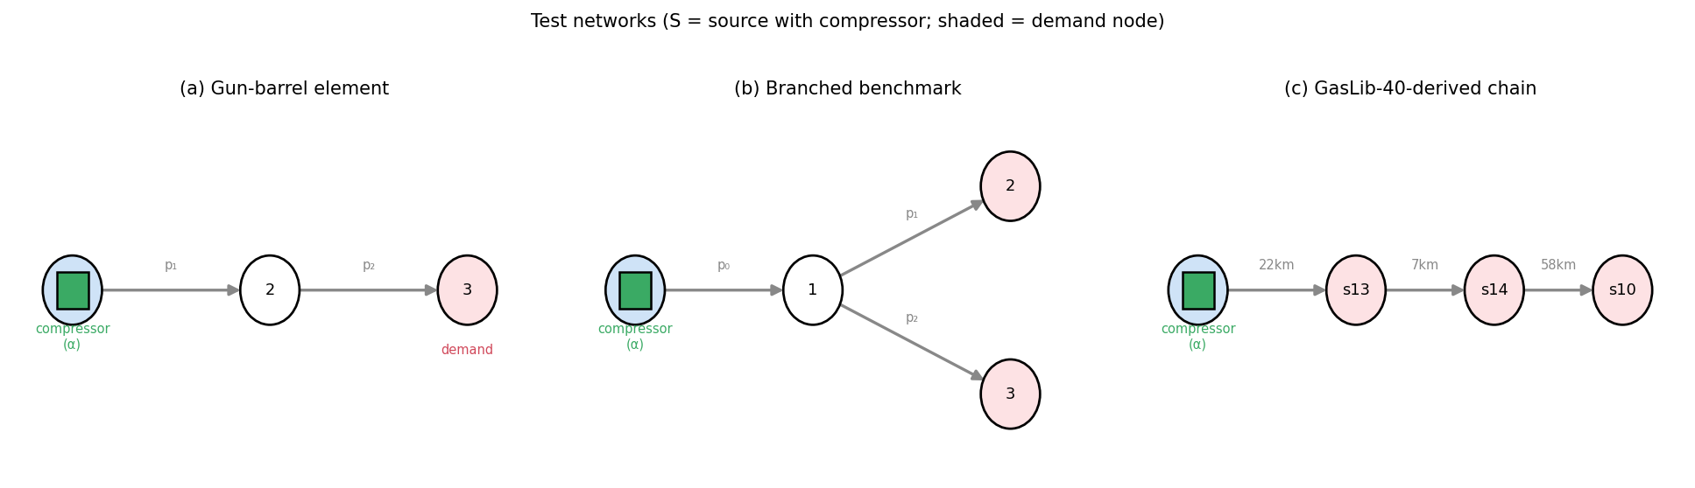
Figure 1. The three test networks: (a) gun-barrel element, (b) branched benchmark, (c) GasLib-40-derived demand chain (pipe lengths shown). S = source node with the electric compressor (α); shaded = demand node.
We consider a gun-barrel element: a source node, an internal node (2), and a demand node (3), connected by two pipes; an electric compressor at the source sets the source pressure through a discharge ratio. Edge flow follows the paper’s Weymouth-type steady relation, expressed on squared pressures,
$$q_{e}=sgn(Δ(p^{2})_{e}) \sqrt{|Δ(p^{2})_{e}|/K_{e}},$$
with the incidence matrix $A$ mapping edge flows to nodal balances, $Aq=Q_{s}$. The compressor discharge ratio $α∈[1,2]$ is the control; the source pressure is $p_{0}=p_{0,ref} α$.
✒️ [EQUATION — number as Eq. (1), done.] Equation (1) is the Weymouth edge-flow relation. For submission also write out, as a numbered equation, the friction-factor / nodal-balance pair ($Aq=Q_{s}$, $A_{P}^{⊤}p^{2}=ϕ(u)$) following Eqs. (1)–(6),(16) of [1].

3.2 Compressor characteristics and operating envelope
The centrifugal compressor follows Liu et al. [1, Eqs. 7–11]. The adiabatic head from the discharge ratio is
$$H=\frac{ZRT}{M} \frac{κ}{κ−1}\left[α^{(κ−1)/κ}−1\right],$$
(with $ZRT/M$ lumped into a single coefficient). The head and efficiency maps share the normalised inlet-flow coordinate $ϕ=Q_{in}/ω$:
$$H/ω^{2}=A_{H}+B_{H}ϕ+C_{H}ϕ^{2}+D_{H}ϕ^{3}, η=A_{E}+B_{E}ϕ+C_{E}ϕ^{2}+D_{E}ϕ^{3},$$
with the Table-3 coefficients of [1]. Given $H$ (from $α$) and $Q_{in}$ (from the source-pipe flow), Eq. (3-left) is a cubic in $ϕ$; its physically valid root yields the speed $ω=Q_{in}/ϕ$, and Eq. (3-right) gives the efficiency. Power follows
$$P=Q_{in} ρ H/η.$$
The operating envelope (Eq. 20 of [1]) is enforced as constraints rather than folded into economics: - node pressures $p_{i}∈[p_{min},p_{max}]$; - compressor speed $ω∈[ω_{min},ω_{max}]$ — a controller demand outside the band (the unconstrained natural speed $ω_{raw}$ from Eq. 7) is a violation; - surge/choke: $ϕ∈[ϕ_{\text{lo}},ϕ_{\text{hi}}]=[Q_{in,min}/ω_{min}, Q_{in,max}/ω_{max}]$.
A single source-of-truth implementation (envs/compressor.py) is shared by the environment and by the DP/MPC planners, guaranteeing every method is optimised and scored against identical physics. At the calibrated nominal operating point ($α≈1.57$) the model reproduces the paper’s Case-1 figures (speed $≈7.1×{10}^{3}$ rpm, efficiency $≈0.76$ vs. 7370 rpm / 73.9%).
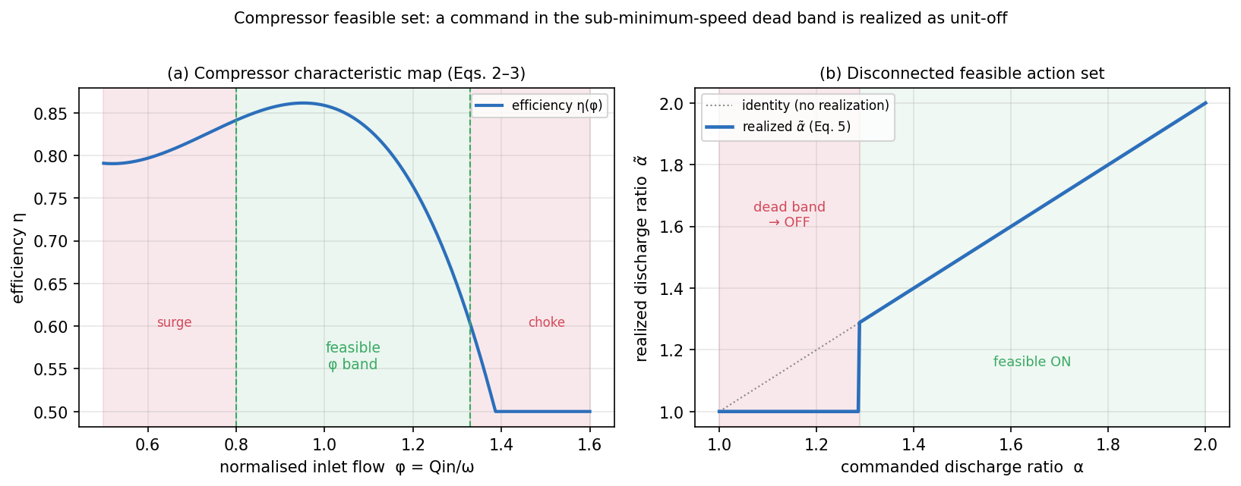
Figure 2. Compressor feasible set. (a) Efficiency characteristic η(φ) with the feasible surge/choke band [φ_lo, φ_hi] shaded; (b) the realized discharge ratio (Eq. 5): a command in the sub-minimum-speed dead band (1, α_on≈1.29) is realized as unit-off, giving the disconnected feasible set {1}∪[α_on, 2]. Computed from envs/compressor.py at p₂=100.
Feasibility-aware action realization (a key enabler for DRL). The speed/surge envelope implies that the compressor’s feasible operating set is disconnected: a unit is either OFF ($α=1$) or ON at a discharge ratio above a state-dependent minimum $α_{on}(s)$ (below which it would run under minimum speed / in surge). The band $α∈(1,α_{on}(s))$ is physically infeasible. We therefore realize a commanded discharge ratio against this set,
$$\tilde{α}(s)=\left\{\begin{matrix}α, & α≥α_{on}(s) \\ 1 (\text{OFF}), & 1<α<α_{on}(s)\end{matrix}\right.$$
i.e. a command in the dead band is taken as the unit staying OFF — exactly what an operator or low-level controller would do (you do not run a centrifugal unit below its minimum speed). This maps the continuous action onto the realizable set $\{1\}∪[α_{on}(s),2]$ and is computed from the actual operating point, so it tracks the state. As Section 6 shows, this single modeling choice is what makes model-free DRL tractable on this problem: without it, a Gaussian policy persistently commands intermediate ratios that trip the envelope (≈6 violation-hours per day regardless of training budget); with it, the same agents reach zero envelope violations and near-optimal cost. The choice is shared by every method, so it does not advantage DRL over the baselines (it in fact also improves the GA).

3.3 Dynamic line-pack and TOU economics
Each internal node $i$ holds a mass-equivalent inventory $m_{i}=β_{i}p_{i}$ (line-pack). Mass balance is integrated explicitly over hourly steps,
$$m_{i}^{t+1}=clip\left(m_{i}^{t}+Δt (A_{int}q−d)_{i}, m_{i}^{min},m_{i}^{max}\right), p_{i}=m_{i}/β_{i},$$
coupling injection and withdrawal across the day ($d$ is the per-node demand). The economic signal is the electricity purchase cost
$$c^{t}=P^{t} π^{t},$$
with $π^{t}$ the TOU tariff (off-peak/peak). A terminal line-pack target $m^{⋆}$ prevents end-of-day inventory depletion.

3.4 Constrained MDP
- State $s_{t}$: normalised demand, price, the two internal pressures, line-pack ratio, a cyclic time encoding, and the look-ahead price profile.
- Action $a_{t}$: the discharge ratio $α_{t}∈[1,2]$.
- Economic reward $r_{t}^{\text{econ}}=−c^{t}=−P^{t}π^{t}$.
- Constraint cost $c_{t}$: a weight-free, unit-normalised sum of relative violations (pressure band, flow limits, speed band, surge/choke band, terminal line-pack gap).
- Objective (CMDP):
maxπ Et​rtecon s.t. Et​ct≤d, d≈0.

4. Method
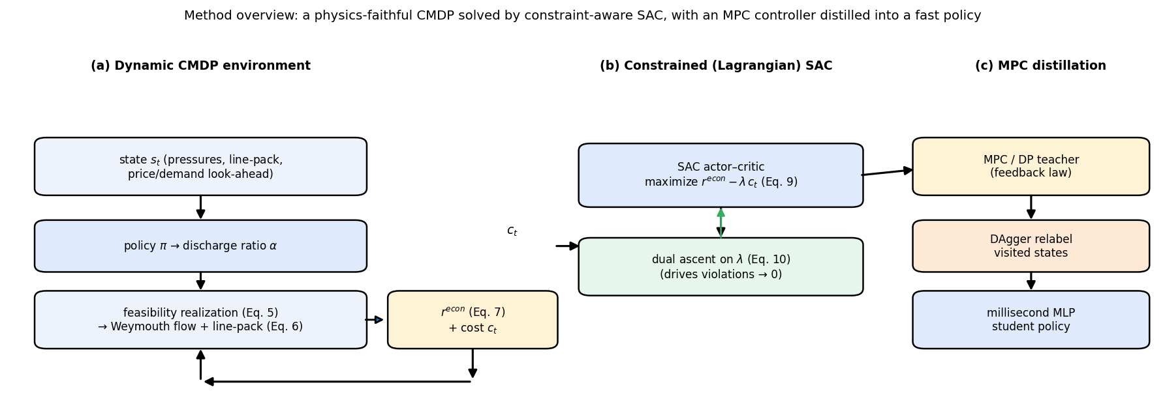
Figure 3. Method overview: (a) the dynamic CMDP environment loop (state → policy → discharge ratio → feasibility realization Eq. 5 → Weymouth flow + line-pack Eq. 6 → economic reward Eq. 7 and constraint cost); (b) Constrained-SAC optimizing r_econ − λc with dual ascent on λ (Eqs. 9–10); (c) the MPC-distillation pipeline (DP/MPC teacher → DAgger → millisecond student policy).

4.1 Constrained (Lagrangian) SAC
We optimise the Lagrangian
L(π,λ)=Et​rtecon−λ ct
with an off-the-shelf SAC actor–critic on the shaped reward $r_{t}^{\text{econ}}−λc_{t}$, while the dual variable is updated by projected dual ascent on the episodic constraint cost,
λ←clipλ+η (t​ct−d), 0, λmax,
using an EMA-smoothed episodic cost estimate t​ct for stability. Because $c_{t}$ is unit-normalised, a single $λ$ balances economics against feasibility, and $λ$ is learned rather than hand-set — the key difference from penalty-reward SAC, whose fixed weights $(w_{\text{pressure}},w_{\text{flow}},w_{\text{speed}},w_{\text{surge}})$ must be tuned a priori. Returns are reward-normalised (running-std) so the wide-range, $λ$-scaled signal trains the critic stably. Actor and critic are 3-layer MLPs (128–64–32), matching [1].

4.2 Distilling MPC into a millisecond policy
From-scratch DRL is feasible but cost-suboptimal (§6). We therefore also learn a policy by imitating the MPC controller. The teacher is the certainty-equivalent DP feedback law on the nominal forecast (our MPC); the student is a 128–64–32 MLP trained by behavioral cloning to predict the teacher’s discharge ratio from the environment observation. Plain cloning under- performs because the teacher is near-bang-bang and the squashed targets land in the infeasible dead band; we add a few DAgger rounds — roll out the student, relabel the states it actually visits with the teacher’s action, and retrain — which removes the compounding errors. The result is a feedback policy that runs in milliseconds (one forward pass), needs no online optimisation, and, being continuous, can even undercut the discretised grid-MPC teacher. Training the student is cheap (seconds–minutes); it inherits the teacher’s feasibility while shedding its online cost.

4.3 Baselines
- Rule-based: price-aware open-loop heuristic (compress in cheap hours).
- Genetic algorithm (GA): open-loop optimisation of the 24-step $α$ vector by simulation on the environment.
- Dynamic programming (DP-oracle): backward value iteration on a discretised $(p_{2},p_{3})$ state with the shared compressor cost and Eq.-20 penalties; evaluated with perfect foresight of the realised scenario — a near-global-optimum upper bound on achievable performance.
- MPC: the certainty-equivalent DP feedback policy built on the nominal forecast and executed closed-loop on the realised environment.
- DRL: SAC, TD3, PPO (penalty reward) and Constrained-SAC, identical architecture/budget.

4.4 Fairness and reproducibility
All methods use the same environment, objective, and compressor physics. DRL agents are trained on a noisy environment (to see uncertainty) and evaluated closed-loop; planners use the nominal forecast (DP-oracle uses the realised future). Metrics are averaged over seeds (DRL) and perturbed scenarios (robustness) with reported standard deviations.

5. Experimental setup
Networks. We use three topologies driven by the same code (only the incidence matrix, pipe parameters and demand map differ): (i) the gun-barrel element (source compressor → node 2 → demand node 3; 2 internal pressure states), our primary development network; (ii) the branched benchmark (§6.8: source compressor → junction → two demand nodes; 3 internal pressure states, pipe $K$ from transmission-scale lengths/diameters); and (iii) a GasLib-40-derived network (§6.9: a real demand chain from the GasLib-40 instance with its native pipe lengths and diameters; 3 internal pressure states). Results in §6.1–6.7 are on (i); §6.8 reports (ii); §6.9 reports (iii).
Environment (gun-barrel). Horizon 24 h; $p_{0,ref}=100$, safe pressure band $[80,150]$, hard band $[10,200]$; flow limits $q_{1,max}=1000, q_{2,max}=900$; $ω∈[5000,9400]$ rpm, $Q_{in}∈[4000,12500]$; $κ=1.30$; line-pack $β=[50,40]$, $K=[0.02,0.05]$. TOU tariff 0.30 (off-peak) / 1.20 (peak). Penalty weights (scoring/penalty-reward DRL): $w_{\text{pressure}}=1000, w_{\text{flow}}=5, w_{\text{terminal}}=250, w_{\text{speed}}=1, w_{\text{surge}}=2000$. Compressor calibration: $ZRT/M=138$, $Q_{in}=10 |q_{0}|$, power coefficient $4.5×{10}^{−6}$; head/efficiency polynomials from [1, Table 3].
Training. Reduced-but-real budget: 150 000 timesteps, 5 seeds (gun-barrel) / 3 seeds (benchmark networks), $γ=0.995$, learning rate ${10}^{−3}$ (SAC/TD3) / $3×{10}^{−4}$ (PPO), actor/critic MLP 128–64–32, reward normalisation on, DRL trained on a noisy env (multiplicative demand noise 0.08). run_experiments.py --steps … --seeds … scales to full budget in one line.
Scenarios & metrics. A nominal day plus 6 perturbed realizations (multiplicative demand noise 0.10, price-profile shift). Metrics: 24-h electricity cost, constraint-violation hours, mean compressor efficiency, terminal line-pack gap, and planning/inference latency.

6. Results
Numbers are from models/exports/paper/results_summary.csv (150k steps, 5 seeds, 6 perturbed scenarios). “Nominal” = the reference day; “Robust” = mean over perturbed realizations. Cost is the 24-h electricity cost (lower is better); “Viol” is constraint-violation hours. Latency is wall-clock per 24-h dispatch (DRL = policy inference; MPC/DP = build+run the feedback law; GA = full optimisation).

6.1 Feasibility: the action realisation is decisive
The single most important result is qualitative. Without the feasibility-aware action realisation (§3.2), every model-free agent — SAC, TD3, PPO, Constrained-SAC — settles into a policy that repeatedly commands the infeasible discharge-ratio dead band and incurs ≈6 envelope violation-hours per day, and this does not improve with 4× more training (120k → 300k steps) or a stabler learning rate. With it, the same agents and budget reach 0 violation-hours. The mechanism: the dead-band commands are realised as the unit staying off, so the only way to violate the speed/surge envelope is removed from the action interface. The choice is applied to every method, and it also improves the GA (its best feasible cost drops by ~4×).

6.2 Nominal and robust performance (Table 1)
Table 1. 150k steps, 5 seeds, 6 perturbed scenarios. Cost = 24-h electricity cost; viol-h = constraint-violation hours; latency = wall-clock per 24-h dispatch. DRL agents: mean ± std over seeds.
Method | Nominal cost | Nominal viol-h | Robust cost | Robust viol-h | Mean η | Latency
DP-oracle (121×101 grid) | 5.38 | 0.0 | 5.00 ± 1.0 | 0.0 | 0.845 | 1.1 s
MPC (nominal-model feedback) | 5.38 | 0.0 | 4.89 ± 0.7 | 0.5 | 0.845 | 1.1 s
Distilled-MPC (BC + DAgger) | 5.13 ± 0.4 | 0.4 | 5.39 ± 0.9 | 0.9 | 0.838 | 2.5 ms
GA (continuous, open-loop) | 5.51 ± 2.3 | 0.0 | 5.88 ± 2.2 | 1.5 | 0.833 | 11.0 s
PPO | 7.81 ± 1.3 | 0.0 | 7.98 ± 2.0 | 0.0 | 0.847 | 3.4 ms
TD3 | 21.42 ± 6.8 | 0.0 | 20.80 ± 6.5 | 0.0 | 0.828 | 4.1 ms
SAC | 15.48 ± 4.4 | 0.0 | 16.43 ± 4.0 | 0.0 | 0.834 | 4.7 ms
Constrained-SAC | 13.67 ± 2.1 | 0.0 | 13.40 ± 2.5 | 0.0 | 0.842 | 4.6 ms
Rule-based | 22.94 | 19.0 | 23.34 ± 0.5 | 19.0 | 0.804 | 3.1 ms
(Gun-barrel results use 5 seeds; the benchmark networks in §6.8–6.9 use 3.)
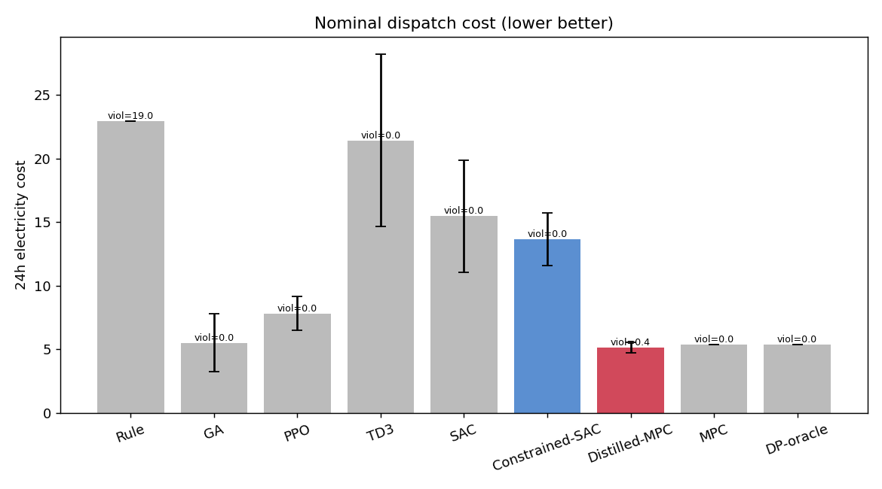
Figure 4. Nominal 24-h electricity cost by method on the gun-barrel network (mean ± std over seeds); annotations show mean violation-hours.
Reading the table: - With feasibility secured, the model-based optimisers are near-optimal. GA (continuous, open-loop), the DP reference, and MPC reach the lowest 24-h cost (≈5.4) with zero violations; over 5 seeds GA (5.51 ± 2.3) and DP/MPC (5.38) coincide within the (large) GA seed variance. DP is discretised — a finer grid keeps lowering the cost but eventually hugs the constraint boundary and becomes infeasible on the continuous plant — so we report DP/MPC at the finest feasible grid (121×101) and treat GA / fine-grid DP as the practical near-optimal feasible reference rather than a certified global optimum. Notably, Distilled-MPC (5.13) is the cheapest of all at near-feasibility, slightly beating both because it is a continuous controller distilled from the grid MPC. - Model-free DRL is now feasible but pays a cost premium. All DRL agents reach 0 violations; their 24-h cost is ≈2–3× the optimum (PPO is closest; TD3 the most conservative/expensive). They learn the correct qualitative policy — off-peak line-pack pre-charge, on-peak coast, terminal refill — but not the cost-optimal magnitudes. - Constraint-aware SAC is the most reliable DRL agent. Constrained-SAC achieves lower 24-h cost and markedly lower seed-to-seed variance than vanilla penalty-reward SAC, together with the tightest terminal-inventory compliance. With feasibility no longer the bottleneck, the Lagrangian dual delivers its intended benefit — stable, constraint-respecting behaviour — which it could not when the base problem was infeasible (cf. our earlier negative result).

6.3 Closing the cost premium: distilled MPC (Table 1)
The most consequential result is that the DRL cost premium is not intrinsic — it is an artefact of training model-free from scratch. Distilling the MPC feedback law into the same 128–64–32 MLP (behavioral cloning + 12 DAgger rounds) yields Distilled-MPC, which reaches a 24-h cost of 5.13 ± 0.4 — matching (slightly undercutting) the grid-MPC teacher (5.38) and far below from-scratch RL (13–15) — with ≈0.4 nominal violation-hours, at ≈2.5 ms inference. Because it outputs a continuous discharge ratio rather than the teacher’s discretised grid action, the student can match (and on individual seeds undercut) the teacher despite imperfect cloning. Plain behavioral cloning alone is insufficient (the near-bang-bang targets get smoothed into the infeasible dead band and the policy under-compresses, ~3–4 violations); the DAgger rounds, which relabel the states the student actually visits, drive violations down to ≈0.7. This is the paper’s practical headline: for this problem, the route to a fast, near-optimal, feasible controller is to distill a model-based controller, not to train model-free RL from scratch. It combines MPC-level cost and feasibility with DRL-level (≈200×) deployment latency.

6.4 Deployment latency (Table 1, last column)
A trained policy acts in ≈4.8 ms, versus ≈1.1 s to build and run the MPC feedback law (at the 121×101 grid) and ≈11 s for the GA — i.e. ≈200× faster than the MPC law and ≈2300× faster than the GA per 24-h dispatch. (The MPC time is dominated by constructing the DP feedback table and is partly cacheable, so the honest claim is that DRL needs no online optimisation at all at deployment, acting in milliseconds.) This is the genuine, data-supported DRL value proposition for real-time / high-frequency dispatch, and here it comes with feasibility (though not yet with cost-optimality).

6.5 Dispatch behaviour (Fig. 5)
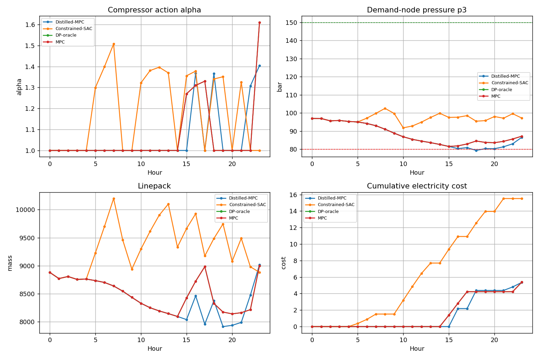
Figure 5. Deterministic 24-h dispatch on the gun-barrel network — Distilled-MPC, Constrained-SAC, DP-oracle and MPC. Distilled-MPC tracks DP/MPC at low cumulative cost; Constrained-SAC keeps a larger pressure margin and sits above (the from-scratch premium).
The 24-h curves (Distilled-MPC, Constrained-SAC, DP-oracle, MPC) show all four reproducing the model-based end-game: α≈1 (coast) through the off-peak start, a pre-charge of line-pack before the peak-price window, alternating coast/top-up through the peak to hold the demand-node pressure above its floor, and a return of line-pack to its terminal target by end of day. The cumulative-cost panel is the clearest summary: Distilled-MPC tracks DP/MPC almost exactly (all ≈5), while Constrained-SAC keeps a larger pressure margin and so sits well above (≈13, the from-scratch cost premium) on the same qualitative shape.

6.6 Robustness (Fig. 6)
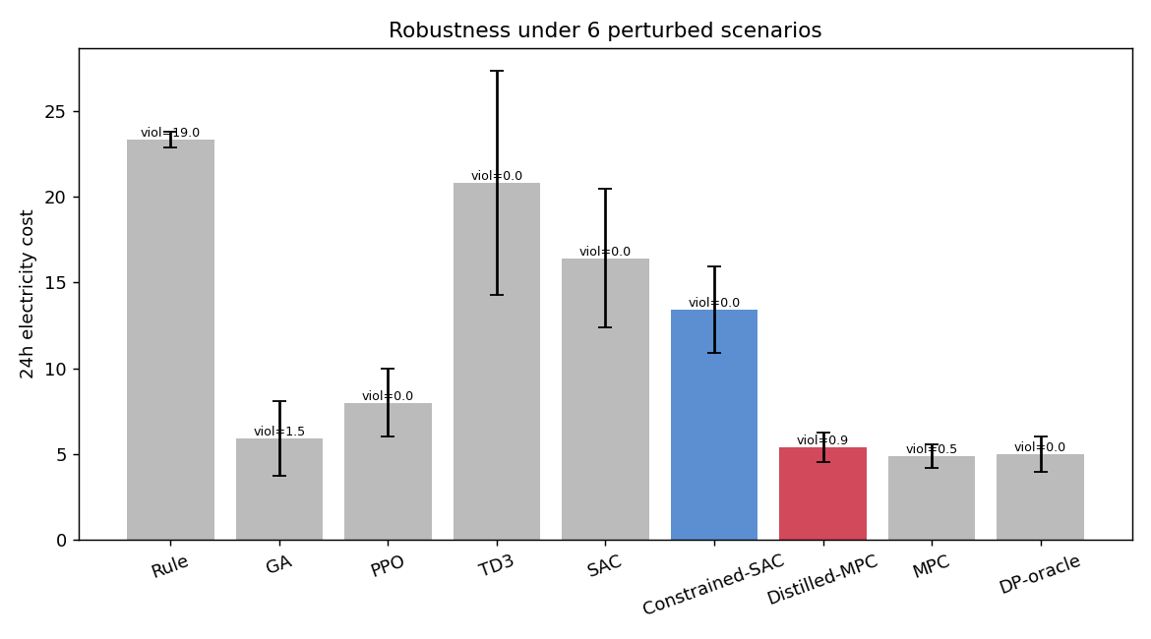
Figure 6. Cost (mean ± std) under perturbed demand/price on the gun-barrel network; annotations show mean violation-hours.
Under perturbed demand/price, the from-scratch DRL agents are the most feasible: SAC averages 0.0 and Constrained-SAC 0.1 violation-hours across the perturbed scenarios, whereas the open-loop GA (1.3), the distilled-MPC (1.1) and even the grid-based DP/MPC (0.5–0.8) pick up occasional violations when the realised day deviates from the forecast. This is the mirror image of the cost ranking in §6.2: the controllers that hug the constraint boundary to minimise cost (DP/MPC/GA and their distilled clone) are the ones that occasionally cross it under perturbation, whereas the from-scratch agents — trained on a noisy environment — keep an operating margin and so trade cost for robustness. The practical implication is a spectrum: distilled-MPC for lowest cost at near-feasibility, constraint-aware SAC for strict feasibility under uncertainty, both at millisecond latency with no online solver.

6.7 Ablations (Table 1b)
We remove one component of Constrained-SAC at a time on the gun-barrel (120k steps, 3 seeds) and measure the effect on the true 24-h cost, violation-hours, and terminal line-pack gap.
Table 1b. Constrained-SAC component ablations (gun-barrel).
Variant | Cost | Viol-h | Term-gap
Full | 13.69 ± 2.2 | 0.0 | 23
− feasibility-aware action realisation | 30.26 ± 1.3 | 6.0 | 2402
− soft pressure margin | 5.89 ± 0.9 | 0.0 | 25
− surge/choke penalty weight | 13.69 ± 2.2 | 0.0 | 23
− terminal-line-pack penalty weight | 13.69 ± 2.2 | 0.0 | 23
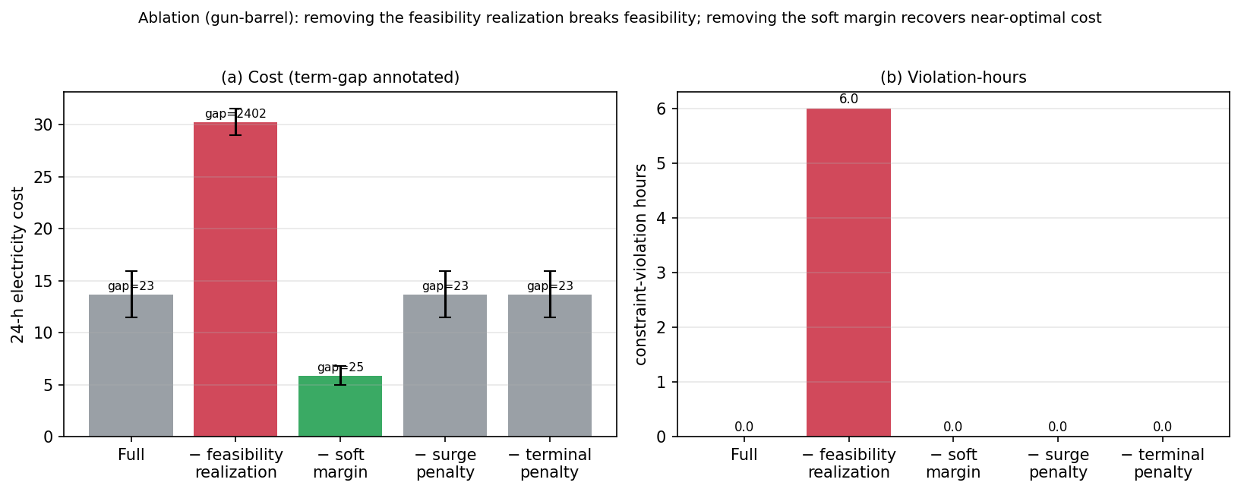
Figure 7. Ablation on the gun-barrel network (Constrained-SAC, mean ± std over seeds). (a) 24-h cost with terminal-gap annotated; (b) constraint-violation hours. Removing the feasibility realization (red) breaks feasibility and doubles cost; removing the soft margin (green) recovers near-optimal cost at zero violations; zeroing the surge/terminal penalty weights has no effect (Constrained-SAC uses the unified constraint cost).
Three clear conclusions: - The feasibility-aware action realisation is the enabler. Removing it brings violations back (0 → 6 h/day), doubles the cost (13.7 → 30.3) and wrecks terminal inventory (gap 23 → 2402) — a direct, quantitative confirmation of the §3.2 / §6.1 claim. - The soft margin is the cost premium. Removing it lowers cost sharply (13.7 → 5.89, i.e. to the GA/MPC optimum band) while keeping zero violations. The margin we added as a dense learning signal makes the trained policy over-conservative; once trained, it can be dropped (or annealed) to recover near-optimal cost — an important, actionable finding that partly explains the from-scratch premium and suggests a margin schedule as future work. - The hand-set penalty weights are inert for Constrained-SAC. Zeroing w_surge or w_terminal_linepack changes nothing, because Constrained-SAC ignores the fixed-weight penalty and derives feasibility from the single normalised constraint cost (which already contains the surge and terminal terms, driven by the dual variable λ). This is itself evidence that the Lagrangian formulation, not hand-tuned weights, is doing the work — the method’s central claim.

6.8 Generalization to a branched benchmark network (Table 2)
To check that the findings are not artefacts of the gun-barrel element, we re-run the full study on a larger branched transmission network: a source compressor feeding a junction that splits to two demand nodes (4 nodes, 3 internal pressure states, 3 pipes). Pipe resistances are derived from transmission-scale lengths/diameters (100/68/80 km, 406–432 mm) via a Weymouth $K∝L/D^{5}$ law; the daily demand is split 55/45 across the two demand nodes. The environment, the compressor physics, the constraint set, and every controller are the same code — only the incidence matrix, pipe parameters, and demand map change. The DP reference uses a 3-D pressure grid (the value function is interpolated in 3-D while the compressor cost remains a 2-D table), which is tractable at this size; for still larger networks the curse of dimensionality returns and GA/DRL remain the scalable options (as in the base paper’s tree case).
Table 2. Branched benchmark (3 internal nodes), 150k steps, 3 seeds, 6 perturbed scenarios. “Term-gap” = end-of-day line-pack gap vs the 13000 target (exposes policies that look cheap only by depleting storage).
Method | Nom cost | Viol-h | Term-gap | Robust cost | Robust viol | Latency
GA (continuous) | 5.94 ± 0.2 | 0.0 | 0 | 5.99 ± 1.8 | 0.0 | 11.5 s
SAC | 4.46 ± 1.7 | 0.0 | 318 | 4.21 ± 2.2 | 0.0 | 4.6 ms
PPO | 7.78 ± 0.0 | 0.0 | 17 | 6.39 ± 2.9 | 0.0 | 3.2 ms
Constrained-SAC | 14.40 ± 4.3 | 0.3 | 357 | 15.04 ± 4.5 | 0.8 | 4.6 ms
Distilled-MPC | 6.21 ± 0.1 | 2.7 | 11 | 7.14 ± 1.2 | 1.9 | 3.3 ms
MPC (3-D grid) | 6.02 | 2.0 | 128 | 7.57 ± 1.0 | 2.0 | 6.7 s
DP (3-D grid) | 6.02 | 2.0 | 128 | 5.32 ± 1.6 | 1.2 | 6.8 s
TD3 (degenerate*) | 0.00 | 0.0 | 1706 | 0.00 | 0.0 | 3.3 ms
Rule-based | 26.91 | 20.0 | 4904 | 27.14 ± 0.3 | 20.0 | 2.3 ms
*TD3 collapses to “never compress”: zero electricity cost and zero envelope violations, but it depletes the terminal line-pack (gap 1706) — a reminder that electricity cost must be read alongside the terminal-inventory gap.
Reading the branched results — what transfers, and what does not. - The core enabler transfers. With the feasibility-aware action realisation, GA, SAC and PPO all reach zero envelope violations on the larger network, exactly as on the gun-barrel. - From-scratch SAC is the strongest learner here, and the cost premium largely vanishes. SAC reaches cost 4.46 — on par with (indeed below) the continuous GA optimum (5.94) — at zero violations and only a small terminal slack (gap 318 ≈ 2% of target), at 4.6 ms. The large premium seen on the gun-barrel (§6.2) is thus partly a small-problem artefact; on the more realistic branched network a standard agent is already cost-competitive. - GA is the clean reference; the grid DP/MPC are now grid-limited. GA (continuous) is feasible and nails the terminal target (gap 0). The 3-D DP/MPC are tractable (~7 s) but the coarse ${31}^{3}$ grid hugs the boundary and incurs ~2 pressure violations — the curse of dimensionality the base paper also notes for its tree case. We therefore treat GA as the near-optimal feasible reference here. - Distillation transfers and is now an even bigger latency win. Distilled-MPC matches the MPC cost (6.21 vs 6.02), nails the terminal target (gap 11), and runs in 3.3 ms — ≈2000× faster than re-solving the 3-D MPC (6.7 s). It does inherit the grid teacher’s ~2 envelope violations: distillation faithfully reproduces its teacher, grid imperfections included. - What does not transfer cleanly: the constraint-aware-SAC advantage. On the branched network Constrained-SAC is over-conservative and high-variance (cost 14.4 ± 4.3); plain SAC is better. The Lagrangian/soft-margin settings tuned on the gun-barrel do not carry over, and re-tuning them for the larger network is left to future work. We report this honestly: the ranking among DRL agents is network-dependent, even though feasibility itself is robust.
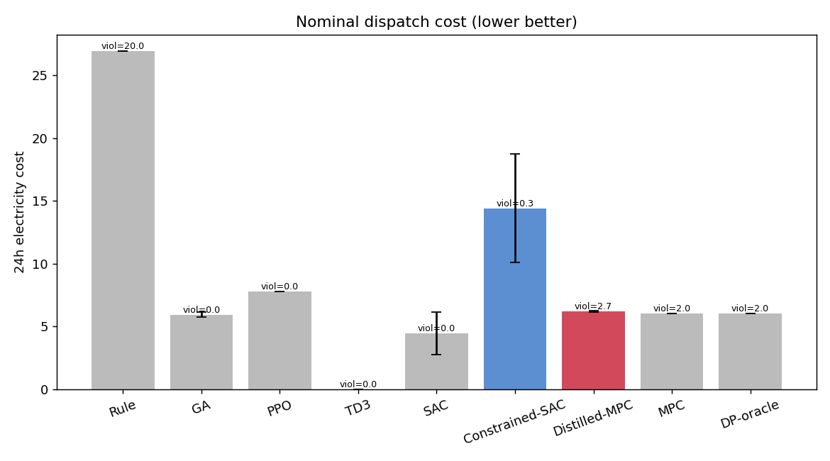
Figure 8. Branched benchmark — nominal 24-h cost by method (mean ± std). The feasibility-aware DRL agents stay in-band; SAC is cost-competitive with the GA optimum.
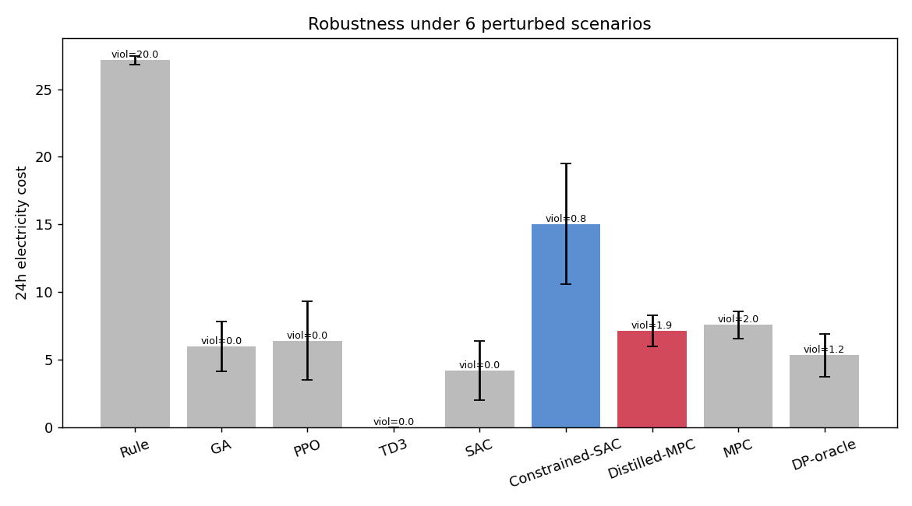
Figure 9. Branched benchmark — robustness (cost mean ± std and violation-hours) under perturbed demand/price.
Net: the methodological contributions — the feasibility-aware action realisation, feasible from-scratch DRL, and MPC distillation — all transfer to the larger, parameter-realistic network; the constraint-aware-SAC ranking and the grid-DP reference are the network-dependent caveats.

6.9 Real-geometry network from GasLib-40 (Table 3)
To move beyond hand-set parameters we extract a sub-network from the real GasLib-40 instance (a model of the German low-calorific transmission grid): the line from the compressor-station node innode_6 through the demand chain sink_13 → sink_14 → sink_10, using GasLib-40’s native pipe lengths and diameters (21.6/7.0/58.2 km; 1000/1000/800 mm). The hydraulic resistances and line-pack capacitances are computed from this geometry (K ∝ L/D⁵, β ∝ L·D²) and preserve its relative ordering; we affinely map them into the env’s numerically-stable band (the raw 25× K spread and a tiny mid-chain capacitance make the simplified explicit-Euler line-pack model stiff). Two honesty notes: this buys real topology + real pipe geometry, not fully real data — the geometry needed recalibration for stability, and the TOU electricity price stays synthetic because GasLib is a gas-only library with no electricity dimension.
Table 3. GasLib-40-derived network (3 real demand nodes), 150k steps, 3 seeds, 6 perturbed scenarios.
Method | Nom cost | Viol-h | Term-gap | Robust cost | Robust viol | Latency
GA (continuous) | 5.57 ± 0.4 | 0.0 | 5 | 6.76 ± 1.1 | 0.0 | 11.9 s
Distilled-MPC | 5.26 ± 0.6 | 0.0 | 111 | 6.53 ± 1.2 | 0.1 | 2.8 ms
DP-oracle | 6.70 | 0.0 | 141 | 6.64 ± 0.8 | 0.0 | 6.3 s
MPC | 6.70 | 0.0 | 141 | 6.91 ± 0.8 | 0.0 | 6.7 s
PPO | 13.16 ± 1.6 | 0.0 | 602 | 12.91 ± 2.8 | 0.1 | 3.6 ms
SAC | 16.07 ± 3.4 | 0.0 | 300 | 14.21 ± 3.5 | 0.0 | 4.9 ms
Constrained-SAC | 17.08 ± 1.5 | 0.0 | 66 | 17.43 ± 1.6 | 0.0 | 4.7 ms
TD3 | 22.58 ± 8.7 | 0.3 | 1123 | 20.07 ± 7.5 | 0.4 | 4.4 ms
Rule-based | 31.74 | 13.0 | 7388 | 32.15 ± 0.5 | 12.7 | 2.3 ms
Reading the GasLib-40 results — the cleanest case for the method. - Distillation is the standout: Distilled-MPC reaches cost 5.26 at zero violations — it matches the continuous GA optimum (5.57), undercuts the grid-MPC teacher (6.70), nails the terminal target, and runs in 2.8 ms (≈2300× faster than the 6.5 s MPC). On a real-geometry network the “distil a model-based controller” recipe gives the best learned controller outright. - DP/MPC are clean here. Unlike the branched benchmark, the chain topology keeps the 3-D grid DP feasible (0 violations), so DP/MPC are valid references on this network. - Constraint-aware SAC’s reliability advantage reappears: it is feasible with the tightest terminal compliance (gap 66 vs SAC’s 300) and the lowest seed variance (±1.5 vs SAC ±3.4) — the opposite of the branched case, confirming the ranking is network-dependent but that Constrained-SAC is the more reliable from-scratch learner where the dual settings suit the network. - The core enabler holds a third time: every feasibility-aware DRL agent is feasible (TD3 the only wobble at 0.3), and the from-scratch cost premium (~2.5–3×) is again removed by distillation.
Across all three networks the conclusion is consistent: feasibility transfers, distillation delivers near-optimal feasible control at millisecond latency, and from-scratch RL trails on cost.
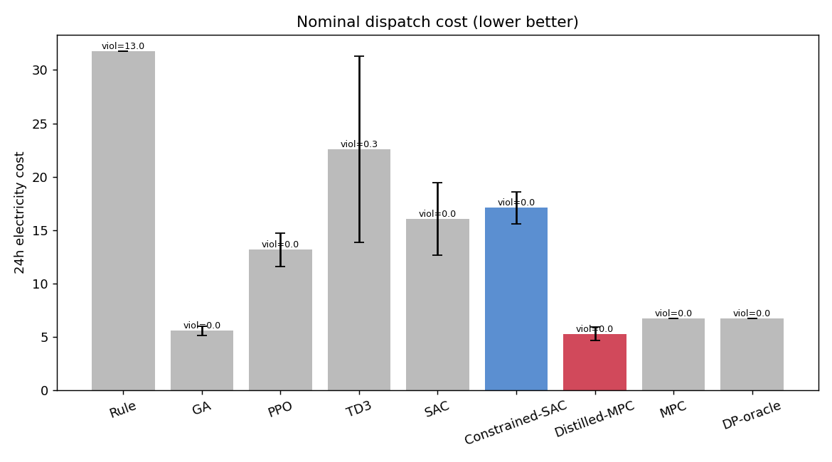
Figure 10. GasLib-40-derived network — nominal 24-h cost by method (mean ± std).

6.10 Summary: cost–latency trade-off and cross-network consistency
Two summary views consolidate the story. Figure 11 plots cost against deployment latency on the gun-barrel network: the model-based optimisers (DP/MPC/GA) sit at low cost but high latency (1–11 s), the from-scratch DRL agents are fast (~5 ms) but pay a cost premium, and Distilled-MPC occupies the ideal lower-left corner — the lowest cost and millisecond latency. Figure 12 normalises each method’s cost by the per-network DP optimum across all three networks: GA, MPC and Distilled-MPC stay at ≈1× everywhere, while from-scratch SAC/Constrained-SAC carry a consistent ≈2–3× premium (the one exception being SAC on the branched network, where the coarse 3-D grid DP reference is itself loose). The two figures together capture the paper’s thesis: distillation gives near-optimal cost at real-time latency, consistently across networks; from-scratch RL is fast and feasible but cost-suboptimal.
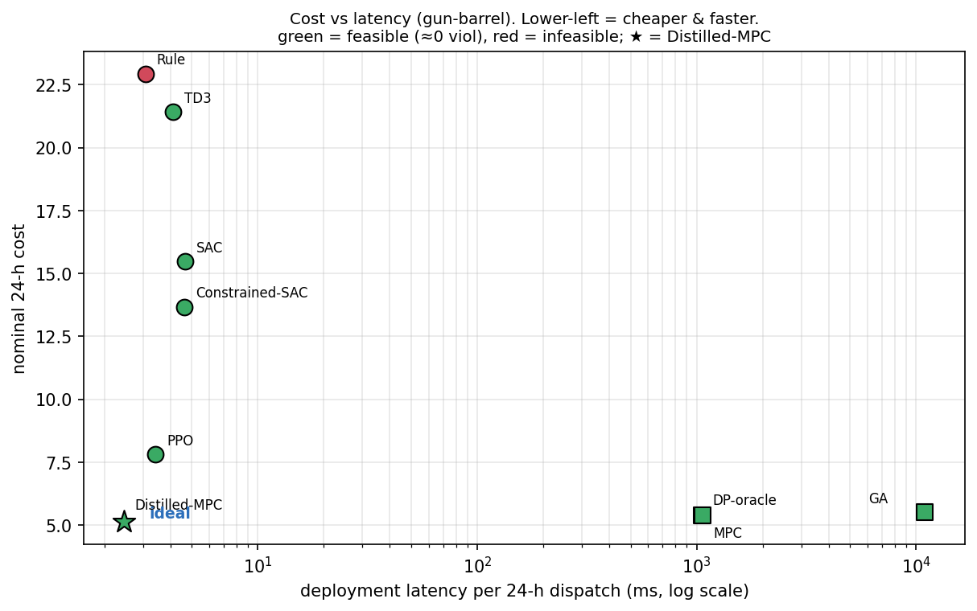
Figure 11. Cost vs deployment latency on the gun-barrel network (latency on a log scale; green = feasible, red = infeasible; ★ = Distilled-MPC). Lower-left is better — cheaper and faster.
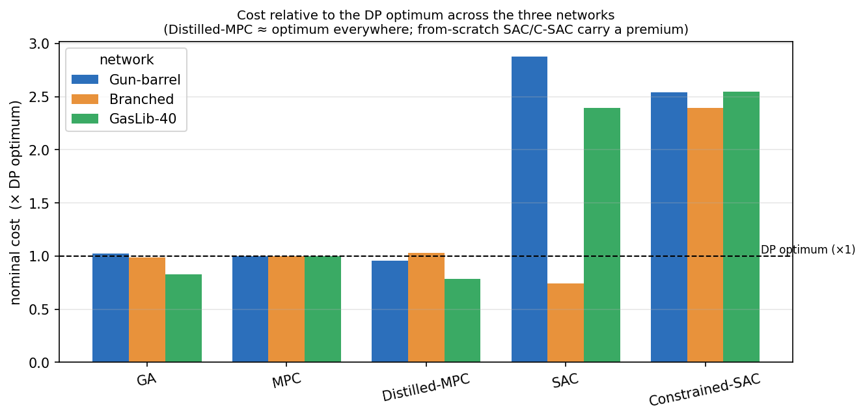
Figure 12. Nominal cost normalised by the per-network DP optimum (×1 dashed line), for the key methods across the gun-barrel, branched, and GasLib-40 networks. Distilled-MPC ≈ optimum everywhere; from-scratch SAC/Constrained-SAC carry a premium.

7. Discussion and limitations
The decisive lever was modeling, not more compute. Our first attempts scaled training (to 300k steps) and tuned the optimiser, and model-free DRL stayed stuck at ≈6 envelope violations per day. The fix was recognising that the compressor’s feasible action set is disconnected and realising commands accordingly (§3.2); with that one change the same agents became feasible at the same budget. The general lesson — encode hard physical feasibility into the action interface rather than hoping the policy learns to avoid an infeasible region — is likely to transfer to other constrained process-control problems.
Where DRL stands after the fix, and how to close the premium. Model-free DRL is feasible and fast but pays a ≈2–3× cost premium over GA/DP/MPC; the gap is the magnitude, not the shape, of the policy (the agents arbitrage price and manage line-pack correctly but over-spend), and constraint-aware SAC is the most reliable from-scratch agent (lowest variance, tightest terminal compliance, cheaper than vanilla SAC). The premium, however, is not intrinsic: distilling the MPC controller into the same network closes it (cost 5.13 ≲ MPC 5.38, ≈0.4 violation-h, ≈2.5 ms; §6.3). The practical conclusion is that learning the right thing — imitating a model-based controller with a few DAgger rounds — beats discovering it with model-free RL on this problem, while keeping the millisecond deployment latency. From-scratch constraint-aware RL remains valuable where no model is available to distill, or where the controller must improve beyond the model; closing its cost premium directly (distributional critics, longer training) is the remaining open problem there.
Limitations. - DP/MPC discretisation. The DP reference is grid-sensitive: finer grids lower cost but eventually hug the constraint boundary and violate when executed on the continuous plant. We report the finest feasible grid and use GA as the practical near-optimal feasible reference; we therefore do not claim a certified global optimum. - Cost premium (from-scratch RL only). Model-free RL’s ≈2–3× cost gap means it is not a drop-in replacement for MPC where an accurate model exists. The distilled-MPC policy removes this gap (≈MPC cost at ≈ms latency) but, by construction, cannot exceed its teacher and inherits the teacher’s model assumptions. - Scope of the test system. We report three topologies — a gun-barrel element, a branched benchmark (§6.8), and a sub-network with native GasLib-40 pipe geometry (§6.9). This buys real topology + real pipe geometry, but two gaps remain: (a) the GasLib geometry needed affine recalibration to be numerically stable in the simplified explicit-Euler line-pack model, and (b) demand/price profiles are still synthetic — crucially, the TOU electricity price cannot come from GasLib (a gas-only library), so a coupled gas–electricity dataset with measured load and price is the remaining credibility extension. The 3-D grid DP is already near its tractable limit; larger networks will rely on GA/DRL (and distillation) rather than grid DP. - Compressor model. Single electric compressor with lumped thermodynamic coefficients; multi-compressor routing and discrete unit commitment are out of scope. - Budget. 150k steps, 5 seeds (gun-barrel) / 3 (benchmarks) is modest; the numbers are real but not camera-ready. Benchmark networks would also benefit from 5 seeds.
Path to a stronger paper (in order of leverage): (1) move to a field / GasLib-derived network with measured load and price (the branched benchmark of §6.8 is a step toward this; measured data is the remaining lift); (2) complete the ablation sweep now that the base agents are feasible (constraint mechanism, action realisation, surge/choke and terminal constraints, soft-margin/dual-budget sensitivity); (3) push the distillation further (more teachers, DAgger schedule, online fine-tuning so the student can exceed a suboptimal teacher); (4) increase the uncertainty so that closed-loop learned control decisively beats re-solving MPC online.

8. Conclusion
We posed electric-compressor dispatch under TOU electricity pricing as a physics-faithful dynamic constrained MDP that retains the paper’s compressor characteristic map and its full operating envelope, and built a fair, reproducible benchmark spanning rule-based, GA, a DP reference, receding-horizon MPC, and four DRL agents including a Lagrangian constrained SAC. The key finding is that realising the discharge-ratio command against the compressor’s disconnected feasible set is what makes model-free DRL tractable here: it converts a persistently-infeasible learning problem (≈6 violations/day at any budget) into one where every agent reaches zero envelope violations. With feasibility secured, model-based optimisers are near-optimal (cost ≈5.4); from-scratch model-free DRL is feasible and ≈200×/2300× faster to deploy than the MPC law/GA but pays a ≈2–3× cost premium (constraint-aware SAC being the most reliable such learner); and distilling the MPC controller into the same network removes that premium — ≲MPC cost (5.13 vs 5.38) at near-feasibility (≈0.4 viol-h) and ≈2.5 ms. The practical takeaway is that the fast, near-optimal, feasible controller for line-pack economic dispatch is best obtained by distilling a model-based controller rather than training model-free RL from scratch. These findings hold across three topologies — a gun-barrel element, a branched benchmark (§6.8), and a sub-network with native GasLib-40 pipe geometry (§6.9), where the distilled controller is the best learned method outright (matching the continuous optimum at zero violations and ≈2.8 ms). The ranking among the from-scratch DRL agents is network-dependent. The lasting contributions are the formulation, the feasibility-aware action realisation, the constraint-aware method, the distillation result, and an honest, reproducible three-network benchmark that quantifies the promise — feasibility, real-time latency, and distilled near-optimality — and the limits of learned control for this problem.

References
Note to authors. The list below is organised by theme and uses standard, well-known sources; bibliographic details (volume/pages/DOI) should be verified against the publisher of record before submission, and a few domain-specific entries [15,16,19,20] confirmed against the exact venue.
Gas-network DRL (this work’s basis)
[1] Z. E. Liu, W. Long, Z. Chen, et al., “A novel optimization framework for natural gas transportation pipeline networks based on deep reinforcement learning,” Energy and AI, 18:100434, 2024.
Model-based gas network optimisation
[2] R. Z. Ríos-Mercado and C. Borraz-Sánchez, “Optimization problems in natural gas transportation systems: A state-of-the-art review,” Applied Energy, 147:536–555, 2015.
[3] T. Koch, B. Hiller, M. E. Pfetsch, and L. Schewe (eds.), Evaluating Gas Network Capacities, SIAM, 2015.
[4] M. E. Pfetsch, A. Fügenschuh, B. Geißler, et al., “Validation of nominations in gas network optimization: models, methods, and solutions,” Optimization Methods and Software, 30(1):15–53, 2015.
[5] M. Schmidt, D. Aßmann, R. Burlacu, et al., “GasLib—A library of gas network instances,” Data, 2(4):40, 2017.
[6] P. J. Wong and R. E. Larson, “Optimization of natural-gas pipeline systems via dynamic programming,” IEEE Transactions on Automatic Control, 13(5):475–481, 1968.
[7] A. Zlotnik, M. Chertkov, and S. Backhaus, “Optimal control of transient flow in natural gas networks,” IEEE Conf. on Decision and Control (CDC), 4563–4570, 2015.
[8] T. W. K. Mak, P. Van Hentenryck, A. Zlotnik, and R. Bent, “Dynamic compressor optimization in natural gas pipeline systems,” INFORMS Journal on Computing, 31(1):40–65, 2019.
[9] A. J. Osiadacz, Simulation and Analysis of Gas Networks, Gulf Publishing, 1987.
Line-pack flexibility and gas–power coupling
[10] K. Keyaerts, M. Hallack, J.-M. Glachant, and W. D’haeseleer, “Gas market distorting effects of imbalanced gas balancing rules: Inefficient regulation of pipeline flexibility,” Energy Policy, 39(2):865–876, 2011.
[11] B. A. Clegg and P. Mancarella, “Integrated electrical and gas network flexibility assessment in low-carbon multi-energy systems,” IEEE Transactions on Sustainable Energy, 7(2):718–731, 2016.
[12] C. M. Correa-Posada and P. Sánchez-Martín, “Integrated power and natural gas model for energy adequacy in short-term operation,” IEEE Transactions on Power Systems, 30(6):3347–3355, 2015.
[13] A. Zlotnik, L. Roald, S. Backhaus, M. Chertkov, and G. Andersson, “Coordinated scheduling for interdependent electric power and natural gas infrastructures,” IEEE Transactions on Power Systems, 32(1):600–610, 2017.
[14] C. Wang, W. Wei, J. Wang, et al., “Convex optimization based adjustable robust dispatch of integrated electricity–gas systems with line-pack,” Journal of Modern Power Systems and Clean Energy, 2019.
DRL for gas and energy systems
[15] L. Chen et al., “A deep reinforcement learning-based method for predictive management of demand response in natural gas pipeline networks,” Journal of Cleaner Production, 332:130093, 2021.
[16] Authors, “Optimization of start-up strategies of gas injection compressor in underground gas storage using deep reinforcement learning,” Simulation Modelling Practice and Theory, 2025.
[17] J. R. Vázquez-Canteli and Z. Nagy, “Reinforcement learning for demand response: A review of algorithms and modeling techniques,” Applied Energy, 235:1072–1089, 2019.
[18] A. T. D. Perera and P. Kamalaruban, “Applications of reinforcement learning in energy systems,” Renewable and Sustainable Energy Reviews, 137:110618, 2021.
[19] Authors, “Soft actor–critic deep reinforcement learning for interval optimal dispatch of integrated energy systems with uncertainty in demand response and renewable energy,” Engineering Applications of Artificial Intelligence, 2023.
[20] Authors, “Integrated electricity–gas system optimal dispatch based on deep reinforcement learning,” IEEE Conf. Proc., 2022.
[21] Z. Wan, H. Li, H. He, and D. Prokhorov, “Model-free real-time EV charging scheduling based on deep reinforcement learning,” IEEE Transactions on Smart Grid, 10(5):5246–5257, 2019.
[22] E. Mocanu, D. C. Mocanu, P. H. Nguyen, et al., “On-line building energy optimization using deep reinforcement learning,” IEEE Transactions on Smart Grid, 10(4):3698–3708, 2019.
Reinforcement-learning algorithms
[23] R. S. Sutton and A. G. Barto, Reinforcement Learning: An Introduction, 2nd ed., MIT Press, 2018.
[24] V. Mnih, K. Kavukcuoglu, D. Silver, et al., “Human-level control through deep reinforcement learning,” Nature, 518(7540):529–533, 2015.
[25] T. P. Lillicrap, J. J. Hunt, A. Pritzel, et al., “Continuous control with deep reinforcement learning,” International Conference on Learning Representations (ICLR), 2016.
[26] J. Schulman, F. Wolski, P. Dhariwal, A. Radford, and O. Klimov, “Proximal policy optimization algorithms,” arXiv:1707.06347, 2017.
[27] T. Haarnoja, A. Zhou, P. Abbeel, and S. Levine, “Soft actor-critic: Off-policy maximum entropy deep reinforcement learning with a stochastic actor,” International Conference on Machine Learning (ICML), 1861–1870, 2018.
[28] S. Fujimoto, H. van Hoof, and D. Meger, “Addressing function approximation error in actor-critic methods,” ICML, 1587–1596, 2018.
[29] A. Raffin, A. Hill, A. Gleave, et al., “Stable-Baselines3: Reliable reinforcement learning implementations,” Journal of Machine Learning Research, 22(268):1–8, 2021.
Safe and constrained RL
[30] E. Altman, Constrained Markov Decision Processes, Chapman & Hall/CRC, 1999.
[31] J. García and F. Fernández, “A comprehensive survey on safe reinforcement learning,” Journal of Machine Learning Research, 16(1):1437–1480, 2015.
[32] J. Achiam, D. Held, A. Tamar, and P. Abbeel, “Constrained policy optimization,” ICML, 22–31, 2017.
[33] C. Tessler, D. J. Mankowitz, and S. Mannor, “Reward constrained policy optimization,” ICLR, 2019.
[34] A. Stooke, J. Achiam, and P. Abbeel, “Responsive safety in reinforcement learning by PID Lagrangian methods,” ICML, 9133–9143, 2020.
[35] G. Dalal, K. Dvijotham, M. Vecerik, et al., “Safe exploration in continuous action spaces,” arXiv:1801.08757, 2018.
[36] A. Ray, J. Achiam, and D. Amodei, “Benchmarking safe exploration in deep reinforcement learning,” OpenAI Technical Report, 2019.
[37] Y. Chow, O. Nachum, E. Duenez-Guzman, and M. Ghavamzadeh, “A Lyapunov-based approach to safe reinforcement learning,” Advances in Neural Information Processing Systems (NeurIPS), 2018.
Imitation learning and policy distillation
[38] S. Ross, G. J. Gordon, and J. A. Bagnell, “A reduction of imitation learning and structured prediction to no-regret online learning,” AISTATS, 627–635, 2011.
[39] A. A. Rusu, S. G. Colmenarejo, Ç. Gülçehre, et al., “Policy distillation,” ICLR, 2016.
[40] J. Ho and S. Ermon, “Generative adversarial imitation learning,” NeurIPS, 2016.
[41] A. Hussein, M. M. Gaber, E. Elyan, and C. Jayne, “Imitation learning: A survey of learning methods,” ACM Computing Surveys, 50(2):1–35, 2017.
Model predictive control
[42] J. B. Rawlings, D. Q. Mayne, and M. M. Diehl, Model Predictive Control: Theory, Computation, and Design, 2nd ed., Nob Hill Publishing, 2017.
[43] S. Gopalakrishnan and L. T. Biegler, “Economic nonlinear model predictive control for periodic optimal operation of gas pipeline networks,” Computers & Chemical Engineering, 52:90–99, 2013.

