Exploratory Data Analysis

1. Dataset Overview
The dataset, sourced from Globose Technology Solutions on Kaggle, contains 2,149 patients: 759 diagnosed with Alzheimer's (35.4%) and 1,390 healthy controls (64.6%). Each patient is described by 32 variables spanning demographics, lifestyle factors, medical history, clinical measurements, cognitive/functional assessments, and self-reported symptoms.

Demographics
Variable | Summary
Sample size | 2,149 (Alzheimer's: 759 = 35.4%, Healthy: 1,390 = 64.6%)
Age | 75 ± 9 years
Gender | 50% Female, 50% Male
Ethnicity | 60% Caucasian, 20% African American, 10% Asian, 10% Other
Education Level | 20.8% None, 39.7% High School, 29.6% Bachelor's, 9.9% Higher

2. Continuous Variables
The dataset contains 15 continuous variables covering lifestyle (BMI, alcohol consumption, physical activity, diet quality, sleep quality), clinical measurements (blood pressure, cholesterol panels), and cognitive/functional assessments (MMSE, Functional Assessment, ADL). EducationLevel, though ordinal, is also treated as continuous for scaling purposes.

Descriptive Statistics
Variable | Mean | SD | Min | Max
Age | 74.91 | 8.99 | 60.0 | 90.0
BMI | 27.66 | 7.22 | 15.01 | 39.99
AlcoholConsumption | 10.04 | 5.76 | 0.00 | 19.99
PhysicalActivity | 4.92 | 2.86 | 0.00 | 9.99
DietQuality | 4.99 | 2.91 | 0.01 | 10.00
SleepQuality | 7.05 | 1.76 | 4.00 | 10.00
SystolicBP | 134.26 | 25.95 | 90.0 | 179.0
DiastolicBP | 89.85 | 17.59 | 60.0 | 119.0
CholesterolTotal | 225.20 | 42.54 | 150.09 | 299.99
CholesterolLDL | 124.34 | 43.37 | 50.23 | 199.97
CholesterolHDL | 59.46 | 23.14 | 20.00 | 99.98
CholesterolTriglycerides | 228.28 | 101.99 | 50.41 | 399.94
MMSE | 14.76 | 8.61 | 0.01 | 29.99
FunctionalAssessment | 5.08 | 2.89 | 0.00 | 10.00
ADL | 4.98 | 2.95 | 0.00 | 10.00
EducationLevel | 1.29 | 0.90 | 0.00 | 3.00

No outliers were detected across any continuous variable using the 1.5 × IQR criterion, indicating a clean dataset without extreme values requiring removal.

Distribution of Continuous Variables
Histograms across all 15 continuous variables reveal broadly uniform or near-uniform distributions for most lifestyle and clinical variables (alcohol consumption, physical activity, diet quality, cholesterol panels). This even spread suggests no systematic floor/ceiling effects. The figure below shows a representative sample.
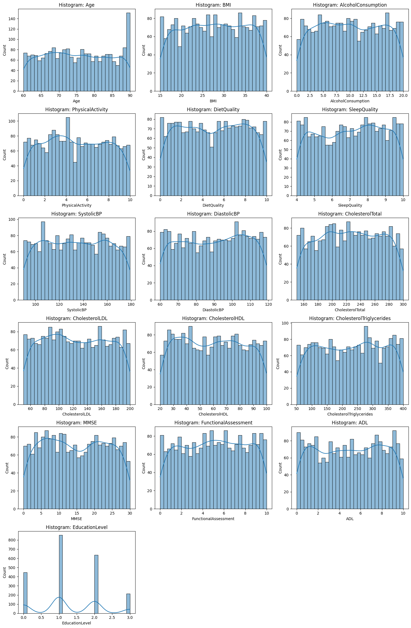
Figure 1. Representative histograms of continuous variables.

KDE Overlay by Diagnosis Group
To assess which continuous variables carry predictive signal, kernel density estimates (KDE) were plotted separately for Diagnosis = 0 (healthy) and Diagnosis = 1 (Alzheimer's). Most lifestyle and clinical variables show nearly identical distributions between groups. Three variables stand out with clear diagnostic separation: MMSE scores are substantially lower in the Alzheimer's group (concentrated near 0–10) versus healthy patients (broadly distributed up to 30); Functional Assessment and ADL scores follow the same pattern — Alzheimer's patients cluster toward lower functional scores. This visual separation foreshadows their dominance in the correlation analysis.
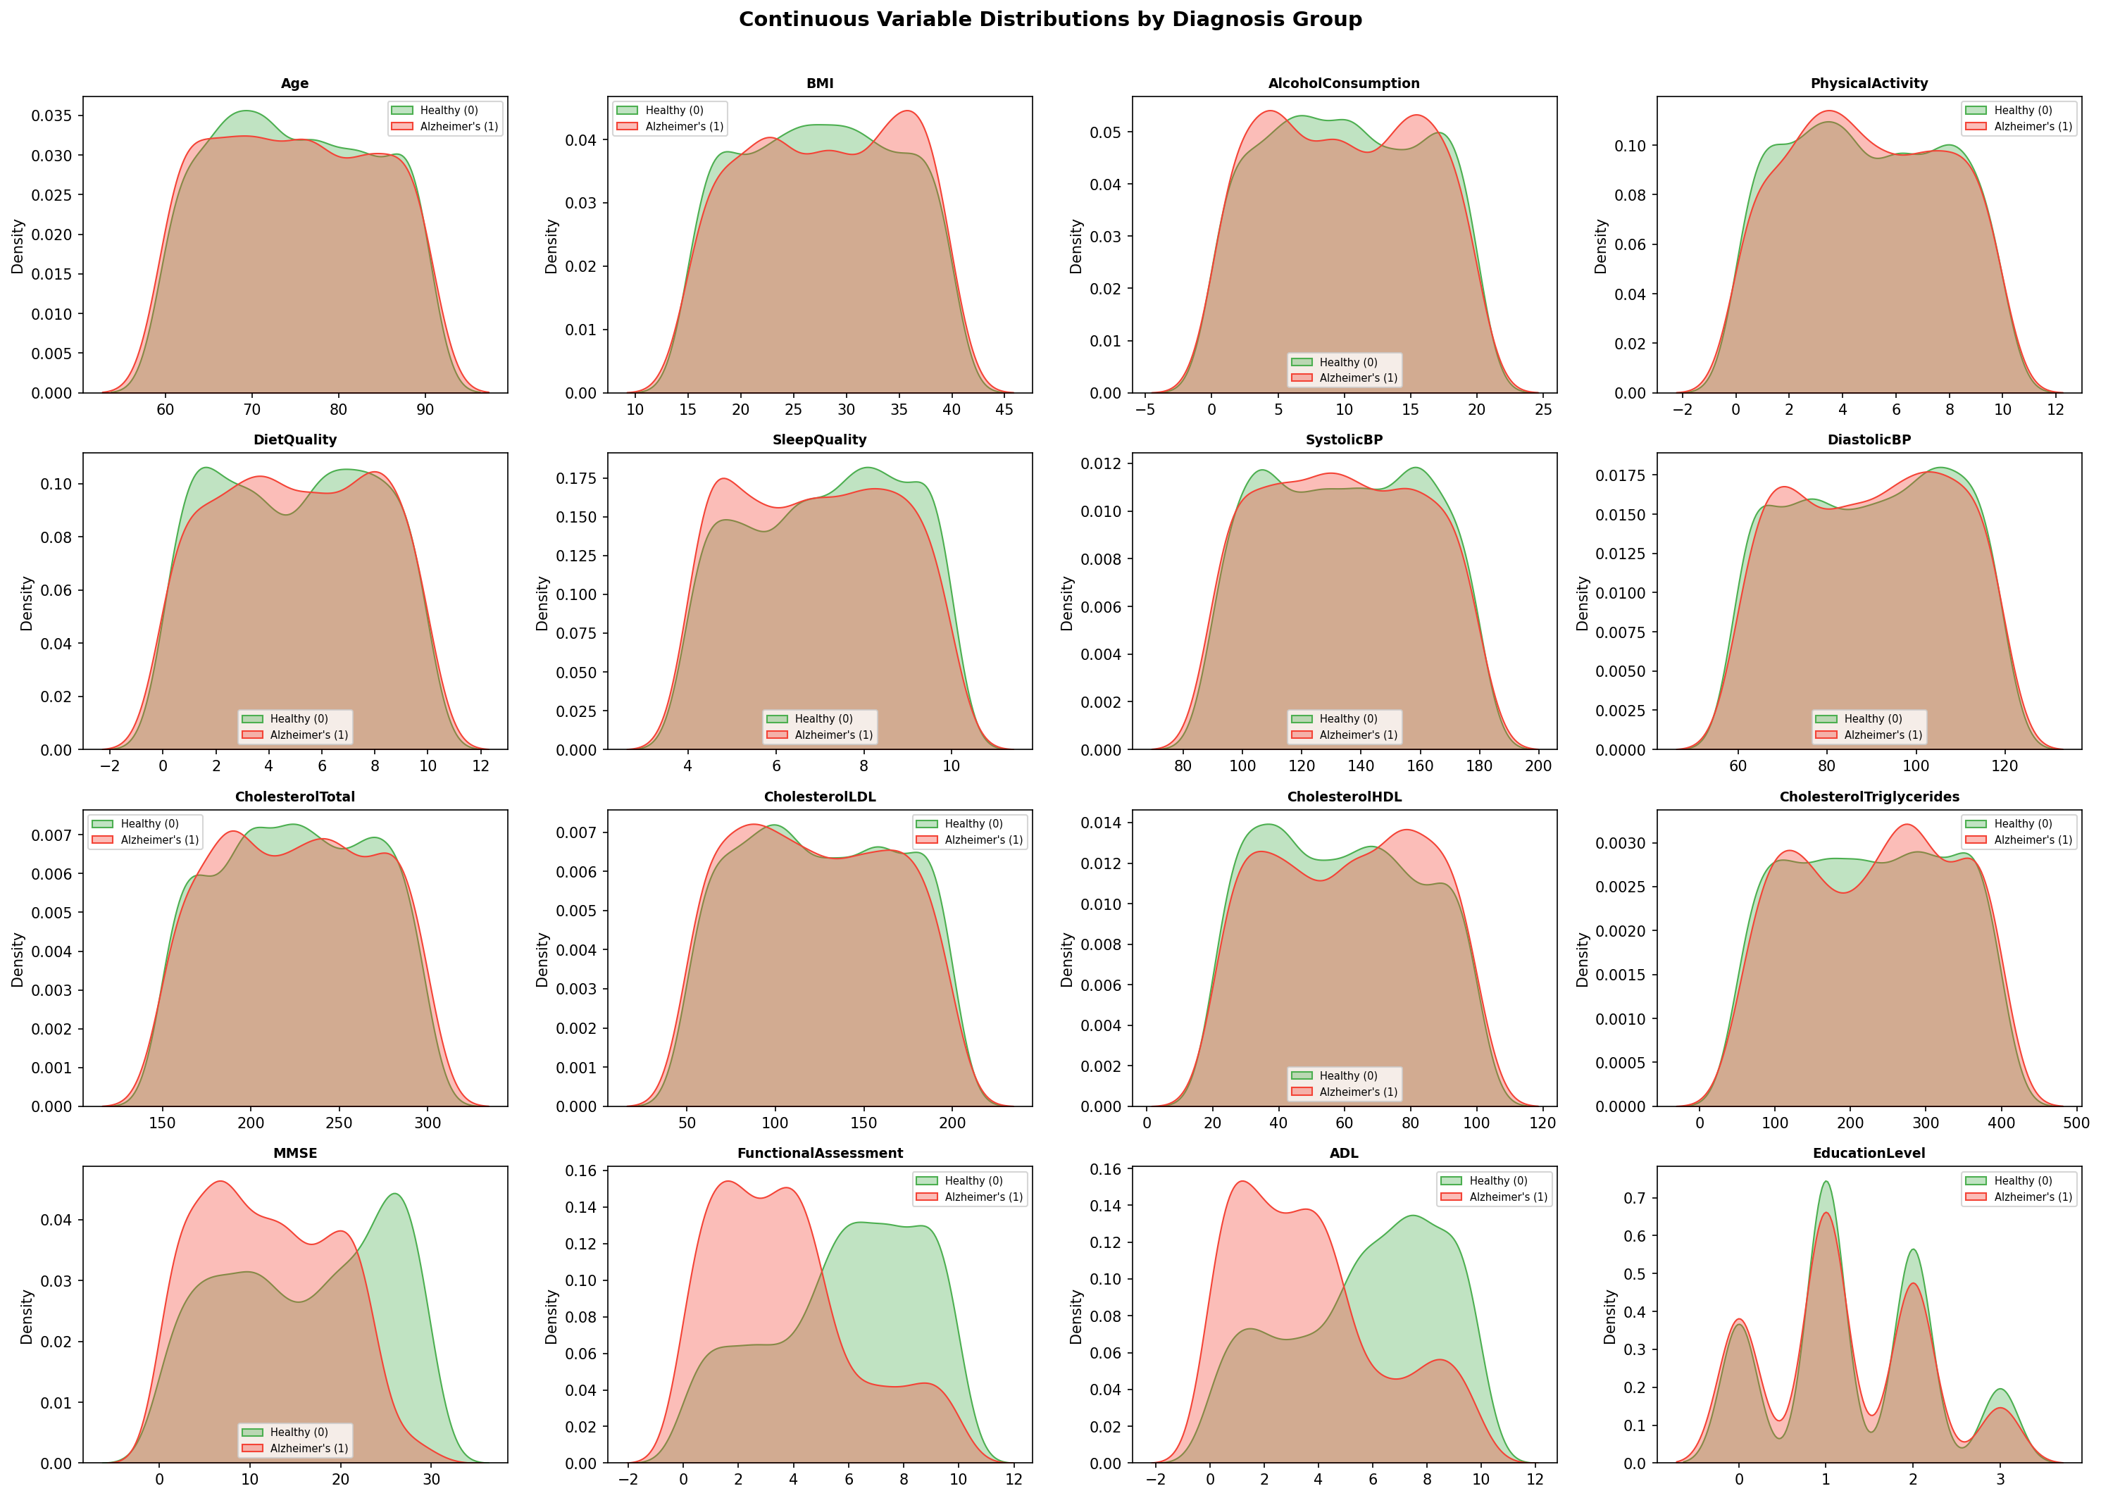
Figure 2. KDE overlay of continuous variables by diagnosis group. MMSE, Functional Assessment, and ADL show the clearest separation.

3. Categorical Variables
Categorical variables include binary medical history flags (smoking, diabetes, depression, family history of Alzheimer's, cardiovascular disease, hypertension, head injury) and symptom indicators (memory complaints, behavioral problems, confusion, disorientation, personality changes, difficulty completing tasks, forgetfulness), as well as ordinal/nominal variables Education Level and Ethnicity.

Binary Variables: Discrimination Gap
The plot below shows the difference in prevalence between Alzheimer's and healthy groups for each binary variable (P(var=1 | Alzheimer's) − P(var=1 | Healthy)). Memory Complaints and Behavioral Problems show the largest positive gaps — patients with Alzheimer's report these symptoms at substantially higher rates than healthy individuals, consistent with the clinical profile of the disease. Most demographic and medical history flags (smoking, family history, diabetes, cardiovascular disease) show differences near zero, indicating limited discriminatory value on their own.
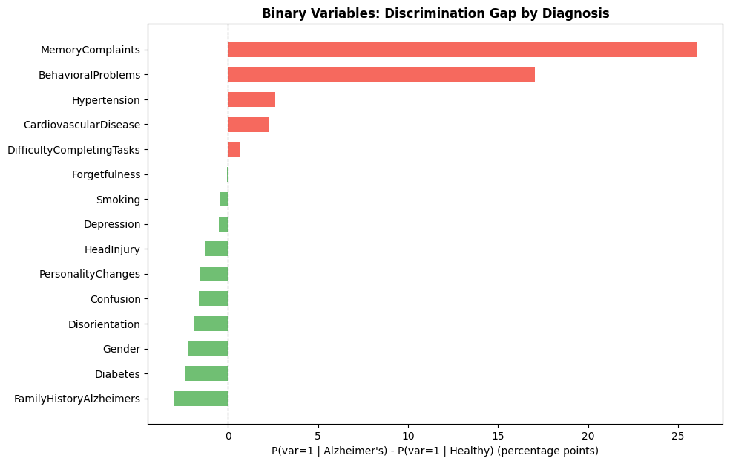
Figure 3. Discrimination gap for binary variables: P(var=1|Alzheimer's) − P(var=1|Healthy).

Categorical Variables: Alzheimer's Rate by Level

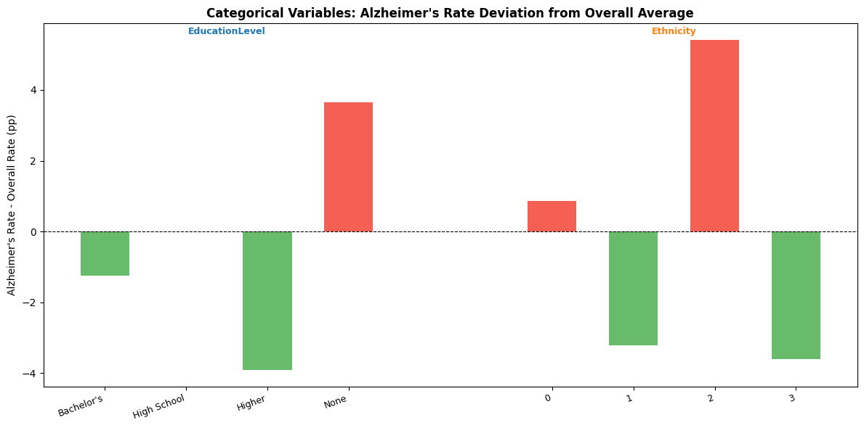
Figure 4. Alzheimer's rate deviation from the overall average (35.4%) by category level.

4. Correlation with Diagnosis
Pearson correlations between all features and Diagnosis confirm the visual patterns above. The five strongest correlates are:
Variable | Correlation | Interpretation
FunctionalAssessment | −0.365 | Lower daily function → more likely Alzheimer's
ADL | −0.332 | Lower daily living ability → more likely Alzheimer's
MemoryComplaints | +0.307 | Presence of complaints → more likely Alzheimer's
MMSE | −0.237 | Lower cognitive score → more likely Alzheimer's
BehavioralProblems | +0.224 | Presence of problems → more likely Alzheimer's

All remaining variables — including age, BMI, blood pressure, cholesterol, and all demographic variables — correlate with diagnosis at |r| < 0.06, effectively near zero. This is a critical finding: the dataset's predictive signal is almost entirely concentrated in cognitive/functional assessment scores and self-reported cognitive symptoms. Demographic and lifestyle variables show negligible association with diagnosis, which has important implications for model performance when these high-signal variables are excluded.

