Methods and Results: Decision Tree

Methods

Decision Tree
A Decision Tree (DT) is a supervised classification algorithm that recursively partitions the feature space by selecting, at each internal node, the feature and threshold that best separates the target classes. Classification is determined by traversing the tree from the root to a leaf, where the predicted label corresponds to the majority class of training samples in that leaf.
Hyperparameters were selected via 5-fold cross-validated grid search (GridSearchCV) optimising ROC-AUC over: maximum tree depth ∈ {2, 3, 5}, minimum samples per leaf ∈ {5, 10, 20}, and class weighting ∈ {None, 'balanced'}. Data were partitioned into training (70%) and test (30%) sets using stratified sampling. For No-LLE conditions, the raw (unscaled) feature matrix was passed to the DT; for LLE conditions, the scaled LLE-transformed matrix was used.
Two feature sets were evaluated. The full-variable dataset retained all 32 predictors including cognitive/functional assessments strongly correlated with diagnosis (FunctionalAssessment r = −0.365, ADL r = −0.332, MMSE r = −0.237). The risk-only dataset excluded all ten high-signal variables (MMSE, FunctionalAssessment, ADL, MemoryComplaints, BehavioralProblems, Confusion, Disorientation, PersonalityChanges, DifficultyCompletingTasks, Forgetfulness) to test classification using only upstream risk factors.

Results

Risk Assessment: No LLE + Decision Tree
Grid search selected: depth = 5, min_samples_leaf = 20, class_weight = 'balanced' (CV AUC = 0.496). Test-set ROC-AUC = 0.517, accuracy = 52.1%.
 | Precision | Recall | F1-score | Support
Healthy Individuals | 0.65 | 0.56 | 0.60 | 417
Alzheimer's patients | 0.36 | 0.46 | 0.40 | 228
Accuracy |  |  | 0.52 | 645
Macro Average | 0.51 | 0.51 | 0.50 | 645
Weighted Average | 0.55 | 0.52 | 0.53 | 645

Performance is near chance. The model captures 45.6% of Alzheimer's cases (recall 0.456) but at very low precision (0.360), so most positive predictions are false positives. An AUC of 0.517 is negligibly above the 0.50 random baseline. This confirms that the remaining risk-factor variables — age, BMI, blood pressure, cholesterol, lifestyle factors, and binary medical history flags — carry no meaningful collective discriminatory signal for Alzheimer's classification.
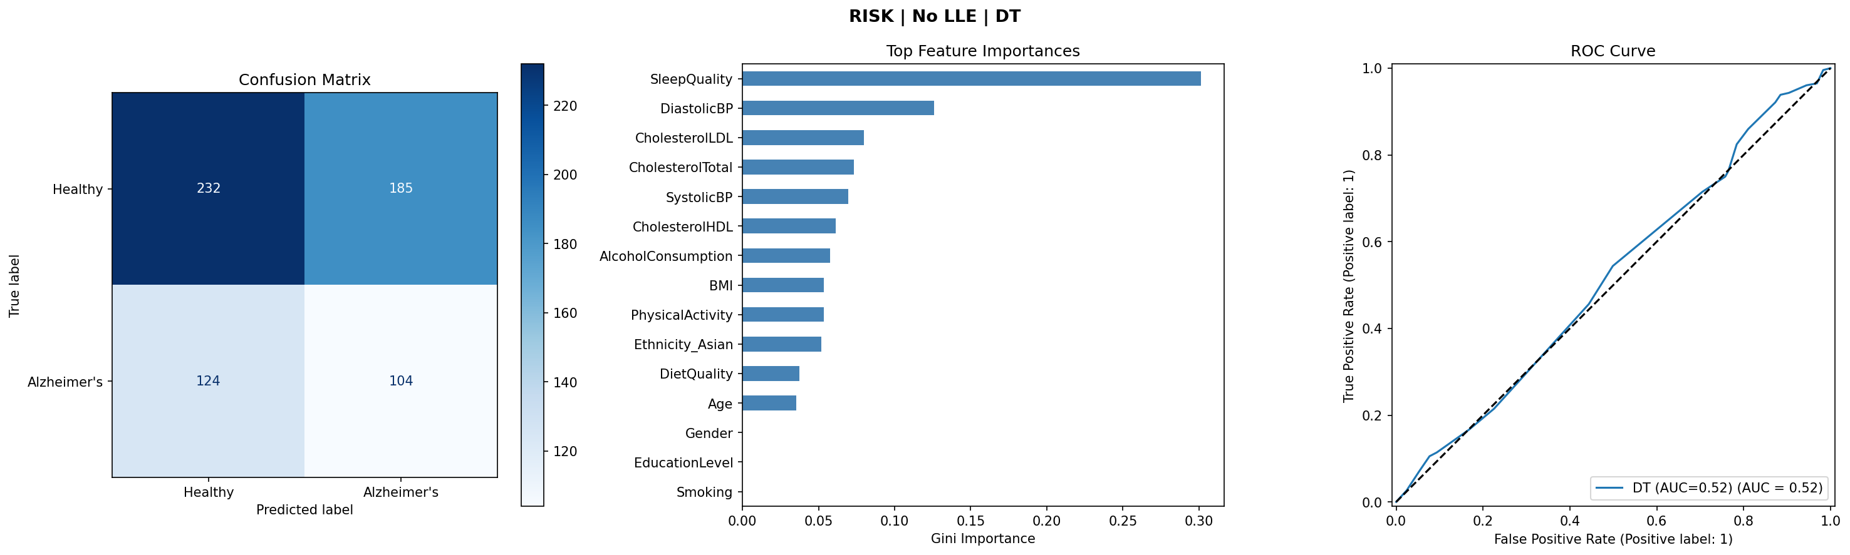
Figure 1. Risk-only, No LLE + DT: confusion matrix, feature importances, and ROC curve.

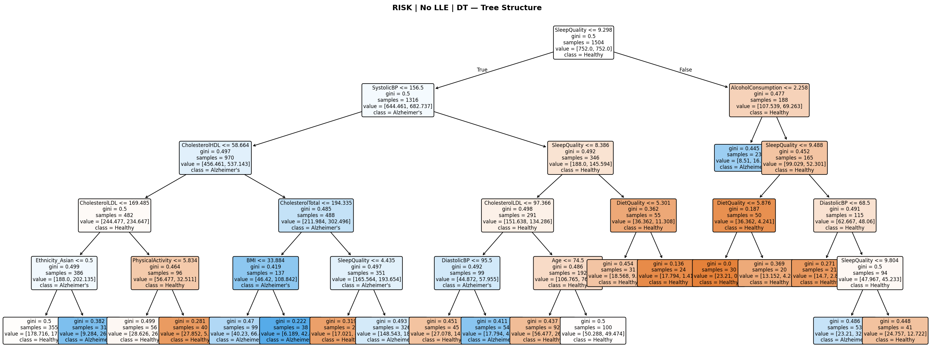
Figure 2. Decision tree structure — Risk-only, No LLE + DT.
The tree structure reflects the model's inability to find principled separation. The root splits on SystolicBP — a variable with near-zero correlation to diagnosis — and subsequent splits descend through AlcoholConsumption, CholesterolHDL, PhysicalActivity, SleepQuality, and Ethnicity_Asian, none of which provide strong discriminatory signal. Nearly every internal node retains a Gini impurity near 0.45–0.49, indicating the two classes remain almost equally mixed at each split. Leaf nodes are similarly impure, visually confirming the near-chance AUC.

Risk Assessment: LLE + Decision Tree
Grid search selected: depth = 3, min_samples_leaf = 5, class_weight = None (CV AUC = 0.551). Test-set ROC-AUC = 0.523, accuracy = 64.7%.
 | Precision | Recall | F1-score | Support
Healthy Individuals | 0.65 | 0.99 | 0.78 | 417
Alzheimer's patients | 0.50 | 0.01 | 0.02 | 228
Accuracy |  |  | 0.65 | 645
Macro Average | 0.57 | 0.50 | 0.40 | 645
Weighted Average | 0.59 | 0.65 | 0.51 | 645

The 64.7% accuracy is degenerate — the model classifies virtually every patient as Healthy (recall for Alzheimer's = 0.009, meaning only 2 of 228 Alzheimer's patients were correctly identified). GridSearchCV selected class_weight = None, allowing the model to ignore the minority class entirely and exploit the 64.6% healthy base rate. The AUC of 0.523 confirms no real discriminatory ability. LLE applied to the already low-signal risk features did not recover meaningful manifold structure; the classification problem remains near-random regardless of dimensionality reduction.
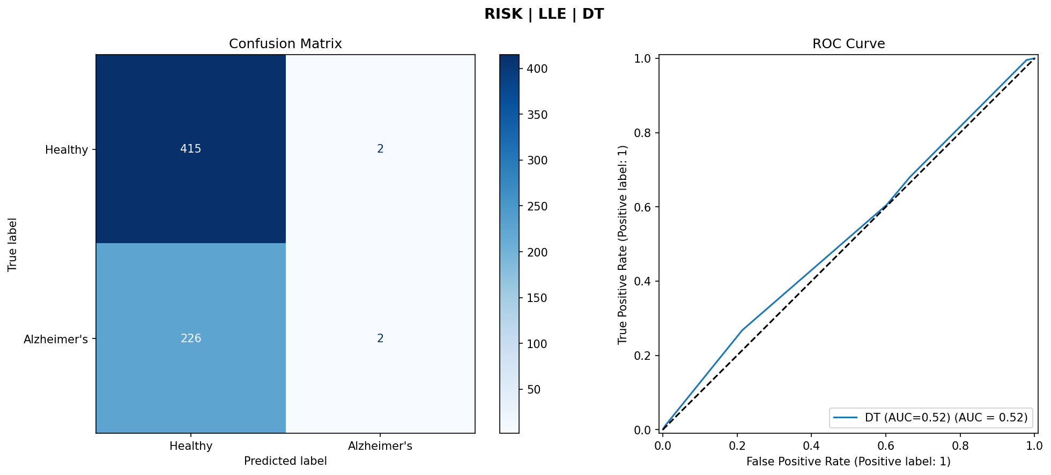
Figure 3. Risk-only, LLE + DT: confusion matrix and ROC curve.

Full Variables: No LLE + Decision Tree
Grid search selected: depth = 5, min_samples_leaf = 10, class_weight = 'balanced' (CV AUC = 0.945). Test-set ROC-AUC = 0.938, accuracy = 93.8%.
 | Precision | Recall | F1-score | Support
Healthy Individuals | 0.95 | 0.95 | 0.95 | 417
Alzheimer's patients | 0.91 | 0.91 | 0.91 | 228
Accuracy |  |  | 0.94 | 645
Macro Average | 0.93 | 0.93 | 0.93 | 645
Weighted Average | 0.94 | 0.94 | 0.94 | 645

Both classes classified with high and balanced precision and recall (≥ 0.91), with a weighted F1-score of 0.94. This result is attributable to the inclusion of FunctionalAssessment, MMSE, and ADL, which are strongly correlated with diagnosis and function as clinical proxies for Alzheimer's status. While impressive, this condition has limited practical value: the high-signal variables require clinical assessment and are themselves diagnostic indicators rather than upstream risk factors.
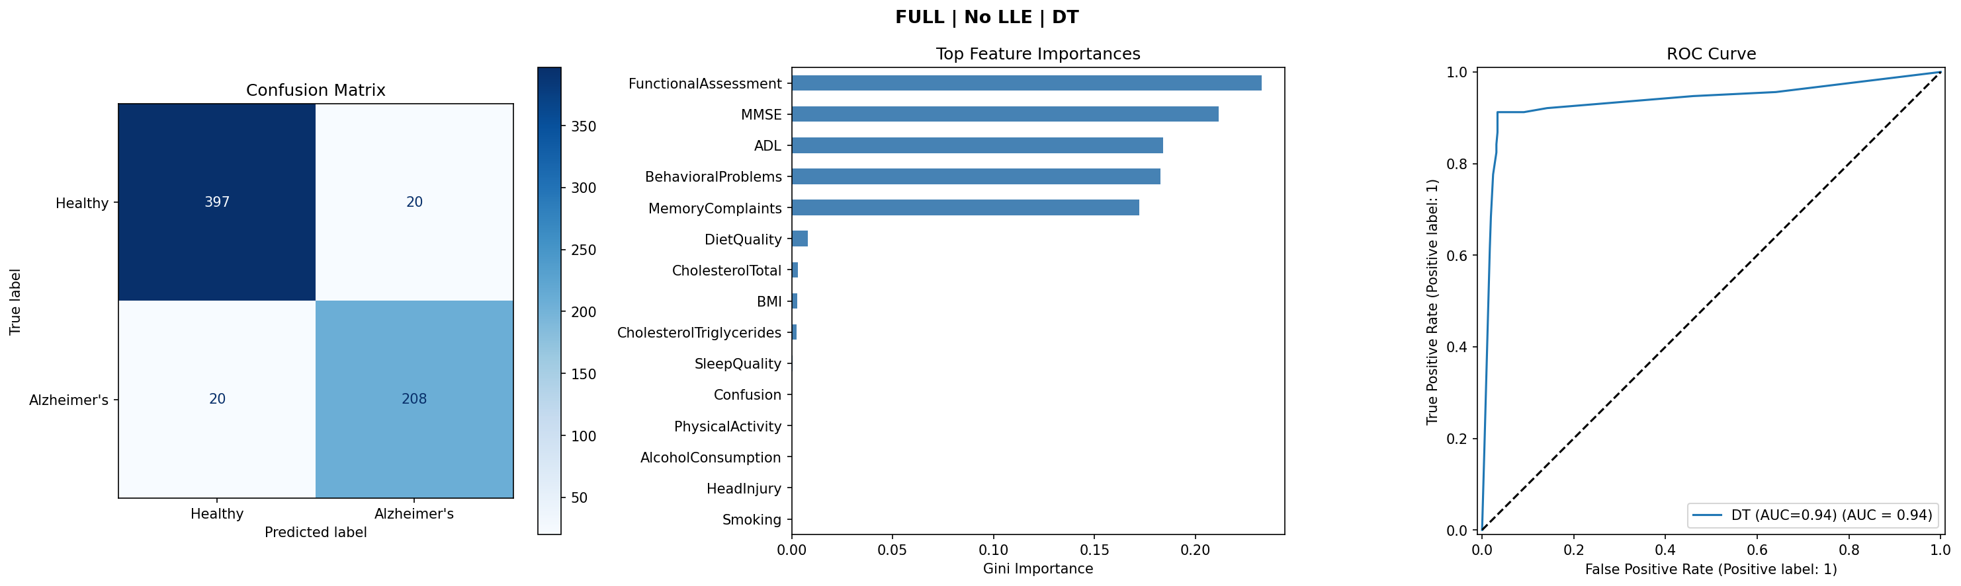
Figure 4. Full variables, No LLE + DT: confusion matrix, feature importances, and ROC curve.

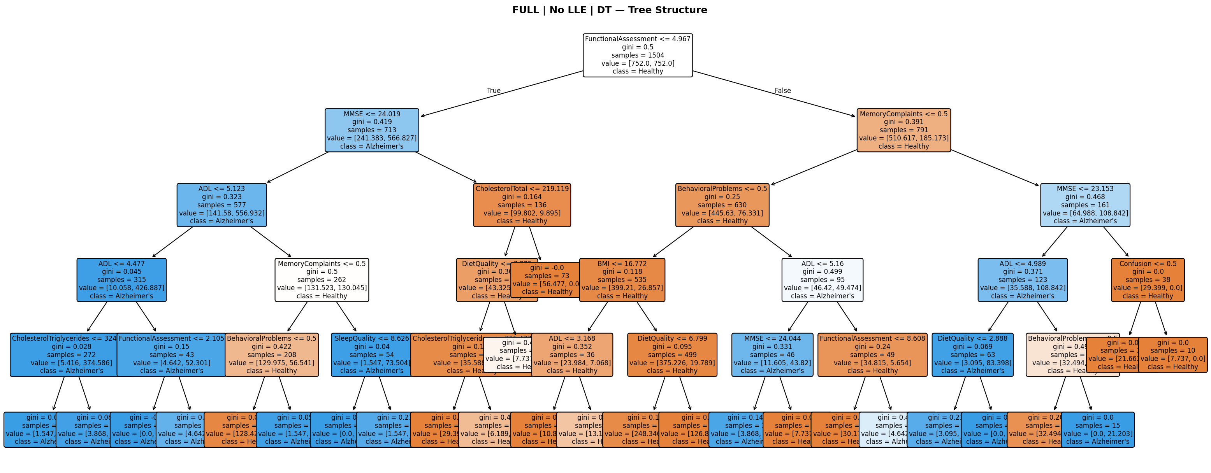
Figure 5. Decision tree structure — Full variables, No LLE + DT.
The root splits on FunctionalAssessment (the strongest predictor, r = −0.365) and the second level immediately uses MMSE. Patients with low FunctionalAssessment are rapidly routed into near-pure Alzheimer's leaves within two to three splits. Gini impurity drops sharply from root (~0.43) toward near-zero at most leaves. The majority of leaf nodes are near-pure blue (Healthy) or orange (Alzheimer's), and the path 'low FunctionalAssessment AND low MMSE → Alzheimer's' is directly readable from the diagram — clinically coherent and matching known diagnostic knowledge.

Full Variables: LLE + Decision Tree
Grid search selected: depth = 3, min_samples_leaf = 20, class_weight = 'balanced' (CV AUC = 0.644). Test-set ROC-AUC = 0.614, accuracy = 66.5%.
 | Precision | Recall | F1-score | Support
Healthy Individuals | 0.68 | 0.92 | 0.78 | 417
Alzheimer's patients | 0.58 | 0.20 | 0.29 | 228
Accuracy |  |  | 0.67 | 645
Macro Average | 0.63 | 0.56 | 0.54 | 645
Weighted Average | 0.64 | 0.67 | 0.61 | 645

LLE applied to the full dataset substantially degraded performance despite the rich input. Recall for Alzheimer's patients dropped to 0.197, meaning four out of five Alzheimer's patients were missed, while recall for healthy individuals rose to 0.921. The AUC of 0.614 is higher than the risk-only LLE condition (0.523), confirming that some signal from the full feature set survives LLE compression — but far less than the no-LLE baseline (0.938). LLE's neighborhood-based embedding appears to destroy the fine-grained linear boundaries provided by FunctionalAssessment and MMSE, folding high-signal dimensions into a 5-component manifold that blurs the class boundary.
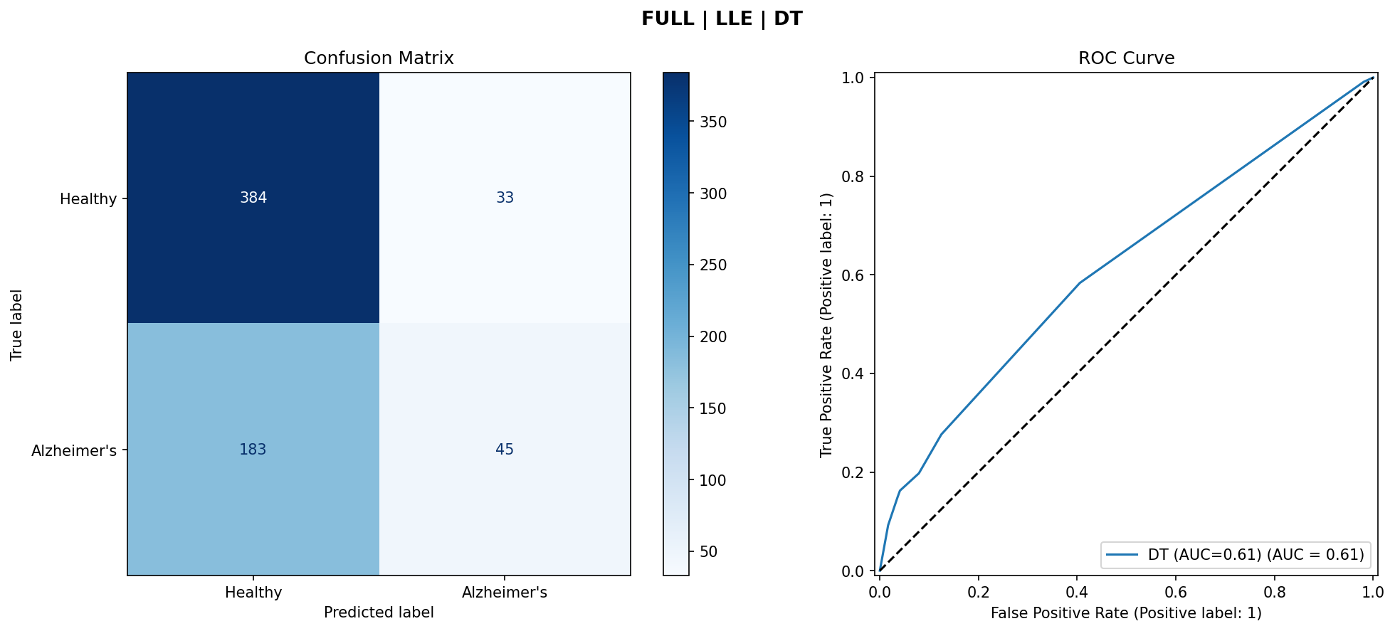
Figure 6. Full variables, LLE + DT: confusion matrix and ROC curve.

Summary
Table 5 summarises all four Decision Tree conditions.
Condition | Best Params (depth|leaf|cw) | Accuracy | Sensitivity | Specificity | ROC-AUC
Risk-only, No LLE + DT | 5 | 20 | balanced | 0.521 | 0.456 | 0.556 | 0.517
Risk-only, LLE + DT | 3 | 5 | None | 0.647 | 0.009 | 0.995 | 0.523
Full Variables, No LLE + DT | 5 | 10 | balanced | 0.938 | 0.912 | 0.952 | 0.938
Full Variables, LLE + DT | 3 | 20 | balanced | 0.665 | 0.197 | 0.921 | 0.614

The results reveal a consistent pattern: the full-variable model without LLE achieves near-perfect classification (AUC = 0.938) driven entirely by cognitive assessment variables. LLE degrades performance in both feature sets — collapsing Alzheimer's sensitivity to near zero in the risk-only condition and halving AUC in the full-variable condition. Risk-only models perform near chance regardless of LLE (AUC 0.517–0.523), confirming that demographic, lifestyle, and medical history variables in this dataset lack sufficient signal for reliable Alzheimer's classification.

