1. Data & Preprocessing

Where the Data Comes From
For this project, we used the Alzheimer’s Disease Patient Dataset published by Globose Technology Solutions, which we accessed through Kaggle. The dataset contains 2,149 patient records and 32 columns covering demographic information, lifestyle factors, medical history, clinical measurements, cognitive assessments, symptoms, and a binary Alzheimer’s diagnosis label. Of the 2,149 patients, roughly 35.4% (759) have a positive Alzheimer’s diagnosis and 64.6% (1,390) are healthy controls, giving us a moderately imbalanced classification problem. We selected this dataset because it pairs risk factors (e.g., lifestyle, cardiovascular disease, family history) with cognitive and functional symptoms in the same record, allowing us to model both early risk factors and clinical presentation within a single supervised learning framework.

Key Variables
The dataset contains 32 variables organized into five conceptual groups, as summarized in Table 1 below.
Variables (32) | Demographics (categorical): PatientID, Age, Gender, Ethnicity, EducationLevel
 | Lifestyle Factors: BMI, Smoking, AlcoholConsumption, PhysicalActivity, DietQuality, SleepQuality
 | Medical History (categorical): FamilyHistoryAlzheimers, CardiovascularDisease, Diabetes, Depression, HeadInjury, Hypertension
 | Clinical Measurements: SystolicBP, DiastolicBP, CholesterolTotal, CholesterolLDL, CholesterolHDL, CholesterolTriglycerides
 | Cognitive & Functional Assessments: MMSE, FunctionalAssessment, MemoryComplaints, BehavioralProblems, ADL
 | Symptoms: Confusion, Disorientation, PersonalityChanges, DifficultyCompletingTasks, Forgetfulness
Outcome | Diagnosis (binary, 0 = healthy, 1 = Alzheimer's)
Table 1. Variable groups in the Alzheimer's dataset.

Categorical variables
- Binary: (0/1 coded, n = 16): Gender, Smoking, FamilyHistoryAlzheimers, CardiovascularDisease, Diabetes, Depression, HeadInjury, Hypertension, MemoryComplaints, BehavioralProblems, Confusion, Disorientation, PersonalityChanges, DifficultyCompletingTasks, Forgetfulness.
- Non-binary: Ethnicity (4 categories), EducationLevel (5 ordinal levels).
Continuous variables (n = 15): Age, BMI, AlcoholConsumption, PhysicalActivity, DietQuality, SleepQuality, SystolicBP, DiastolicBP, CholesterolTotal, CholesterolLDL, CholesterolHDL, CholesterolTriglycerides, MMSE, FunctionalAssessment, and ADL.

Distributions by Diagnosis Group
Figure 1 shows side-by-side boxplots for all 15 continuous predictors grouped by diagnosis. Three variables stand out with clear distributional separation: MMSE, FunctionalAssessment, and ADL. Alzheimer's patients score markedly lower on all three — the MMSE median is 11.6 for Alzheimer's patients versus 17.1 for healthy controls, and FunctionalAssessment and ADL medians are approximately 3.3 versus 6.2 — and the interquartile ranges barely overlap. All remaining continuous variables (Age, BMI, blood pressure, cholesterol measures, and lifestyle scores) show near-identical distributions across the two groups, with boxes almost completely overlapping and medians differing by fewer than 3 units. These three cognitive/functional variables are therefore the primary continuous predictors of Alzheimer's diagnosis in this dataset.
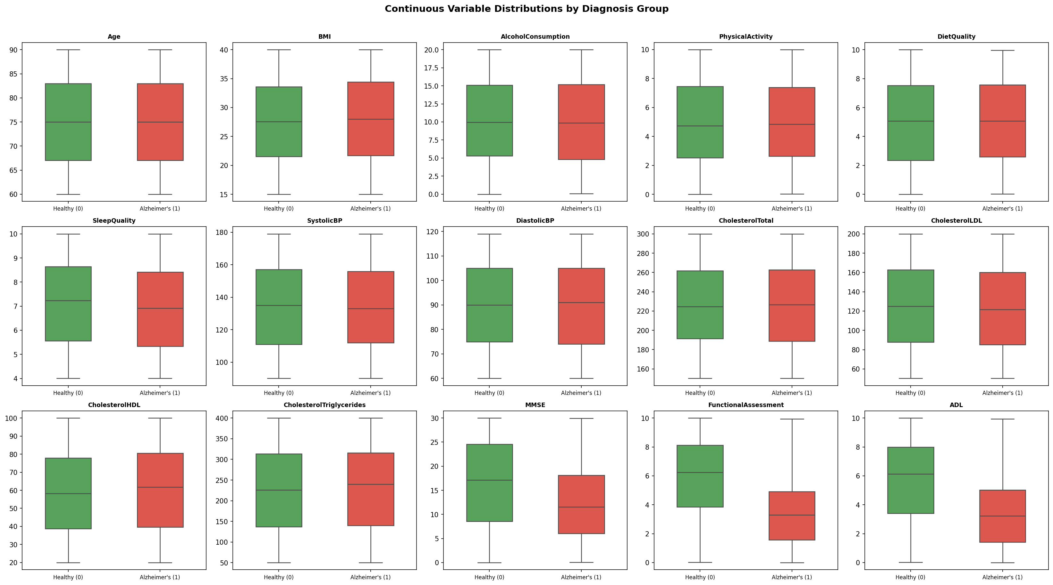
Figure 1. Boxplots of continuous variables by diagnosis group (green = Healthy, red = Alzheimer's).
Figure 2 shows the prevalence of each binary predictor by diagnosis group. Only two variables exhibit meaningful between-group differences: MemoryComplaints (11.6% in healthy controls vs. 37.6% in Alzheimer's patients, a +26 percentage-point gap) and BehavioralProblems (9.6% vs. 26.7%, +17 pp). All other binary variables — including lifestyle flags (Smoking), medical history (FamilyHistoryAlzheimers, CardiovascularDisease, Diabetes, Hypertension), and notably Forgetfulness — show prevalence differences of 3 percentage points or less, indicating they carry little discriminative signal for Alzheimer's diagnosis.
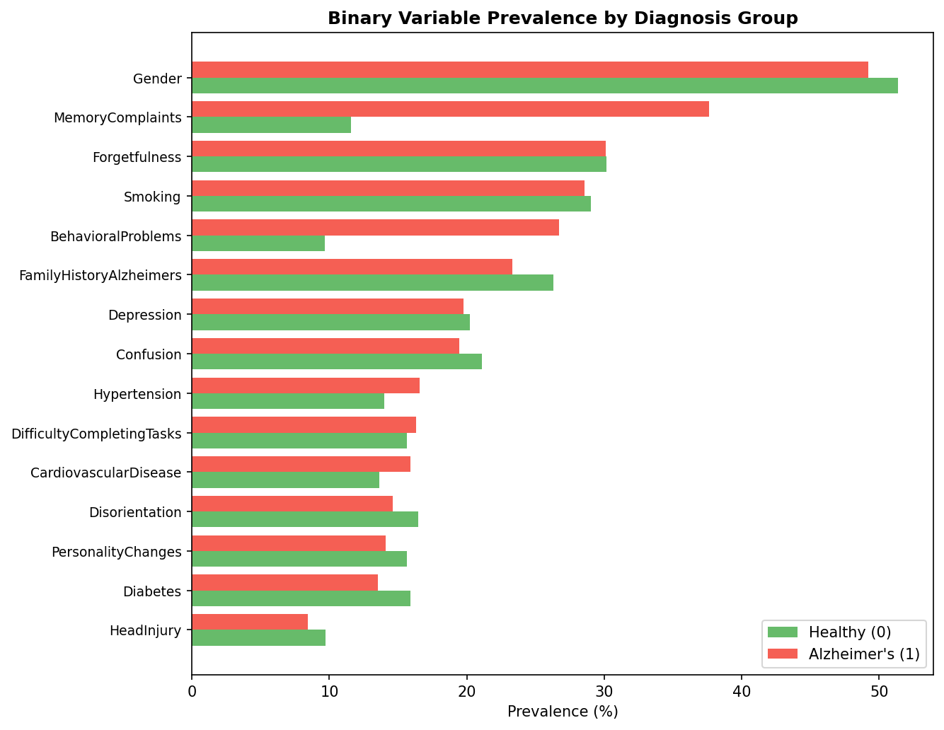
Figure 2. Binary variable prevalence by diagnosis group (green = Healthy, red = Alzheimer's).
A correlation analysis with Diagnosis confirmed that the strongest predictors are exactly the cognitive/symptom variables: FunctionalAssessment (r = −0.36), ADL (r = −0.33), MMSE (r = −0.24), MemoryComplaints (r = 0.31), and BehavioralProblems (r = 0.22). All other variables, including demographic and lifestyle factors, showed correlations below |0.06| with the target.

Cleaning and Preprocessing
Fortunately, the dataset is already very clean. We confirmed that there are no missing values in any column, so no imputation was required. We dropped two columns that carried no predictive information: PatientID (a row identifier) and DoctorInCharge (a constant placeholder string). All categorical variables are already dummy-coded as integers, so no additional one-hot encoding was needed.
We inspected the continuous variables for outliers using the IQR rule (values below Q1 − 1.5·IQR or above Q3 + 1.5·IQR). The proportion of out-of-range values was negligible across all features, and the histograms showed approximately uniform or symmetric distributions for the continuous variables, so we kept all rows rather than deleting samples.
For the LLE-based pipelines, we applied StandardScaler (mean = 0, SD = 1) to the continuous variables only (Age, BMI, AlcoholConsumption, PhysicalActivity, DietQuality, SleepQuality, blood pressure, cholesterol, MMSE, FunctionalAssessment, ADL), leaving binary indicators on their original 0/1 scale. For the plain decision-tree pipeline, no scaling was applied because tree splits are scale-invariant.
Finally, because several cognitive variables function as symptoms rather than independent risk factors, we ran our models on three feature sets: (1) the full dataset, (2) the dataset with the five strongest symptom predictors removed (MMSE, FunctionalAssessment, MemoryComplaints, BehavioralProblems, ADL), and (3) the dataset with all 10 cognitive/symptom variables removed, allowing us to evaluate whether the model is predicting Alzheimer’s risk or simply reconstructing the clinical diagnosis. All splits used a 70/30 train/test split, stratified by Diagnosis with random_state = 42 for reproducibility.

