1.移动到最左

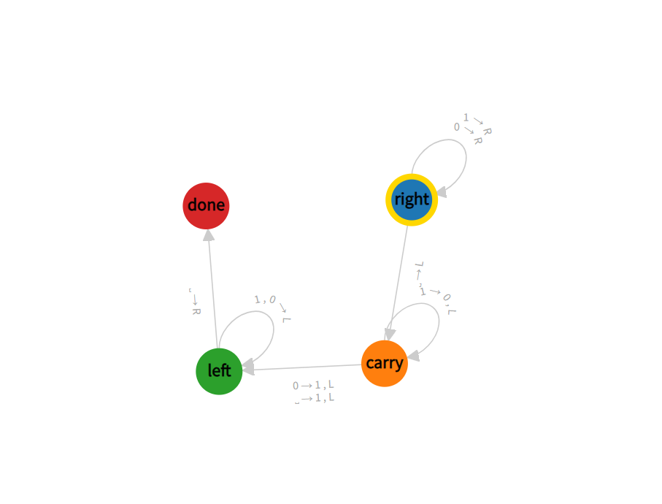

input: '111111'

blank: ' '

start state: right

table:

#scan to the rightmost digit

right:

1 : R

0 : R

' ': {L: carry}

carry:

1 : {write: 0,L: carry}

0 : {write: 1,L: left}

' ': {write: 1,L: left}

left:

[1,0]: {L: left}

' ' : {R: done}

done:

2.加2

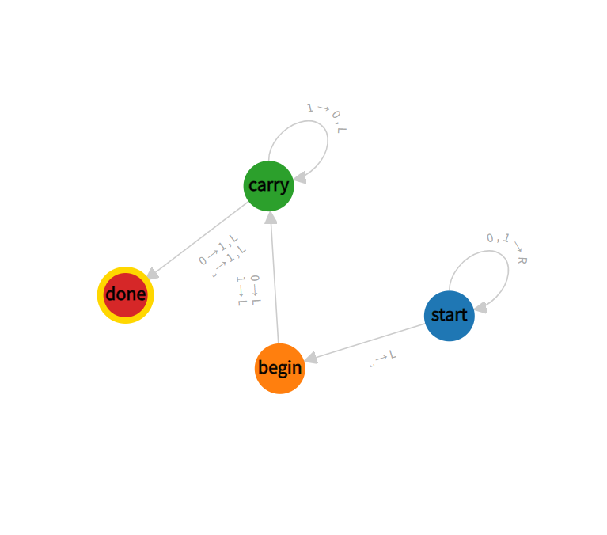

input: '11111'

blank: ' '

start state: start

table:

start:

[0,1]: R

' ': {L: begin}

begin:

0: {L: carry}

1: {L: carry}

carry:

0 : {write: 1, L: done}

' ' : {write: 1, L: done}

1 : {write: 0, L}

done:

3.减1

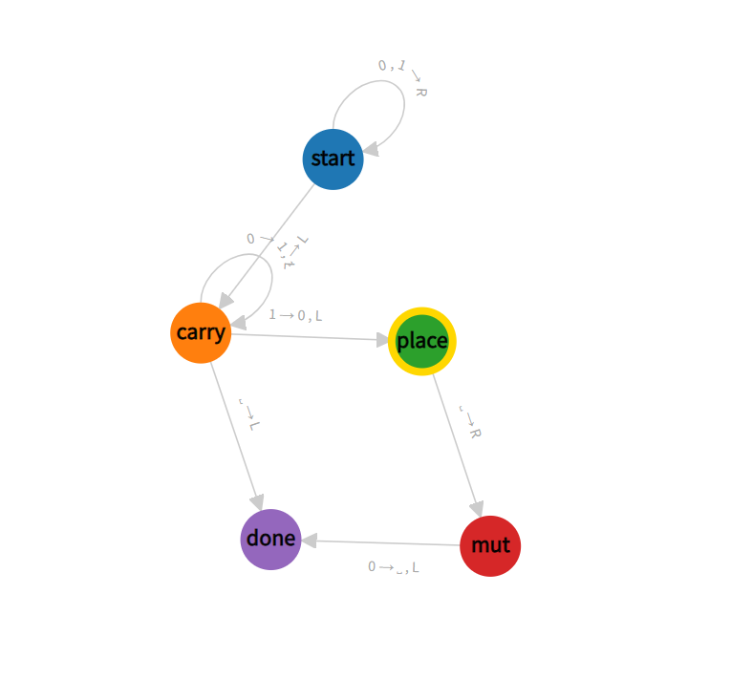

input: '11000'

blank: ' '

start state: start

table:

start:

[0,1]: R

' ': {L: carry}

carry:

1: {write: 0,L: place}

0: {write: 1,L: carry}

' ': {L: done}

place:

' ': {R: mut}

mut:

0: {write: ' ',L: done}

done: