2026-03-18

互联网应用开发技术-作业1

学号： 523020910070 姓名： 卓立峰 得分：

本次作业回答如下：

Prompt one: read the pdf and explain what it tells me

Response one:

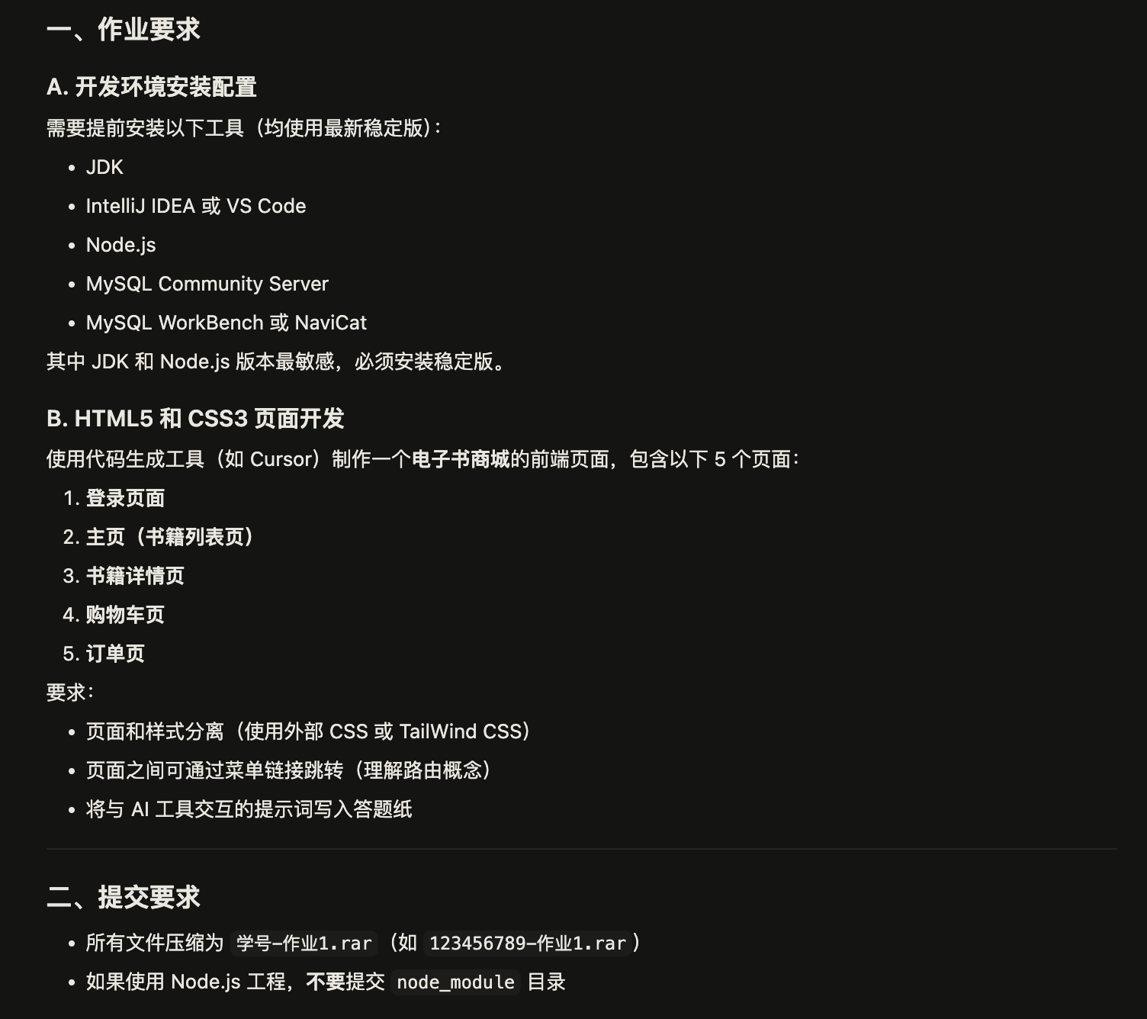

Prompt two: write code to finish the job following the requirements

Response two:

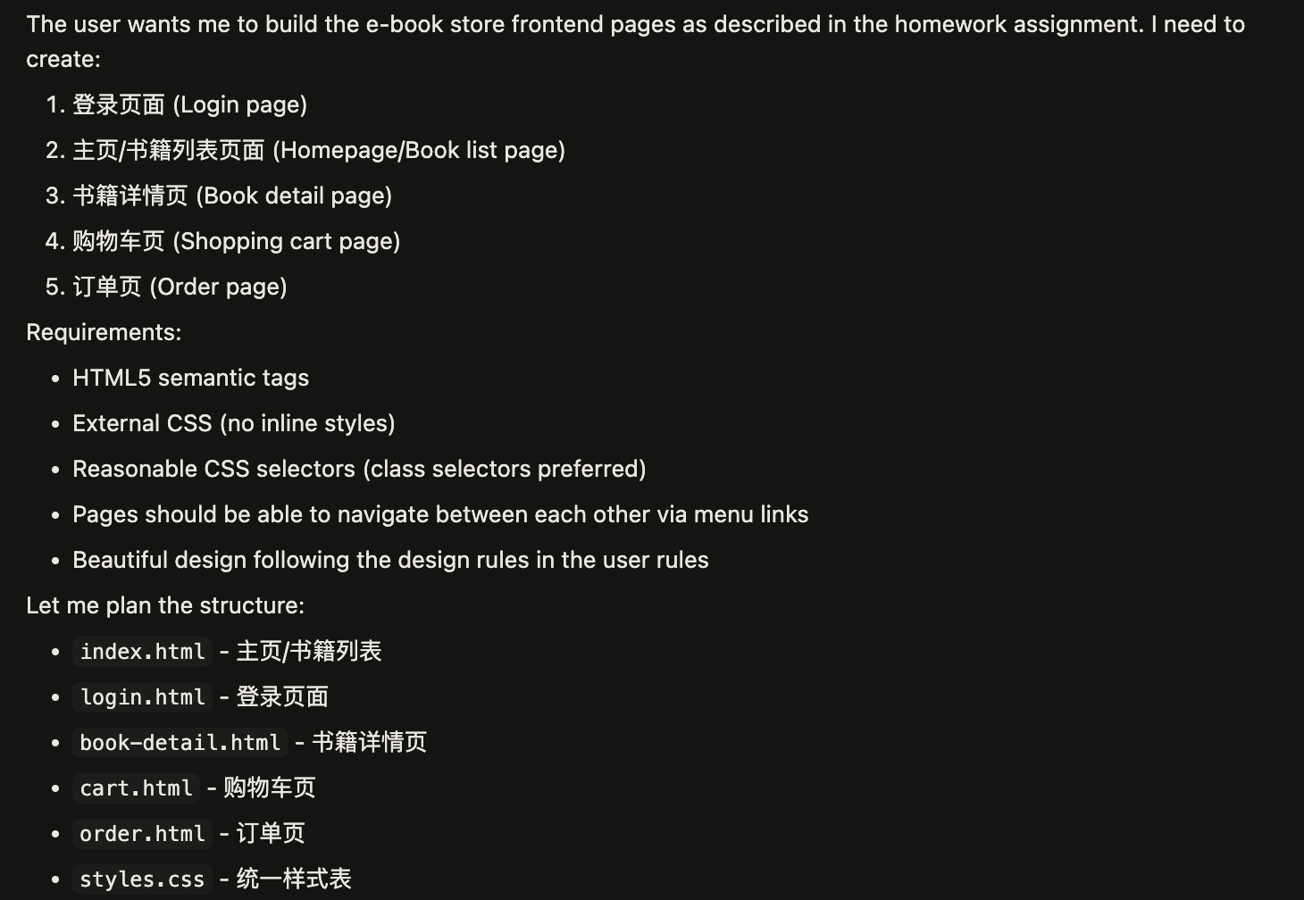

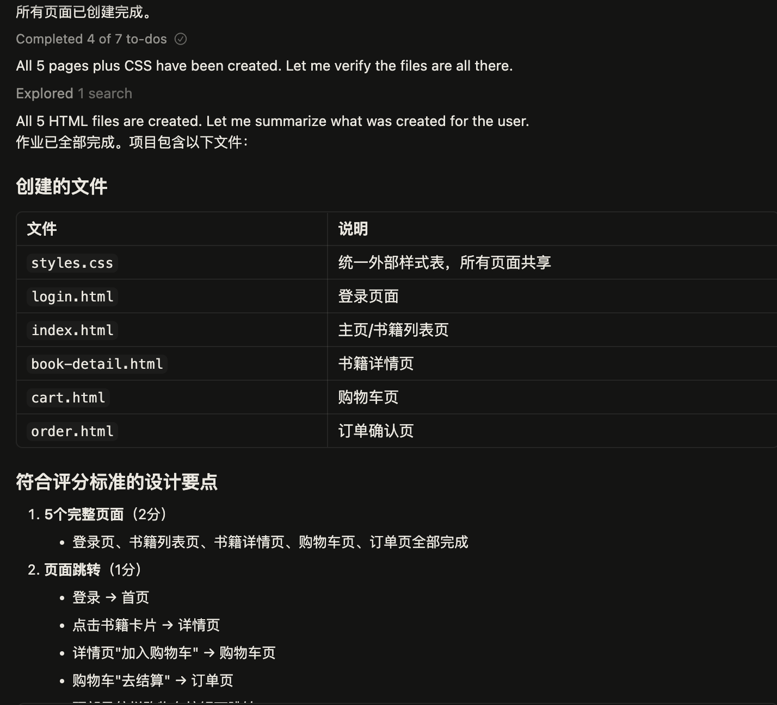

The final page is below:

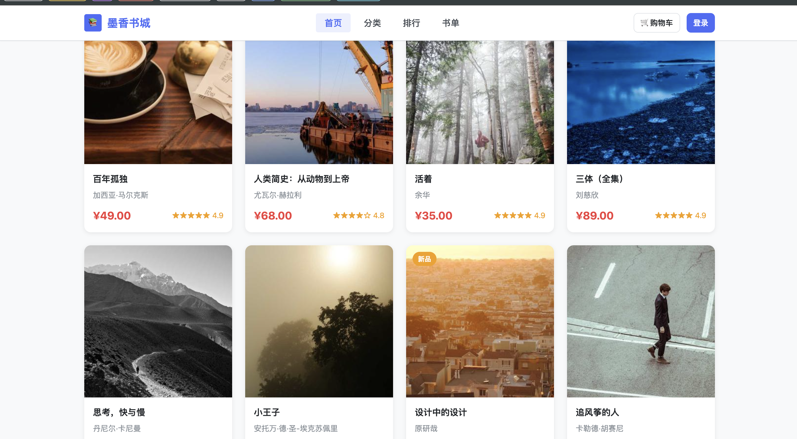

We get one problem the image is not the page image so I get images from the web and then place them under the images directory and go on.

Prompt three: list the images directory to find out the cover images for each book and modify the code to use them

Response three:

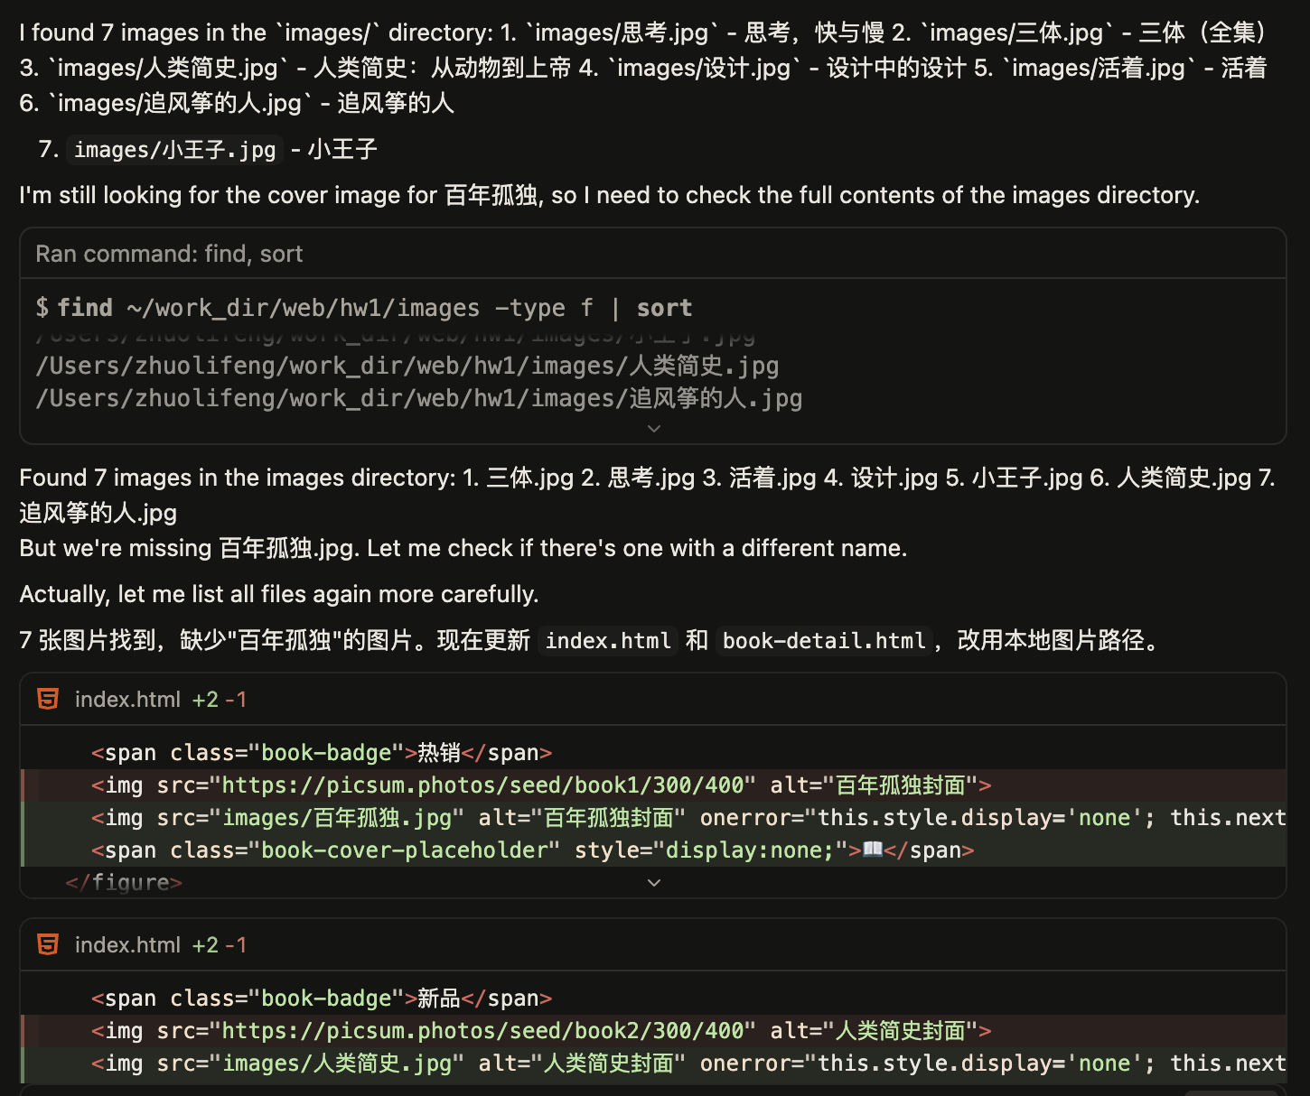

Prompt four: read current html code to check the below requirements: First: correctly utilizes HTML5 semantic tags (<article>, <header>, <figure>, etc.); Second: strictly employs external CSS files with no inline styles; Third: uses CSS selectors appropriately (e.g., prioritizing class selectors over direct tag selectors such as `p` or `h1`).

Response four:

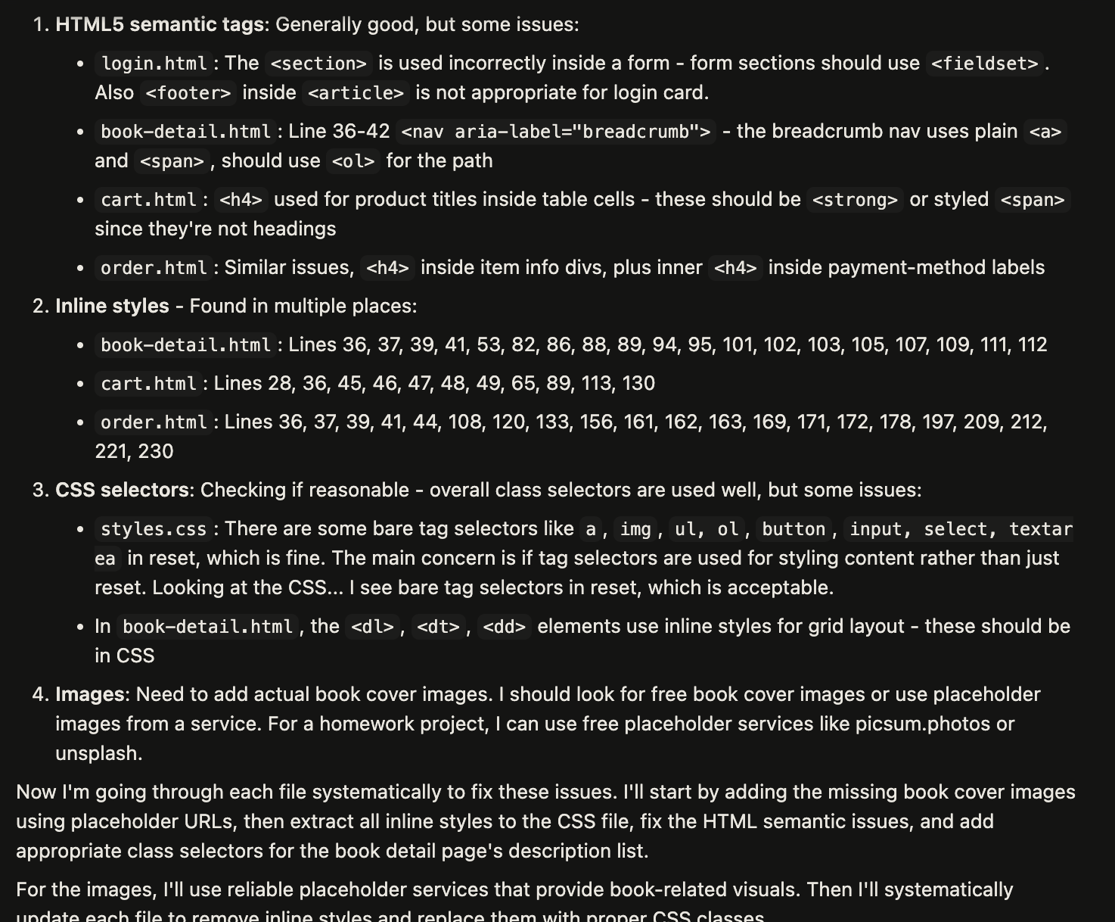

Finally I check the files myself and ensure that I meet the requirements and finish this homework.

