**[Labor’s real value-added vs stock market performance: Long-term Signal](https://fred.stlouisfed.org/graph/?g=1iTKv)**

* Real value-added output = the output produced that has been adjusted for changes in inventory (gross output) and the removal of intermediate inputs (energy, material, and services).

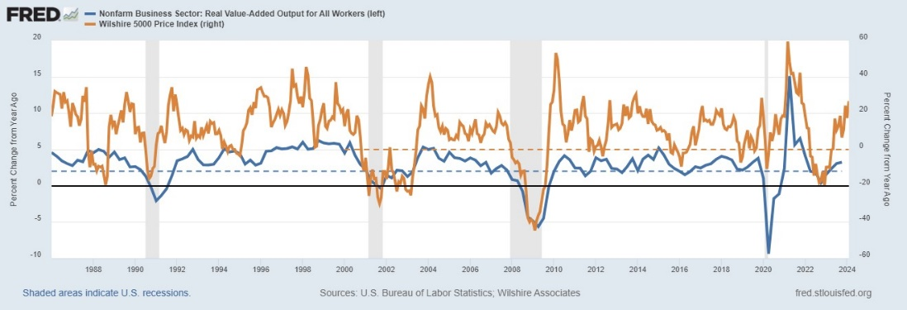

*If the real output growth from labor stays at or above 2%, the economy pie is growing bigger (expansion), that benefits U.S. workers and drives up consumptions. Thus, stock market should be trending higher (than last year).*

[**Labor Wage and Productivity**](https://fred.stlouisfed.org/graph/?g=1iSBY)**:**

* Productivity = real GDP / total # of hours
* Hourly wage scaled by CPI (consumers’ purchasing power) vs. Hourly wage scaled by PPI / GDP price deflator (businesses assess how to allocate resources to factors of production (i.e. capital, intermediates, commodities)

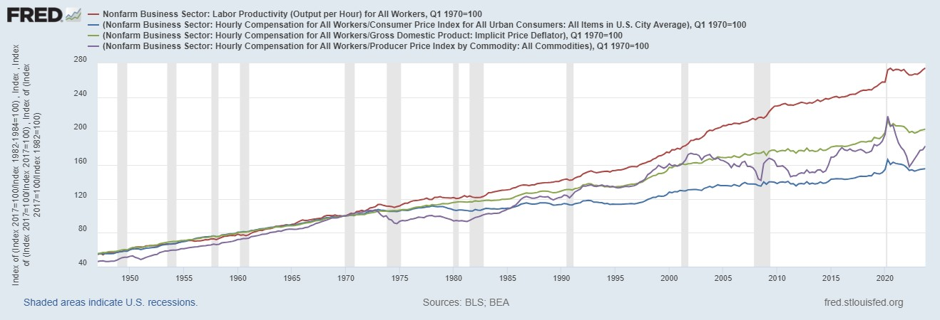

*US workers only partially benefitted from the increases in their productivity since the 1970s, as the labor productivity (real GDP/# hours, red) is diverging from the real pay.*

**[Labor Supply x Demand:](https://fred.stlouisfed.org/graph/?g=1iTSU)**

* Supply = Civilian Labor Force Level vs. Demand = Employment Level + Job Openings

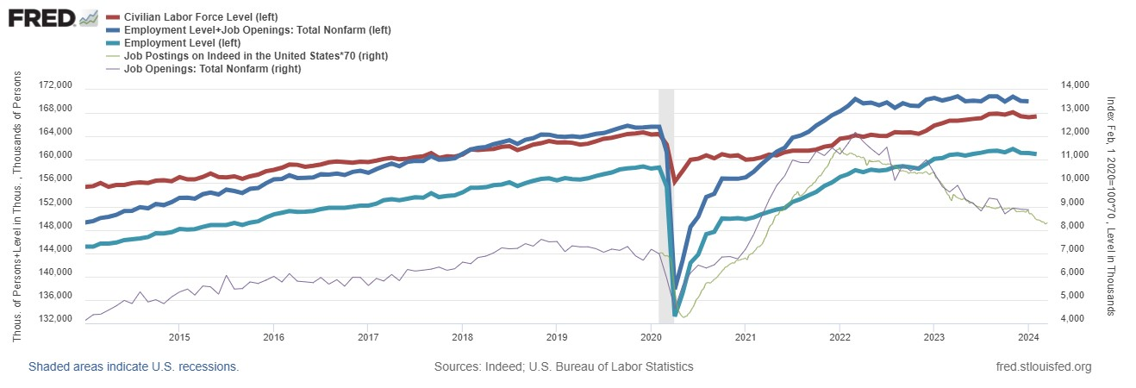

*There’s labor shortage as demand(blue) > supply(red), creating upward wage pressure, despite its dwindling recently.*

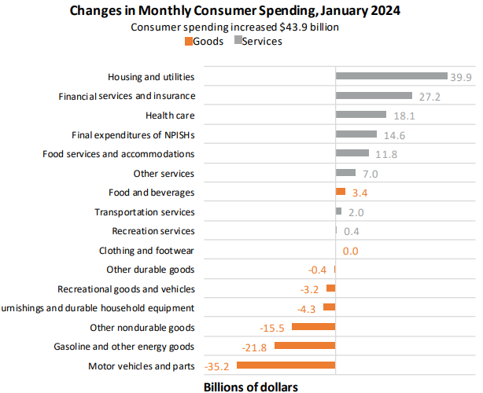[**Consumer Spending:**](https://www.bea.gov/news/current-releases) **Medium-term signal**

BEA publishes “Personal Income and Outlays” monthly (e.g., Jan Report was released on Feb-29). [Looking at previously published reports](https://www.bea.gov/news/archive?field_related_product_target_id=All&created_1=All&title=Personal+Income+and+Outlays) can provide some trending analysis on consumer spending.

[Table 2.8.x](https://apps.bea.gov/iTable/?reqid=19&step=2&isuri=1&categories=survey&_gl=1*4q08yk*_ga*MTQ3MzQ5NjIxMi4xNzExMjQ2MTk4*_ga_J4698JNNFT*MTcxMjUyMDk2MS42LjEuMTcxMjUyMDk3Mi40OS4wLjA.#eyJhcHBpZCI6MTksInN0ZXBzIjpbMSwyLDNdLCJkYXRhIjpbWyJjYXRlZ29yaWVzIiwiU3VydmV5Il0sWyJOSVBBX1RhYmxlX0xpc3QiLCI4MiJdXX0=) Personal Consumption Expenditures by Major Type of Product, Monthly,

Major type of product is like **Motor vehicles and parts - Durable goods**

[Table 2.4.x](https://apps.bea.gov/iTable/?reqid=19&step=2&isuri=1&categories=survey&_gl=1*4q08yk*_ga*MTQ3MzQ5NjIxMi4xNzExMjQ2MTk4*_ga_J4698JNNFT*MTcxMjUyMDk2MS42LjEuMTcxMjUyMDk3Mi40OS4wLjA.#eyJhcHBpZCI6MTksInN0ZXBzIjpbMSwyLDNdLCJkYXRhIjpbWyJjYXRlZ29yaWVzIiwiU3VydmV5Il0sWyJOSVBBX1RhYmxlX0xpc3QiLCI3MCJdXX0=) Personal Consumption Expenditures by Type of Product, Quarterly

Type of product is like **New motor vehicles -** **Motor vehicles and parts - Durable goods**

[**Interest Rate**](https://fred.stlouisfed.org/graph/?g=1eath)**: Short-term signal**

