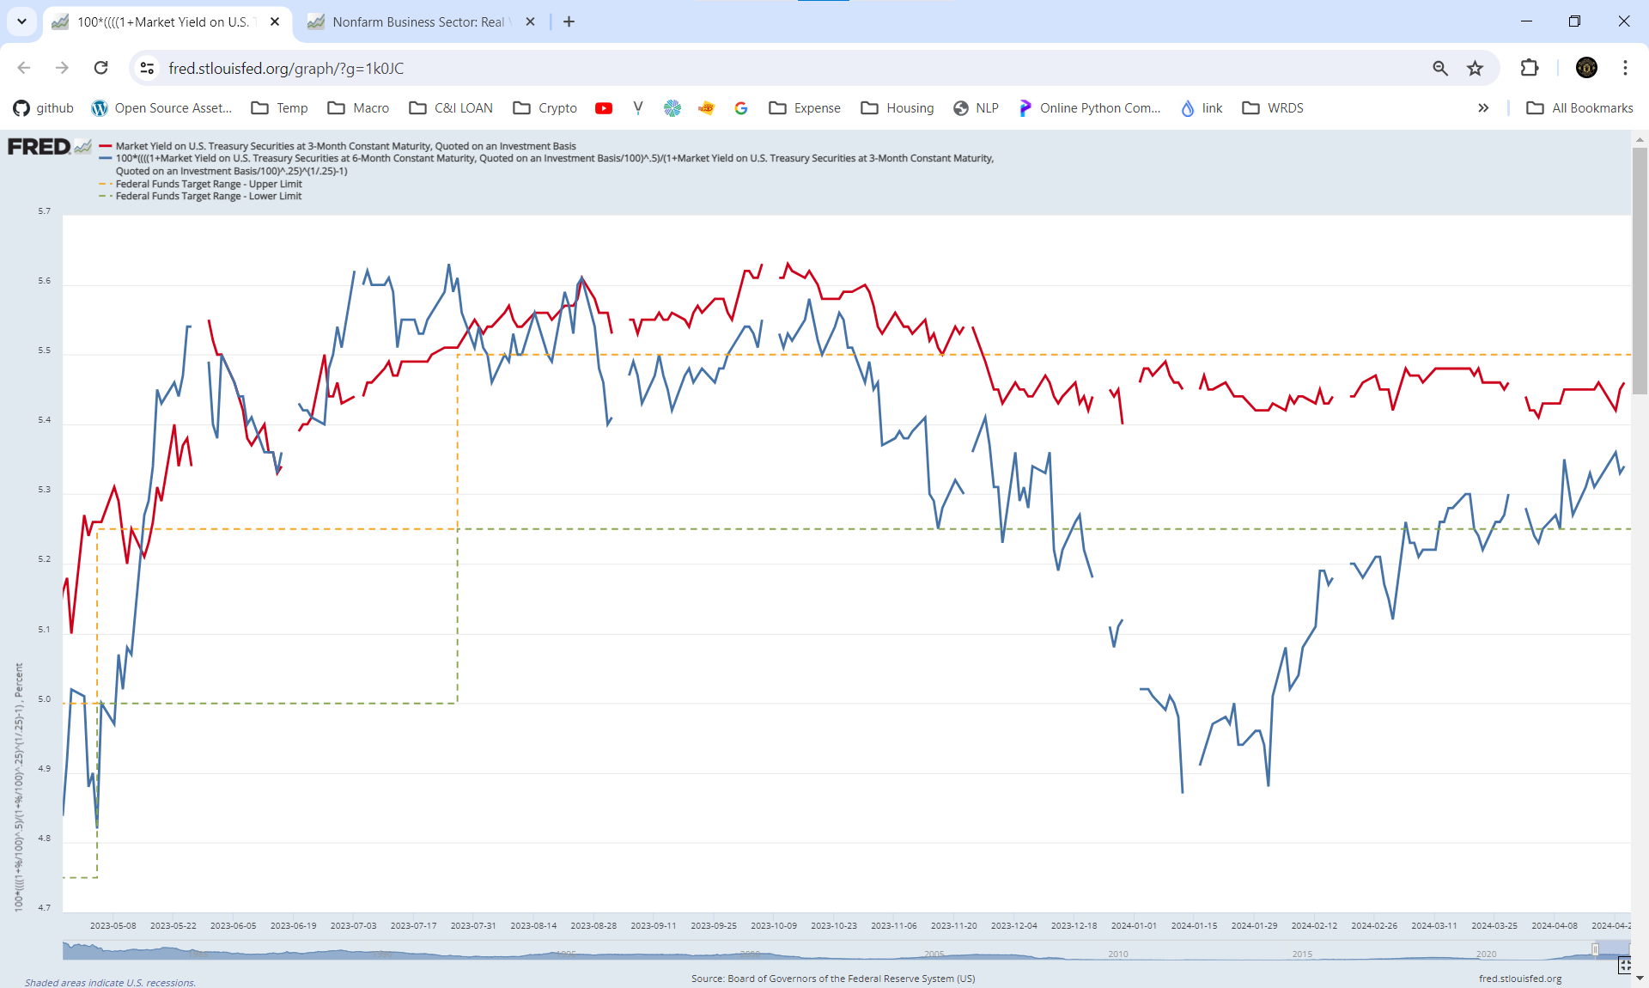

*Confirmed: not cut in 3-month horizon*

[**Fed Interest Rate**](https://fred.stlouisfed.org/graph/?g=1k0JC)

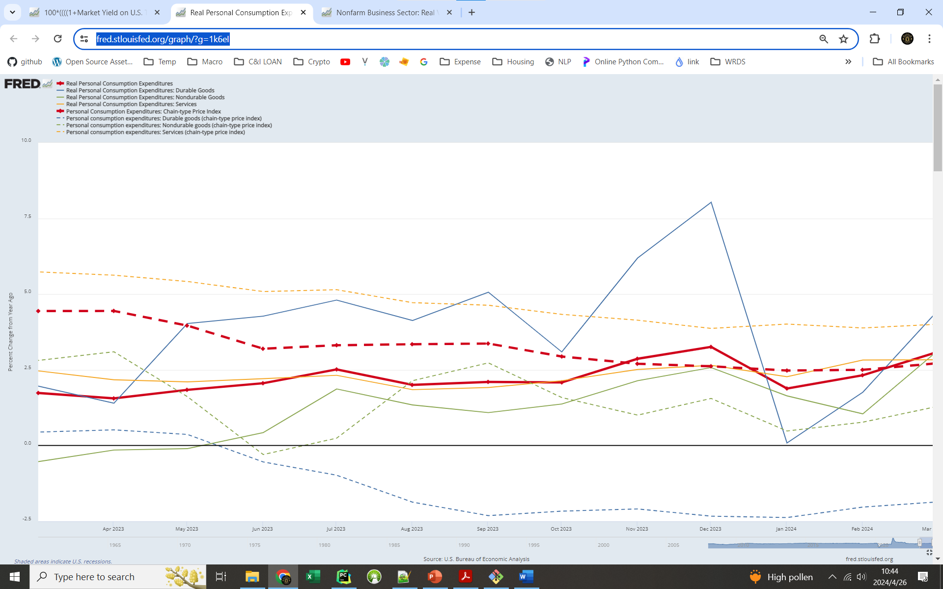

[**Consumer Spending: Real + Price**](https://fred.stlouisfed.org/graph/?g=1k6eI) **(**[**official release**](https://www.bea.gov/news/current-releases)**)**

***Price Index:***

*PCEPI / PCEPI-Service is decreasing steadily.*

*Durable-goods is deflating (like pre-pandemic), non-durable goods can be fluctuated, driven mainly by O&G price*

***Real Spending****: Durable-nonDur-Service=1-2-6.*

*total / service is growing at 3.0% and 2.8%, respectively.*

*Strong confidence as durable-spending > non-durable-spending > 0*

durable spending is highly cyclical, but non-durable-spending is less cyclical

[**Labor’s value-added vs market performance**](https://fred.stlouisfed.org/graph/?g=1iTKv)

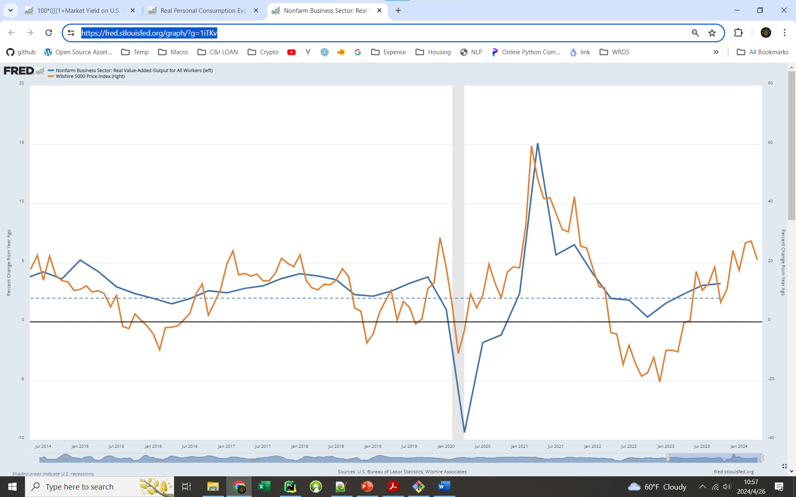

*When Real Labor Productivity is at or above 2%, U.S. economy is in good/health state.*