[Labor Supply x Demand](https://fred.stlouisfed.org/graph/?g=1iTSU)

* Supply = Civilian Labor Force Level vs. Demand = Employment Level + Job Openings

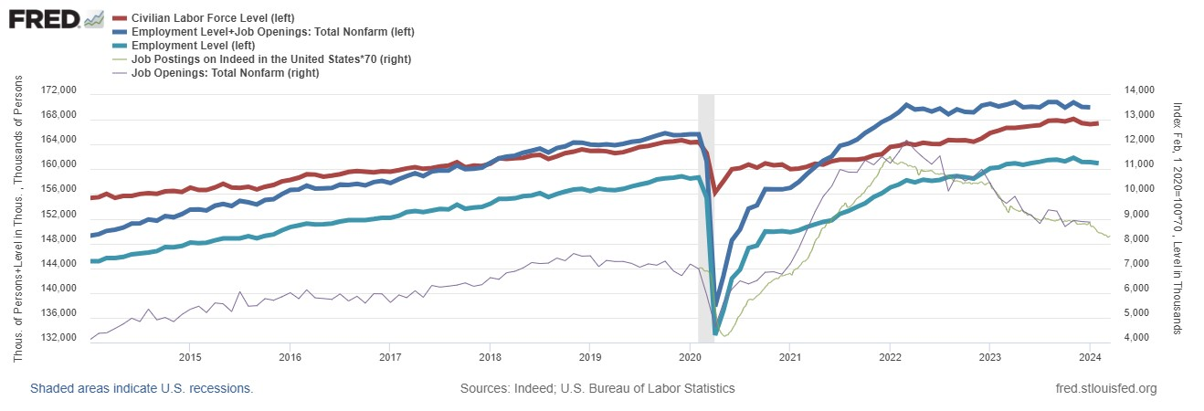

*There’s labor shortage as demand(blue) > supply(red), creating upward wage pressure, despite its dwindling recently.*

[Labor Wage and Productivity](https://fred.stlouisfed.org/graph/?g=1iSBY)

* Productivity = real GDP / total # of hours
* Hourly wage scaled by CPI (consumers’ purchasing power) vs. Hourly wage scaled by PPI / GDP price deflator (businesses assess how to allocate resources to factors of production (i.e. capital, intermediates)

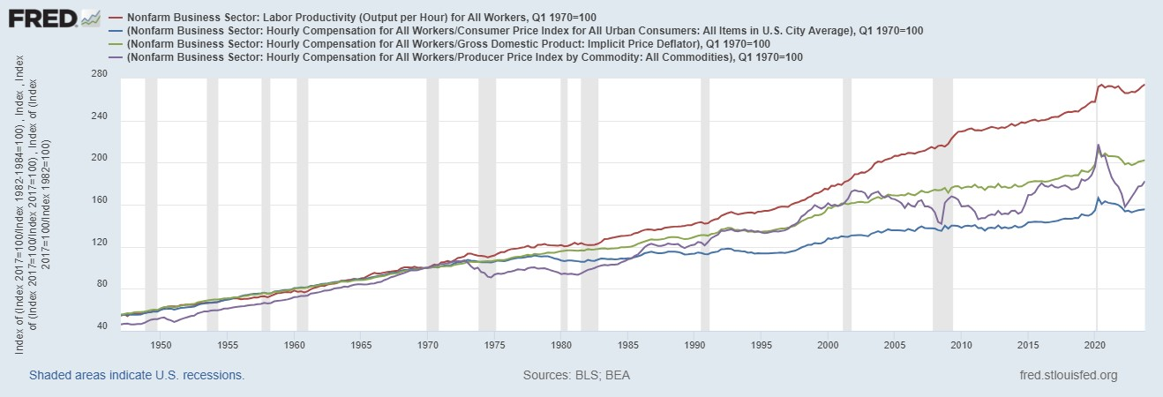

*US workers only partially benefitted from the increases in their productivity since the 1970s, as the labor productivity (real GDP/# hours, red) is diverging from the real pay.*

[Labor’s real value-added vs stock market performance:](https://fred.stlouisfed.org/graph/?g=1iTKv)

* Productivity = real GDP / total # of hours

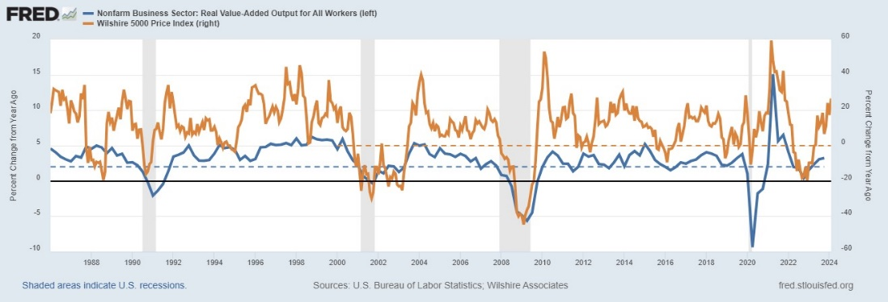

*If the real output growth from labor stays at or above 2%, the economy is in expansion and the stock market is trending higher than last year.*