Stock Market Analysis & Screening Framework: a top-down approach

Step 1: Market Overview (Macroeconomic Analysis)
- Monitor Broad Market Sentiment (Daily)
  - FFT – Daily: Look for any major shifts in financial flows and liquidity conditions.
    - 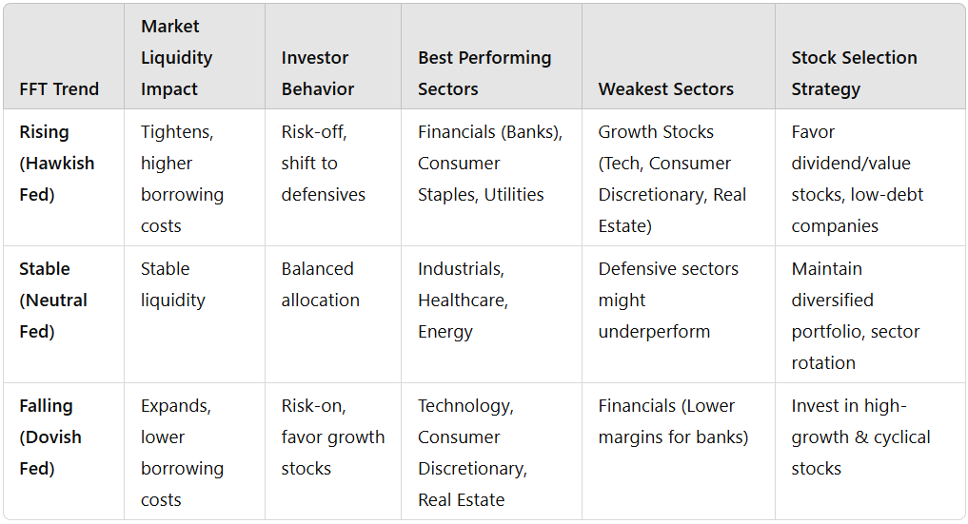
  - SP500 Implied Correlation – Daily: High correlation suggests risk-off sentiment; low correlation indicates stock-specific opportunities.
    - Low correlation indicates stock-specific opportunities (Move to industry-momentum and individual stock selection.).
    - High correlation suggests market-wide risks dominate; Focus on broad market indicators (CPI, PCE, GDP) and defensive positions (Consumer Staples, Health Care, Utilities).
      - Exception:
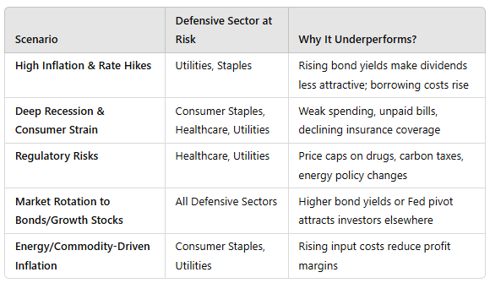
- Assess Key Monthly Economic Indicators
  - Unemployment (UE – Monthly, Beginning): Rising unemployment may indicate economic slowdown.
  - Consumer Price Index (CPI – Mid-Month):
    - General CPI: Inflation trends affecting interest rates and consumer purchasing power.
    - CPI Auto | Leisure-related: Insight into consumer discretionary spending.
  - Industrial Production (Ind. Prod – 3rd Week): Measures economic activity in manufacturing and production sectors.
  - Personal Consumption Expenditures (PCE – End of Month):
    - PCE – DD: Deeper breakdown of consumer spending trends.
- Quarterly Economic Trends
  - Real GDP (RGDP – End of Quarter): Determines overall economic growth.
  - Labor Productivity (Quarter Begin): Higher productivity can lead to earnings growth, signaling margin expansion and earnings potential.
  - Earnings Breakdown (Quarterly): Corporate earnings trends provide insights into market cycles.

Step 2: Sector & Industry Trend Analysis
Once the macroeconomic picture is clear, focus on identifying attractive industries and sectors.
- Fundamental Sector Analysis
  - Compare sector performance against macroeconomic conditions.
  - Determine if industries are in expansion, contraction, or rotation phases.
  - Visual: 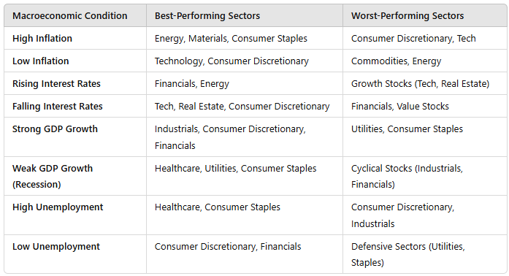
- Momentum-Based Industry Analysis
  - Industry-Momentum Indicator: Identifies sectors showing consistent uptrend/downtrend.
  - Ticker-Momentum Indicator: Pinpoints strong stocks within outperforming sectors.

Step 3: Individual Stock Screening
After identifying promising sectors, select specific stocks for investment.
- SP500 Scorecard (Daily)
  - Examine fundamental and technical performance of SP500 stocks.
  - Identify stocks with strong earnings, revenue growth, and valuation metrics.
- Stock-Specific Momentum Indicators
  - Ticker-Momentum Indicator: Screens stocks based on technical strength (price trends, volume, relative strength).
  - Compare stock performance against Industry-Momentum to ensure it aligns with broader trends.

Final Decision-Making
After filtering stocks, conduct a final qualitative analysis, considering:
- Company fundamentals: Earnings growth, profit margins, competitive advantage.
- Valuation metrics: P/E ratio, PEG ratio, price-to-sales ratio.
- News & sentiment analysis: Management changes, industry disruptions, macro risks.

Summary Workflow
- Assess Market Conditions → (Macro Indicators: CPI, UE, GDP, PCE, etc.)
- Identify Strong Sectors → (Industry-Momentum, Fundamental Analysis)
- Screen Individual Stocks → (SP500 Scorecard, Ticker-Momentum)

