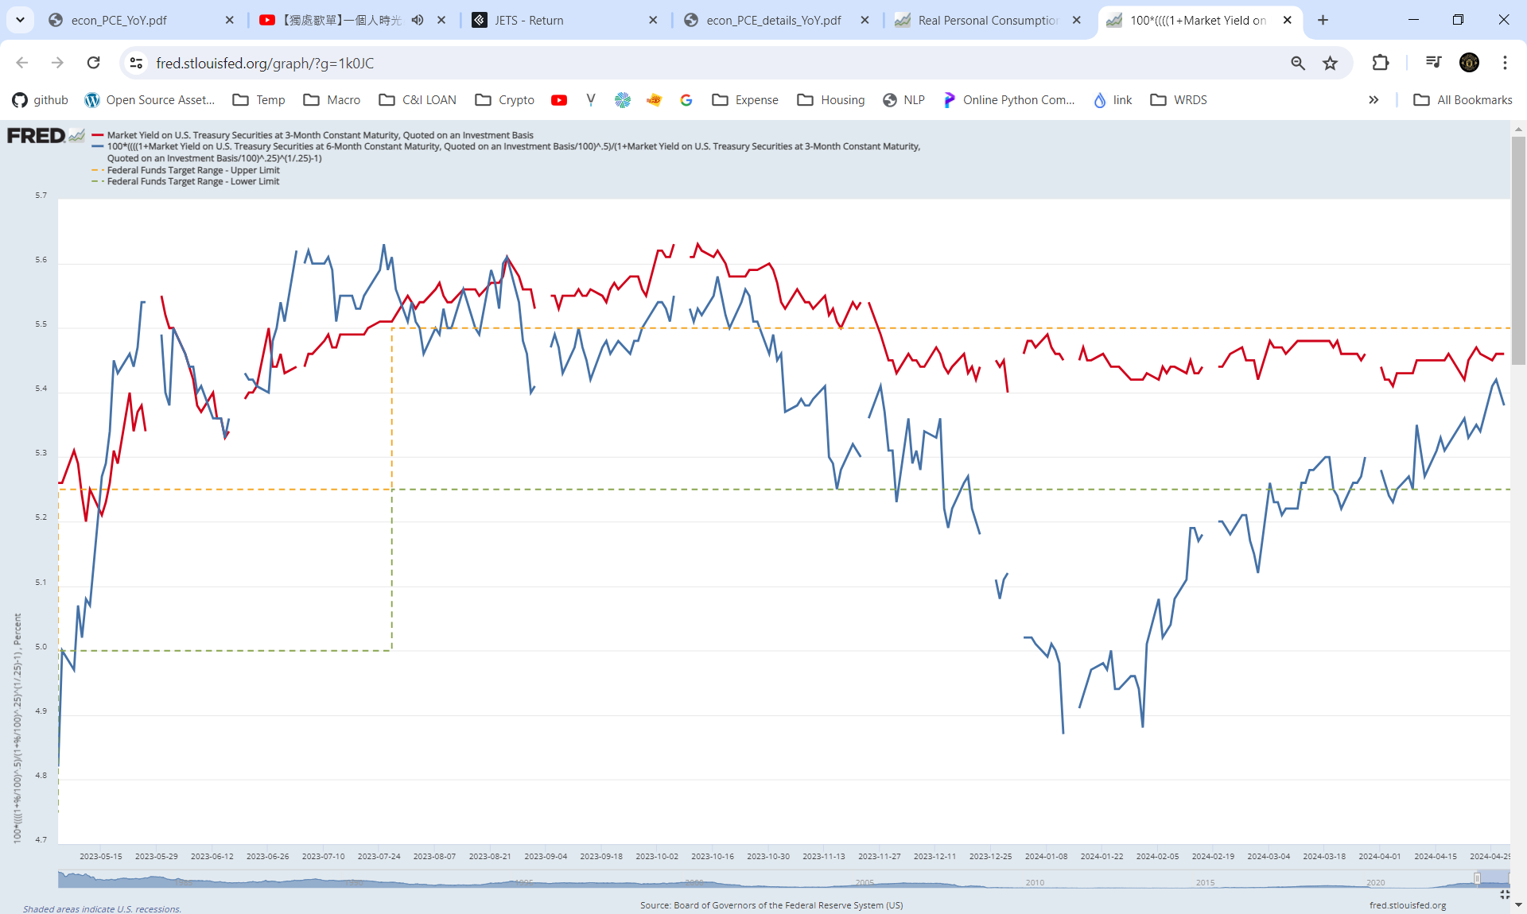
Confirmed: Fed confirmed no hike, or cut in 3-month horizon.
Fed Interest Rate
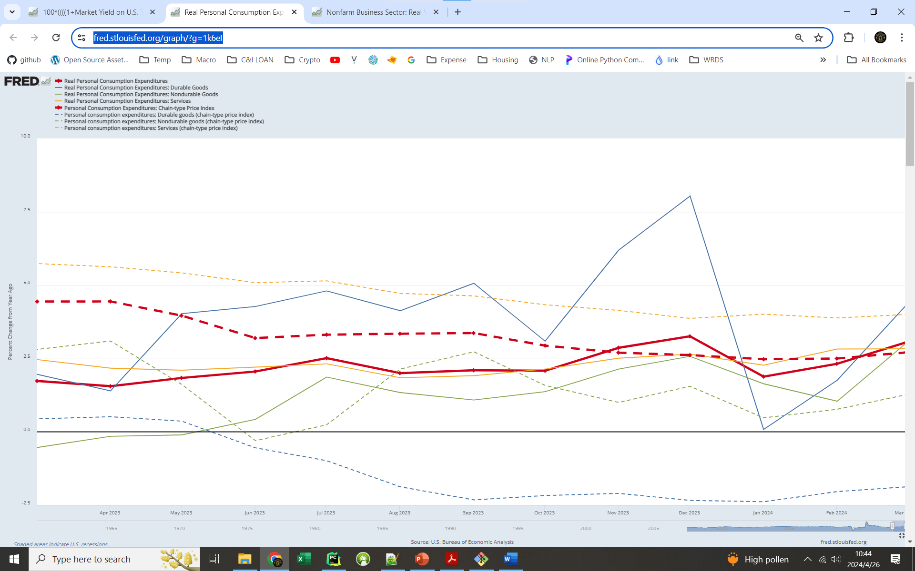
Consumer Spending: Real + Price (official release)

Price Index:
PCEPI / PCEPI-Service is decreasing steadily.
Durable-goods is deflating (like pre-pandemic), non-durable goods can be fluctuated, driven mainly by O&G price
Real Spending: Durable-nonDur-Service=1-2-6.
total / service is growing at 3.0% and 2.8%, respectively.
Strong confidence as durable-spending > non-durable-spending > 0

durable spending is highly cyclical, but non-durable-spending is less cyclical

Labor’s value-added vs market performance
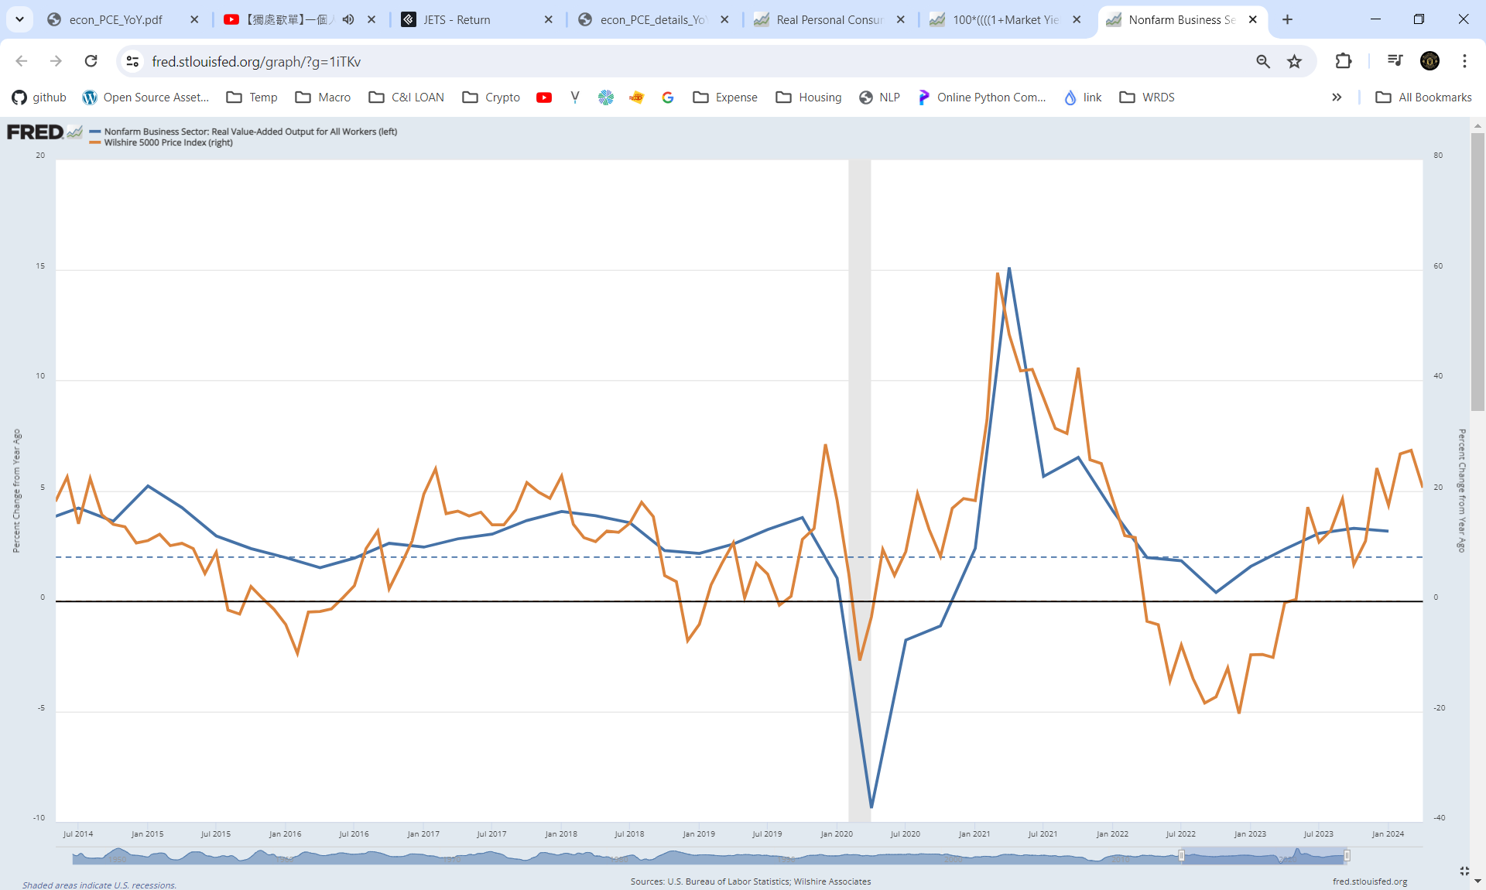
When Real Labor Productivity is at or above 2%, U.S. economy is in good/health state. It is 3.17% in 24Q1 vs 3.33% om 23Q4

