Screening Tools

FFT – Daily  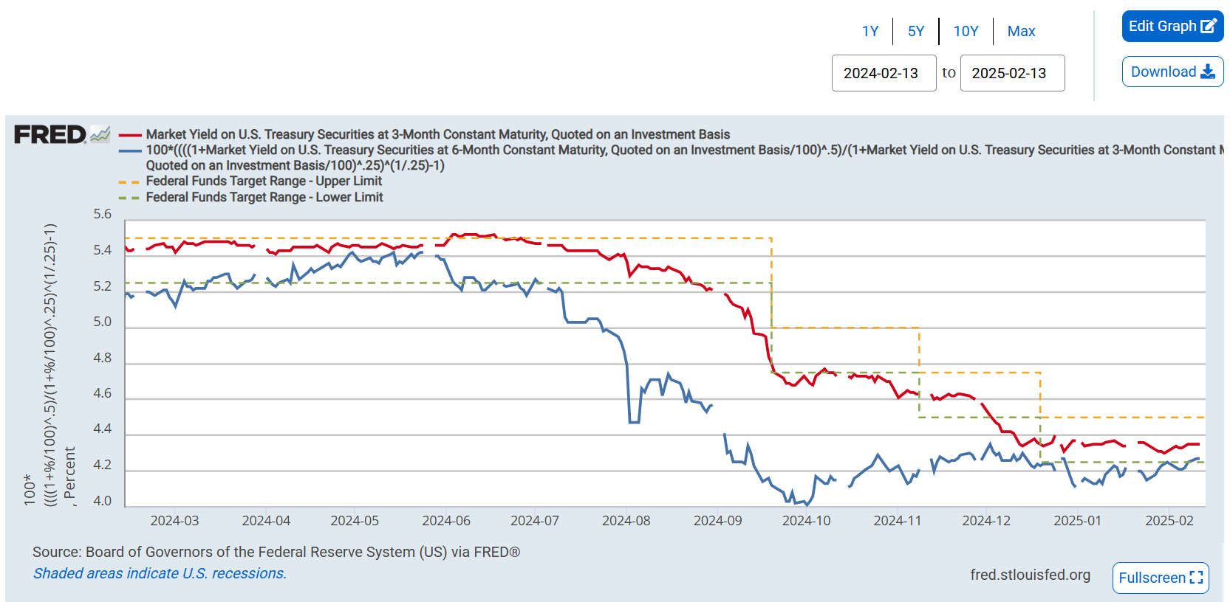 | SP500 Implied Correlation – Daily  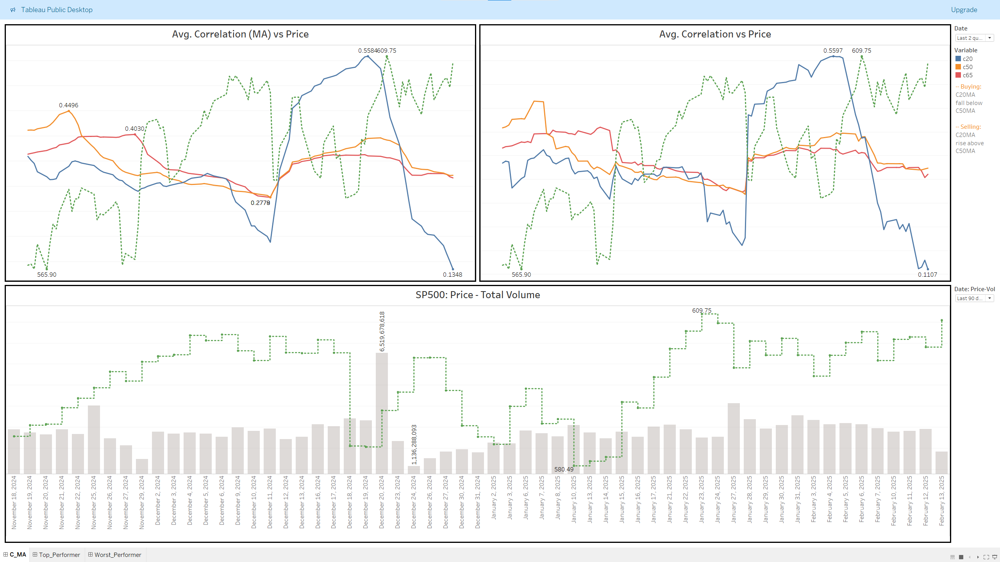 | SP500 Scorecard -Daily  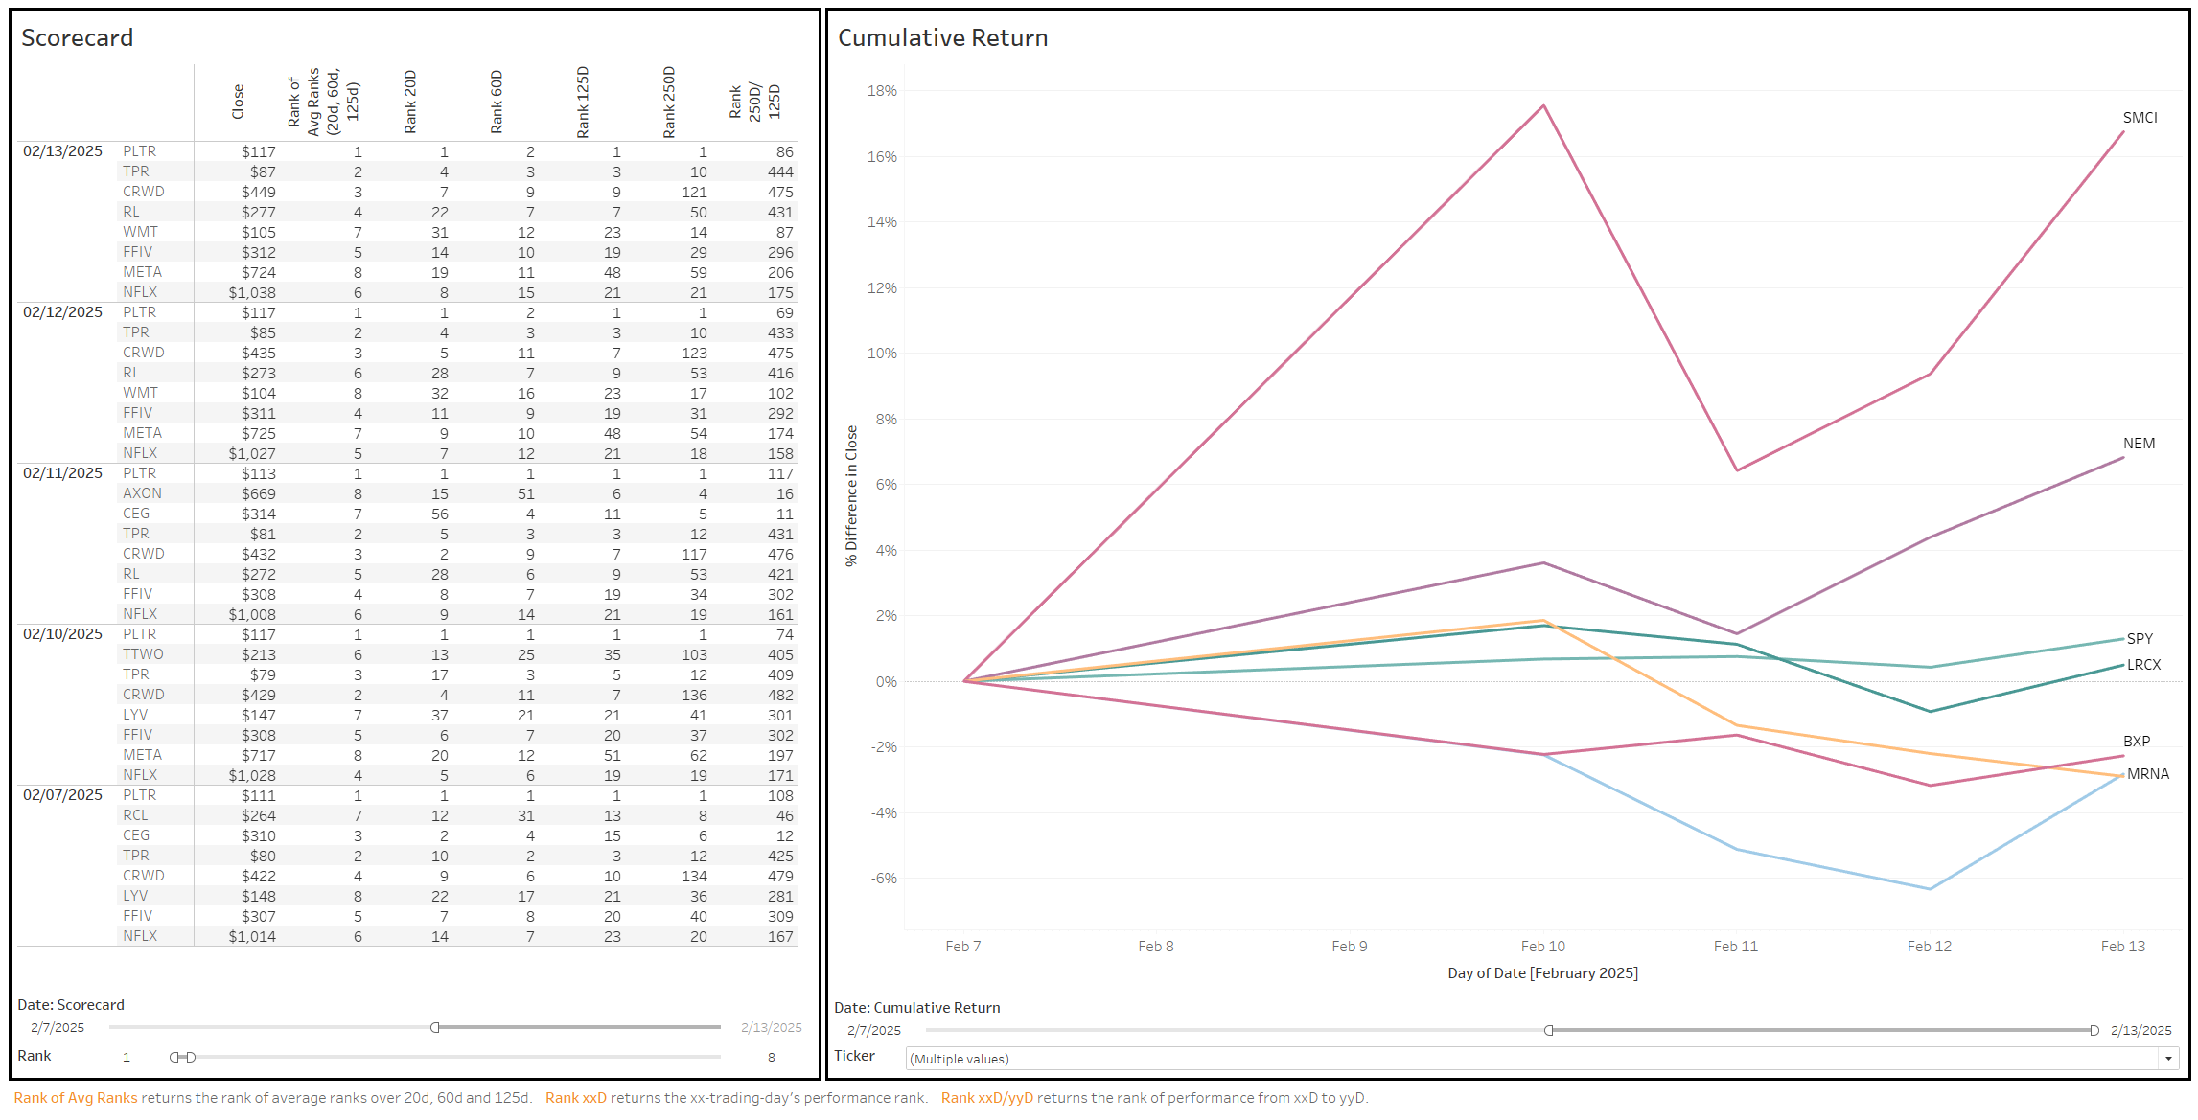
UE: Monthly (beginning of each month)  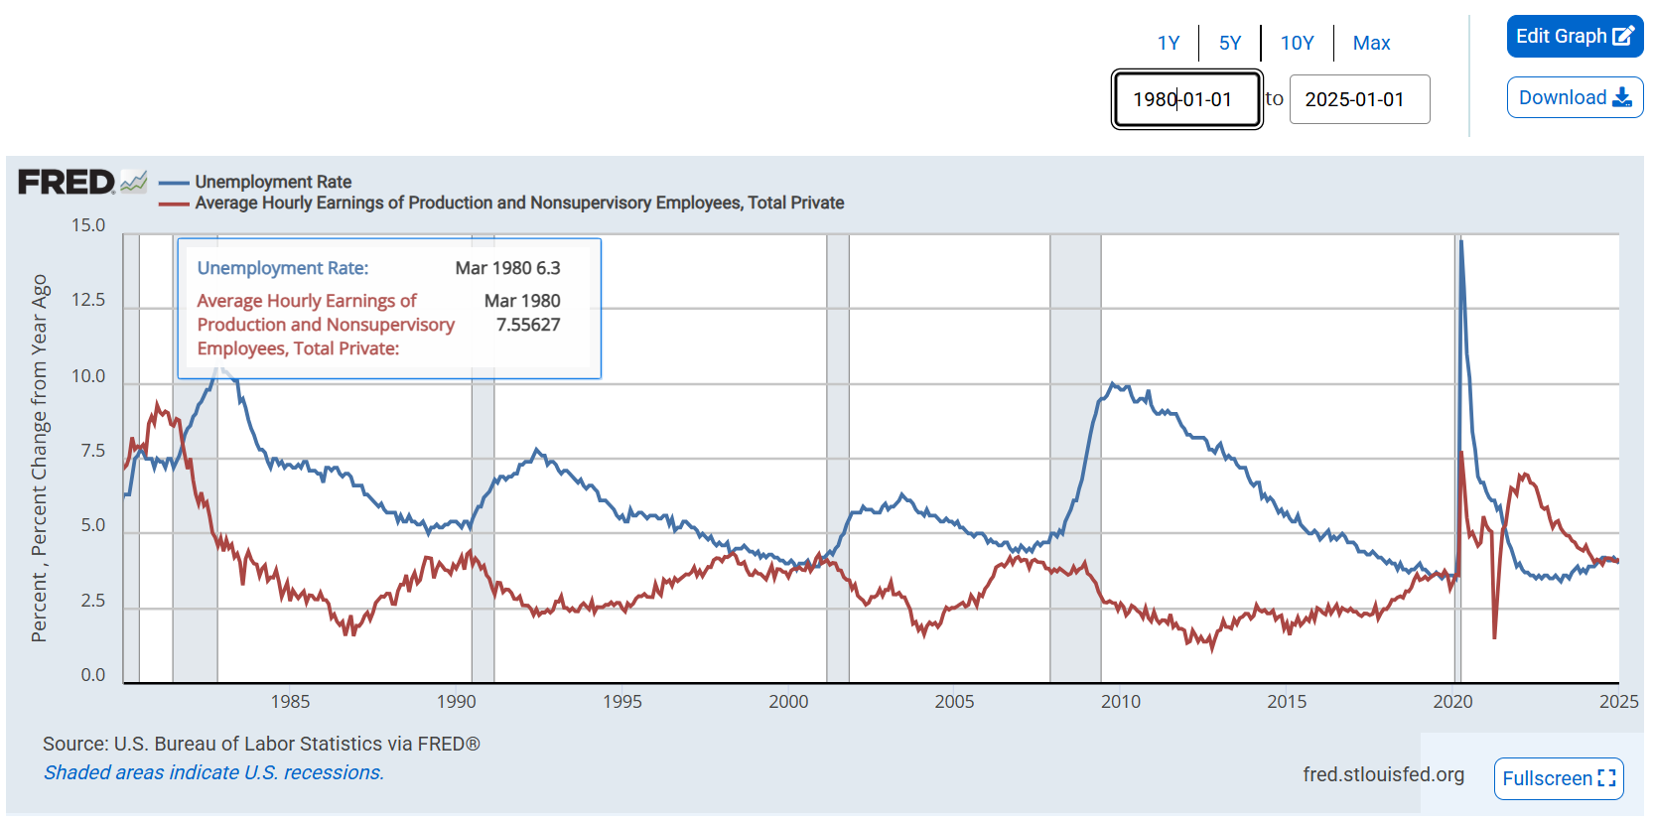 | CPI: Monthly (mid of each month)  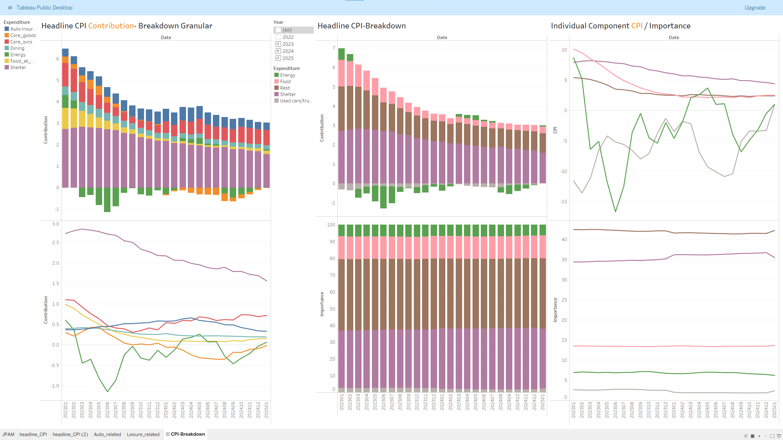 | CPI Auto | Leisure-related – Monthly  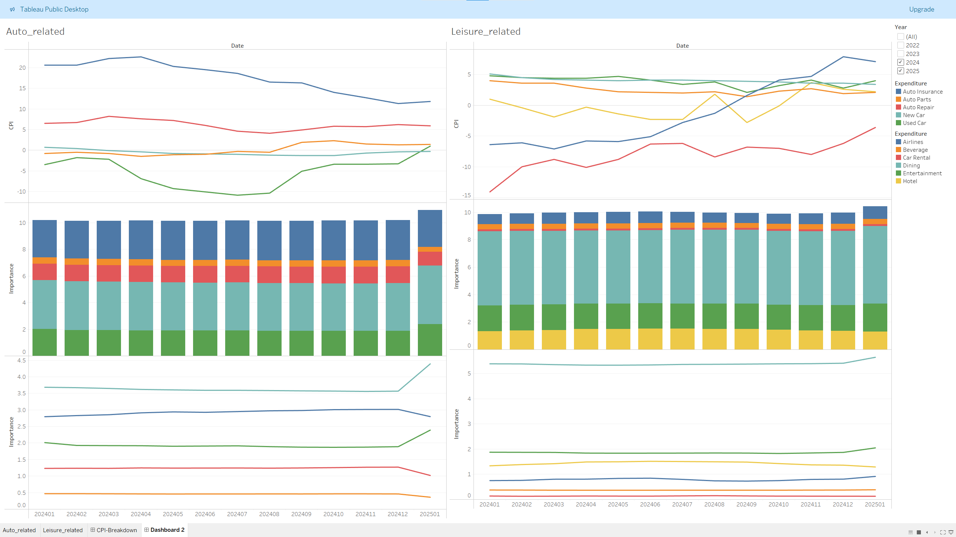
Ind. Prod: Monthly (3rd week)  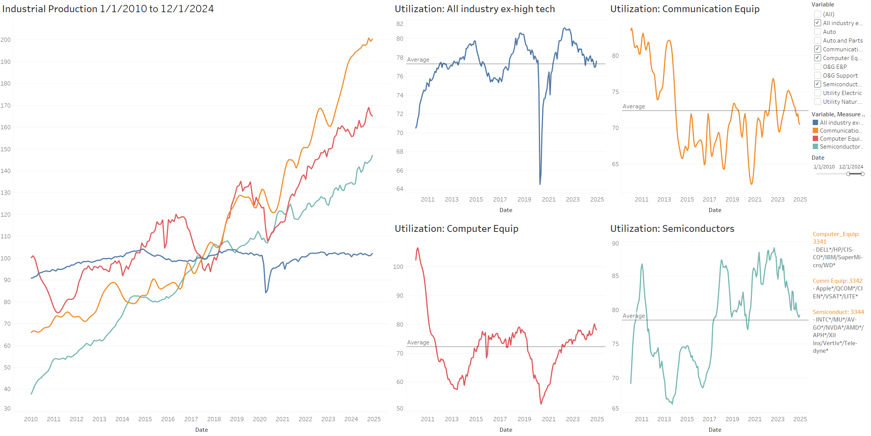 | PCE: Monthly (end of each month)  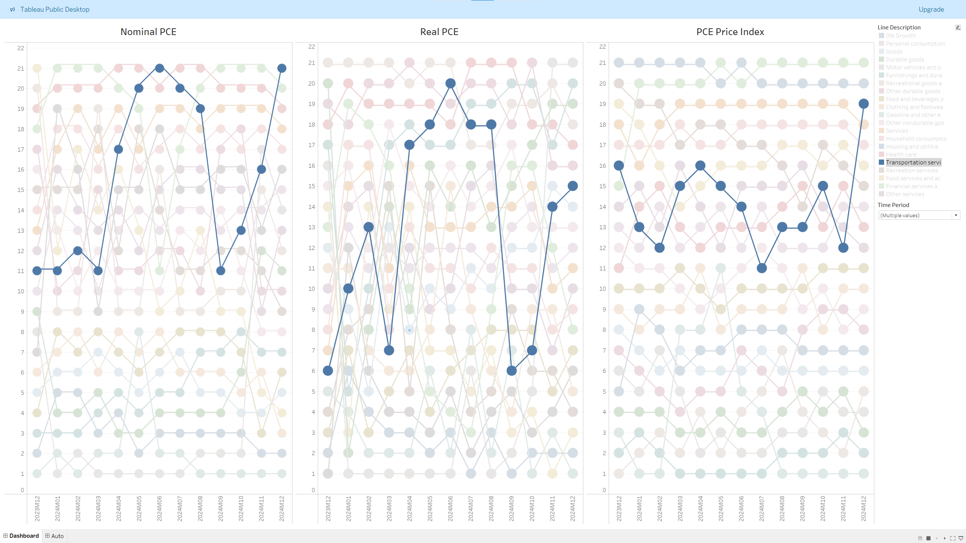 | PCE – DD: Monthly  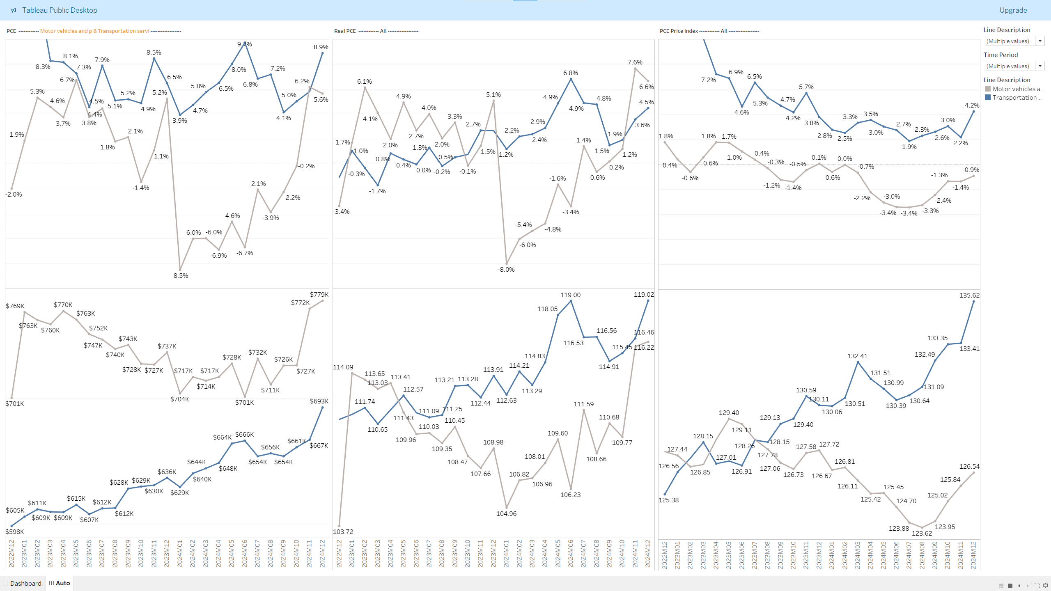
RGDP: Quarterly (end of each month)  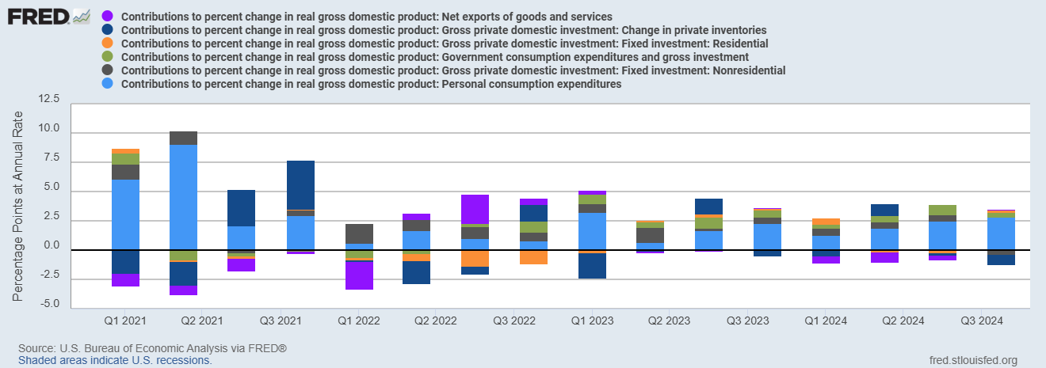 | Labor Productivity: Quarterly (begin)  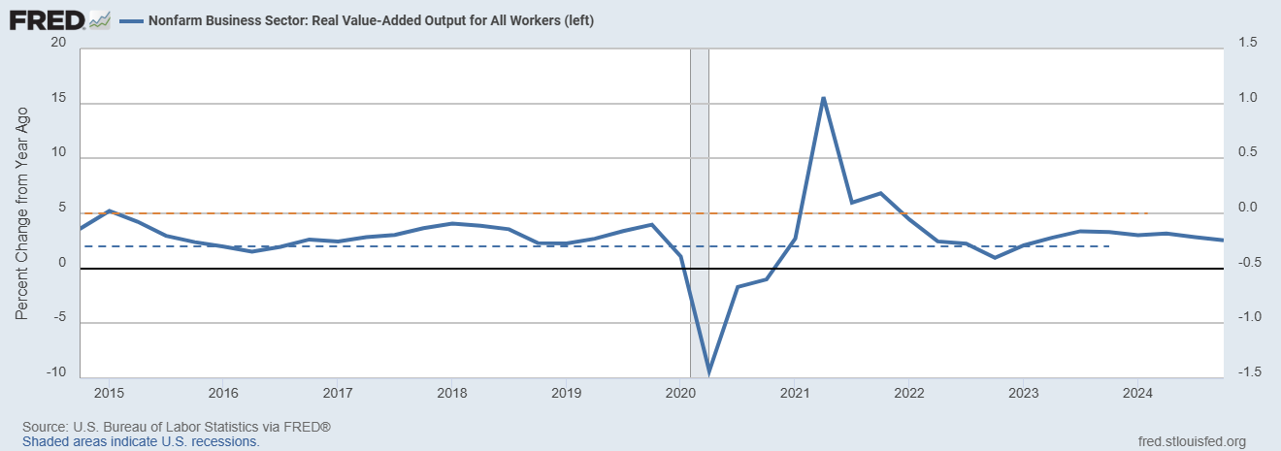 | Earnings Breakdown: Quarterly  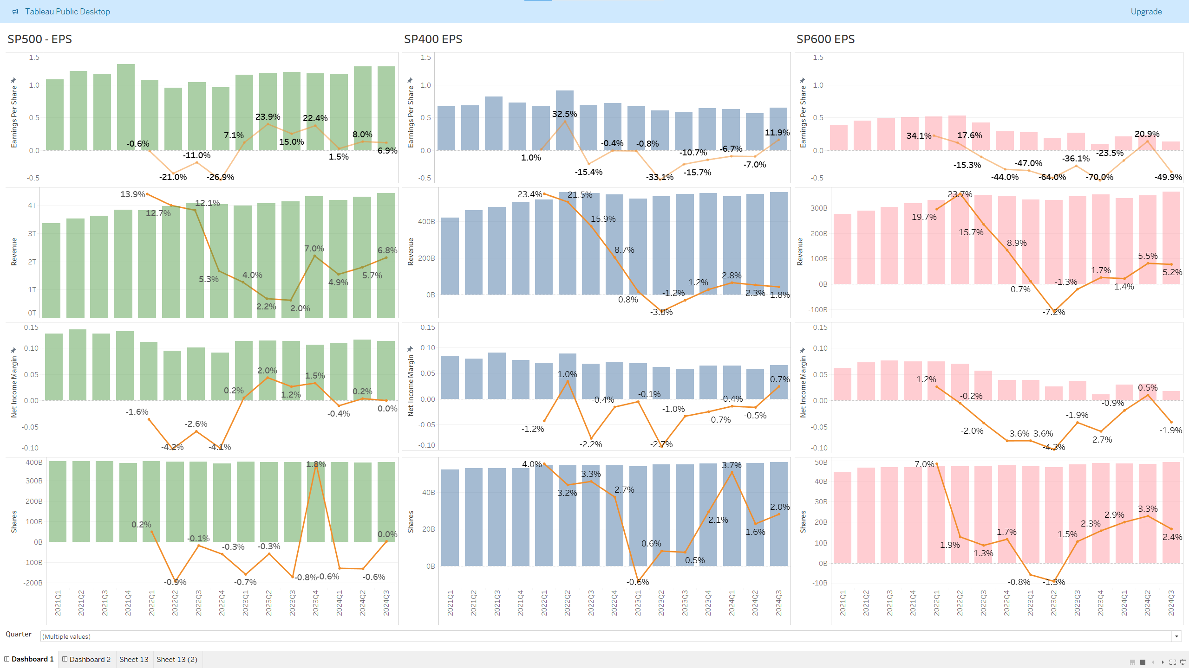
Fundamental  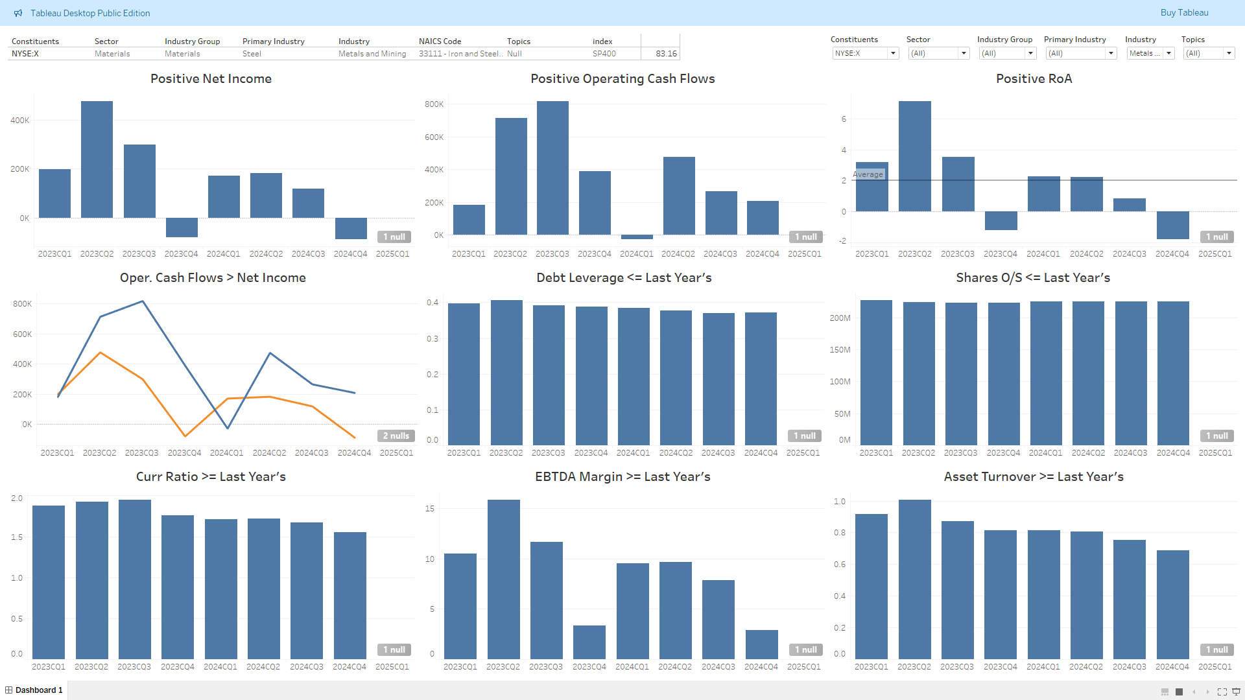 | Ticker-Momentum  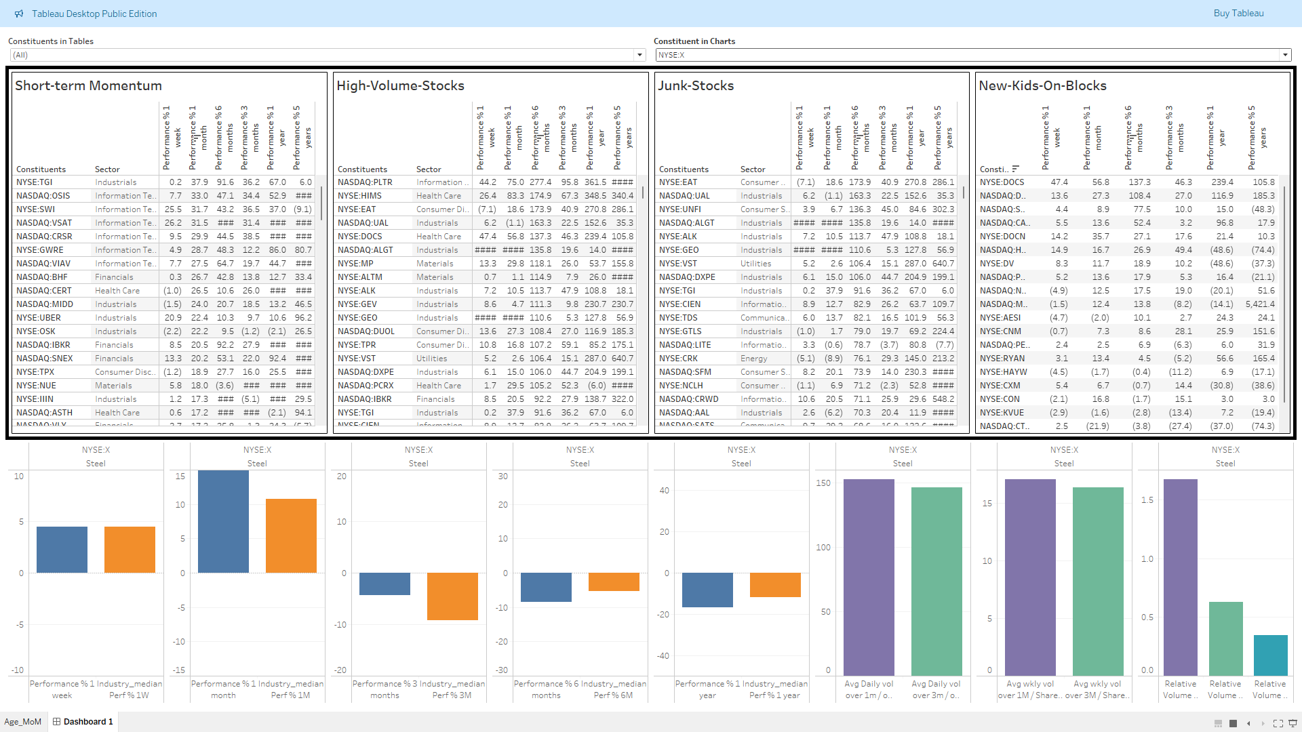 | Industry-Momentum  