[Wolfspeed, Inc. (WOLF) Stock Options Chain, Prices, Historical Calls & Puts | Seeking Alpha](https://seekingalpha.com/symbol/WOLF/options)

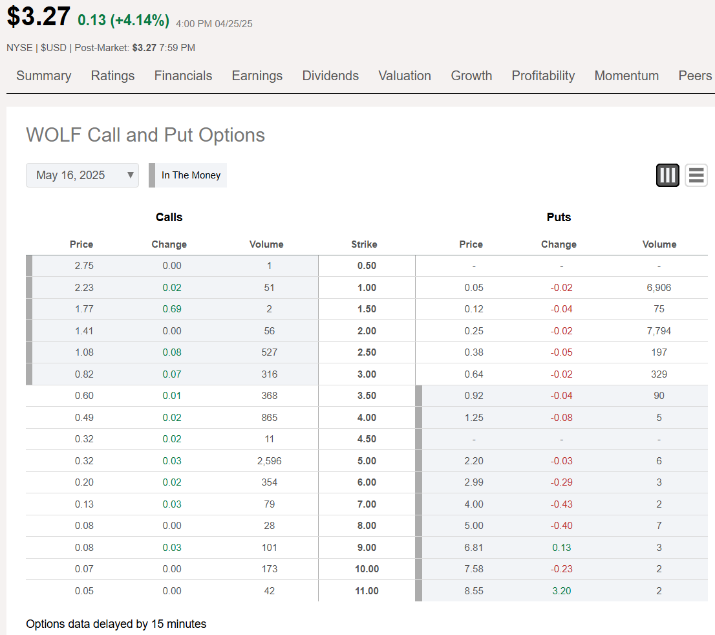

[WOLF Put/Call Ratio for Wolfspeed Stock - Barchart.com](https://www.barchart.com/stocks/quotes/WOLF/put-call-ratios)

4.22

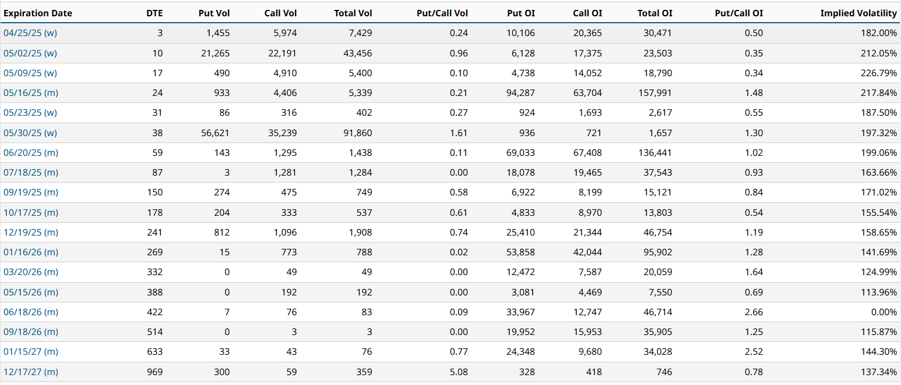

4.23

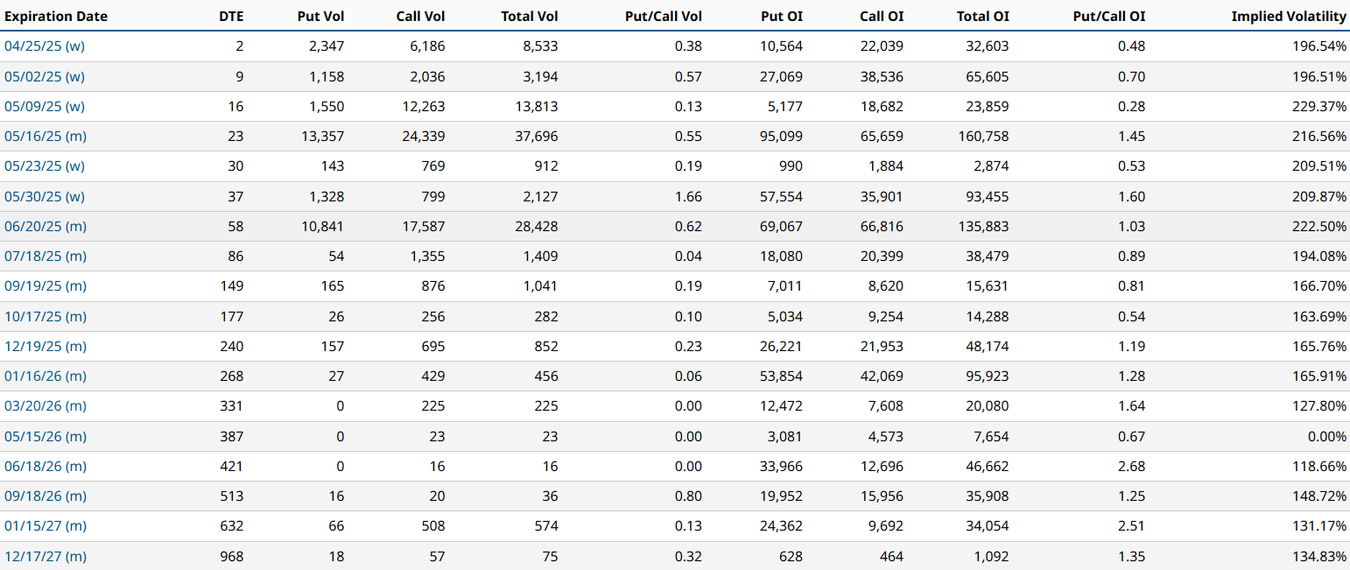

4.24

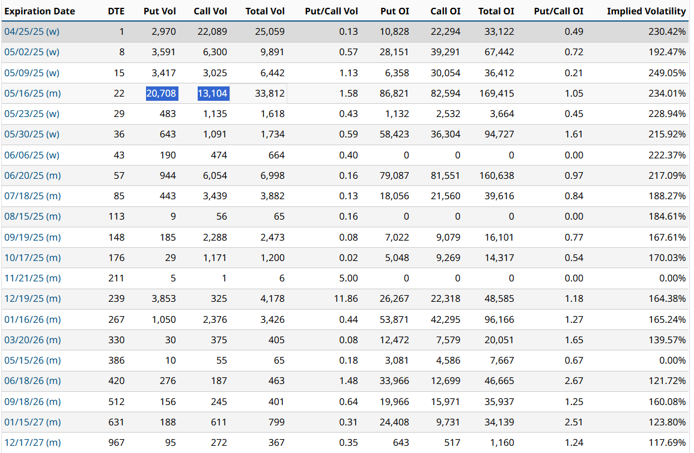

4.25

