[Wolfspeed, Inc. (WOLF) Options Chain - Yahoo Finance](https://finance.yahoo.com/quote/WOLF/options/)

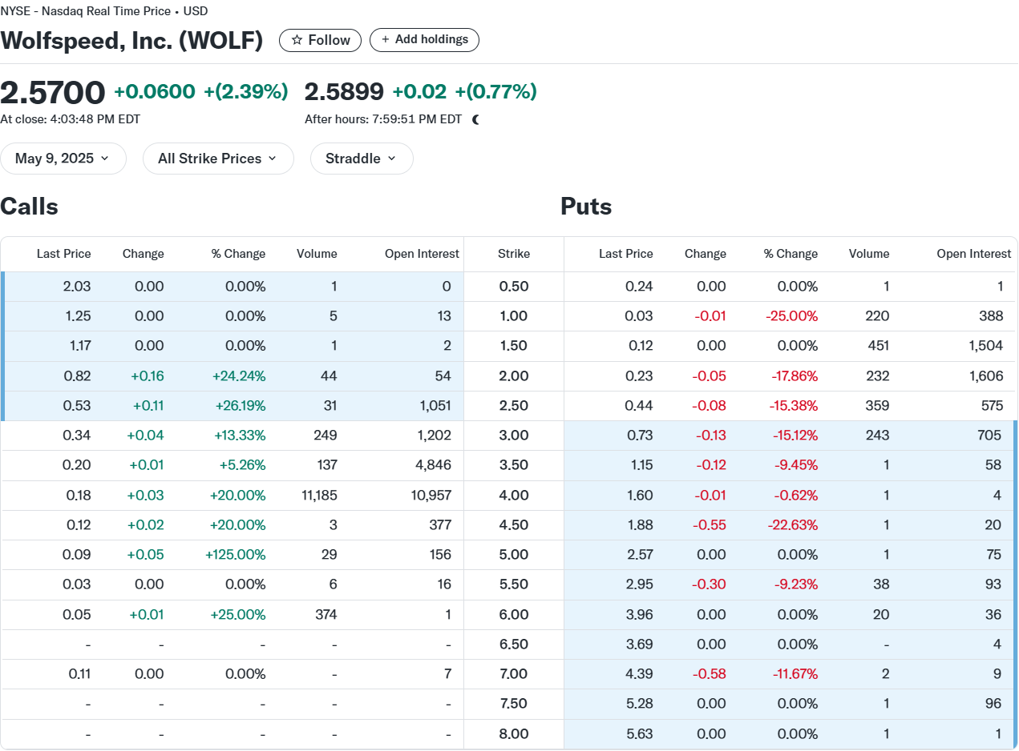

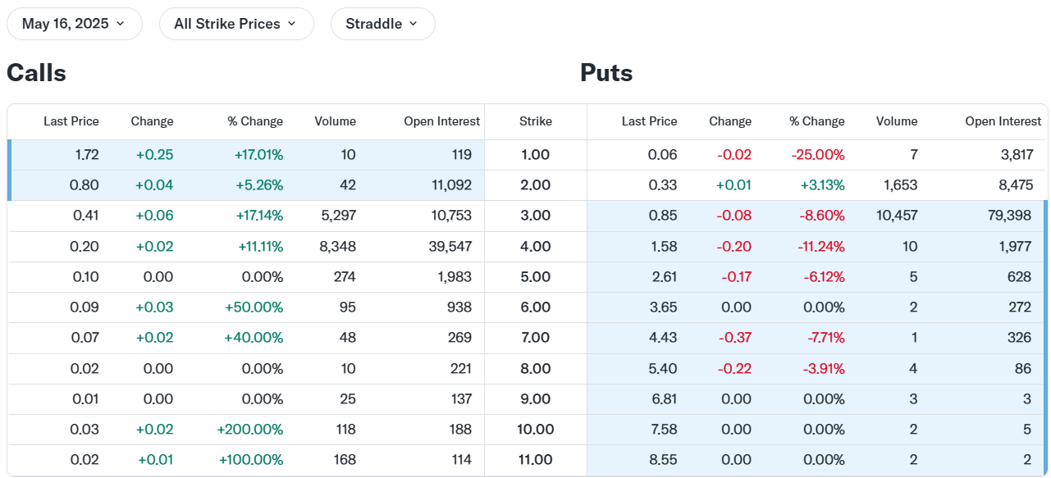

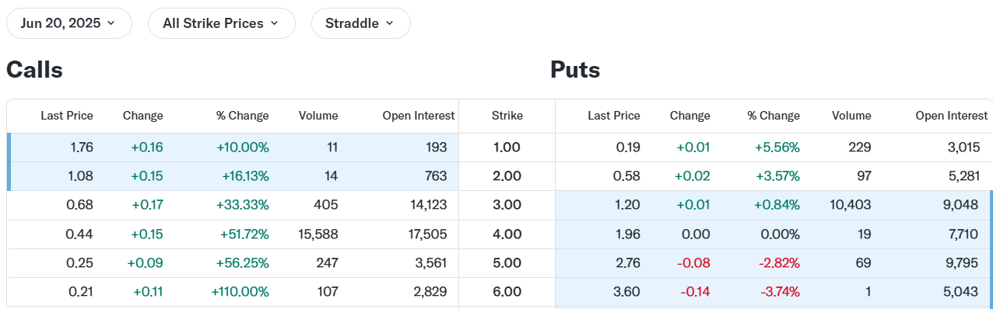

[WOLF Put/Call Ratio for Wolfspeed Stock - Barchart.com](https://www.barchart.com/stocks/quotes/WOLF/put-call-ratios)

4.22

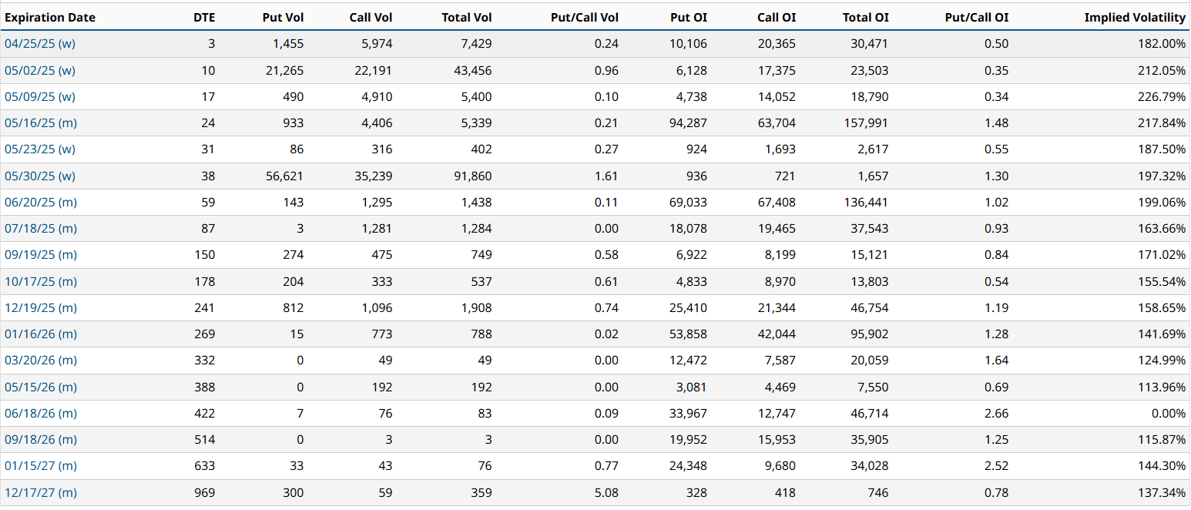

4.23

