A reference manuscript template for LaTeX to Word conversion
First Author¹, Second Author¹, Third Author^{2,*}
¹Department of Example Engineering, Example University, City, ST 00000, USA
²Institute of Placeholder Studies, Second University, City, ST 11111, USA
*Corresponding author: corresponding@example.edu
Abstract
This template is placeholder prose. Its purpose is to exercise every LaTeX construct the converter handles, so that a successful build proves the conversion path end to end rather than proving that one particular manuscript happens to work. It contains numbered and unnumbered equations, cross-references of every cleveref flavour, citations in both parenthetical and textual form, figures with sub-captions, a booktabs table with siunitx alignment, nested lists with custom labels, chemical formulae, and quantities with units and uncertainties. Replace the text with your own; keep the structure.
Keywords: placeholder; template; document conversion; regression fixture; reproducible builds

Introduction
This paragraph shows ordinary body text with a parenthetical citation [1] and a textual one: Roe et al. [2] reported a similar effect. Multiple keys collapse into a compressed range, [1–4], because natbib is loaded with sort&compress. A citation with more than two authors abbreviates to "et al." in the text but lists everyone in the bibliography.
Cross-references come in several forms and each must survive as a live Word field: Section 2 capitalises the type name, section 3 does not, and (1) prints the bare number. Equations are referenced as Eq. (1), figures as Figure 1, and tables as Table 1.

Scope
Sub-sections must be numbered and left aligned. This one exists only to prove that the heading hierarchy survives, including a third level.

A third-level heading
Inline mathematics such as $η​(x,t)$ and $T_{s}​=120 °C$ sits inside running text. Note the macro $η$ ends with , so the space before "sits" is preserved but no space appears before the comma here: $η$, exactly as in the source.
Quantities are written with siunitx and must appear as readable text, not as raw markup: the anneal is held at 120 °C, the peak at 150 °C, the applied pressure is 8.27 MPa, the field of view is 5.3 µm×1.0 µm, hold times are 0 min, 5 min and 10 min, the sweep spans 300 to 420 K, the population is 57 655 individuals, the smallest coefficient is 1.0 × 10⁻¹⁶, and the modulus is 9.4 ± 0.6 GPa.
Chemical formulae go through mhchem and need real subscripts: ${CaCO}_{3}$, $H_{2}{SO}_{4}$, and the mixed composition $A_{0.8}B_{0.15}C_{0.05}D_{2}$.

Theory

Governing equation
A numbered display equation carries a right-aligned number that must become a live SEQ field in Word, so inserting a new equation renumbers the rest:
$\frac{∂η​}{∂t}=−M\frac{δF}{δη​}=M\left(κ∇^{2}η​−\frac{∂f}{∂η​}\right).$ (1)
An unnumbered equation must stay unnumbered. This is the case pandoc-tex-numbering gets wrong on its own: it numbers every display equation, which shifts every later number out of step with the LaTeX original.
F[η​]=Ω​f(η​)+12κ|∇η​|2dΩ.
Note the \tfrac above: LaTeX renders it as a stacked fraction one size down, and the converter has to force that, because pandoc maps it to Word’s "linear" fraction type, which prints a slash instead.

Multi-line derivation
An align block gives every row its own number. Each row is wrapped in linenomath so that lineno numbers the rows without breaking amsmath’s per-row labels.
$σ_{ij}=C_{ijkl} ε_{kl},$ (2)
$ε_{kl}=\frac{1}{2}\left(∂_{k}u_{l}+∂_{l}u_{k}\right).$ (3)
Combining Eq. (2)-4 and integrating over the domain gives a scalar energy. Operators with limits must keep them above and below:
$E=\sum_{k=1}^{N}{w_{k}}\int_{0}^{1}{h^{′}}(u) \hat{q}(u) du≈\sqrt{\frac{1}{N}\sum_{k=1}^{N}{{\left(x_{k}−\overset{‾}{x}\right)}^{2}}}.$ (4)
Words set inside a formula with \text stay upright and keep their spaces, and a variable named inside one is still a variable. Word records the difference: the prose carries m:nor where an operator name carries only m:sty, which is how the converter tells $ln$ from $\text{and}$ without a list of function names.
$η_{k}(t)=\left\{\begin{matrix}1 & \text{if grain }k\text{ survives to }t, \\ 0 & \text{otherwise.}\end{matrix}\right.$ (5)

Assumptions
A list with custom labels. pandoc cannot express label=(\roman*) on its own, so the converter rewrites it and repairs the numbering definition afterwards. The third item is the interesting one: "(iii)" is wider than the default hanging indent, which used to glue it to the text.
- The medium is isotropic and the coefficients are constant in time;
- Boundaries are traction free except where stated;
- Higher-order gradient terms are neglected, which is exact to leading order in the small parameter and adequate elsewhere.
An ordinary numbered list, for contrast:
- First point. Bold lead-ins should stay bold.
- Second point. Inline maths such as $v_{n}∝ΔE$ should stay on the same line.
- Third point. And nothing should wander off the margin.
And a bulleted list, which must remain bulleted rather than turning into numbers when the converter merges its own numbering definitions:
- first bullet;
- second bullet;
- third bullet.

Results

Figures
A multi-panel figure. In LaTeX the panels sit side by side; the converter puts one image per line with its sub-caption underneath, because Word gives a paragraph containing several inline images no sensible way to caption them individually. Expect the Word version to be taller than the PDF.
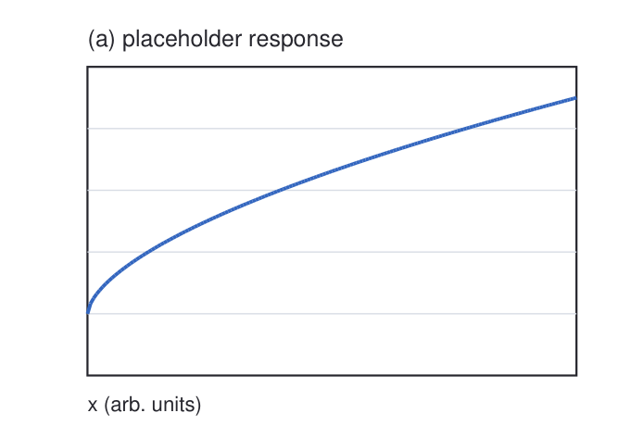
(a) First placeholder panel
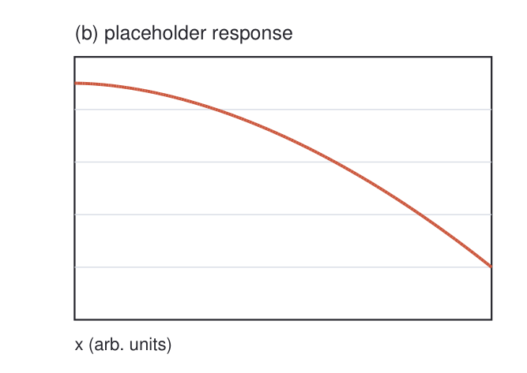
(b) Second placeholder panel
Figure 1: A two-panel figure. (a,b) Placeholder panels drawn only to occupy space. The caption must sit on its own line, stay with its figure across a page break, and carry a live figure number.
A single wide figure, and one supplied as a PDF so the converter has to rasterise it – Word cannot embed PDF artwork.
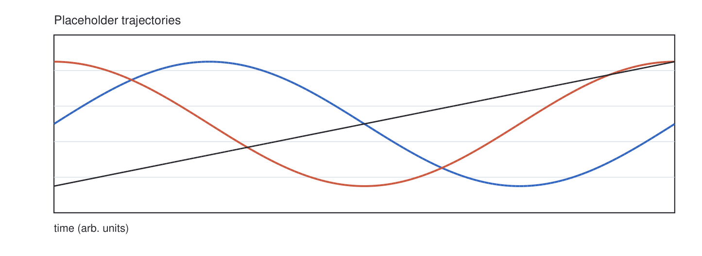
Figure 2: A wide placeholder figure. Every image is scaled to one uniform width in the Word output, so the relative sizes of the source figures are not preserved.
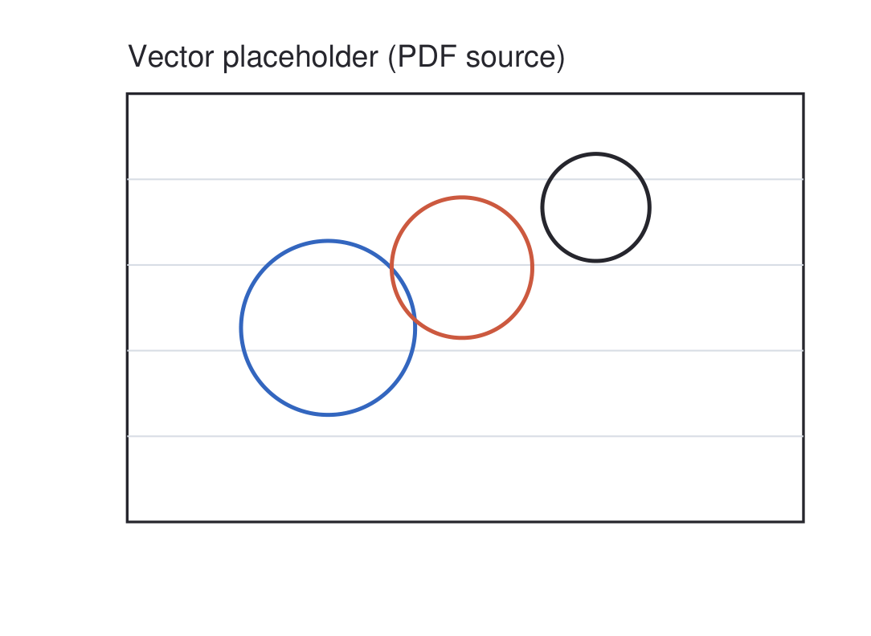
Figure 3: A figure supplied as PDF. The converter rasterises it at 300 dpi before handing the document to pandoc.

Tables
A booktabs table whose numeric columns are plain c columns holding pre-formatted values. siunitx S columns are deliberately avoided in a line-numbered document: lineno redefines the row separator, which breaks siunitx’s table collector. Word has no decimal-aligned column type anyway, so the values have to be formatted by hand either way.
Case | Label | Response | Count
A | baseline | $0.279±0.023$​ | 50
B | uniform loading | $0.281±0.024$​ | 50
C | constant pressure | $0.372±0.044$​ | 48
D | ramped input | $0.316±0.030$​ | 49
Table 1: Summary of placeholder measurements, reported as mean $±$ standard deviation across repeats.
As reported in Table 1, case C differs from the baseline while the others do not. The corresponding trajectories appear in Figure 2, and the derivation behind Eq. (4) is given in Appendix A.

Discussion
Text after the floats, to confirm that the body resumes cleanly. A URL in running prose must become a clickable link with its trailing punctuation excluded: see https://doi.org/10.1000/placeholder.2020.101. A bare URL inside parentheses is the case that used to break, because the closing parenthesis was swallowed into the link target (https://example.org/path_with_parens).

Supporting derivation
Appendix headings are lettered rather than numbered, and cross-references to them must say "Appendix A" – that is what \crefalias in the preamble arranges. Referring back to the body still works: see Section 2 and Eq. (1).
Starting from Eq. (1) and projecting onto the equilibrium profile,
$v_{n}\frac{σ}{κ}=\frac{1}{2}ME\int_{0}^{1}{h^{′}}(u) \hat{q}(u) du,$ (6)
which reduces, to leading order, to
$v_{n}=M\left(W_{2}−W_{1}\right).$
The unnumbered form above is deliberate: it is an intermediate step, not a result, and it must not consume an equation number.

Numerical parameters
A second appendix, so the converter has to recognise more than one appendix title. The parameters used throughout are collected in Table 2.
Symbol | Value | Units
$M$​ | 2.0 | s⁻¹
$κ$​ | 1.0 × 10⁻¹⁶ | m² s⁻¹
$E$​ | 9.4 | GPa
Table 2: Placeholder numerical parameters.
The relative tolerance was 1 × 10⁻⁶, the grid spacing 25 nm, and the domain 10 µm×1 µm. Robust statistics follow Noe and Roe [5].

References
[1] Jane Doe and Richard Roe. A placeholder study of diffusion in layered media. Journal of Placeholder Results, 12 (3): 101–118, 2020. doi: https://doi.org/10.1000/placeholder.2020.101.
[2] Richard Roe, Ada Poe, and Sam Moe. Kinetics of an entirely fictional phase transformation. Examples in Applied Science, 5: 44–59, 2021. doi: https://doi.org/10.1000/placeholder.2021.44.
[3] Ada Poe. Methods for Documents That Do Not Exist. Fictional Press, Nowhere, 2019.
[4] Sam Moe and Jane Doe. Imaging protocols for synthetic microstructures. Placeholder Microscopy, 8 (2): 77–90, 2022. doi: https://doi.org/10.1000/placeholder.2022.77.
[5] Kim Noe and Richard Roe. Robust statistics for made-up populations. Statistics for Examples, 31: 203–221, 2023. doi: https://doi.org/10.1000/placeholder.2023.203.

