**Project Description**

The Habit Tracker Web Application aims to help users build and maintain positive daily routines through a simple, data-driven interface.

It enables users to create habits, record daily progress, visualize long-term performance and set notification to calendar.

The project is built with Node + Express + Mongo + HTML5.

**User Persona**

Information

* Name: Lily Li
* Age: 25
* Occupation: Graduate Student in Computer Science
* Location: Boston, MA

Behavioral Traits

* Goal-oriented: She sets clear, measurable goals and values steady progress over perfection.
* Organized: Uses Google Calendar and reminder apps daily to stay on schedule.
* Data-motivated: Visual progress and measurable streaks drive her motivation.
* Minimalism: Enjoys simple, focused tools over complex apps with overwhelming contents.

Goals

* Build and maintain consistent daily habits such as exercise, studying, and drinking water.
* Keep all habit reminders synchronized across devices through her calendar.
* Receive automatic notifications before scheduled habit times.
* Track progress visually through data-driven insights and boost her motivation.
* Manage all habits and progress easily.

Pain Points

* Forgets habits when reminders don’t stay in sync between her app and calendar.
* Finds most habit apps either too cluttered with unnecessary social features, functions and ads.
* Wants a lightweight solution that combines habit tracking + reminders in one place.

Motivations

* Feels satisfied and motivated when she can see a complete streak history and performance results.
* Appreciates apps that blend into her existing workflow (e.g., Google Calendar).
* Seeks consistency and autonomy rather than social comparison.

**User Stories**

Login & Auth & Setting — Chirag

* As a user, I can sign up, sign in, and sign out securely.
* As a user, I can access only my own data once authenticated.
* As a user, I can set up my information.

Habits Manage — Zhuoyu

* As a user, I can manage(add/delete) all the habits.

Habits Checkin — Zhuoyu

* As a user, I can check in when the habits are completed for today and track daily habits progress.

Habits Statistics — Zhuoyu

* As a user, I can track all the habits statistics(today's rate, longest streak, average streak, total check-ins, and best performing habits).

Calendar Subscription Integration — Chirag

* As a user, I can subscript habits' notifications to my calendar(Google, Apple, etc.).

**Design Mockups**

— created by using Figma

Sign in/ Sign up Page

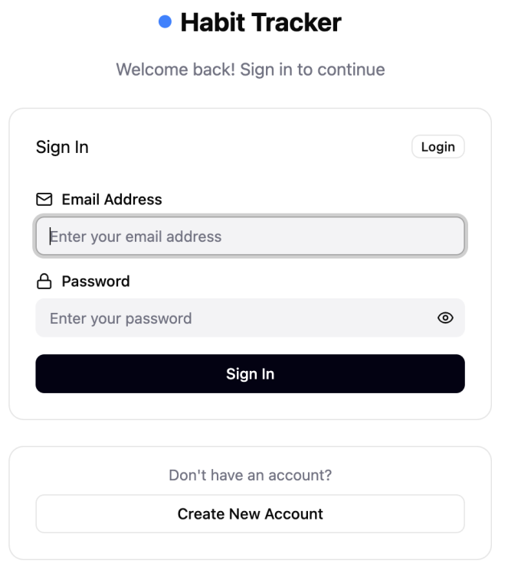

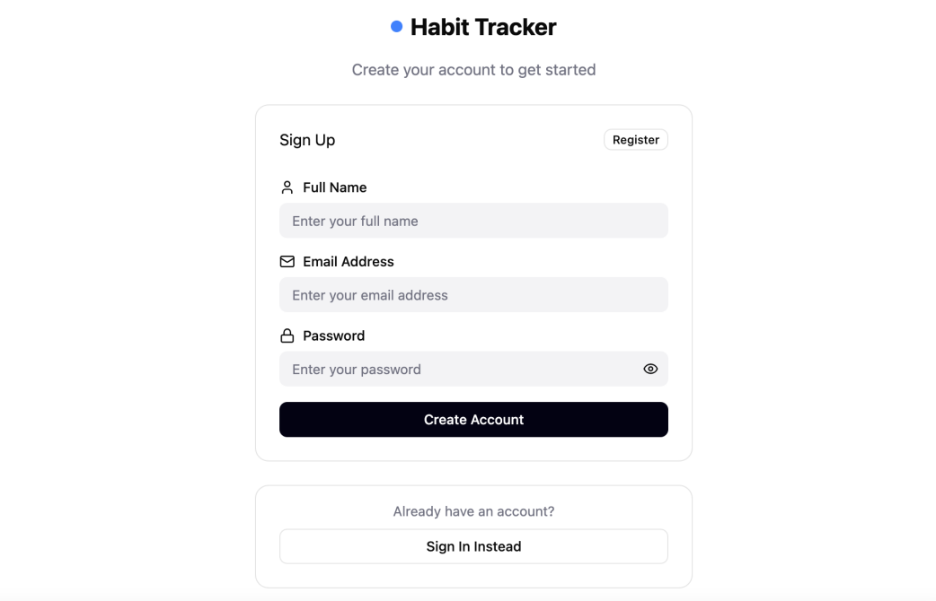

User setting and Sign out Card

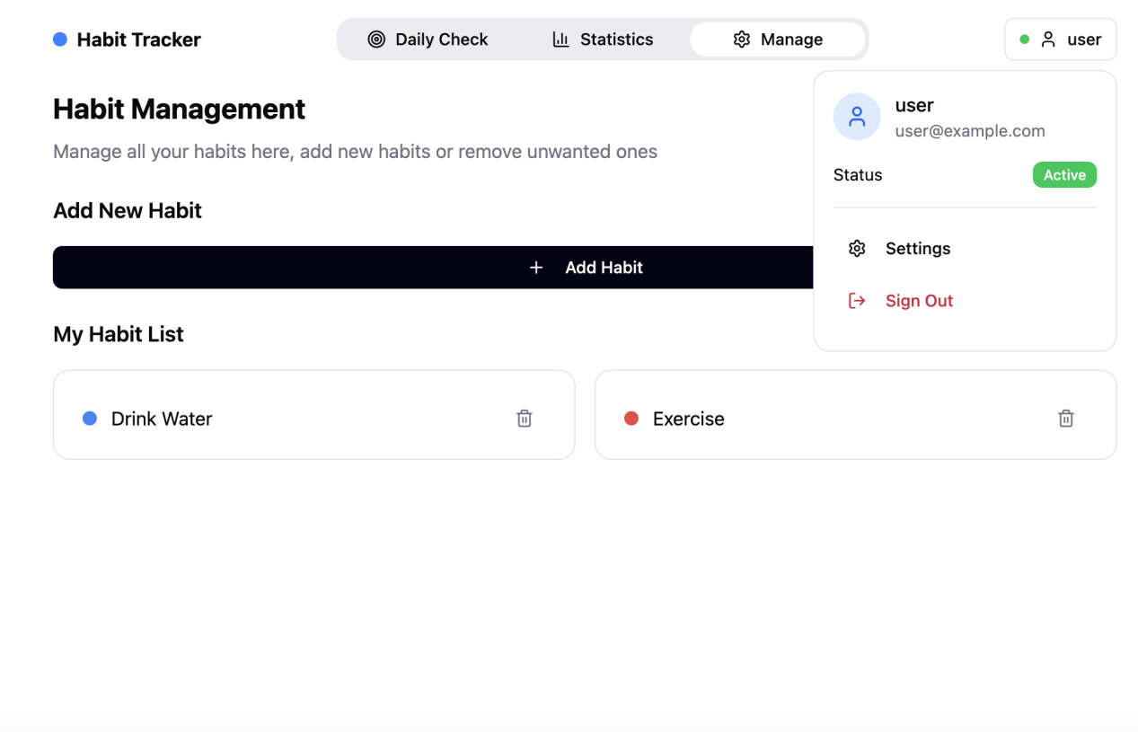

Daily Check Page

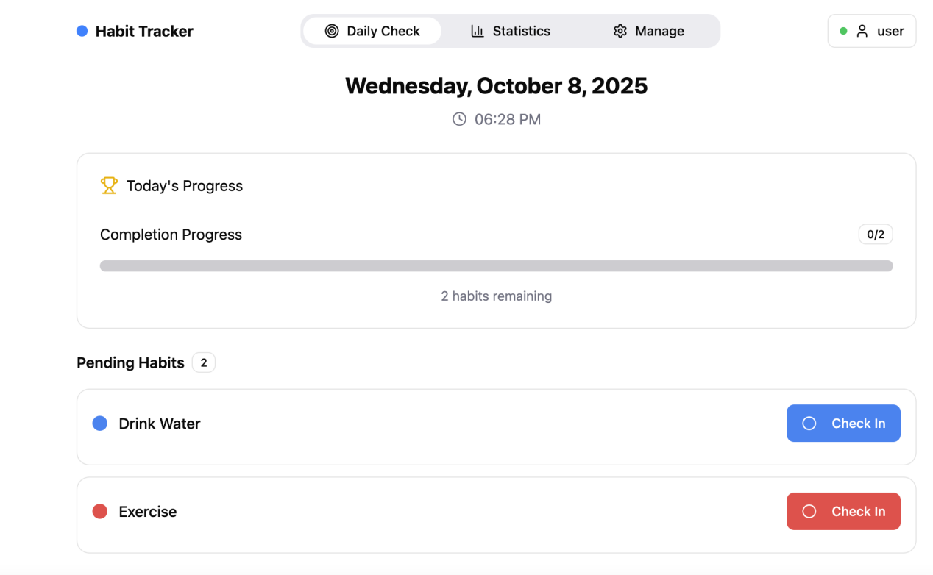

Statistics page

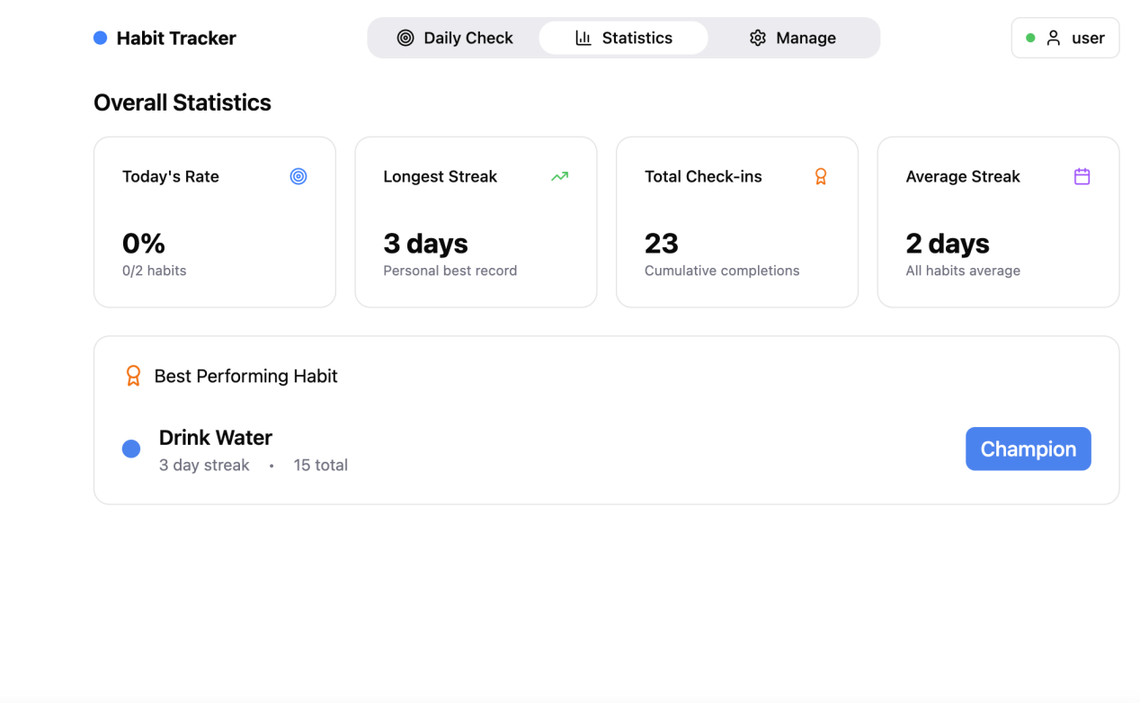

Manage Page

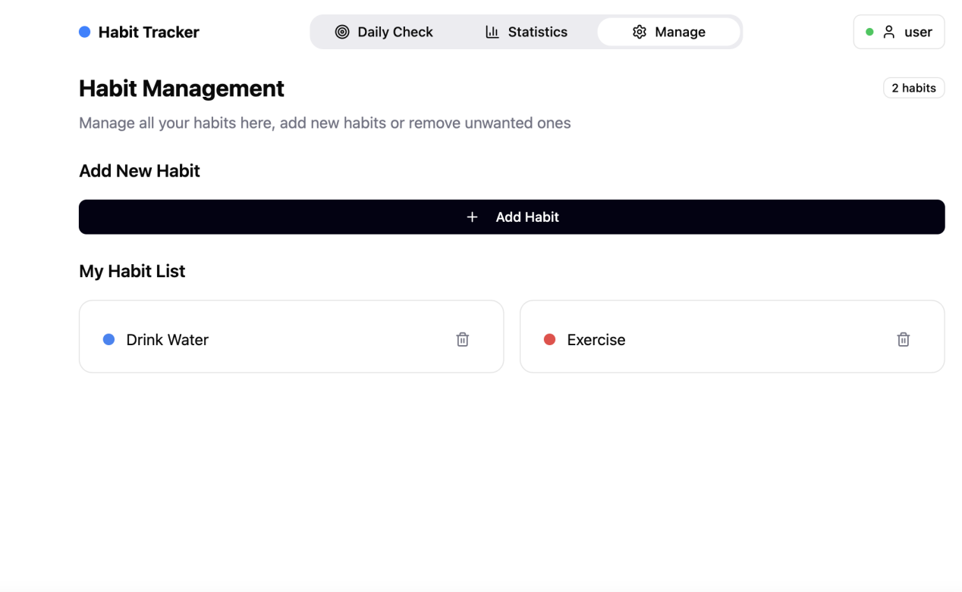

Add Habit Form

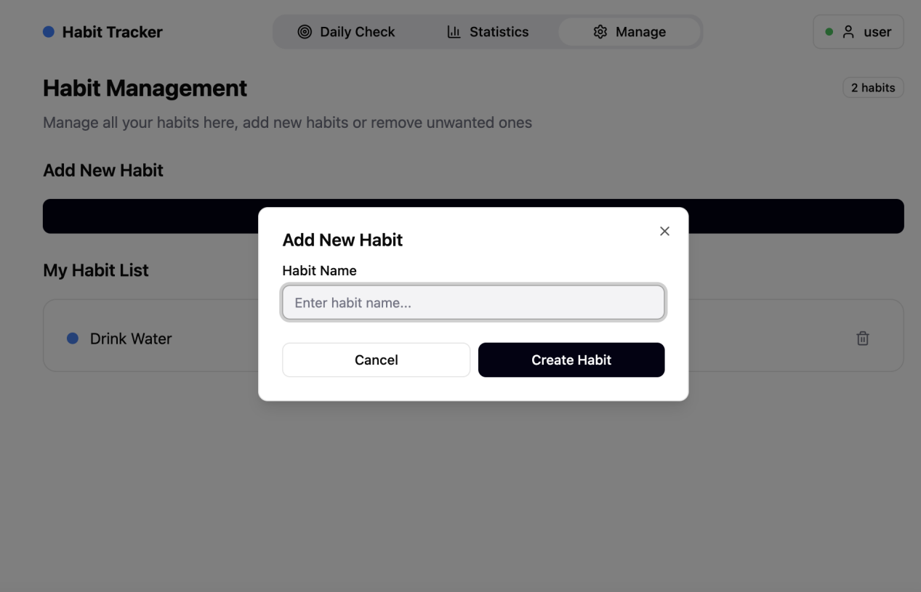

Setting Page

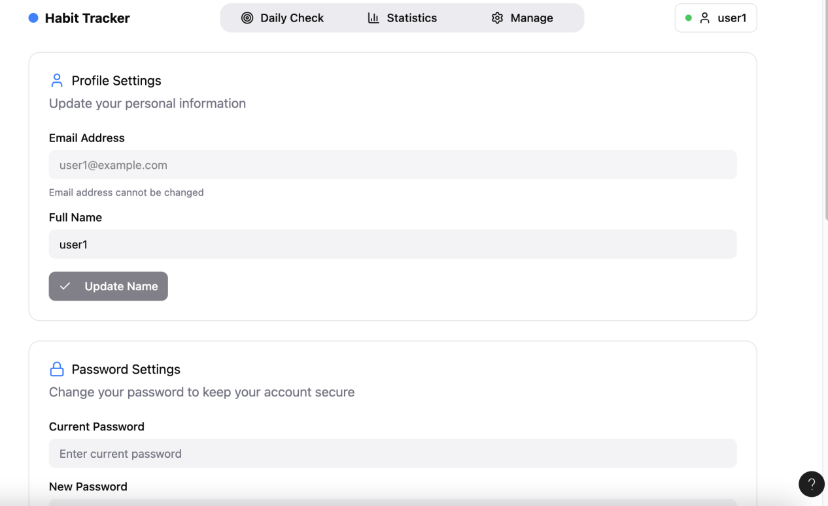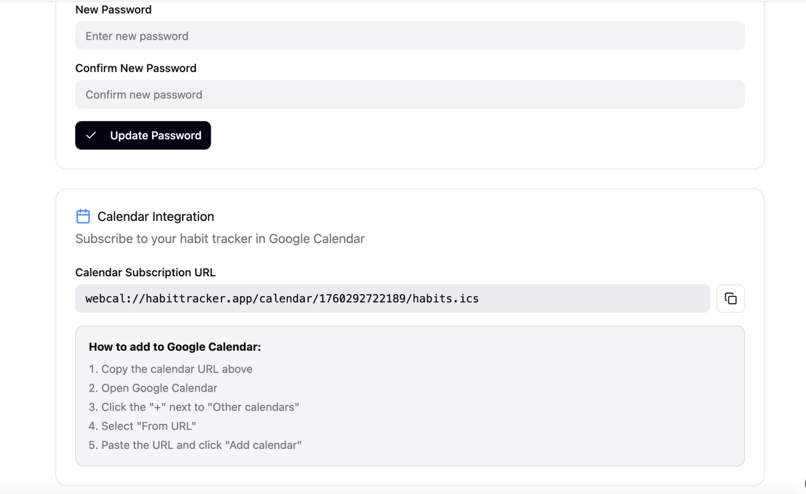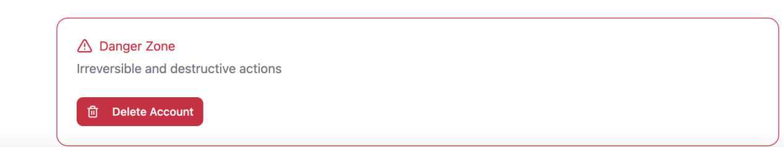

**Database**

There are 50 users + 50 * 10 habits + 1500 checkins = 2050 records in total

