Band-Gap Machine Learning: A Six-Dataset Report
University of Missouri — Evan Research Group

1. Overview
We study six public datasets of inorganic band gaps, spanning three orders of magnitude in size (1.3k–106k materials), the full range of zero-inflation (0–96% metals), and several target types (PBE, GLLB-SC, experimental, and a fitted surrogate). All models use Magpie composition descriptors plus each dataset's native numeric columns, with gradient-boosted trees (XGBoost).
Dataset | N | Target | Non-zero | Gap range eV (nz median) | Notes
Expt gap | 6,354 | gap expt (experimental) | 61.3% | 0.02–11.70 (1.83) | composition-only; solid solutions present
MP gap | 106,113 | gap pbe (PBE) | 56.5% | 0.02–9.72 (1.95) | Materials Project; composition from structures
Wolverton oxides | 4,914 | gap pbe (PBE) | 20.8% | 0.19–6.22 (1.45) | ABO3; structural + energetic features
Castelli | 18,928 | gap gllbsc (GLLB-SC) | 3.9% | 0.20–7.00 (1.40) | cubic perovskites; electronic features
Double perovskites | 1,306 | gap gllbsc (GLLB-SC) | 100% | 0.11–8.34 (4.07) | A2BB'O6; no zero gaps
Tol-screened | 67,916 | Band gap(HSE-mf1) | 100% | 0.88–6.52 (3.36) | solid-solution grid; surrogate target; no zeros

2. Key cross-dataset findings

2.1 Aggregate accuracy hides poor regression on semiconductors
Because band-gap datasets are zero-inflated (most candidates are metals), a single regressor earns a high aggregate accuracy dominated by trivially-correct metals while doing poorly on the materials that actually have a gap. Reporting non-zero-material MAE exposes this. On Castelli, aggregate accuracy is 0.93 while the non-zero MAE is ~1 eV.
Dataset (single-stage baseline) | Aggregate acc <0.07 eV | Non-zero acc <0.07 eV | Non-zero MAE (eV)
Expt gap | 0.317 | 0.220 | 0.356
MP gap (106k) | 0.313 | 0.093 | 0.601
Wolverton | 0.656 | 0.204 | 0.435
Castelli | 0.925 | 0.038 | 1.013

2.2 A two-stage model, and an honest decomposition
A metal/non-metal classifier gating a regressor trained only on non-zero-gap materials (log target) lowers non-zero MAE by 23–42% end-to-end. But a leak-free nested cross-validation that holds features constant shows most of that gain comes from the richer features, not the two-stage structure. The pure method effect is modest where rich descriptors exist (Wolverton −4.8%, n.s.; Castelli −8.6%, p=0.007) but substantial on composition-only data (expt_gap −14.7%, p=1e-5; MP gap −7.8%, all folds).
Dataset | Single-stage MAE | Two-stage MAE | Method effect
Expt gap (composition-only) | 0.356 | 0.304 | −14.7% (p=1e-5)
MP gap (106k) | 0.601 | 0.554 | −7.8% (all folds)
Wolverton | 0.364 | 0.347 | −4.8% (n.s.)
Castelli | 0.651 | 0.595 | −8.6% (p=0.007)
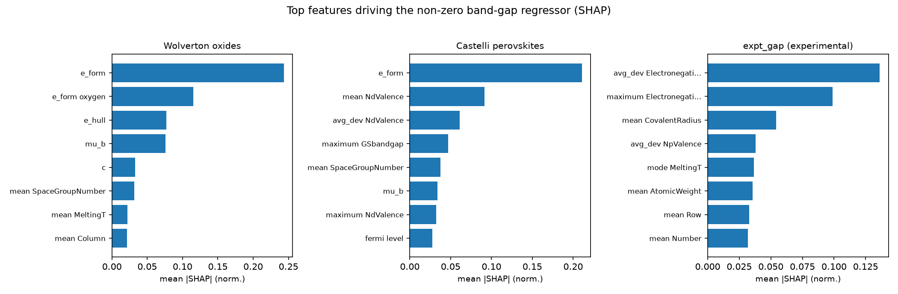
Figure: SHAP feature importance per dataset. Energetic descriptors dominate Wolverton (51% of total importance); electronegativity statistics drive the experimental set.

2.3 Random-split optimism is concentrated on solid-solution datasets
Random train/test splits can place near-identical compositions on both sides, overstating generalization. The size of this effect is dataset-dependent. A simple redundancy count does NOT predict it (Pearson r=0.54, n.s.) — Castelli has 49% repeated compositions yet no optimism. The factor that does separate the datasets is the share of solid-solution (fractional) compositions, which let the model interpolate within a continuous composition family. Optimism is large only on those sets (Tol 99.8% fractional, expt_gap 21.5%) and negligible on collections of distinct compounds; the solid-solution share tracks optimism with Spearman 0.90.
Dataset | Solid-solution share | Optimism (by-chemistry / random MAE)
Tol-screened | 99.8% | 1.64×
Expt gap | 21.5% | 1.55×
MP gap (106k) | ~0% (polymorph duplicates) | 1.14×
Wolverton | 1.3% | 1.02×
Castelli | 0.5% | 1.00×
Double perovskites | 0.0% | 1.01×
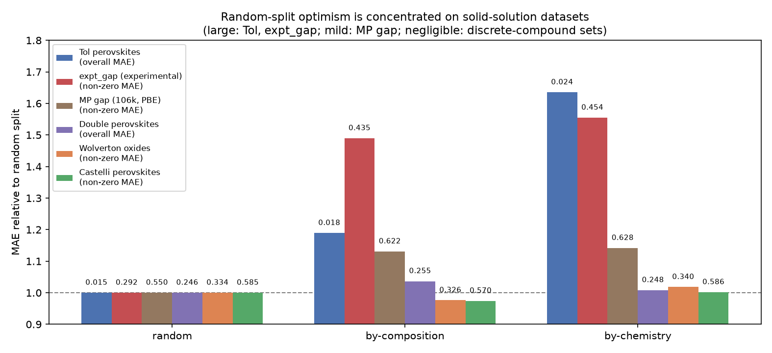
Figure: MAE under leakage-controlled splits, relative to a random split, for all six datasets. Optimism is large on the solid-solution sets, mild on MP gap, negligible elsewhere.
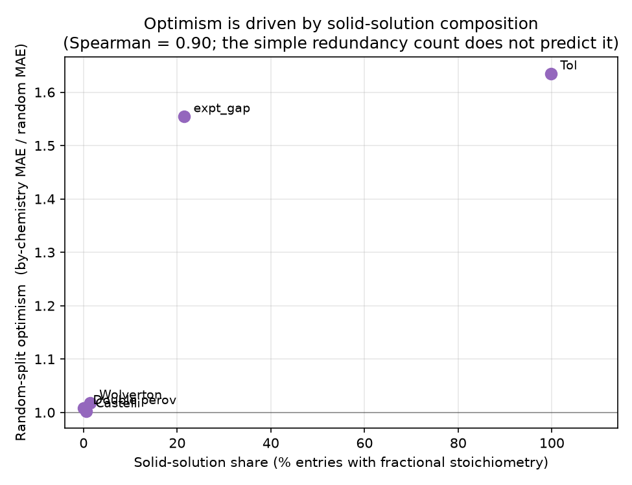
Figure: Random-split optimism vs. solid-solution share (Spearman 0.90). A simple redundancy count does not predict optimism (r=0.54, n.s.).

2.4 Data-limited, and the no-zero datasets
Learning curves show Castelli and expt_gap are still improving at full training size — data-limited, not algorithm-limited. The two no-zero datasets (Double perovskites, Tol) need no two-stage gating: Tol's surrogate target is nearly deterministic (R²≈0.9998, MAE 0.015 eV) and even survives chemistry-extrapolation at R²≈0.999, while the double-perovskite set (1,306 distinct compounds) regresses to MAE ≈ 0.25 eV with no split optimism.
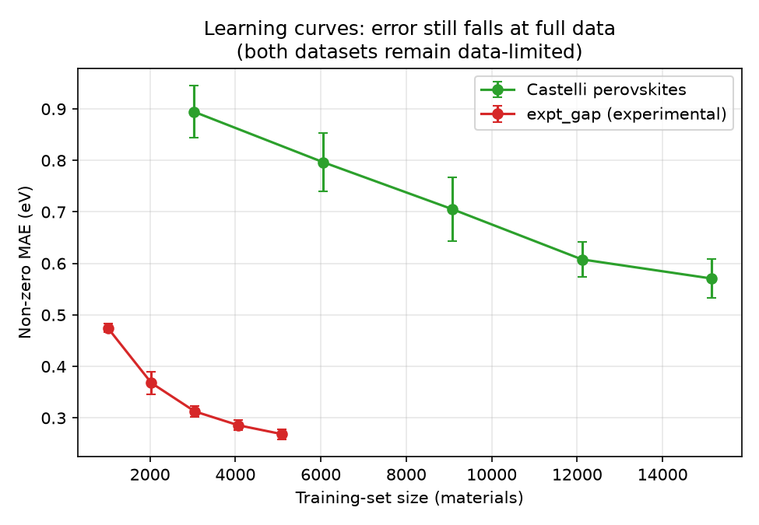
Figure: Learning curves. Neither data-limited dataset has plateaued at full size.

3. Takeaways
- Report non-zero-material MAE alongside aggregate accuracy on zero-inflated band-gap data; aggregate accuracy is dominated by metals and is misleading.
- The two-stage classify-then-regress model helps most when only composition features are available; with rich structural/energetic features, the features carry most of the gain.
- Run a grouped (by-chemistry) split as a cheap diagnostic — it matters most for datasets containing solid solutions (alloys, mixed-site screening grids).
- Energetic descriptors (formation/hull energy) are the single most informative feature group for the oxide gaps; electronegativity statistics drive the experimental set.

Generated from the analysis scripts in scripts/ (see reproduce_all.py). All numbers are 5–10-fold cross-validated unless noted.

