《MATLAB语言》课程实践报告
姓名 朱琪 专业 工业工程 学号 2022104565 编号 58
电邮2191199803@qq.com 联系电话13536557135日期 2023年10月29日
代码：
主程序：
load(' C:\Users\Administrator\Desktop\indirect\Hcaca\Hca1ca1.mat')
fca1ca1=a0;
a4ca1ca1=a4;
a5ca1ca1=a5;
Hca1ca1=[a4ca1ca1+1i*a5ca1ca1]./(-(2*pi*fca1ca1).^2);
load(' C:\Users\Administrator\Desktop\indirect\Hcaca\Hca1ca2.mat')
fca1ca2=a0;
a4ca1ca2=a4;
a5ca1ca2=a5;
Hca1ca2=[a4ca1ca2+1i*a5ca1ca2]./(-(2*pi*fca1ca2).^2);
load(' C:\Users\Administrator\Desktop \indirect\Hcaca\Hca2ca1.mat')
fca2ca1=a0;
a4ca2ca1=a4;
a5ca2ca1=a5;
Hca2ca1=[a4ca2ca1+j*a5ca2ca1]./(-(2*pi*fca2ca1).^2);
load(' C:\Users\Administrator\Desktop \indirect\Hcaca\Hca2ca2.mat')
fca2ca2=a0;
a4ca2ca2=a4;
a5ca2ca2=a5;
Hca2ca2=[a4ca2ca2+j*a5ca2ca2]./(-(2*pi*fca2ca2).^2);
load(' C:\Users\Administrator\Desktop \indirect\Hcbcb\Hcb1cb1.mat')
fcb1cb1=a0;
a4cb1cb1=a4;
a5cb1cb1=a5;
Hcb1cb1=[a4cb1cb1+j*a5cb1cb1]./(-(2*pi*fcb1cb1).^2);
load(' C:\Users\Administrator\Desktop \indirect\Hcbcb\Hcb1cb2.mat')
fcb1cb1=a0;
clear fcb1cb1
fcb1cb2=a0;
a4cb1cb2=a4;
a5cb1cb2=a5;
Hcb1cb2=[a4cb1cb2+j*a5cb1cb2]./(-(2*pi*fcb1cb2).^2);
load(' C:\Users\Administrator\Desktop \indirect\Hcbcb\Hcb2cb1.mat')
fcb2cb1=a0;
a4cb2cb1=a4;
a5cb2cb1=a5;
Hcb2cb1=[a4cb2cb1+j*a5cb2cb1]./(-(2*pi*fcb2cb1).^2);
load(' C:\Users\Administrator\Desktop \indirect\Hcbcb\Hcb2cb2.mat')
fcb2cb2=a0;
a4cb2cb2=a4;
a5cb2cb2=a5;
Hcb2cb2=[a4cb2cb2+j*a5cb2cb2]./(-(2*pi*fcb2cb2).^2);
load(' C:\Users\Administrator\Desktop \indirect\Hoaca\Hoa1ca1.mat')
foa1ca1=a0;
a4oa1ca1=a4;
a5oa1ca1=a5;
Hoa1ca1=[a4oa1ca1+j*a5oa1ca1]./(-(2*pi*foa1ca1).^2);
load(' C:\Users\Administrator\Desktop \indirect\Hoaca\Hoa1ca2.mat')
foa1ca2=a0;
a4oa1ca2=a4;
a5oa1ca2=a5;
Hoa1ca2=[a4oa1ca2+j*a5oa1ca2]./(-(2*pi*foa1ca2).^2);
load(' C:\Users\Administrator\Desktop \indirect\Hoaca\Hoa2ca1.mat')
foa2ca1=a0;
a4oa2ca1=a4;
a5oa2ca1=a5;
Hoa2ca1=[a4oa2ca1+j*a5oa2ca1]./(-(2*pi*foa2ca1).^2);
load(' C:\Users\Administrator\Desktop \indirect\Hoaca\Hoa2ca2.mat')
foa2ca2=a0;
a4oa2ca2=a4;
a5oa2ca2=a5;
Hoa2ca2=[a4oa2ca2+j*a5oa2ca2]./(-(2*pi*foa2ca2).^2);
load(' C:\Users\Administrator\Desktop \indirect\Hcbib\Hcb1ib1.mat')
fcb1ib1=a0;
a4cb1ib1=a4;
a5cb1ib1=a5;
Hcb1ib1=[a4cb1ib1+j*a5cb1ib1]./(-(2*pi*fcb1ib1).^2);
load(' C:\Users\Administrator\Desktop \indirect\Hcbib\Hcb1ib2.mat')
fcb1ib2=a0;
a4cb1ib2=a4;
a5cb1ib2=a5;
Hcb1ib2=[a4cb1ib2+j*a5cb1ib2]./(-(2*pi*fcb1ib2).^2);
load(' C:\Users\Administrator\Desktop \indirect\Hcbib\Hcb2ib1.mat')
fcb2ib1=a0;
a4cb2ib1=a4;
a5cb2ib1=a5;
Hcb2ib1=[a4cb2ib1+j*a5cb2ib1]./(-(2*pi*fcb2ib1).^2);
load(' C:\Users\Administrator\Desktop \indirect\Hcbib\Hcb2ib2.mat')
fcb2ib2=a0;
a4cb2ib2=a4;
a5cb2ib2=a5;
Hcb2ib2=[a4cb2ib2+j*a5cb2ib2]./(-(2*pi*fcb2ib2).^2);
load(' C:\Users\Administrator\Desktop \indirect\Hsoaib\Hsoa1ib1.mat')
fsoa1ib1=a0;
a4soa1ib1=a4;
a5soa1ib1=a5;
Hsoa1ib1=[a4soa1ib1+j*a5soa1ib1]./(-(2*pi*fsoa1ib1).^2);
load(' C:\Users\Administrator\Desktop \indirect\Hsoaib\Hsoa1ib2.mat')
fsoa1ib2=a0;
a4soa1ib2=a4;
a5soa1ib2=a5;
Hsoa1ib2=[a4soa1ib2+j*a5soa1ib2]./(-(2*pi*fsoa1ib2).^2);
load(' C:\Users\Administrator\Desktop \indirect\Hsoaib\Hsoa2ib1.mat')
fsoa2ib1=a0;
a4soa2ib1=a4;
a5soa2ib1=a5;
Hsoa2ib1=[a4soa2ib1+j*a5soa2ib1]./(-(2*pi*fsoa2ib1).^2);
load(' C:\Users\Administrator\Desktop \indirect\Hsoaib\Hsoa2ib2.mat')
fsoa2ib2=a0;
a4soa2ib2=a4;
a5soa2ib2=a5;
Hsoa2ib2=[a4soa2ib2+j*a5soa2ib2]./(-(2*pi*fsoa2ib2).^2);
for i=2:1:401
Hcbib=[Hcb1ib1(i),Hcb1ib2(i);Hcb2ib1(i),Hcb2ib2(i)];
Hsoaib=[Hsoa1ib1(i),Hsoa1ib2(i);Hsoa2ib1(i),Hsoa2ib2(i)];
Hoaca=[Hoa1ca1(i),Hoa1ca2(i);Hoa2ca1(i),Hoa2ca1(i)];
Hcbcb=[Hcb1cb1(i),Hcb1cb2(i);Hcb2cb1(i),Hcb2cb2(i)];
Hcaca=[Hca1ca1(i),Hca1ca2(i);Hca2ca1(i),Hca2ca2(i)];
Ks=inv(Hcbib*inv(Hsoaib)*Hoaca-Hcaca-Hcbcb);
Ks11ind(i)=Ks(1,1);
Ks22ind(i)=Ks(2,2)
end
load(C:\Users\Administrator\Desktop \direct\Hscaca\Hsca1ca1.mat')
fsca1ca1=a0;
a4sca1ca1=a4;
a5sca1ca1=a5;
Hsca1ca1=[a4sca1ca1+j*a5sca1ca1]./(-(2*pi*fsca1ca1).^2);
load(' C:\Users\Administrator\Desktop \direct\Hscaca\Hsca1ca2.mat')
fsca1ca2=a0;
a4sca1ca2=a4;
a5sca1ca2=a5;
Hsca1ca2=[a4sca1ca2+j*a5sca1ca2]./(-(2*pi*fsca1ca2).^2);
load(' C:\Users\Administrator\Desktop \direct\Hscaca\Hsca2ca1.mat')
fsca2ca1=a0;
a4sca2ca1=a4;
a5sca2ca1=a5;
Hsca2ca1=[a4sca2ca1+j*a5sca2ca1]./(-(2*pi*fsca2ca1).^2);
load(' C:\Users\Administrator\Desktop \direct\Hscaca\Hsca2ca2.mat')
fsca2ca2=a0;
a4sca2ca2=a4;
a5sca2ca2=a5;
Hsca2ca2=[a4sca2ca2+j*a5sca2ca2]./(-(2*pi*fsca2ca2).^2);
load(' C:\Users\Administrator\Desktop \direct\Hscacb\Hsca1cb1.mat')
fsca1cb1=a0;
a4sca1cb1=a4;
a5sca1cb1=a5;
Hsca1cb1=[a4sca1cb1+j*a5sca1cb1]./(-(2*pi*fsca1cb1).^2);
load(' C:\Users\Administrator\Desktop \direct\Hscacb\Hsca1cb2.mat')
fsca1cb2=a0;
a4sca1cb2=a4;
a5sca1cb2=a5;
Hsca1cb2=[a4sca1cb2+j*a5sca1cb2]./(-(2*pi*fsca1cb2).^2);
load(' C:\Users\Administrator\Desktop \direct\Hscacb\Hsca2cb1.mat')
fsca2cb1=a0;
a4sca2cb1=a4;
a5sca2cb1=a5;
Hsca2cb1=[a4sca2cb1+j*a5sca2cb1]./(-(2*pi*fsca2cb1).^2);
load(' C:\Users\Administrator\Desktop \direct\Hscacb\Hsca2cb2.mat')
fsca2cb2=a0;
a4sca2cb2=a4;
a5sca2cb2=a5;
Hsca2cb2=[a4sca2cb2+j*a5sca2cb2]./(-(2*pi*fsca2cb2).^2);
load(' C:\Users\Administrator\Desktop \direct\Hscbcb\Hscb1cb1.mat')
fscb1cb1=a0;
a4scb1cb1=a4;
a5scb1cb1=a5;
Hscb1cb1=[a4scb1cb1+j*a5scb1cb1]./(-(2*pi*fscb1cb1).^2);
load(C:\Users\Administrator\Desktop \direct\Hscbcb\Hscb1cb2.mat')
fscb1cb2=a0;
a4scb1cb2=a4;
a5scb1cb2=a5;
Hscb1cb2=[a4scb1cb2+j*a5scb1cb2]./(-(2*pi*fscb1cb2).^2);
load(' C:\Users\Administrator\Desktop \direct\Hscbcb\Hscb2cb1.mat')
fscb2cb1=a0;
a4scb2cb1=a4;
a5scb2cb1=a5;
Hscb2cb1=[a4scb2cb1+j*a5scb2cb1]./(-(2*pi*fscb2cb1).^2);
load(' C:\Users\Administrator\Desktop \direct\Hscbcb\Hscb2cb2.mat')
fscb2cb2=a0;
a4scb2cb2=a4;
a5scb2cb2=a5;
Hscb2cb2=[a4scb2cb2+j*a5scb2cb2]./(-(2*pi*fscb2cb2).^2);
for i=2:1:401
Hscbcb=[Hscb1cb1(i),Hscb1cb2(i);Hscb2cb1(i),Hscb2cb2(i)];
Hscacb=[Hsca1cb1(i),Hsca1cb2(i);Hsca2cb1(i),Hsca2cb2(i)];
Hscaca=[Hsca1ca1(i),Hsca1ca2(i);Hsca2ca1(i),Hsca2ca2(i)];
Ksd=inv(Hscaca*inv(Hscacb')*Hscbcb-Hscacb);
Ks11d(i)=Ksd(1,1);
Ks22d(i)=Ksd(2,2);
end
ks11=197800;
ks22=189300;
cs11=1344.2;
cs22=1625.4;
Ks11=ks11+j*pi*a0*cs11;
Ks22=ks22+j*pi*a0*cs22;
Ks11indf=smoth(Ks11ind);
Ks22indf=smoth(Ks22ind);
Ks11df=smoth(Ks11d);
Ks22df=smoth(Ks22d);
Ks11f=smoth(Ks11);
Ks22f=smoth(Ks22);
f=a0;
subplot(2,1,1)
semilogy(f,Ks11indf,'-r',f,Ks11df,'-b',f,Ks11f,'-g')
legend('间接法','直接法','测量法')
xlabel('Ks11 频率f 单位：Hz');
ylabel('耦合动刚度Ks11（N/m）')
title('耦合动刚度分析');
subplot(2,1,2)
semilogy(f,Ks22indf,'-r',f,Ks22df,'-b',f,Ks22f,'-g')
legend('间接法','直接法','测量法')
xlabel('Ks22 频率f 单位：Hz ')
ylabel('耦合动刚度Ks22（N/m）');

子程序：
function [smothing] = smooth(input)
smooth= smoothdata(abs(input));
smoothing = movmean(smoth,9);
End
2.给出整副含2个比较K_{s11}(f_{k})和K_{s22}(f_{k})模值的子图绘图；
分析比较结果，说明数据处理（“实验验证”）逆子结构动态分析方法在检测机械装配耦合体动刚度的有效性情况。
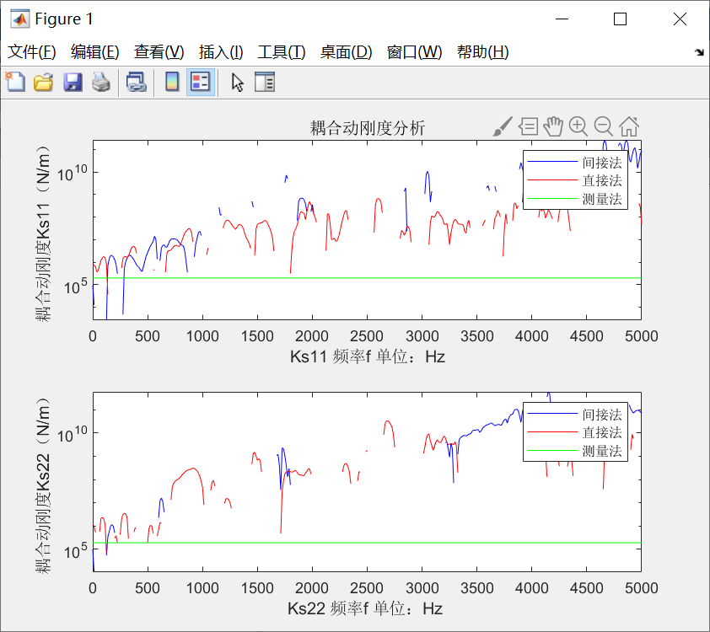

取得了很多数据，并绘制了三种图像，可以看出直接法、间接法在检测机械装配耦合体动刚度实验中是很有效的，二者相差值挺大，但整体水平保持一致，在ks11图中差异较明显，有效性相对而言不算高；在ks22中则相差较小，数据更为可信，有效性更高。

