1.

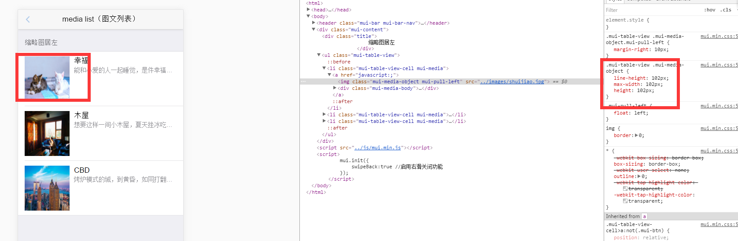

.mui-table-view .mui-media-object {
line-height: 102px;
max-width: 102px;
height: 102px;

