Міністерство освіти і науки України

Черкаський державний технологічний університет

Кафедра програмного забезпечення автоматизованих систем

ЗВІТ

про виконання лабораторної роботи № 2

з дисципліни:

«Об’єктно орієнтоване програмування»

|  |  |
| --- | --- |
| Перевірив:  викладач кафедри ПЗАС  Крайовий В. М .  ____________________  «____» __________ 2016 р. | Виконав:  студент 2 курсу  групи ПЗ-154  Журавленко М. В. |

Черкаси 2016

# Лабораторна робота № 1

**Тема роботи:** Найпростіші програми на Java. Абстракція. Інкапсуляція. Створення і використання власного класу.

**Мета роботи:** Навчитись створювати власні класи, описувати поля та методи. Навчитись використовувати власні класи.

**Індивідуальне завдання:** Створити на мові Java клас, який описує поняття реального світу згідно з варіантом завдання. Клас повинен мати не менше 5 полів, що описують властивості данго поняття та не менше 3 методів, які описують його поведінку. Методи повинні працювати з полями, читати або записувати їх; всі поля повинні бути задіяні в методах. Імена полів повинні починатись з іменника або прикметника, методів - з дієслова. Створити програму, яка створює вікно з чотирма кнопками. При натисненні на першу кнопку повинен створюватись об’єкт нашого класу, при натисненні на кожну з інших кнопок повинен запускатись відповідний метод нашого класу

Варіанти (поняття реального світу для створення класу).

5. Квітка.

**Текст програми на Java:**

import javax.swing.*;

import java.awt.*;

import java.awt.event.*;

import java.util.Random;

//---створення головного класу

class main {

public static void main(String[] args) {

//---Підключення класів

Random random = new Random();

Flower_properties flower_properties_cls = new Flower_properties();

//---Створення головної форми

JFrame Flower = new JFrame("Flower");

Flower.setDefaultCloseOperation(JFrame.EXIT_ON_CLOSE);

Flower.setVisible(true);

JButton create_flower = new JButton("Create Flower");

create_flower.setFont(new Font("Verdana", Font.PLAIN, 15));

create_flower.setPreferredSize(new Dimension(100, 50));

GridLayout flower_grid = new GridLayout(1, 1);

Flower.setLayout(flower_grid);

Flower.getContentPane().add(create_flower);

Flower.setSize(300, 70);

Flower.setResizable(false);

//---створення форми для вибору квітки

JFrame Flower_Choice = new JFrame("Flower Choice");

Flower_Choice.setDefaultCloseOperation(JFrame.EXIT_ON_CLOSE);

Flower_Choice.setVisible(false);

JButton flower_random = new JButton("Create Random Flower");

flower_random.setFont(new Font("Verdana", Font.PLAIN, 15));

flower_random.setPreferredSize(new Dimension(100, 50));

JButton flower_from_list = new JButton("Create Flower From List");

flower_from_list.setFont(new Font("Verdana", Font.PLAIN, 15));

flower_from_list.setPreferredSize(new Dimension(100, 50));

GridLayout create_flower_grid = new GridLayout(1, 2);

Flower_Choice.setLayout(create_flower_grid);

Flower_Choice.getContentPane().add(flower_random);

Flower_Choice.getContentPane().add(flower_from_list);

Flower_Choice.setSize(400, 70);

Flower_Choice.setResizable(false);

//---створення форми для вибору квітки зі списку

JFrame Flower_Choice_From_List = new JFrame("Flower Choice From List");

Flower_Choice.setDefaultCloseOperation(JFrame.EXIT_ON_CLOSE);

Flower_Choice.setVisible(false);

JComboBox<String> flower_list = new JComboBox<>(flower_properties_cls.get_array_name_of_flowers());

flower_list.setFont(new Font("Verdana", Font.PLAIN, 15));

flower_list.setPreferredSize(new Dimension(100, 50));

JButton ok = new JButton("Ok");

ok.setFont(new Font("Verdana", Font.PLAIN, 15));

ok.setPreferredSize(new Dimension(100, 50));

GridLayout flower_list_grid = new GridLayout(2, 1);

Flower_Choice_From_List.setLayout(flower_list_grid);

Flower_Choice_From_List.getContentPane().add(flower_list);

Flower_Choice_From_List.getContentPane().add(ok);

Flower_Choice_From_List.setSize(400, 140);

Flower_Choice_From_List.setResizable(false);

//---творення форми для квітки

JFrame Current_Flower = new JFrame("Current Flower");

Current_Flower.setDefaultCloseOperation(JFrame.EXIT_ON_CLOSE);

Current_Flower.setVisible(false);

JTextField current_flower_name = new JTextField();

current_flower_name.setFont(new Font("Verdana", Font.PLAIN, 15));

JTextField current_flower_number_of_blades = new JTextField();

current_flower_number_of_blades.setFont(new Font("Verdana", Font.PLAIN, 15));

JTextField current_flower_height_of_flowers = new JTextField();

current_flower_height_of_flowers.setFont(new Font("Verdana", Font.PLAIN, 15));

JTextField current_flower_make_tea = new JTextField();

current_flower_make_tea.setFont(new Font("Verdana", Font.PLAIN, 15));

JTextField current_flower_color_of_blades = new JTextField();

current_flower_color_of_blades.setFont(new Font("Verdana", Font.PLAIN, 15));

JTextField current_flower_healing_porperties = new JTextField();

current_flower_healing_porperties.setFont(new Font("Verdana", Font.PLAIN, 15));

JTextField current_flower_the_place_where_they_grows = new JTextField();

current_flower_the_place_where_they_grows.setFont(new Font("Verdana", Font.PLAIN, 15));

JTextField current_flower_familia_of_flowers = new JTextField();

current_flower_familia_of_flowers.setFont(new Font("Verdana", Font.PLAIN, 15));

JTextField current_flower_form_of_blades = new JTextField();

current_flower_form_of_blades.setFont(new Font("Verdana", Font.PLAIN, 15));

JTextField current_flower_domain_of_flowers = new JTextField();

current_flower_domain_of_flowers.setFont(new Font("Verdana", Font.PLAIN, 15));

JTextField current_flower_regnum_of_flowers = new JTextField();

current_flower_regnum_of_flowers.setFont(new Font("Verdana", Font.PLAIN, 15));

JTextField current_flower_division_of_flowers = new JTextField();

current_flower_division_of_flowers.setFont(new Font("Verdana", Font.PLAIN, 15));

JTextField current_flower_classis_of_flowers = new JTextField();

current_flower_classis_of_flowers.setFont(new Font("Verdana", Font.PLAIN, 15));

JTextField current_flower_ordo_of_flowers = new JTextField();

current_flower_ordo_of_flowers.setFont(new Font("Verdana", Font.PLAIN, 15));

JTextField current_flower_genus_of_flowers = new JTextField();

current_flower_genus_of_flowers.setFont(new Font("Verdana", Font.PLAIN, 15));

JButton current_flower_plant_flower = new JButton("Plant Flower");

current_flower_plant_flower.setFont(new Font("Verdana", Font.PLAIN, 15));

JButton current_flower_watered_flower = new JButton("Watered Flower");

current_flower_watered_flower.setFont(new Font("Verdana", Font.PLAIN, 15));

JButton current_flower_tear_off_petal = new JButton("Tear Off Petal");

current_flower_tear_off_petal.setFont(new Font("Verdana", Font.PLAIN, 15));

JButton current_flower_pick_the_flower = new JButton("Pick the flower");

current_flower_pick_the_flower.setFont(new Font("Verdana", Font.PLAIN, 15));

JTextField current_flower_water_level = new JTextField();

current_flower_water_level.setFont(new Font("Verdana", Font.PLAIN, 15));

JTextField current_flower_level_of_nutrients = new JTextField();

current_flower_level_of_nutrients.setFont(new Font("Verdana", Font.PLAIN, 15));

JTextField current_flower_new_number_of_blades = new JTextField();

current_flower_new_number_of_blades.setFont(new Font("Verdana", Font.PLAIN, 15));

JTextField current_flower_is_plant_flower = new JTextField();

current_flower_is_plant_flower.setFont(new Font("Verdana", Font.PLAIN, 15));

JPanel current_flower_info_jpanel = new JPanel(new GridLayout(5, 3));

current_flower_info_jpanel.setPreferredSize(new Dimension(900, 800));

current_flower_info_jpanel.add(current_flower_name);

current_flower_info_jpanel.add(current_flower_number_of_blades);

current_flower_info_jpanel.add(current_flower_height_of_flowers);

current_flower_info_jpanel.add(current_flower_make_tea);

current_flower_info_jpanel.add(current_flower_color_of_blades);

current_flower_info_jpanel.add(current_flower_healing_porperties);

current_flower_info_jpanel.add(current_flower_the_place_where_they_grows);

current_flower_info_jpanel.add(current_flower_familia_of_flowers);

current_flower_info_jpanel.add(current_flower_form_of_blades);

current_flower_info_jpanel.add(current_flower_domain_of_flowers);

current_flower_info_jpanel.add(current_flower_regnum_of_flowers);

current_flower_info_jpanel.add(current_flower_division_of_flowers);

current_flower_info_jpanel.add(current_flower_classis_of_flowers);

current_flower_info_jpanel.add(current_flower_ordo_of_flowers);

current_flower_info_jpanel.add(current_flower_genus_of_flowers);

JPanel current_flower_action_jpanel = new JPanel(new GridLayout(4, 1));

current_flower_action_jpanel.add(current_flower_plant_flower);

current_flower_action_jpanel.add(current_flower_watered_flower);

current_flower_action_jpanel.add(current_flower_tear_off_petal);

current_flower_action_jpanel.add(current_flower_pick_the_flower);

JPanel current_flower_action_info_jpanel = new JPanel(new GridLayout(4, 1));

current_flower_action_info_jpanel.add(current_flower_water_level);

current_flower_action_info_jpanel.add(current_flower_level_of_nutrients);

current_flower_action_info_jpanel.add(current_flower_new_number_of_blades);

current_flower_action_info_jpanel.add(current_flower_is_plant_flower);

Container current_flower_container = Current_Flower.getContentPane();

current_flower_container.setLayout(new GridLayout(3, 1));

current_flower_container.add(current_flower_info_jpanel);

current_flower_container.add(current_flower_action_jpanel);

current_flower_container.add(current_flower_action_info_jpanel);

Current_Flower.setSize(900, 700);

Current_Flower.setResizable(false);

//---Створення обробників натискання кнопо

create_flower.addActionListener(new ActionListener() {

@Override

public void actionPerformed(ActionEvent e) {

Flower_Choice.setVisible(true);

}

}

);

flower_random.addActionListener(new ActionListener() {

@Override

public void actionPerformed(ActionEvent e) {

int rnd = random.nextInt(5);

flower_properties_cls.rrr = flower_properties_cls.get_number_of_blades(rnd);

current_flower_name.setText("the name of flower - \n" + flower_properties_cls.get_name_of_flowers(rnd));

current_flower_number_of_blades.setText("the number of blades - \n" + Integer.toString(flower_properties_cls.get_number_of_blades(rnd)));

current_flower_height_of_flowers.setText("the height of flower - \n" + Integer.toString(flower_properties_cls.get_height_of_flowers(rnd)));

current_flower_make_tea.setText("can i make a tea with flower ? - \n" + Boolean.toString(flower_properties_cls.get_make_tea(rnd)));

current_flower_color_of_blades.setText("the color of flower blades - \n" + flower_properties_cls.get_color_of_blades(rnd));

current_flower_healing_porperties.setText("the healing porperties of this flower - \n" + flower_properties_cls.get_healing_porperties(rnd));

current_flower_the_place_where_they_grows.setText("the place where they grows - \n" + flower_properties_cls.get_the_place_where_they_grows(rnd));

current_flower_familia_of_flowers.setText("the familia of flowers - \n" + flower_properties_cls.get_familia_of_flowers(rnd));

current_flower_form_of_blades.setText("the form of blades - \n" + flower_properties_cls.get_form_of_blades(rnd));

current_flower_domain_of_flowers.setText("the domain of flowers - \n" + flower_properties_cls.get_domain_of_flowers(rnd));

current_flower_regnum_of_flowers.setText("the regnum of flowers - \n" + flower_properties_cls.get_regnum_of_flowers(rnd));

current_flower_division_of_flowers.setText("the division of flowers - \n" + flower_properties_cls.get_division_of_flowers(rnd));

current_flower_classis_of_flowers.setText("the classis of flowers - \n" + flower_properties_cls.get_classis_of_flowers(rnd));

current_flower_ordo_of_flowers.setText("the ordo of flowers - \n" + flower_properties_cls.get_ordo_of_flowers(rnd));

current_flower_genus_of_flowers.setText("the genus of flowers - \n" + flower_properties_cls.get_genus_of_flowers(rnd));

Current_Flower.setVisible(true);

}

}

);

flower_from_list.addActionListener(new ActionListener() {

@Override

public void actionPerformed(ActionEvent e) {

Flower_Choice.setVisible(false);

Flower_Choice_From_List.setVisible(true);

}

}

);

ok.addActionListener(new ActionListener() {

@Override

public void actionPerformed(ActionEvent e) {

int rnd = flower_list.getSelectedIndex();

flower_properties_cls.rrr = flower_properties_cls.get_number_of_blades(rnd);

current_flower_name.setText("the name of flower - \n" + flower_properties_cls.get_name_of_flowers(rnd));

current_flower_number_of_blades.setText("the number of blades - \n" + Integer.toString(flower_properties_cls.get_number_of_blades(rnd)));

current_flower_height_of_flowers.setText("the height of flower - \n" + Integer.toString(flower_properties_cls.get_height_of_flowers(rnd)));

current_flower_make_tea.setText("can i make a tea with flower ? - \n" + Boolean.toString(flower_properties_cls.get_make_tea(rnd)));

current_flower_color_of_blades.setText("the color of flower blades - \n" + flower_properties_cls.get_color_of_blades(rnd));

current_flower_healing_porperties.setText("the healing porperties of this flower - \n" + flower_properties_cls.get_healing_porperties(rnd));

current_flower_the_place_where_they_grows.setText("the place where they grows - \n" + flower_properties_cls.get_the_place_where_they_grows(rnd));

current_flower_familia_of_flowers.setText("the familia of flowers - \n" + flower_properties_cls.get_familia_of_flowers(rnd));

current_flower_form_of_blades.setText("the form of blades - \n" + flower_properties_cls.get_form_of_blades(rnd));

current_flower_domain_of_flowers.setText("the domain of flowers - \n" + flower_properties_cls.get_domain_of_flowers(rnd));

current_flower_regnum_of_flowers.setText("the regnum of flowers - \n" + flower_properties_cls.get_regnum_of_flowers(rnd));

current_flower_division_of_flowers.setText("the division of flowers - \n" + flower_properties_cls.get_division_of_flowers(rnd));

current_flower_classis_of_flowers.setText("the classis of flowers - \n" + flower_properties_cls.get_classis_of_flowers(rnd));

current_flower_ordo_of_flowers.setText("the ordo of flowers - \n" + flower_properties_cls.get_ordo_of_flowers(rnd));

current_flower_genus_of_flowers.setText("the genus of flowers - \n" + flower_properties_cls.get_genus_of_flowers(rnd));

Current_Flower.setVisible(true);

}

}

);

current_flower_plant_flower.addActionListener(new ActionListener() {

@Override

public void actionPerformed(ActionEvent e) {

flower_properties_cls.plant_flower(current_flower_is_plant_flower, current_flower_new_number_of_blades, current_flower_level_of_nutrients, current_flower_water_level, Current_Flower);

}

}

);

current_flower_watered_flower.addActionListener(new ActionListener() {

@Override

public void actionPerformed(ActionEvent e) {

flower_properties_cls.watered_flower(current_flower_water_level, current_flower_level_of_nutrients, Current_Flower);

}

}

);

current_flower_tear_off_petal.addActionListener(new ActionListener() {

@Override

public void actionPerformed(ActionEvent e) {

flower_properties_cls.tear_off_petal(current_flower_new_number_of_blades, Current_Flower);

}

}

);

current_flower_pick_the_flower.addActionListener(new ActionListener() {

@Override

public void actionPerformed(ActionEvent e) {

flower_properties_cls.pick_the_flower(current_flower_is_plant_flower, current_flower_new_number_of_blades, current_flower_level_of_nutrients, current_flower_water_level, Current_Flower);

}

}

);

}

}

//---класс з властивостями і методами

class Flower_properties {

//---Оголошення полів

String[] name_of_flowers = {

"Aster",

"Begonia",

"Buttercup",

"Chrysanthemum",

"Crocus"

};

int[] number_of_blades = {13, 19, 5, 40, 6};

int[] height_of_flowers = {27, 45, 35, 65, 10};

boolean[] make_tea = {

true,

true,

false,

false,

true

};

String[] color_of_blades = {

"white",

"red",

"yellow",

"pink",

"white"

};

String[] healing_porperties = {

"itch, inflammation, flu",

"soothes and relieves stress",

"no",

"cold",

"cold"

};

String[] the_place_where_they_grows = {

"steppe",

"wet forest",

"moderate and cold climate",

"Japan",

"Ukraine"

};

String[] form_of_blades = {

"oval",

"circle",

"convex",

"oval",

"oval"

};

String[] familia_of_flowers = {

"Asteraceae",

"Begoniaceae",

"Ranunculaceae",

"Asteraceae",

"Iridaceae"

};

String[] domain_of_flowers = {

"Eukaryota",

"---",

"Eukaryota",

"Eukaryota",

"Eukaryota"

};

String[] regnum_of_flowers = {

"Viridiplantae",

"Viridiplantae",

"Viridiplantae",

"Viridiplantae",

"Viridiplantae"

};

String[] division_of_flowers = {

"Streptophyta",

"Streptophyta",

"Streptophyta",

"Streptophyta",

"Streptophyta"

};

String[] classis_of_flowers = {

"---",

"---",

"Eudicots",

"Eudicots",

"Liliopsida"

};

String[] ordo_of_flowers = {

"Asterales",

"Cucurbitales",

"Ranunculales",

"Asterales",

"Asparagales",

};

String[] genus_of_flowers = {

"Aster",

"Begonia",

"Ranunculus",

"Chrysanthemum",

"Crocus"

};

int water_level = 0;

int level_of_nutrients = 0;

int new_number_of_blades = 0;

boolean is_plant_flower = false;

int rrr = 0;

//---Оголошення методів

void change_water_level(int i) {

water_level = water_level + i;

}

void change_level_of_nutrients(int i) {

level_of_nutrients = level_of_nutrients + i;

}

void change_new_number_of_blades(int i) {

if (new_number_of_blades != 0) {

new_number_of_blades = new_number_of_blades - 1;

}

}

void change_is_plant_flower(boolean tr) {

is_plant_flower = tr;

}

void plant_flower(JTextField cur_flower_is_plant_flower, JTextField cur_flower_new_number_of_blades, JTextField cur_flower_level_of_nutrients, JTextField cur_flower_water_level, JFrame Cur_Flower) {

change_is_plant_flower(true);

change_water_level(15);

change_level_of_nutrients(10);

new_number_of_blades = rrr;

cur_flower_is_plant_flower.setText("Is plant flower - " + Boolean.toString(is_plant_flower));

cur_flower_new_number_of_blades.setText("Number of blades - " + Integer.toString(new_number_of_blades));

cur_flower_water_level.setText("Water level - " + Integer.toString(water_level));

cur_flower_level_of_nutrients.setText("Level of nutriens - " + Integer.toString(level_of_nutrients));

}

void watered_flower(JTextField cur_flower_water_level, JTextField cur_flower_level_of_nutrients, JFrame Current_Flower) {

if (is_plant_flower) {

change_water_level(15);

change_level_of_nutrients(12);

cur_flower_water_level.setText("Water level - " + Integer.toString(water_level));

cur_flower_level_of_nutrients.setText("Level of nutriens - " + Integer.toString(level_of_nutrients));

}

}

void tear_off_petal(JTextField cur_flower_new_number_of_blades, JFrame Current_Flower) {

if (is_plant_flower) {

change_new_number_of_blades(1);

cur_flower_new_number_of_blades.setText("Number of blades - " + Integer.toString(new_number_of_blades));

}

}

void pick_the_flower(JTextField cur_flower_is_plant_flower, JTextField cur_flower_new_number_of_blades, JTextField cur_flower_level_of_nutrients, JTextField cur_flower_water_level, JFrame Cur_Flower) {

if (is_plant_flower) {

change_is_plant_flower(false);

water_level = 0;

level_of_nutrients = 0;

new_number_of_blades = 0;

cur_flower_is_plant_flower.setText("Is plant flower - " + Boolean.toString(is_plant_flower));

cur_flower_new_number_of_blades.setText("Number of blades - " + Integer.toString(new_number_of_blades));

cur_flower_water_level.setText("Water level - " + Integer.toString(water_level));

cur_flower_level_of_nutrients.setText("Level of nutriens - " + Integer.toString(level_of_nutrients));

}

}

String[] get_array_name_of_flowers() {

return name_of_flowers;

}

String get_name_of_flowers(int i) {

return name_of_flowers[i];

}

int get_number_of_blades(int i) {

return number_of_blades[i];

}

int get_height_of_flowers(int i) {

return height_of_flowers[i];

}

boolean get_make_tea(int i) {

return make_tea[i];

}

String get_color_of_blades(int i) {

return color_of_blades[i];

}

String get_healing_porperties(int i) {

return healing_porperties[i];

}

String get_the_place_where_they_grows(int i) {

return the_place_where_they_grows[i];

}

String get_form_of_blades(int i) {

return form_of_blades[i];

}

String get_familia_of_flowers(int i) {

return familia_of_flowers[i];

}

String get_domain_of_flowers(int i) {

return domain_of_flowers[i];

}

String get_regnum_of_flowers(int i) {

return regnum_of_flowers[i];

}

String get_division_of_flowers(int i) {

return division_of_flowers[i];

}

String get_classis_of_flowers(int i) {

return classis_of_flowers[i];

}

String get_ordo_of_flowers(int i) {

return ordo_of_flowers[i];

}

String get_genus_of_flowers(int i) {

return genus_of_flowers[i];

}

}

**Результати виконання програми на Java:**

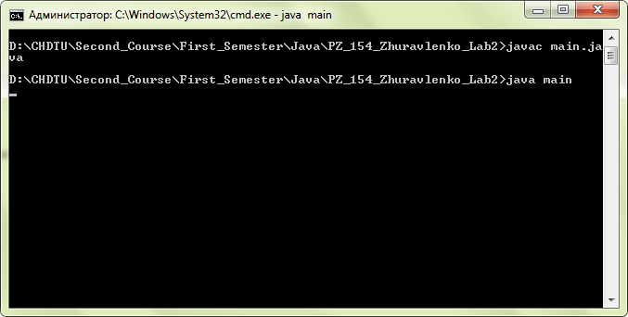

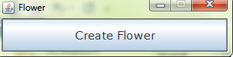

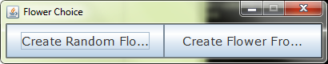

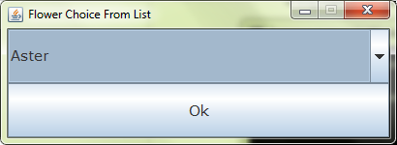

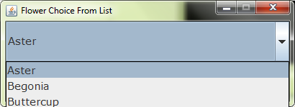

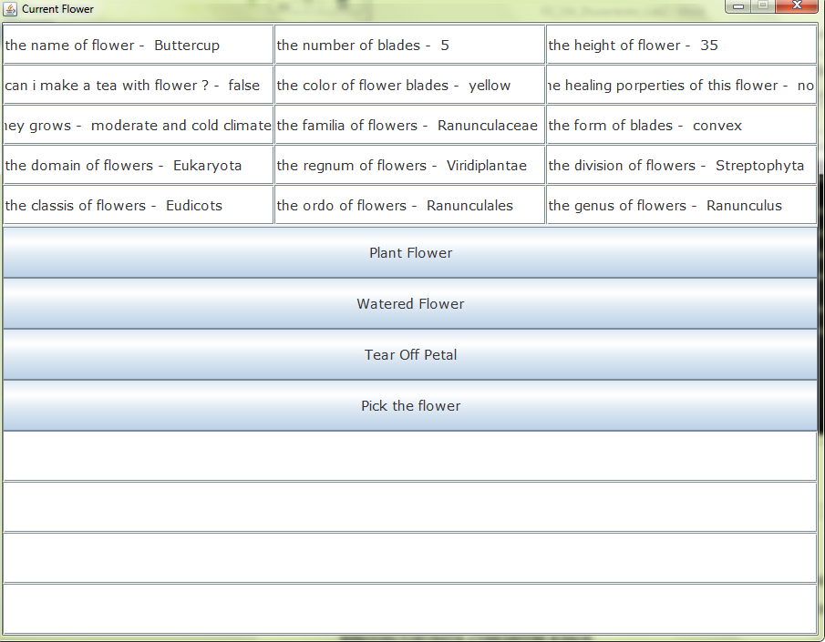

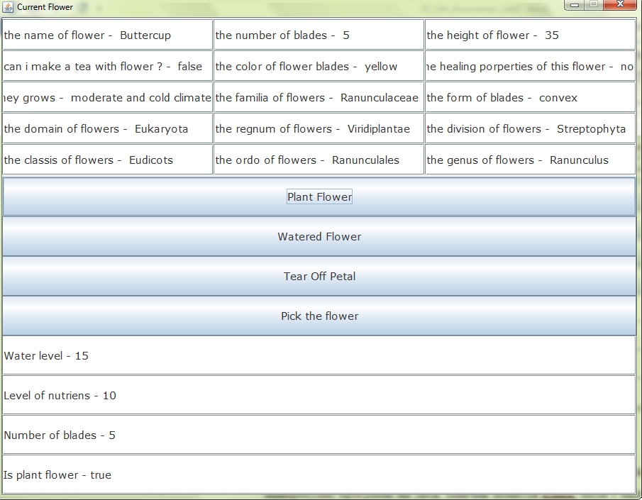

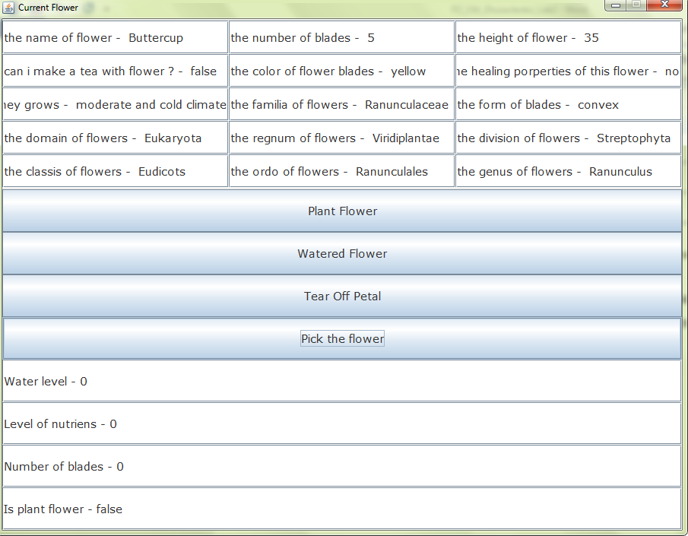

**Висновок:** Виконуючи цю лабораторну роботу, я навчився створювати власні класи, описувати поля та методи, а також використовувати їх.