Stereo

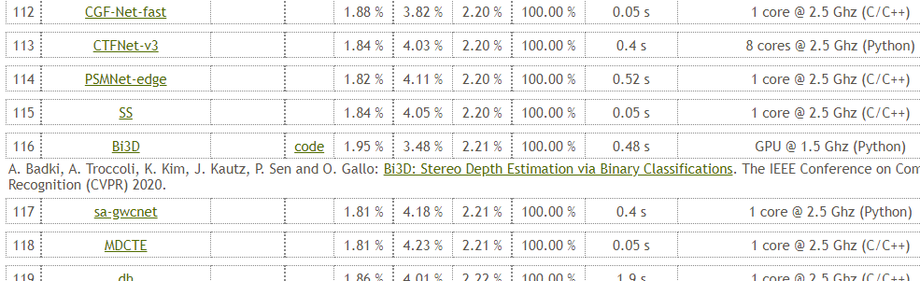



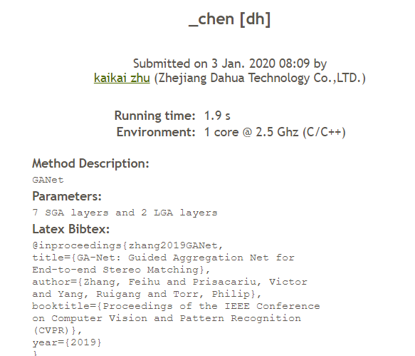

Flow

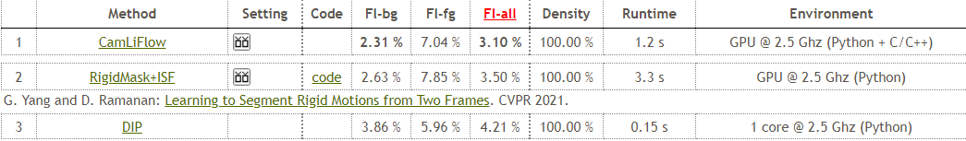

2020-9-25

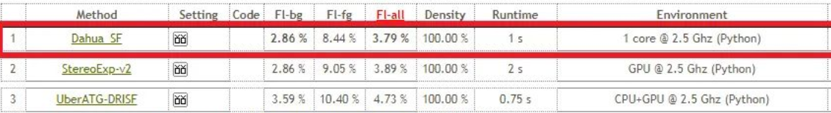

scenceFlow

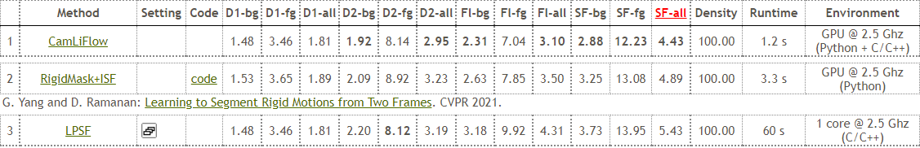

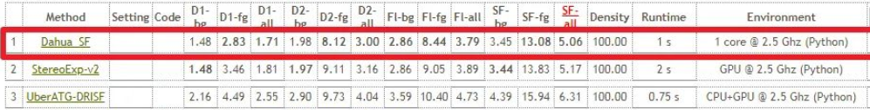

Track

18



Seq



3DObj

2021-1

