Siyue Zhu

AMATH 301 Spring 2020

HW1

Problem 3

X1 and x3 are exactly zero, but x2 and x4 are not. 0.25, 0.2, 0.125 and 0.1 can be written as 1/4, 1/5, 1/8 and 1/10. Because things are stored with binary representation so 2^n is stored more accurately, thus we can get x1 and x3 exactly equal to zero.

Problem 4

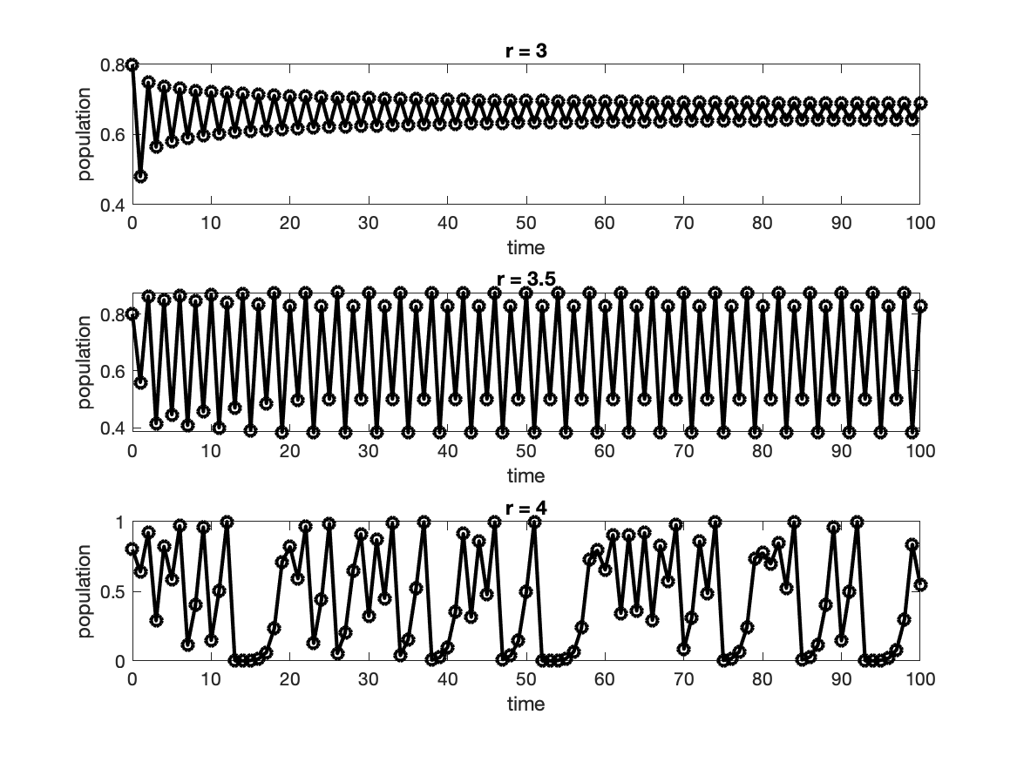

Problem 5

D

Code

%Problem 3

sum1 = 0;

for k = 1:8000

sum1 = sum1 + 0.25;

end

x1 = abs(2000-sum1);

disp(x1);

sum2 = 0;

for k = 1:10000

sum2 = sum2 + 0.2;

end

x2 = abs(2000-sum2);

disp(x2);

sum3 = 0;

for k = 1:16000

sum3 = sum3 + 0.125;

end

x3 = abs(2000-sum3);

disp(x3);

sum4 = 0;

for k = 1:20000

sum4 = sum4 + 0.1;

end

x4 = abs(2000-sum4);

disp(x4);

%Problem 4

p = [1:101];

p(1) = 0.8;

for j = 1:3

subplot(3,1,j)

r = 3 + 0.5 * (j-1);

for k = 2:101

p(k) = r * p(k-1)*(1-p(k-1));

end

time = [0:100];

plot(time, p, 'ko-', 'Linewidth', [2])

xlabel('time')

ylabel('population')

title(['r = ' num2str(r)])

end

print('HW1_fig1.png','-dpng')