Siyue Zhu

AMATH 301 Spring 2020

HW3

Problem4

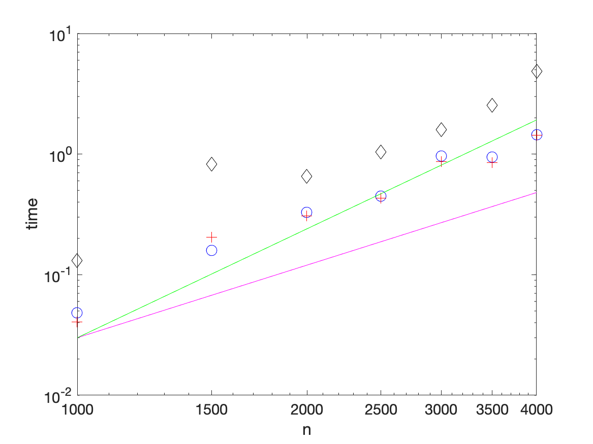

The lu method is the fastest method, backslash is the second and the inverse is the lowest method.

Problem5

|  |  |  |
| --- | --- | --- |
|  | Time for 1000 Systems | Time for 10000 Systems |
| Backslash | 0.2151 | 1.8869 |
| LU | 0.0255 | 0.2376 |
| Inverse | 0.3567 | 3.2293 |

Problem6

(b)(c)(d)

Code

%% Problem4

clear; close all; clc

nvec = 1000:500:4000;

for n = nvec

A = rand(n);

b = rand(n,1);

tic

x = A\b;

bstime = toc;

loglog(n,bstime, 'ob', 'markersize', 10)

hold on

tic

[L,U,P] = lu(A);

y = L\(P*b);

x = U\y;

lutime = toc;

loglog(n,lutime, 'r+', 'markersize', 10)

hold on

tic

x = inv(A)*b;

intime = toc;

loglog(n,intime, 'kd', 'markersize', 10)

hold on

end

xlabel('n')

ylabel('time')

set(gca, 'fontsize', 14)

loglog(nvec,3e-8*nvec.^2,'m')

loglog(nvec,3e-11*nvec.^3,'g')

print('HW3_fig1.png','-dpng')

%% Problem5

clear; close all; clc

A = toeplitz(1:100);

b = rand(100,1);

[L,U,P] = lu(A);

tic

for k = 1:1000

x = A\b;

end

backslashtime1 = toc;

tic

for k = 1:10000

x = A\b;

end

backslashtime2 = toc;

tic

for k = 1:1000

y = L\(P*b);

x = U\y;

end

lutime1 = toc;

tic

for k = 1:10000

y = L\(P*b);

x = U\y;

end

lutime2 = toc;

tic

for k = 1:1000

x = inv(A)*b;

end

intime1 = toc;

tic

for k = 1:10000

x = inv(A)*b;

end

intime2 = toc;

backslashtime1

lutime1

intime1

backslashtime2

lutime2

intime2