Siyue Zhu

AMATH 301 Spring 2020

HW4

Problem 3

Matrix A is not strictly diagonally dominant, so it cannot determine for sure that Jacobi and Gauss-Seidel will converge.

Problem 4

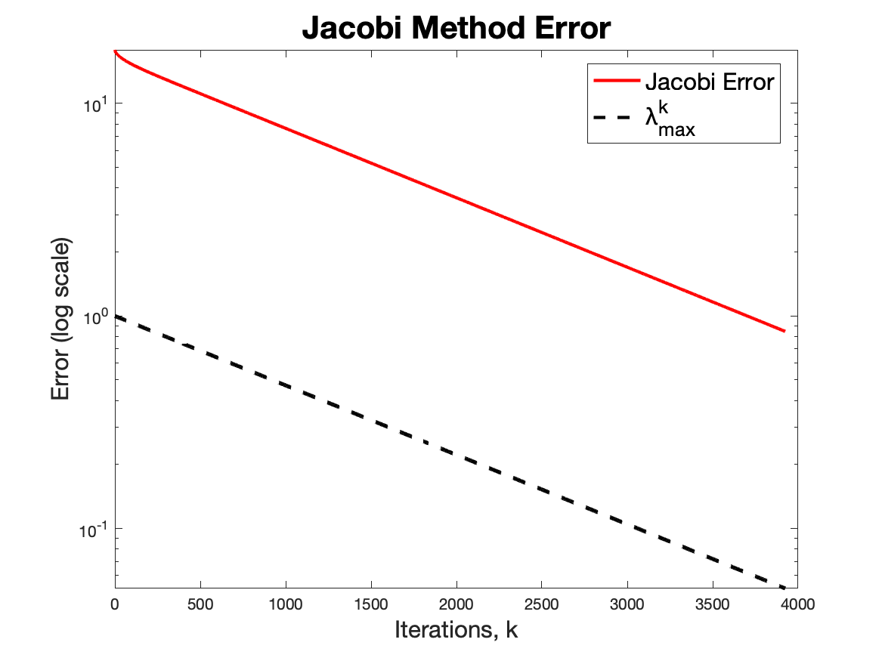

The error of the Jacobi method is larger than the error given by lambda. And they both converge.

Problem 5

b c

Code

%% Problem4

clear; close all; clc

a1 = [1,80];

for k = 1:80

a1(k) = 2;

end

a2 = [1,79];

for k = 1:79

a2(k) = -1;

end

A = diag(a1) + diag(a2,1) + diag(a2,-1);

b = [80;1];

for k = 1:80

b(k) = exp(-15*pi/10)*sin(15*pi*k/81);

end

x_exact = A\b;

x0 = 2*ones(80,1);

tol = 1e-4;

maxIter = 10000000;

D = diag(diag(A));

T = A - D;

M = -D\T;

change = 2*tol;

c = D\b;

xk = x0;

iteration = 0;

error_vector = [norm(x_exact - x0)];

k = [0];

while change > tol && iteration < maxIter

xkplus1 = M*xk + c;

change = norm(xkplus1-xk,inf);

iteration = iteration + 1;

k(iteration + 1) = iteration;

error_vector(iteration + 1) = norm(x_exact - xkplus1);

xk = xkplus1;

end

semilogy(k, error_vector, 'r', 'LineWidth', 2)

hold on

lambda = max(abs(eig(M)));

lambda_vector = [];

for j = 1:length(k)

lambda_vector(j) = lambda^(j-1);

end

semilogy(k, lambda_vector, 'k--', 'LineWidth', 2)

title('Jacobi Method Error', 'fontsize', [20])

xlabel('Iterations, k', 'fontsize', [15])

ylabel('Error (log scale)', 'fontsize', [15])

legend('Jacobi Error', 'Œª^k_m_a_x', 'location', 'best', 'fontsize', [15])

print('HW4_fig1.png','-dpng')