Siyue Zhu

AMATH 301 Spring 2020

HW6

Problem 2

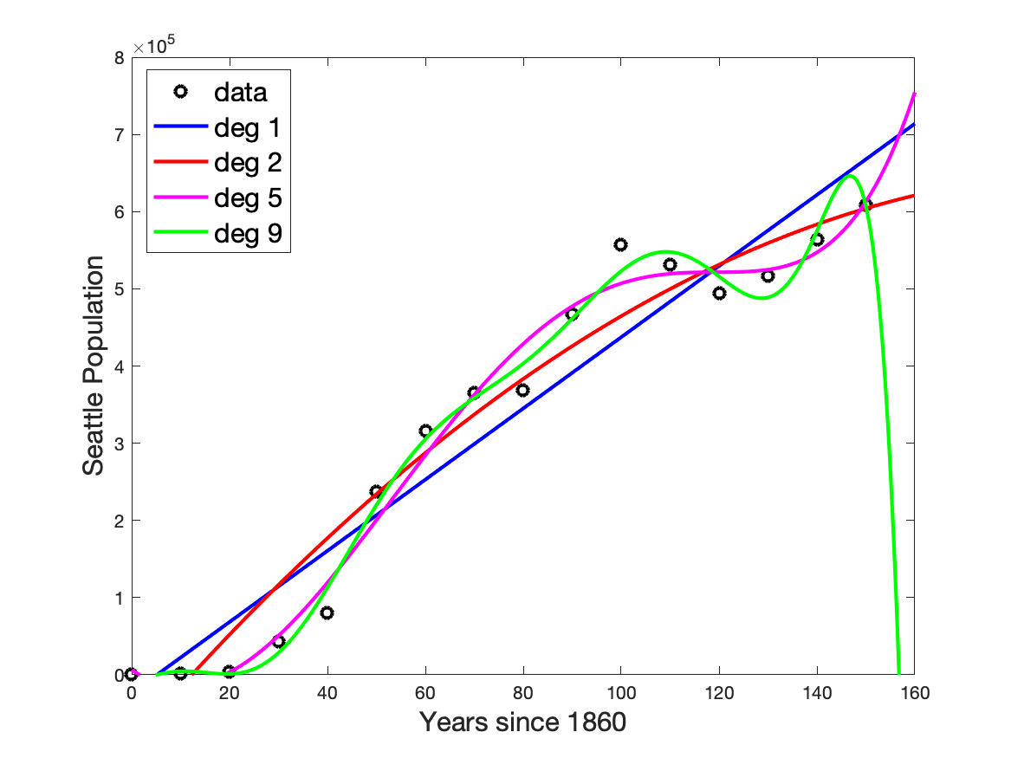

(b)The real-world interpretation of the slope of the data is the rate of the population growth. The population of Seattle will increase with the trend show in the graph.

(c)Deg 5 gives the best prediction and deg 9 gives the worst prediction. I would like to choose deg 5 to predict the population in 2025 since it gives the most accurate prediction. I trust deg 5 the most since it follows the trend of most points so that it can give a more reliable prediction.

Problem 4

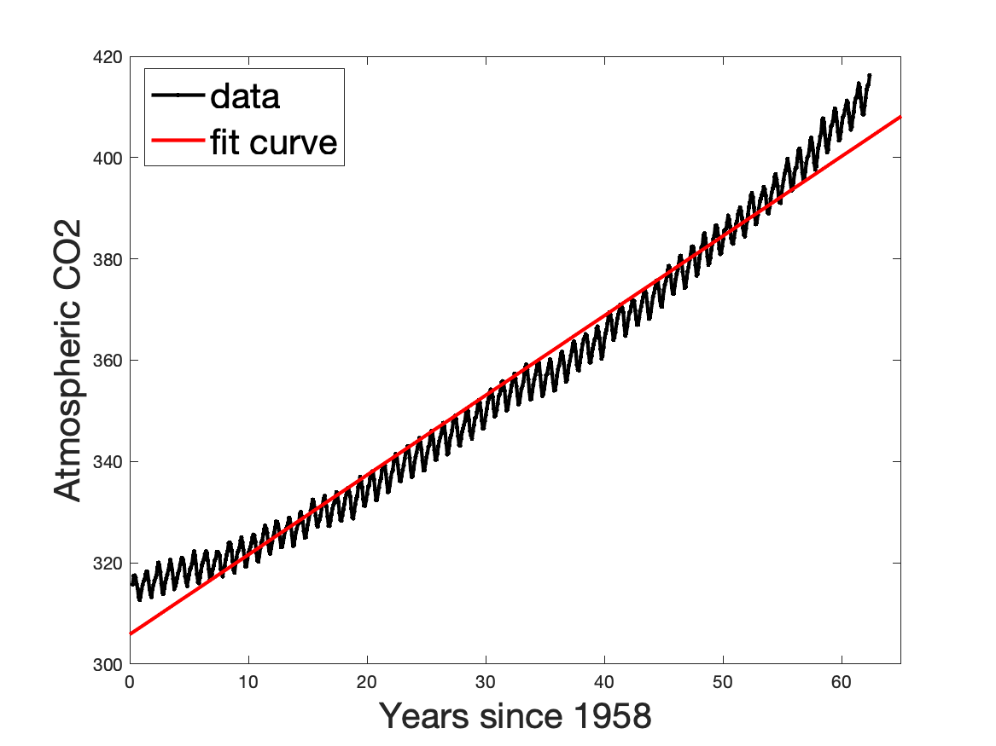

Problem 6

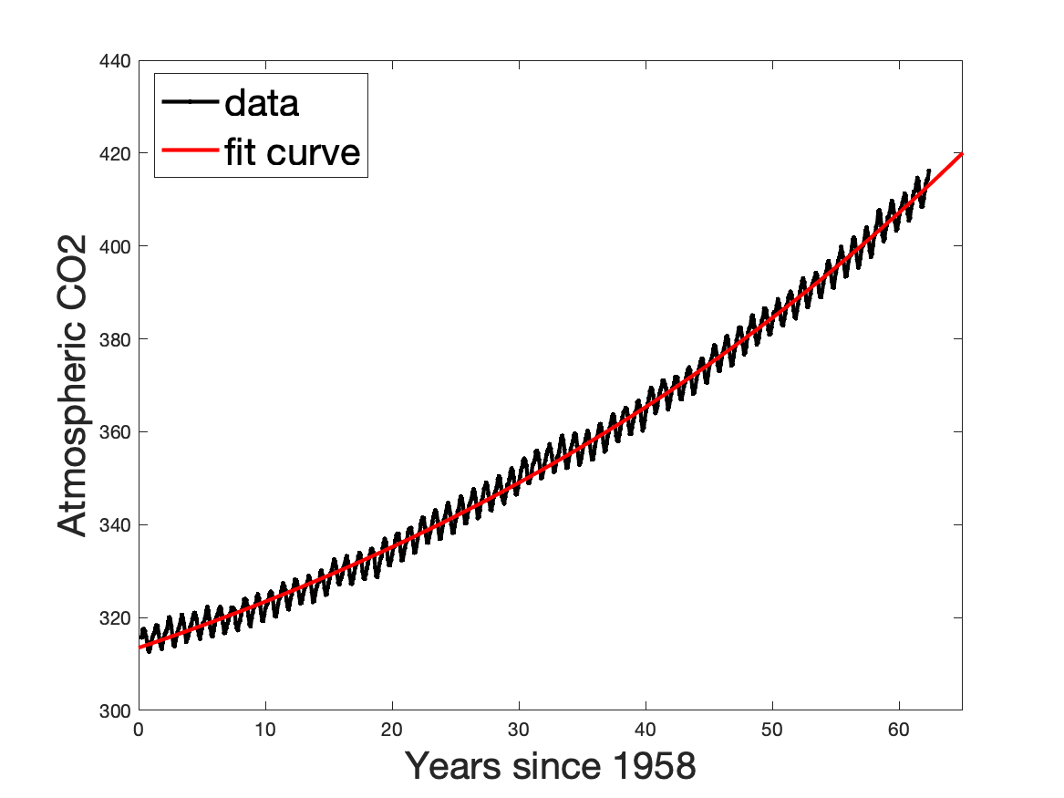

Problem 8

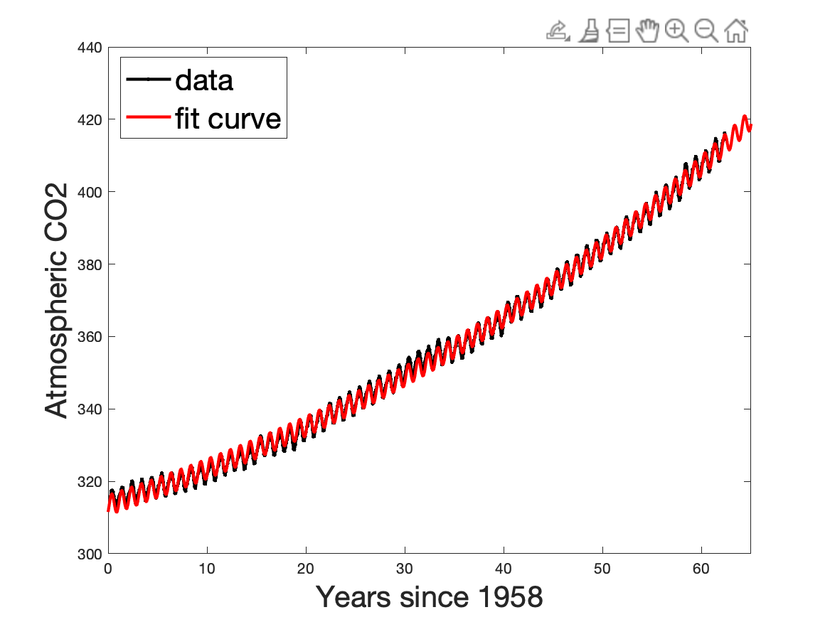

Problem 9

A

Code

%% Problem2

clear; close all; clc

load('SeaPopData.mat')

plot(t, Seattle_Pop, 'ko', 'LineWidth', 2)

hold on

lin_fit = polyfit(t, Seattle_Pop, 1);

ans1 = lin_fit(1);

ans2 = lin_fit(1) * 159 + lin_fit(2);

x_plot = 0:0.1:160;

y_plot = polyval(lin_fit, x_plot);

plot(x_plot, y_plot, 'b', 'LineWidth', 2)

hold on

poly_fit = polyfit(t, Seattle_Pop, 2);

y_plot = polyval(poly_fit, x_plot);

plot(x_plot, y_plot, 'r', 'LineWidth', 2)

hold on

ans3 = poly_fit(1) * 159^2 + poly_fit(2) * 159 + poly_fit(3);

poly_fit5 = polyfit(t, Seattle_Pop, 5);

y_plot = polyval(poly_fit5, x_plot);

plot(x_plot, y_plot, 'm', 'LineWidth', 2);

hold on

sum1 = 0;

for k = 1:length(poly_fit5)

sum1 = sum1 + poly_fit5(k) * 159^(6-k);

end

sum1;

poly_fit9 = polyfit(t, Seattle_Pop, 9);

y_plot = polyval(poly_fit9, x_plot);

plot(x_plot, y_plot, 'g', 'LineWidth', 2)

hold on

axis([0 160 0 800000])

xlabel('Years since 1860', 'fontsize', [20])

ylabel('Seattle Population', 'fontsize', [20])

legend('data', 'deg 1', 'deg 2', 'deg 5', 'deg 9', 'fontsize', [20], 'location', 'northwest')

print('HW6_fig1.png','-dpng')

sum2 = 0;

for k = 1:length(poly_fit9)

sum2 = sum2 + poly_fit9(k) * 159^(10-k);

end

sum2;

ans4 = [sum1, sum2];

%% Problem4

clear; close all; clc

load('CO2_data.mat')

% lin_fit = polyfit(t, log(CO2), 1);

lin_fit = polyfit(t, (CO2), 1);

ans5 = lin_fit(1);

ans6 = exp(lin_fit(2));

x_plot = 0:0.1:70;

y_plot = polyval(lin_fit, x_plot);

% plot(t, log(CO2), '-k.', 'LineWidth', 2)

plot(t, (CO2), '-k.', 'LineWidth', 2)

hold on

plot(x_plot, y_plot, 'r', 'LineWidth', 2)

xlim([0 65])

xlabel('Years since 1958', 'fontsize', [20])

ylabel('Atmospheric CO2', 'fontsize', [20])

legend('data', 'fit curve', 'fontsize', [20], 'location', 'northwest')

print('HW6_fig2.png','-dpng')

%% Problem6

clear; close all; clc

load('CO2_data.mat')

a = 30;

r = 0.03;

b = 300;

% error = exponential_shift(a, r, b);

guess = [30, 0.03, 300];

[best, ans8] = fminsearch(@(arb) exponential_shift(arb), guess);

ans7 = best.';

% plot(t, log(CO2), '-k.', 'LineWidth', 2)

plot(t, (CO2), '-k.', 'LineWidth', 2)

hold on

x_plot = 0:0.1:70;

% y_plot = log(best(1)*exp(best(2) * x_plot) + best(3));

y_plot = (best(1)*exp(best(2) * x_plot) + best(3));

plot(x_plot, y_plot, 'r', 'LineWidth', 2)

xlim([0 65])

xlabel('Years since 1958', 'fontsize', [20])

ylabel('Atmospheric CO2', 'fontsize', [20])

legend('data', 'fit curve', 'fontsize', [20], 'location', 'northwest')

print('HW6_fig3.png','-dpng')

%% Problem8

guess2 = [ans7(1), ans7(2), ans7(3), 3, 6, 0];

[best2, ans10] = fminsearch(@(arbcde) exponential_shift_sin(arbcde), guess2);

ans9 = best2.';

% plot(t, log(CO2), '-k.', 'LineWidth', 2)

plot(t, (CO2), '-k.', 'LineWidth', 2)

hold on

x_plot = 0:0.1:70;

% y_plot = log(best2(1)*exp(best2(2) * x_plot) + best2(3) + best2(4)*sin(best2(5)*(x_plot - best2(6))));

y_plot = (best2(1)*exp(best2(2) * x_plot) + best2(3) + best2(4)*sin(best2(5)*(x_plot - best2(6))));

plot(x_plot, y_plot, 'r', 'LineWidth', 2)

xlim([0 65])

xlabel('Years since 1958', 'fontsize', [20])

ylabel('Atmospheric CO2', 'fontsize', [20])

legend('data', 'fit curve', 'fontsize', [20], 'location', 'northwest')

print('HW6_fig4.png','-dpng')

function [sum2, error2] = exponential_shift_sin(arbcde)

a = arbcde(1);

r = arbcde(2);

b = arbcde(3);

c = arbcde(4);

d = arbcde(5);

e = arbcde(6);

load('CO2_data.mat')

sum2 = 0;

for k = 1:length(t)

sum2 = sum2 + (a*exp(r*t(k)) + b + c*sin(d*(t(k)-e)) - CO2(k))^2;

end

sum2;

error2 = sqrt(1/746*sum2);

end

%%

function [sum, error] = exponential_shift(arb)

a = arb(1);

r = arb(2);

b = arb(3);

load('CO2_data.mat')

sum = 0;

for k = 1:length(t)

sum = sum + (a*exp(r*t(k)) + b - CO2(k))^2;

end

sum;

error = sqrt(1/746*sum);

end