Siyue Zhu

AMATH 301 Spring 2020

HW7

Problem 2

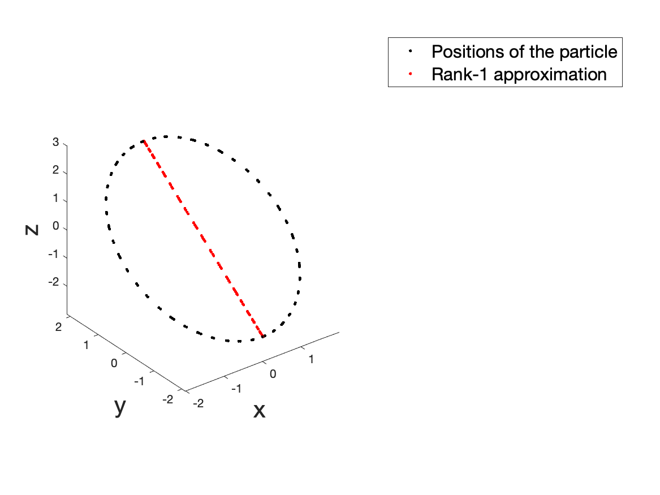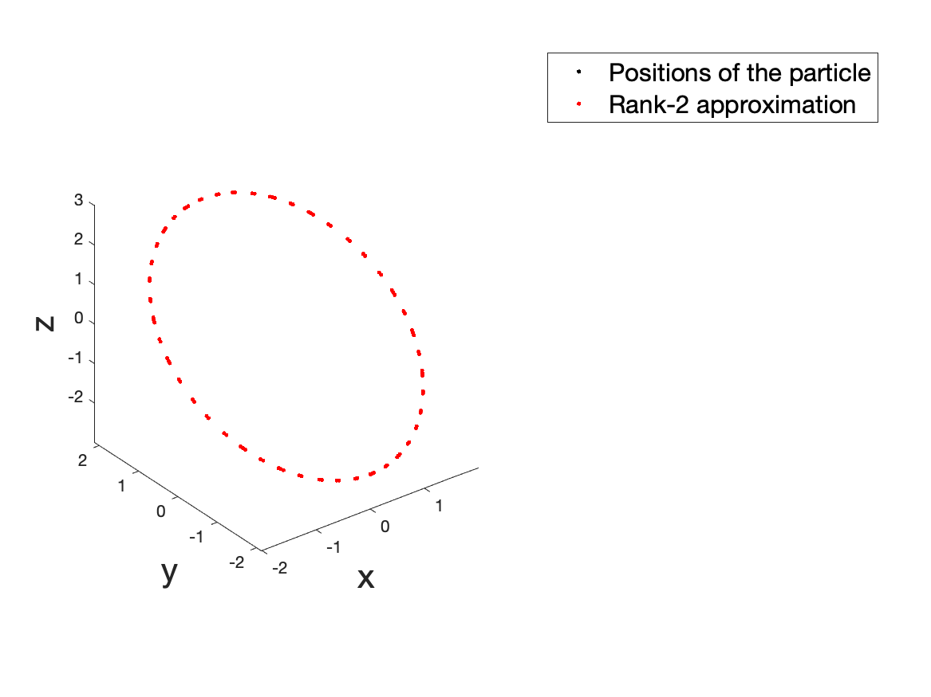

1. The trajectory of the particle is a circle in a 3D space. Rank-1 approximation is a line that connects the furthest two dots on the trajectory, which describes the biggest variance.
2. Rank-2 approximation is also a circle in the 3D space, which can almost perfectly show the trajectory of the original particles.
3. Two of a singular value of A are nonzero, which indicates that there are two dimensions of A have useful information about the trajectory. So that the trajectory of particles is a circle in the 2D plane.

Problem 4

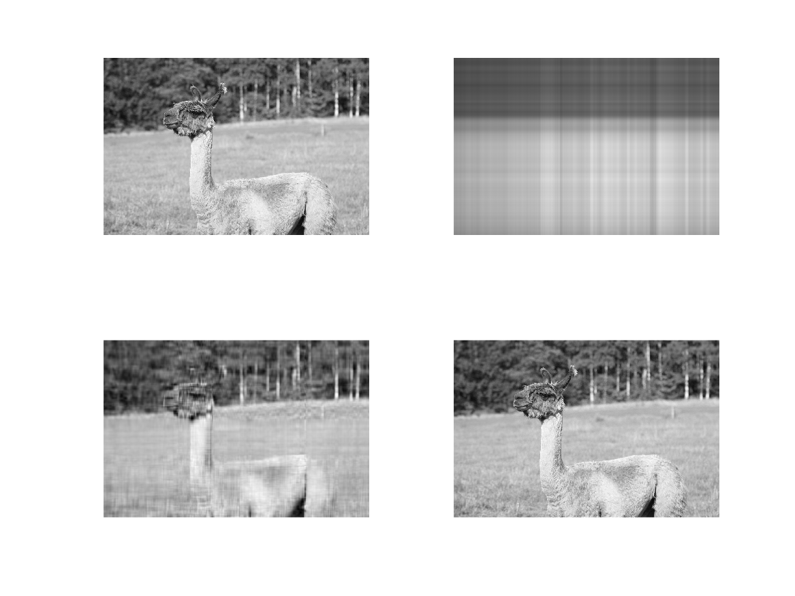

(b) The original picture takes 1151064 pixels, and the rank-206 approximation takes 451346 pixels.

Problem 6

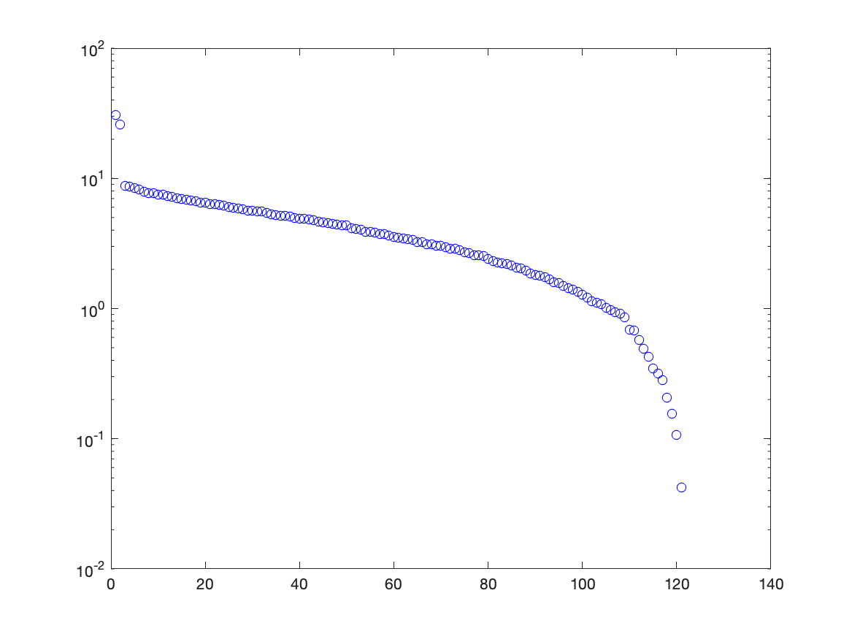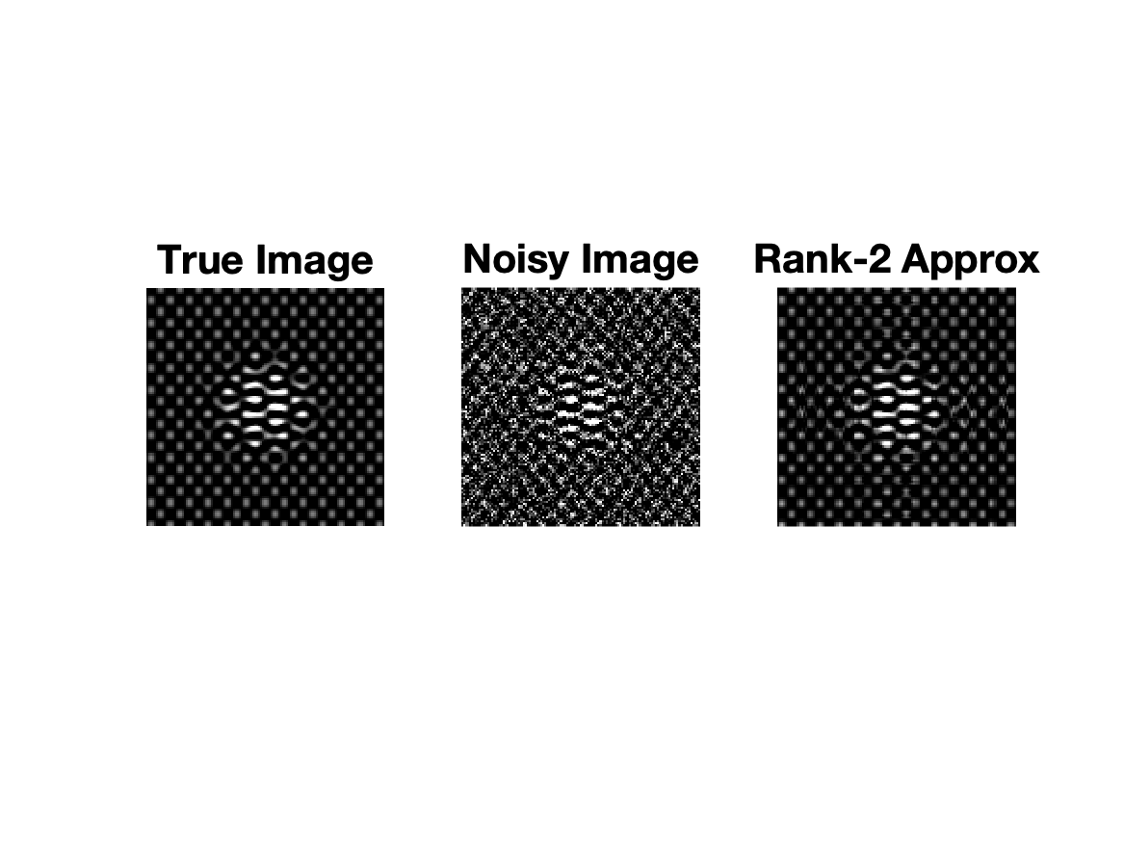

(c) Rank-2 approximation is a good choice to denoise because it already contains most information from the image, but also is not accurate enough to contain all the noise from the noisy image. So, it is a good choice to denoise.

Problem7

(a)

Code

%% Problem 2

plot3( A(1,:),A(2,:),A(3,:), 'k.');

hold on

plot3( Arank1(1,:),Arank1(2,:),Arank1(3,:), 'r.');

axis vis3d

xlabel('x', 'fontsize', [20]);

ylabel('y', 'fontsize', [20]);

zlabel('z', 'fontsize', [20]);

legend('Positions of the particle', 'Rank-1 approximation', 'fontsize', [15]);

print('HW7_fig1.png','-dpng')

%% Problem 4

[U,S,V] = svd(A, 'econ');

Arank1 = U(:,1:1)*S(1:1,1:1)*V(:,1:1)';

Arank20 = U(:,1:20)*S(1:20,1:20)*V(:,1:20)';

Arank206 = U(:,1:206)*S(1:206,1:206)*V(:,1:206)';

subplot(2,2,1)

imshow(A)

subplot(2,2,2)

imshow(Arank1)

subplot(2,2,3)

imshow(Arank20)

subplot(2,2,4)

imshow(Arank206)

print('HW7_fig3.png','-dpng')

%% Problem6

semilogy(diag(S), 'bo')

% energies = cumsum(diagonal) / sum_diagonal

% semilogy(energies)

print('HW7_fig4.png','-dpng')

subplot(1,3,1)

imshow(A)

title('True Image', 'fontsize', [20])

subplot(1,3,2)

imshow(A_noise)

title('Noisy Image', 'fontsize', [20])

subplot(1,3,3)

imshow(A_noise_rank2)

title('Rank-2 Approx', 'fontsize', [20])

print('HW7_fig5.png','-dpng')