Siyue Zhu

AMATH 301 Spring 2020

HW8

Problem 4

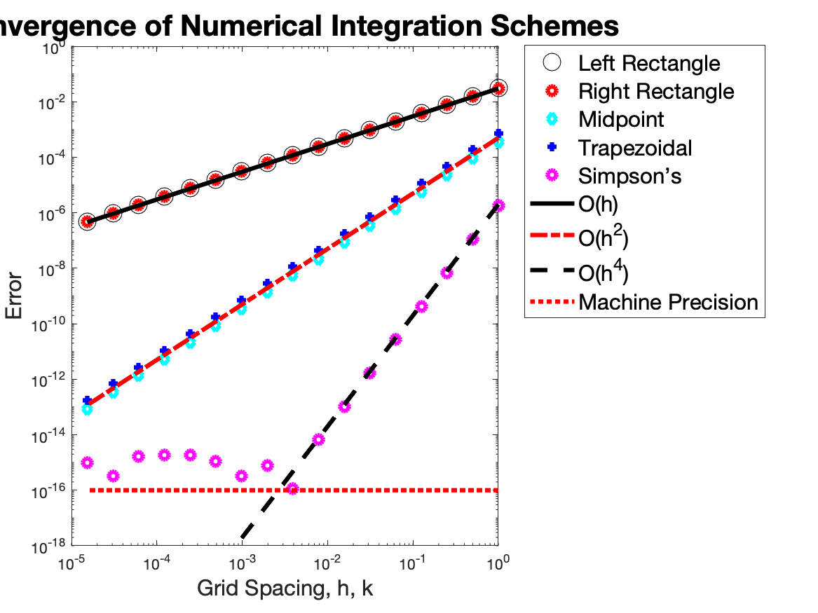

Problem 5

(a)(d)

Code

%% Problem 4

clear; close all; clc

f = @(x) exp(-(x-85).^2/50) / sqrt(50*pi);

exact = integral(f, 76, 86);

n = 0:-1:-16;

dx = 2.^n;

x = 76;

error_left = zeros([1 17]);

error_right = zeros([1 17]);

error_midpoint = zeros([1 17]);

error_trap = zeros([1 17]);

error_simpson = zeros([1 17]);

midpoint = zeros([1 17]);

for k = 1:length(dx)

x = 76:dx(k):86;

left = dx(k) * sum(f(x(1:end-1)));

error_left(k) = abs(exact - left);

right = dx(k) * sum(f(x(2:end)));

error_right(k) = abs(exact - right);

mid = f((x(1:end-1) + x(2:end)) / 2);

midpoint(k) = dx(k) * sum(mid);

error_midpoint = abs(exact - midpoint);

trap(k) = dx(k)/2*(f(x(1)) + 2*sum(f(x(2:end-1))) + f(x(end)));

error_trap = abs(exact - trap);

simpson(k) = dx(k)/3 * (f(x(1)) + 4*sum(f(x(2:2:end-1))) + 2*sum(f(x(3:2:end-2))) + f(x(end)));

error_simpson = abs(exact - simpson);

end

loglog(dx, error_left, 'ko','MarkerSize',12)

hold on

loglog(dx, error_right, 'ro', 'LineWidth', 3)

loglog(dx, error_midpoint, 'cd', 'LineWidth', 3)

loglog(dx, error_trap, 'b+', 'LineWidth', 3)

loglog(dx, error_simpson, 'mo', 'LineWidth', 3)

loglog(dx, 0.03*dx, 'k-', 'LineWidth', 3)

loglog(dx, 0.0005*dx.^2, 'r-.', 'LineWidth', 3)

loglog(dx, 0.000002*dx.^4, 'k--', 'LineWidth', 3)

line = 10^-16 + zeros([1 length(dx)]);

loglog(dx, line, 'r:', 'LineWidth', 3)

title('Convergence of Numerical Integration Schemes', 'fontsize', [20])

xlabel('Grid Spacing, h, k', 'fontsize', [15])

ylabel('Error', 'fontsize', [15])

legend('Left Rectangle', 'Right Rectangle', 'Midpoint', 'Trapezoidal', 'Simpson‚Äôs', 'O(h)', 'O(h^2)', 'O(h^4)', 'Machine Precision', 'fontsize', [15], 'Location', 'Northeastoutside')

ylim([10^-18 1])

print('HW8_fig1.png','-dpng')