Task 1

This NetLogo file is divided into setup simulation environment, units behavior, agent procedure, sensors, effectors (actions) and the utilities.

The run-experiment procedure will execute until no more fires are left for simulation and no more fires are still burning. It will ask the units to execute agent’s behavior and asks fire to spread.

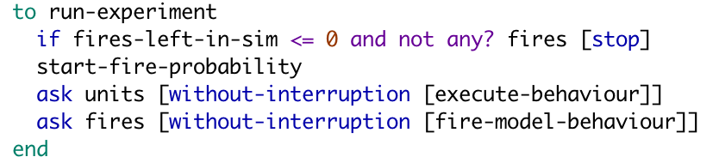

Following procedure determines ground agent’s behavior. Firstly, unit will detect obstacles in front of it, if unit meet the obstacle it will execute the action(avoid-obstacle) otherwise stop this execution. After that, the ground unit will try to detect fire, the same step as detect-obstacle. Then, ground unit will check the amount of water it carried whether used out or not, if the water supplies of the unit are exhausted, it will return to the station (which is the base) and resupply to the unit and back to continue put out fire.

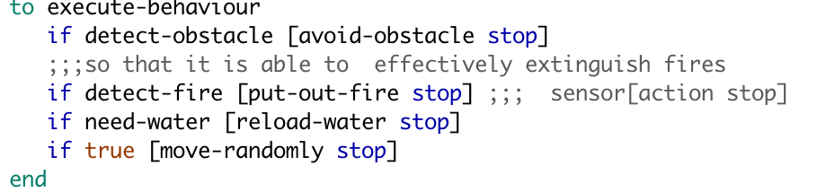

In the put-out-fire procedure, every time the ground unit saved a tree, the water it carried will decrease one unit.

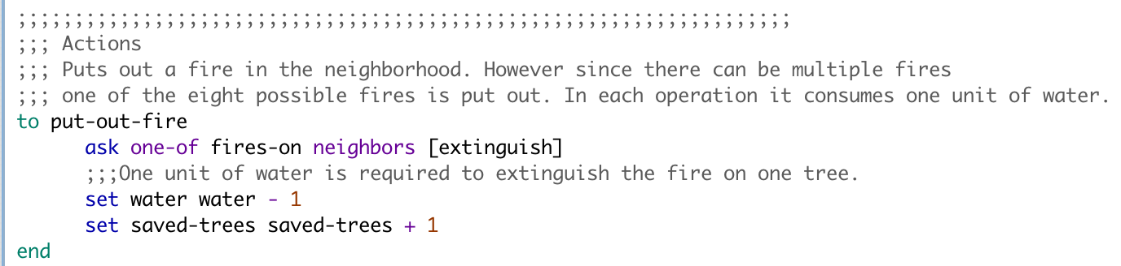

Also, sensor need-water will check whether ground unit exhausted all the water it carried, if the ground unit use out all the water, it will change color from blue to white.

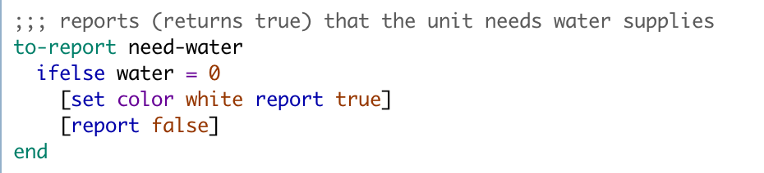

After detecting ground unit need water successfully, it will execute the reload action which will back to the station and resupply.

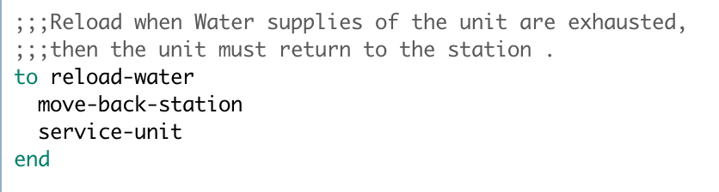Therefore, in the move-back-station action, the ground unit will move to the center of the patch 0,0 where is the location of the station.



In the station(base), ground unit will get the water supply and change color from white to red. When finish the supply of water, ground unit will go to place in the grid randomly to extinguish other fires…

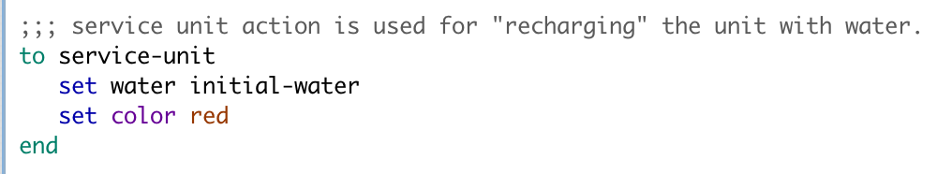

Task 2

There are lots of answers to this experiment about how many trees will dead, how many trees will be saved and how many will unaffected. In this simulation, the ground unit will walk randomly in the grid. There have 4 variables will affect the result, and only two of them can be set. In the first experiment, the number of unit are 5, and we vary the initial water from 1 to 50, by doing this we can see what could happen in the whole procedure. And making this procedure to a line graph will demonstrate better understanding for users. In the second and third experiment, all of these step is the same as first experiment, the only parameter we changed is the number of unit.

The next step is comparing these graph. After compared different parameter we set to the simulation, we could find whether the amount of ground unit will help to extinguish the forest fire, and to what extent the speed of unit will influence the final outcome.

Following is the result by this experiment. According to requirement ,tree number(tree-num) is fixed with 400 , the same as number of fires(number-of-fires) with 40. Also the ground unit number(fire-units-num) only have three options ,that is 5 ,25 and 40. Therefore the only dynamic factor is initial-water, which we could adjust as much as possible.

Firstly, the x-axis is the number of initial water which named initial-water and y-axis its the number of trees(tree-number). Secondly, in every line graph the ground unit number is fixed therefore we could output three line-graphs to reflect our experiment results.

**Graph 1:**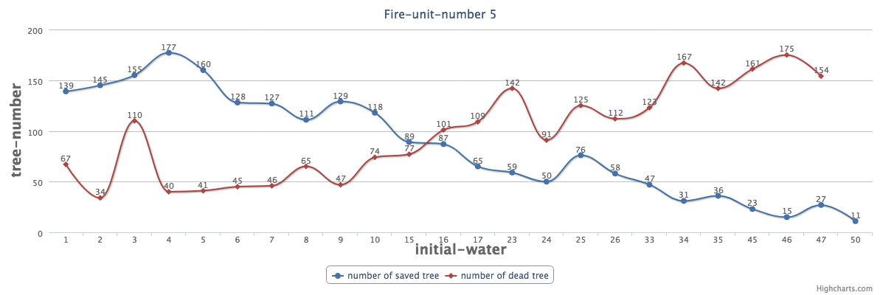

**Graph 2:**

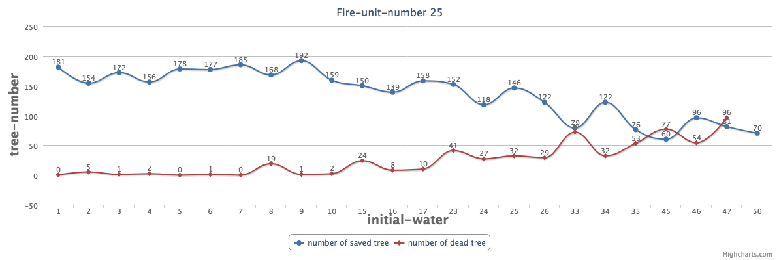

**Graph 3:**

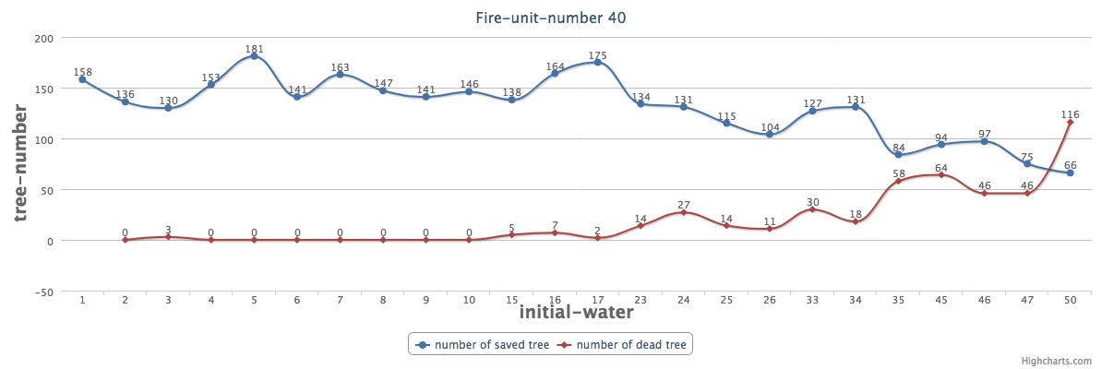

From these graphs we could find in the beginning the ground unit can save a lot of trees as we expect, even though in the whole forest there only have five ground units. But as the ground unit carry more and more water, the number of trees it could save decreased gradually. At the same time, the number of dead tree increased. And this procedure will totally be influenced by the number of ground units, in graph 2 and 3 these lines have similar outcome in the end.

We could say, the speed for ground unit to take action is more important than the amount of water they can carry. Also, through this experiment we can find that the number of ground unit need to be appropriate, not always the larger number of unit is better than the smaller one.

In the view of this experiment, sill have many limitations. For example, the wall will limit the unit to take action to extinguish fire. And the selection to the number of ground unit is limited, there could have more choice about the number of unit.

Task 3

***Propose improvements***

***New types of sensors:***

A new sensor has the ability to detect the location where have the forest fire first. Through this sensor, the ground unit can get the location of the first fire. Comparing to use the neighbor solution (detects a fire in the neighborhood of the unit - 8 patches around unit ) , the first-fire sensor is more accurate and efficient.

This sensor will have the space to remember which tree (according to the tree location) already dead, and which tree the ground unit already saved just a few minute before. By doing this, our ground unit agent will not go to the same place redundant, and the unit will only go to the tree which still has the possibility to be saved. This sensor could save more time than the normal one, also this solution can save a lot of water.

***New types of actions:***

Find the shortest path, this action can use a lot of effective algorithm. For example : like Manhattan distance or A star search algorithm, using the shortest path to get to the first fire location (first-fire sensor) and extinguish the fire. Firstly, it can save a lot of time comparing walking randomly. Secondly, the first fire can only influence a limited amount of trees therefore it could only carry a small amount of water (this will increase the unit speed). Thirdly, by using this shortest path solution, the fire area can be controlled from beginning. That is the reason why it could increase the efficiency of agent system.

***New types of agents:***

Increase an agent which could supply the water. Firstly, it is not like the base which is fixed on the grid. The water-supply agent can walk on the map, also have the same sensor like ground unit such as : avoid-obstacle, have-water, need-water… Secondly , the water-supply agent has the sensor to detect which ground unit water will consume later . Thirdly, it will move to the direction where the ground unit need water. Also, the water-supply agent has the limitation to carry the water, same for the agent speed. But comparing to the fixed water supply station, this agent is more flexible. In the previous solution, every agent need back to station when the water used out. According to this function, there is no necessary for every unit walk back to station every time, and they just need to find the closest water-supply agent.

Task 4

***Advantages***

The reactive agent approach to the forest fire problem has a lot of advantages. Firstly, it is flexible, you can vary any parameter to explore the performance if you want. Also, you could add other agents to extend this system complexity. Secondly, this simulation is more reality, it is more nature to describe how ground agent working in the forest fire situation than normal solution. Thirdly, comparing to have a real test in the forest, using reactive agent approach could save more cost and time. Computer can implement complex simulation in several minutes as most.

***Disadvantages***

There also have a number of disadvantages. This approach could be used as a predictive tool rather than as a learning tool. And the problem it simulated usually is limited, it can not consider all the dynamic factors in the real world. Furthermore, the execution speed will drop if there have amount of agents need to process which means some problem could not be solved by the reactive agent approach.