**Task1: Manipulating Environment Variables**

1. **Use printenv or env command to print out the environment variables. If you are interested in some particular environment variables, such as PWD, you can use "printenv PWD" or "env | grep PWD".**

[09/02/20]seed@VM:~$ printenv

XDG_VTNR=7

XDG_SESSION_ID=c1

XDG_GREETER_DATA_DIR=/var/lib/lightdm-data/seed

CLUTTER_IM_MODULE=xim

SESSION=ubuntu

ANDROID_HOME=/home/seed/android/android-sdk-linux

GPG_AGENT_INFO=/home/seed/.gnupg/S.gpg-agent:0:1

TERM=xterm-256color

VTE_VERSION=4205

XDG_MENU_PREFIX=gnome-

SHELL=/bin/bash

DERBY_HOME=/usr/lib/jvm/java-8-oracle/db

QT_LINUX_ACCESSIBILITY_ALWAYS_ON=1

LD_PRELOAD=/home/seed/lib/boost/libboost_program_options.so.1.64.0:/home/seed/lib/boost/libboost_filesystem.so.1.64.0:/home/seed/lib/boost/libboost_system.so.1.64.0

WINDOWID=29360138

UPSTART_SESSION=unix:abstract=/com/ubuntu/upstart-session/1000/1420

GNOME_KEYRING_CONTROL=

GTK_MODULES=gail:atk-bridge:unity-gtk-module

USER=seed

LS_COLORS=rs=0:di=01;34:ln=01;36:mh=00:pi=40;33:so=01;35:do=01;35:bd=40;33;01:cd=40;33;01:or=40;31;01:mi=00:su=37;41:sg=30;43:ca=30;41:tw=30;42:ow=34;42:st=37;44:ex=01;32:*.tar=01;31:*.tgz=01;31:*.arc=01;31:*.arj=01;31:*.taz=01;31:*.lha=01;31:*.lz4=01;31:*.lzh=01;31:*.lzma=01;31:*.tlz=01;31:*.txz=01;31:*.tzo=01;31:*.t7z=01;31:*.zip=01;31:*.z=01;31:*.Z=01;31:*.dz=01;31:*.gz=01;31:*.lrz=01;31:*.lz=01;31:*.lzo=01;31:*.xz=01;31:*.bz2=01;31:*.bz=01;31:*.tbz=01;31:*.tbz2=01;31:*.tz=01;31:*.deb=01;31:*.rpm=01;31:*.jar=01;31:*.war=01;31:*.ear=01;31:*.sar=01;31:*.rar=01;31:*.alz=01;31:*.ace=01;31:*.zoo=01;31:*.cpio=01;31:*.7z=01;31:*.rz=01;31:*.cab=01;31:*.jpg=01;35:*.jpeg=01;35:*.gif=01;35:*.bmp=01;35:*.pbm=01;35:*.pgm=01;35:*.ppm=01;35:*.tga=01;35:*.xbm=01;35:*.xpm=01;35:*.tif=01;35:*.tiff=01;35:*.png=01;35:*.svg=01;35:*.svgz=01;35:*.mng=01;35:*.pcx=01;35:*.mov=01;35:*.mpg=01;35:*.mpeg=01;35:*.m2v=01;35:*.mkv=01;35:*.webm=01;35:*.ogm=01;35:*.mp4=01;35:*.m4v=01;35:*.mp4v=01;35:*.vob=01;35:*.qt=01;35:*.nuv=01;35:*.wmv=01;35:*.asf=01;35:*.rm=01;35:*.rmvb=01;35:*.flc=01;35:*.avi=01;35:*.fli=01;35:*.flv=01;35:*.gl=01;35:*.dl=01;35:*.xcf=01;35:*.xwd=01;35:*.yuv=01;35:*.cgm=01;35:*.emf=01;35:*.ogv=01;35:*.ogx=01;35:*.aac=00;36:*.au=00;36:*.flac=00;36:*.m4a=00;36:*.mid=00;36:*.midi=00;36:*.mka=00;36:*.mp3=00;36:*.mpc=00;36:*.ogg=00;36:*.ra=00;36:*.wav=00;36:*.oga=00;36:*.opus=00;36:*.spx=00;36:*.xspf=00;36:

QT_ACCESSIBILITY=1

LD_LIBRARY_PATH=/home/seed/source/boost_1_64_0/stage/lib:/home/seed/source/boost_1_64_0/stage/lib:

XDG_SESSION_PATH=/org/freedesktop/DisplayManager/Session0

XDG_SEAT_PATH=/org/freedesktop/DisplayManager/Seat0

SSH_AUTH_SOCK=/run/user/1000/keyring/ssh

DEFAULTS_PATH=/usr/share/gconf/ubuntu.default.path

SESSION_MANAGER=local/VM:@/tmp/.ICE-unix/1728,unix/VM:/tmp/.ICE-unix/1728

XDG_CONFIG_DIRS=/etc/xdg/xdg-ubuntu:/usr/share/upstart/xdg:/etc/xdg

DESKTOP_SESSION=ubuntu

PATH=/home/seed/bin:/usr/local/sbin:/usr/local/bin:/usr/sbin:/usr/bin:/sbin:/bin:/usr/games:/usr/local/games:.:/snap/bin:/usr/lib/jvm/java-8-oracle/bin:/usr/lib/jvm/java-8-oracle/db/bin:/usr/lib/jvm/java-8-oracle/jre/bin:/home/seed/android/android-sdk-linux/tools:/home/seed/android/android-sdk-linux/platform-tools:/home/seed/android/android-ndk/android-ndk-r8d:/home/seed/.local/bin

QT_IM_MODULE=ibus

QT_QPA_PLATFORMTHEME=appmenu-qt5

XDG_SESSION_TYPE=x11

PWD=/home/seed

JOB=dbus

XMODIFIERS=@im=ibus

JAVA_HOME=/usr/lib/jvm/java-8-oracle

GNOME_KEYRING_PID=

LANG=en_US.UTF-8

GDM_LANG=en_US

MANDATORY_PATH=/usr/share/gconf/ubuntu.mandatory.path

COMPIZ_CONFIG_PROFILE=ubuntu

IM_CONFIG_PHASE=1

GDMSESSION=ubuntu

SESSIONTYPE=gnome-session

GTK2_MODULES=overlay-scrollbar

SHLVL=1

HOME=/home/seed

XDG_SEAT=seat0

LANGUAGE=en_US

LIBGL_ALWAYS_SOFTWARE=1

GNOME_DESKTOP_SESSION_ID=this-is-deprecated

XDG_SESSION_DESKTOP=ubuntu

LOGNAME=seed

DBUS_SESSION_BUS_ADDRESS=unix:abstract=/tmp/dbus-WUJdey2FBF

J2SDKDIR=/usr/lib/jvm/java-8-oracle

XDG_DATA_DIRS=/usr/share/ubuntu:/usr/share/gnome:/usr/local/share/:/usr/share/:/var/lib/snapd/desktop

QT4_IM_MODULE=xim

LESSOPEN=| /usr/bin/lesspipe %s

INSTANCE=

XDG_RUNTIME_DIR=/run/user/1000

DISPLAY=:0

XDG_CURRENT_DESKTOP=Unity

GTK_IM_MODULE=ibus

J2REDIR=/usr/lib/jvm/java-8-oracle/jre

LESSCLOSE=/usr/bin/lesspipe %s %s

XAUTHORITY=/home/seed/.Xauthority

_=/usr/bin/printenv

1. **Use export and unset to set or unset environment variables. It should be noted that these two commands are not seperate programs; they are two of the Bash’s internal commands (you will not be able to ﬁnd them outside of Bash).**

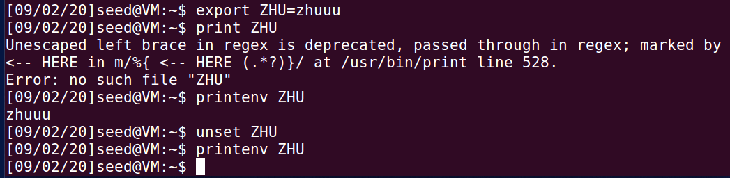

**Task2: PassingEnvironmentVariablesfromParentProcesstoChildProcess**

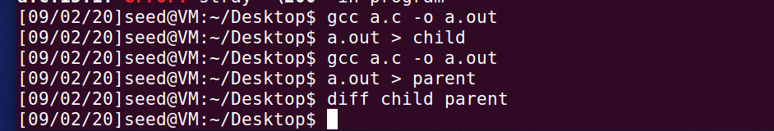

**用diff 命令可知，子进程和父进程的环境变量一致。说明环境变量可以被继承。**

**Task3: Environment Variablesand execve()**

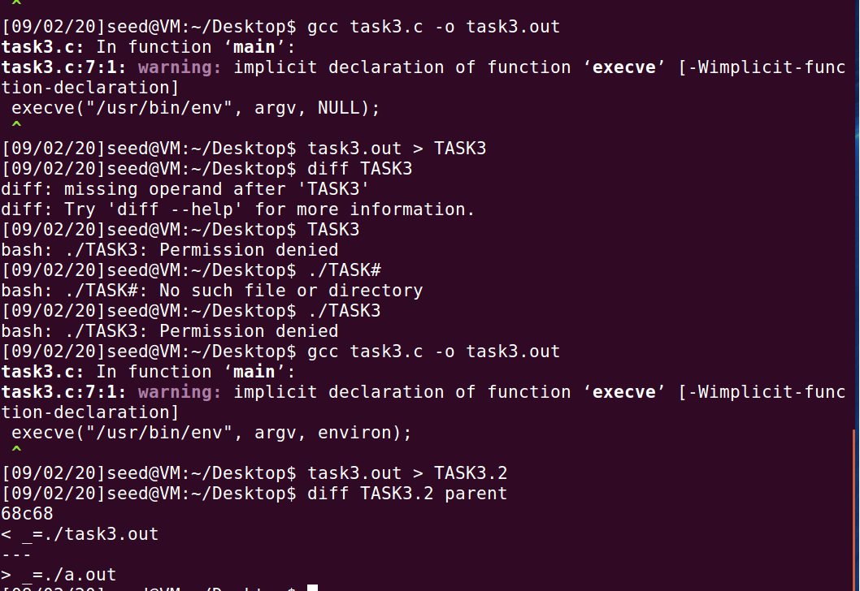

使用execve("/usr/bin/env", argv, NULL); 命令时，输出的环境变量为空。这时因为NULL 强行更改了环境变量为空。当换成execve ("/usr/bin/env", argv, environ);时, 比较此次输出与上一个task的环境变量进行比较，除了最后的文件命名不一样，内容全部一样。说明此时，environ 参数赋予新程序与系统环境变量相同的环境变量。

**Task4: Environment Variablesand system()**

运行结果：

LESSOPEN=| /usr/bin/lesspipe %s

GNOME_KEYRING_PID=

USER=seed

LANGUAGE=en_US

J2SDKDIR=/usr/lib/jvm/java-8-oracle

XDG_SEAT=seat0

SESSION=ubuntu

XDG_SESSION_TYPE=x11

COMPIZ_CONFIG_PROFILE=ubuntu

LD_LIBRARY_PATH=/home/seed/source/boost_1_64_0/stage/lib:/home/seed/source/boost_1_64_0/stage/lib:

SHLVL=1

LIBGL_ALWAYS_SOFTWARE=1

J2REDIR=/usr/lib/jvm/java-8-oracle/jre

HOME=/home/seed

QT4_IM_MODULE=xim

OLDPWD=/home

DESKTOP_SESSION=ubuntu

QT_LINUX_ACCESSIBILITY_ALWAYS_ON=1

GTK_MODULES=gail:atk-bridge:unity-gtk-module

XDG_SEAT_PATH=/org/freedesktop/DisplayManager/Seat0

INSTANCE=

DBUS_SESSION_BUS_ADDRESS=unix:abstract=/tmp/dbus-WUJdey2FBF

GNOME_KEYRING_CONTROL=

QT_QPA_PLATFORMTHEME=appmenu-qt5

MANDATORY_PATH=/usr/share/gconf/ubuntu.mandatory.path

IM_CONFIG_PHASE=1

SESSIONTYPE=gnome-session

LOGNAME=seed

GTK_IM_MODULE=ibus

WINDOWID=29360138

_=./task4.out

DEFAULTS_PATH=/usr/share/gconf/ubuntu.default.path

XDG_SESSION_ID=c1

TERM=xterm-256color

GNOME_DESKTOP_SESSION_ID=this-is-deprecated

GTK2_MODULES=overlay-scrollbar

PATH=/home/seed/bin:/usr/local/sbin:/usr/local/bin:/usr/sbin:/usr/bin:/sbin:/bin:/usr/games:/usr/local/games:.:/snap/bin:/usr/lib/jvm/java-8-oracle/bin:/usr/lib/jvm/java-8-oracle/db/bin:/usr/lib/jvm/java-8-oracle/jre/bin:/home/seed/android/android-sdk-linux/tools:/home/seed/android/android-sdk-linux/platform-tools:/home/seed/android/android-ndk/android-ndk-r8d:/home/seed/.local/bin

DERBY_HOME=/usr/lib/jvm/java-8-oracle/db

SESSION_MANAGER=local/VM:@/tmp/.ICE-unix/1728,unix/VM:/tmp/.ICE-unix/1728

GDM_LANG=en_US

XDG_MENU_PREFIX=gnome-

XDG_SESSION_PATH=/org/freedesktop/DisplayManager/Session0

XDG_RUNTIME_DIR=/run/user/1000

DISPLAY=:0

LD_PRELOAD=/home/seed/lib/boost/libboost_program_options.so.1.64.0:/home/seed/lib/boost/libboost_filesystem.so.1.64.0:/home/seed/lib/boost/libboost_system.so.1.64.0

LANG=en_US.UTF-8

XDG_CURRENT_DESKTOP=Unity

LS_COLORS=rs=0:di=01;34:ln=01;36:mh=00:pi=40;33:so=01;35:do=01;35:bd=40;33;01:cd=40;33;01:or=40;31;01:mi=00:su=37;41:sg=30;43:ca=30;41:tw=30;42:ow=34;42:st=37;44:ex=01;32:*.tar=01;31:*.tgz=01;31:*.arc=01;31:*.arj=01;31:*.taz=01;31:*.lha=01;31:*.lz4=01;31:*.lzh=01;31:*.lzma=01;31:*.tlz=01;31:*.txz=01;31:*.tzo=01;31:*.t7z=01;31:*.zip=01;31:*.z=01;31:*.Z=01;31:*.dz=01;31:*.gz=01;31:*.lrz=01;31:*.lz=01;31:*.lzo=01;31:*.xz=01;31:*.bz2=01;31:*.bz=01;31:*.tbz=01;31:*.tbz2=01;31:*.tz=01;31:*.deb=01;31:*.rpm=01;31:*.jar=01;31:*.war=01;31:*.ear=01;31:*.sar=01;31:*.rar=01;31:*.alz=01;31:*.ace=01;31:*.zoo=01;31:*.cpio=01;31:*.7z=01;31:*.rz=01;31:*.cab=01;31:*.jpg=01;35:*.jpeg=01;35:*.gif=01;35:*.bmp=01;35:*.pbm=01;35:*.pgm=01;35:*.ppm=01;35:*.tga=01;35:*.xbm=01;35:*.xpm=01;35:*.tif=01;35:*.tiff=01;35:*.png=01;35:*.svg=01;35:*.svgz=01;35:*.mng=01;35:*.pcx=01;35:*.mov=01;35:*.mpg=01;35:*.mpeg=01;35:*.m2v=01;35:*.mkv=01;35:*.webm=01;35:*.ogm=01;35:*.mp4=01;35:*.m4v=01;35:*.mp4v=01;35:*.vob=01;35:*.qt=01;35:*.nuv=01;35:*.wmv=01;35:*.asf=01;35:*.rm=01;35:*.rmvb=01;35:*.flc=01;35:*.avi=01;35:*.fli=01;35:*.flv=01;35:*.gl=01;35:*.dl=01;35:*.xcf=01;35:*.xwd=01;35:*.yuv=01;35:*.cgm=01;35:*.emf=01;35:*.ogv=01;35:*.ogx=01;35:*.aac=00;36:*.au=00;36:*.flac=00;36:*.m4a=00;36:*.mid=00;36:*.midi=00;36:*.mka=00;36:*.mp3=00;36:*.mpc=00;36:*.ogg=00;36:*.ra=00;36:*.wav=00;36:*.oga=00;36:*.opus=00;36:*.spx=00;36:*.xspf=00;36:

XMODIFIERS=@im=ibus

XDG_SESSION_DESKTOP=ubuntu

XAUTHORITY=/home/seed/.Xauthority

XDG_GREETER_DATA_DIR=/var/lib/lightdm-data/seed

SSH_AUTH_SOCK=/run/user/1000/keyring/ssh

SHELL=/bin/bash

QT_ACCESSIBILITY=1

GDMSESSION=ubuntu

LESSCLOSE=/usr/bin/lesspipe %s %s

GPG_AGENT_INFO=/home/seed/.gnupg/S.gpg-agent:0:1

UPSTART_SESSION=unix:abstract=/com/ubuntu/upstart-session/1000/1420

XDG_VTNR=7

QT_IM_MODULE=ibus

PWD=/home/seed/Desktop

JAVA_HOME=/usr/lib/jvm/java-8-oracle

CLUTTER_IM_MODULE=xim

ANDROID_HOME=/home/seed/android/android-sdk-linux

XDG_CONFIG_DIRS=/etc/xdg/xdg-ubuntu:/usr/share/upstart/xdg:/etc/xdg

XDG_DATA_DIRS=/usr/share/ubuntu:/usr/share/gnome:/usr/local/share/:/usr/share/:/var/lib/snapd/desktop

VTE_VERSION=4205

JOB=dbus

**Task5: EnvironmentVariableand Set-UID Programs**

**Step 1 ： 执行结果如下**

XDG_VTNR=7

XDG_SESSION_ID=c1

XDG_GREETER_DATA_DIR=/var/lib/lightdm-data/seed

CLUTTER_IM_MODULE=xim

SESSION=ubuntu

ANDROID_HOME=/home/seed/android/android-sdk-linux

GPG_AGENT_INFO=/home/seed/.gnupg/S.gpg-agent:0:1

TERM=xterm-256color

VTE_VERSION=4205

XDG_MENU_PREFIX=gnome-

SHELL=/bin/bash

DERBY_HOME=/usr/lib/jvm/java-8-oracle/db

QT_LINUX_ACCESSIBILITY_ALWAYS_ON=1

LD_PRELOAD=/home/seed/lib/boost/libboost_program_options.so.1.64.0:/home/seed/lib/boost/libboost_filesystem.so.1.64.0:/home/seed/lib/boost/libboost_system.so.1.64.0

WINDOWID=29360138

UPSTART_SESSION=unix:abstract=/com/ubuntu/upstart-session/1000/1420

GNOME_KEYRING_CONTROL=

GTK_MODULES=gail:atk-bridge:unity-gtk-module

USER=seed

LS_COLORS=rs=0:di=01;34:ln=01;36:mh=00:pi=40;33:so=01;35:do=01;35:bd=40;33;01:cd=40;33;01:or=40;31;01:mi=00:su=37;41:sg=30;43:ca=30;41:tw=30;42:ow=34;42:st=37;44:ex=01;32:*.tar=01;31:*.tgz=01;31:*.arc=01;31:*.arj=01;31:*.taz=01;31:*.lha=01;31:*.lz4=01;31:*.lzh=01;31:*.lzma=01;31:*.tlz=01;31:*.txz=01;31:*.tzo=01;31:*.t7z=01;31:*.zip=01;31:*.z=01;31:*.Z=01;31:*.dz=01;31:*.gz=01;31:*.lrz=01;31:*.lz=01;31:*.lzo=01;31:*.xz=01;31:*.bz2=01;31:*.bz=01;31:*.tbz=01;31:*.tbz2=01;31:*.tz=01;31:*.deb=01;31:*.rpm=01;31:*.jar=01;31:*.war=01;31:*.ear=01;31:*.sar=01;31:*.rar=01;31:*.alz=01;31:*.ace=01;31:*.zoo=01;31:*.cpio=01;31:*.7z=01;31:*.rz=01;31:*.cab=01;31:*.jpg=01;35:*.jpeg=01;35:*.gif=01;35:*.bmp=01;35:*.pbm=01;35:*.pgm=01;35:*.ppm=01;35:*.tga=01;35:*.xbm=01;35:*.xpm=01;35:*.tif=01;35:*.tiff=01;35:*.png=01;35:*.svg=01;35:*.svgz=01;35:*.mng=01;35:*.pcx=01;35:*.mov=01;35:*.mpg=01;35:*.mpeg=01;35:*.m2v=01;35:*.mkv=01;35:*.webm=01;35:*.ogm=01;35:*.mp4=01;35:*.m4v=01;35:*.mp4v=01;35:*.vob=01;35:*.qt=01;35:*.nuv=01;35:*.wmv=01;35:*.asf=01;35:*.rm=01;35:*.rmvb=01;35:*.flc=01;35:*.avi=01;35:*.fli=01;35:*.flv=01;35:*.gl=01;35:*.dl=01;35:*.xcf=01;35:*.xwd=01;35:*.yuv=01;35:*.cgm=01;35:*.emf=01;35:*.ogv=01;35:*.ogx=01;35:*.aac=00;36:*.au=00;36:*.flac=00;36:*.m4a=00;36:*.mid=00;36:*.midi=00;36:*.mka=00;36:*.mp3=00;36:*.mpc=00;36:*.ogg=00;36:*.ra=00;36:*.wav=00;36:*.oga=00;36:*.opus=00;36:*.spx=00;36:*.xspf=00;36:

QT_ACCESSIBILITY=1

LD_LIBRARY_PATH=/home/seed/source/boost_1_64_0/stage/lib:/home/seed/source/boost_1_64_0/stage/lib:

XDG_SESSION_PATH=/org/freedesktop/DisplayManager/Session0

XDG_SEAT_PATH=/org/freedesktop/DisplayManager/Seat0

SSH_AUTH_SOCK=/run/user/1000/keyring/ssh

DEFAULTS_PATH=/usr/share/gconf/ubuntu.default.path

SESSION_MANAGER=local/VM:@/tmp/.ICE-unix/1728,unix/VM:/tmp/.ICE-unix/1728

XDG_CONFIG_DIRS=/etc/xdg/xdg-ubuntu:/usr/share/upstart/xdg:/etc/xdg

DESKTOP_SESSION=ubuntu

PATH=/home/seed/bin:/usr/local/sbin:/usr/local/bin:/usr/sbin:/usr/bin:/sbin:/bin:/usr/games:/usr/local/games:.:/snap/bin:/usr/lib/jvm/java-8-oracle/bin:/usr/lib/jvm/java-8-oracle/db/bin:/usr/lib/jvm/java-8-oracle/jre/bin:/home/seed/android/android-sdk-linux/tools:/home/seed/android/android-sdk-linux/platform-tools:/home/seed/android/android-ndk/android-ndk-r8d:/home/seed/.local/bin

QT_IM_MODULE=ibus

QT_QPA_PLATFORMTHEME=appmenu-qt5

XDG_SESSION_TYPE=x11

PWD=/home/seed/Desktop

JOB=dbus

XMODIFIERS=@im=ibus

JAVA_HOME=/usr/lib/jvm/java-8-oracle

GNOME_KEYRING_PID=

LANG=en_US.UTF-8

GDM_LANG=en_US

MANDATORY_PATH=/usr/share/gconf/ubuntu.mandatory.path

COMPIZ_CONFIG_PROFILE=ubuntu

IM_CONFIG_PHASE=1

GDMSESSION=ubuntu

SESSIONTYPE=gnome-session

GTK2_MODULES=overlay-scrollbar

SHLVL=1

HOME=/home/seed

XDG_SEAT=seat0

LANGUAGE=en_US

LIBGL_ALWAYS_SOFTWARE=1

GNOME_DESKTOP_SESSION_ID=this-is-deprecated

XDG_SESSION_DESKTOP=ubuntu

LOGNAME=seed

DBUS_SESSION_BUS_ADDRESS=unix:abstract=/tmp/dbus-WUJdey2FBF

J2SDKDIR=/usr/lib/jvm/java-8-oracle

XDG_DATA_DIRS=/usr/share/ubuntu:/usr/share/gnome:/usr/local/share/:/usr/share/:/var/lib/snapd/desktop

QT4_IM_MODULE=xim

LESSOPEN=| /usr/bin/lesspipe %s

INSTANCE=

XDG_RUNTIME_DIR=/run/user/1000

DISPLAY=:0

XDG_CURRENT_DESKTOP=Unity

GTK_IM_MODULE=ibus

J2REDIR=/usr/lib/jvm/java-8-oracle/jre

LESSCLOSE=/usr/bin/lesspipe %s %s

XAUTHORITY=/home/seed/.Xauthority

_=./task5.out

OLDPWD=/home/seed

**Step 2 执行命令**



**Step 3：执行结果如下：diff 比较更改前后的区别**

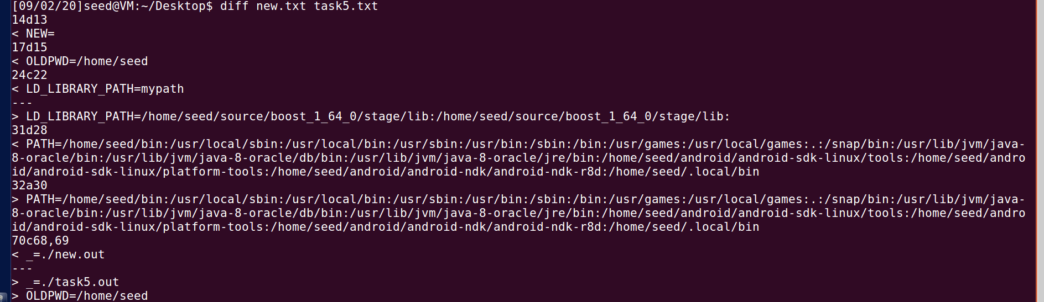

可以看到export 的三个变量都有更改。

**Task6: The PATH Environmen tVariableand Set-UID Programs**

安装shell用来执行system 函数里的ls命令，改变权限为root 并设置为set-uid程序。可以利用该程序在当前路径下执行ls并输出不必非要使用/bin/ls，结果如下

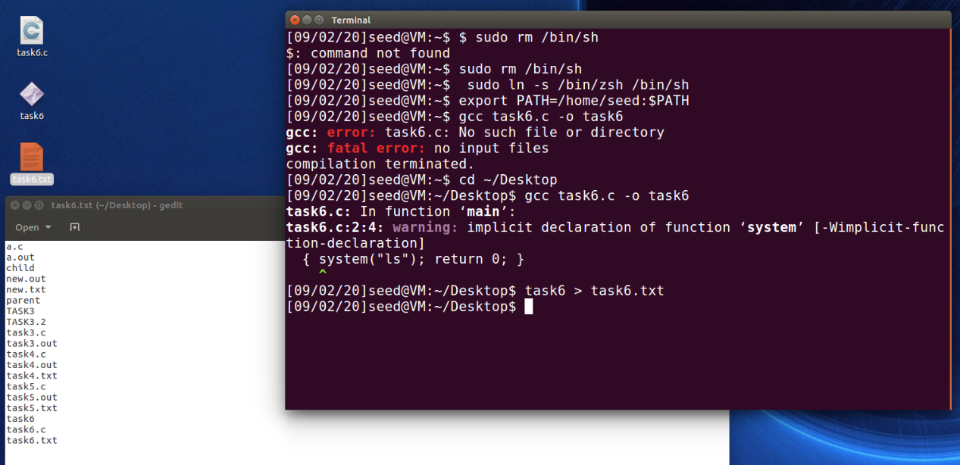

**Task7: The LD PRELOAD Environment Variableand Set-UID Programs**

1. **普通用户，链接动态链接库 输出如下**

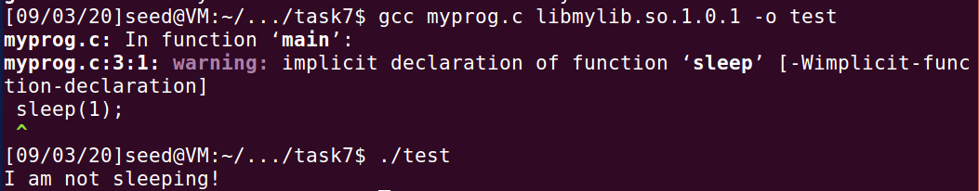

1. **普通用户，将程序设置为set-uid程序，程序报错**

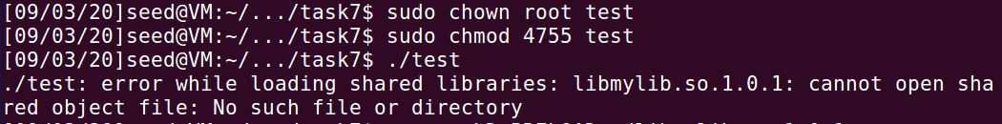

1. **在root模式下修改LD_PRELOAD 环境变量。输出如下：**

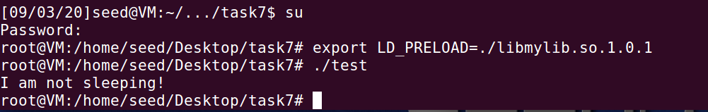

1. **将可执行文件所有权改为新用户，并在seed下exprot动态库并执行：**

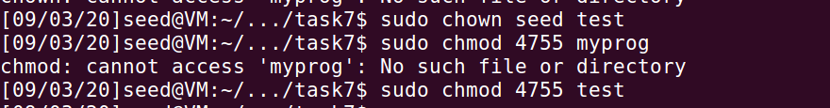



**程序无法执行。程序调用者与程序owner不一致时，ruid与euid不一致时，便不会链接到动态链接库。**

**Task8: Invoking External Programs Using system() versus execve()**

1. **设置文件task8为只读文件**



1. **编译task8.c, 并将task8 改为root用户的set uid 程序**

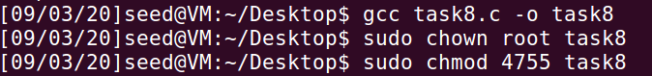

1. **查看此时的文件列表，可以查到有testfile文件的存在**

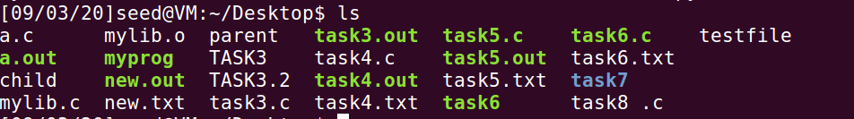

1. **运行task8，发现删除了不可写文件testfile**

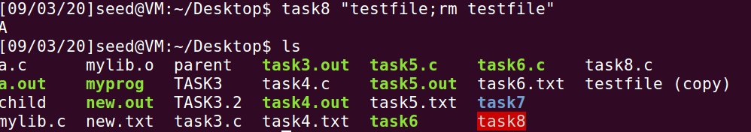

1. **使用execuve（）函数，重新编译，并设可执行文件为root用户的set uid程序**

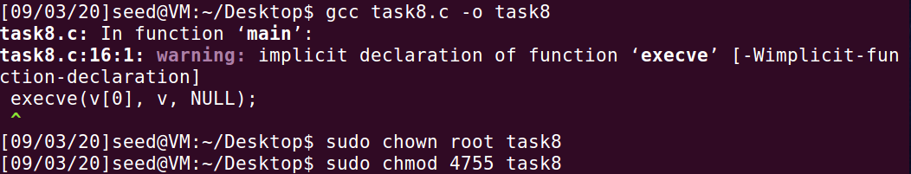

1. **再次尝试删除文件，提示不存在该文件，删除失败**

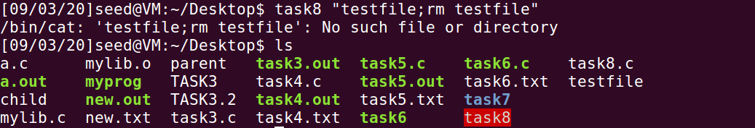

1. **system()由于是调用shell执行cmd，且未对输入进行约束，导致注入攻击能够成功；而execve()不调用shell，所以注入失败。**

**Task9: Capability Leaking**

1. **创建etc/zzz，并设置为root拥有，0644权限**

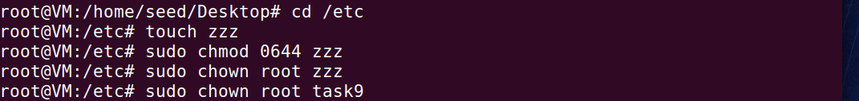

1. **编译test9.c 并把可执行文件设置为root拥有的set uid 程序，执行task9.发现文件被写入了Malicious Data**

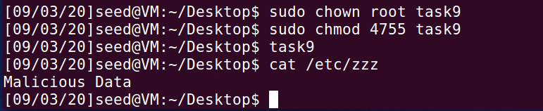

1. **在此实验中，尽管启动进程的用户不再拥有特权，但是由于该进程是fork出的进程，继承了父进程的特权，所以执行该文件仍然可以对zzz文件进行改写**