Xihao Zhu’s comp498 project proposal

Rice id: Xz36

1.Statement of problem:

In this project I will try to deal with Forward Kinematics and Inverse Kinematics of ROS Willow Garage PR2. It’s a human like robot with head and 2 hands. I will just try to analysis only its right hand FK and IK, cause its left hand is just symmetric to its right hand. The following is a pr2 robot

Pr2 is a two-armed wheeled robot of size similar to a human. The PR2 has two 7-DOF arms with a payload of 1.8 kilograms (1,800 g). Sensors include a 5-megapixel camera, a tilting laser range finder, and an inertial measurement unit.

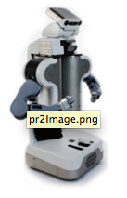

2. Objectives

I will derive Forward Kinematics(mainly) and Inverse Kinematics of Ros pr2’s right hand. Later if time allows I think I will derive DH table and try to mimic what has been done in lab3. That is I will try to animate pr2’s right hand’s movement in matlab if time allows.