Xihao Zhu xz36

HW03

P1.

(1)&(2)

By using parameters set in (1), where learning parameter is 0.001, slope parameter is 1, my training runs 1,000,000 steps and then converges with

w =

1.0370 -1.2786

2.2212 2.5459

-2.1534 -2.5470

v =

2.4976

-2.8639

2.7966

with RMS error <0.2

(3)

(a)By setting up my own parameters, I use 0.003 as learn parameter, 60 as slope parameter. Stopping criteria is “stop when 15,000 learning steps are performed”.

Initial weights are:

w =

0.0020000 0.0020000

0.0070000 0.0020000

0.0100000 -0.0010000

v =

0.0050000

-0.0040000

0.0040000

(b)

Learn step Input vec Desired Actual ek

1000 1 0 0 -1 -0.80169 -0.19831

2000 1 0 0 -1 -0.88773 -0.11227

3000 1 1 1 -1 0.48802 -1.488

4000 1 0 1 1 0.825 0.175

5000 1 0 1 1 0.82421 0.17579

6000 1 1 1 -1 -0.82716 -0.17284

7000 1 1 0 1 0.90349 0.096513

8000 1 1 1 -1 -0.90506 -0.094942

9000 1 0 0 -1 -0.93872 -0.061276

10000 1 1 0 1 0.93619 0.063806

11000 1 1 1 -1 -0.92737 -0.072631

12000 1 1 1 -1 -0.93679 -0.063207

13000 1 1 1 -1 -0.93679 -0.063213

14000 1 0 1 1 0.95429 0.045708

15000 1 0 1 1 0.96056 0.039441

(c)

I use absolute error. The formula is

Error=abs(-1-y1)+abs(1-y2)+abs(1-y3)+abs(-1-y4) .

Where y1, y2, y3, y4 are outputs from neural network using current weights w, v, with inputs [1 1 1], [1 1 0], [1 0 1], [1 0 0].

My m is 15,

err =

Columns 1 through 8:

3.93901 3.42967 1.29216 0.63663 0.44548 0.35740 0.29692 0.26010

Columns 9 through 15:

0.23363 0.21289 0.19567 0.18252 0.17139 0.16199 0.15371

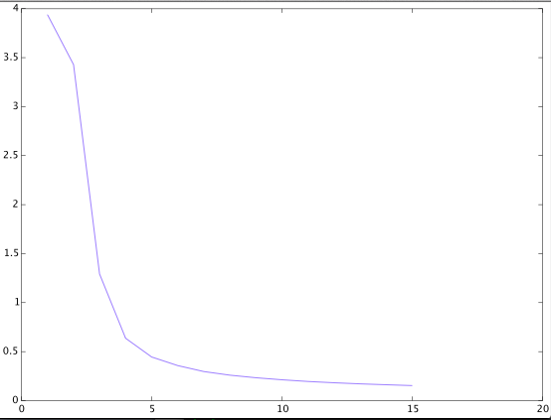

This is a plot of Absolute error VS m step(m x1000 steps)

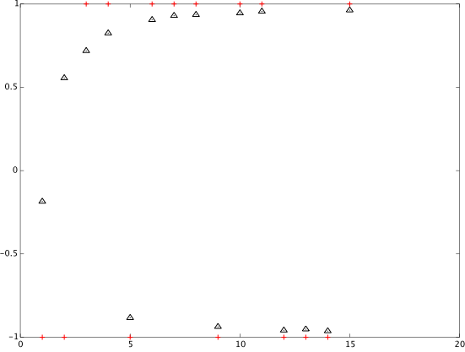

And this figure is a plot of desired outputs VS actual outputs. The red + is desired outputs; black triangle is actual output.

(d)

1,5000 learning steps total.

(e)

step.m is the related code.

P2.

(1)

changed code in step2.m

I use 7 hidden layers to train my data. I use the same parameters: 0.003 as learn parameter, 60 as slope parameter. I didn’t use perfect match, so the initial weights are not same. They are just random weights.

I got resulting network’s absolute error to be 0.12166. which is better than 2-hidden layer network, whose absolute error is 0. 15371(depicted in P1.3.c)

(2)

changed code in step2.m

call:

[w1,v1]=step2(3750,3,7)

r=errorRate(w1,v1) where r is absolute error.

r=0.14

since previously step is 15000. Now epoch is 4, steps needed to run is 15000/4=3750. I found the error rate is slightly worse than 0.12166. When I use 4000 as step, that is, using

r is absolute error.

[w1,v1]=step2(4000,3,7)

r=errorRate(w1,v1)

r=0.115.

which is better than 0.12166. This is an interesting found~

(3)&(4)

It seems that the parameters provided don’t converge for my code. I run 3000K steps but output doesn’t converge.

(a)

By setting up my own parameters, I use 0.0001 as learn parameter, 0.001 as slope parameter. Stopping criteria is “stop when 150,000 learning steps are performed”.

Initial weights are:

w =

Columns 1 through 6:

-0.040000 0.040000 -0.010000 0.060000 0.030000 0.070000

-0.020000 -0.030000 -0.040000 0.090000 -0.080000 0.100000

Columns 7 through 9:

0.040000 0.030000 0.050000

0.010000 -0.030000 0.030000

v =

0.090000

-0.020000

0.080000

-0.070000

0.100000

0.100000

0.010000

0.030000

-0.070000

-0.040000

(b)

Learn step Input vec Desired Actual ek

10000 1 1 8.0023 -7

20000 1 1 8.3239 -7.3

30000 1 1 8.8923 -7.9

40000 1 1 9.2323 -8.2

50000 1 1 9.9882 -8.9

60000 1 1 10 -9

70000 1 1 10 -9

80000 1 1 10 -9

90000 1 1 10 -9

100000 1 1 10 -9

110000 1 1 10 -9

120000 1 1 10 -9

130000 1 1 10 -9

140000 1 1 10 -9

150000 1 1 10 -9

(c)

the error becomes greater and greater as steps increase. And it converges to point where input pattern cannot influence output(output keeps at 10☹)

I think plot doesn’t make sense here.

(d)i use 150,000, and 3,000,000, neither works.

(e)step2.m