Xihao Zhu COMP502 HW4

P1.

Here is my variable test table

|  |  |  |  |  |  |  |
| --- | --- | --- | --- | --- | --- | --- |
| learn parameter | slope parameter | #of hidden layer | momentum term | epoch size | result |  |
| 0.05 | 1 | 10 | 0.8 | 200 | 0.04 | No1 best |
| 0.05 | 1 | 15 | 0.8 | 200 | 0.06 | No2 best |
| 0.05 | 1 | 5 | 0.8 | 200 | 0.08 | not that good… |
| 0.07 | 1 | 10 | 0.8 | 200 | 0.05(but fluctuates a lot) | No3 best |
| 0.05 | 1 | 10 | 0.08 | 1000 | 0.17 | bad. |
| 0.05 | 1 | 10 | 0.08 | 800 | 0.12 | bad |

3 best parameter results No1, No2, No3:

No1:

(a)

For own parameters, I use 0.05 as learn parameter, 1 as slope parameter, 10 hidden layers, 0.8 as momentum term constant, 200 as epoch size. Stopping criteria is “stop when 50,000 learning steps are performed”.

Initial weights are:

w =

-0.050000 0.070000 -0.040000 0.040000 0.040000 -0.050000 0.020000 0.010000 -0.020000

0.080000 0.050000 -0.010000 -0.060000 -0.070000 -0.010000 -0.030000 0.040000 -0.040000

v =

-0.020000

-0.060000

0.040000

0.090000

0.050000

-0.050000

0.090000

0.050000

-0.070000

-0.030000

(b)

Learn step Input vec Desired Actual ek

5000 0.31598 -0.90834 -0.63253 -0.27581

10000 0.05245 -0.83657 -0.64877 -0.18781

15000 -0.3855 -0.60019 -0.46913 -0.13105

20000 0.26646 -0.89697 -0.82332 -0.073653

25000 -0.11237 -0.77221 -0.64679 -0.12543

30000 -0.29141 -0.67257 -0.58968 -0.082884

35000 -0.53822 -0.43109 -0.34116 -0.089926

40000 1 0.12608 -0.85973 -0.90121 0.04148

45000 1 -0.59081 -0.34938 -0.17634 -0.17304

50000 1 0.42721 -0.9312 -0.97158 0.040372

(c)

The error measurement is like this:

I use absolute error. The formula is to get sum of absolute value of every network’s output(200 samples for train data and 100 for test data) minus desired output. Then scaling back the sum by multiplying by 4.5, so that the error is real error treating y as range of [1, 10].

Here is the plot

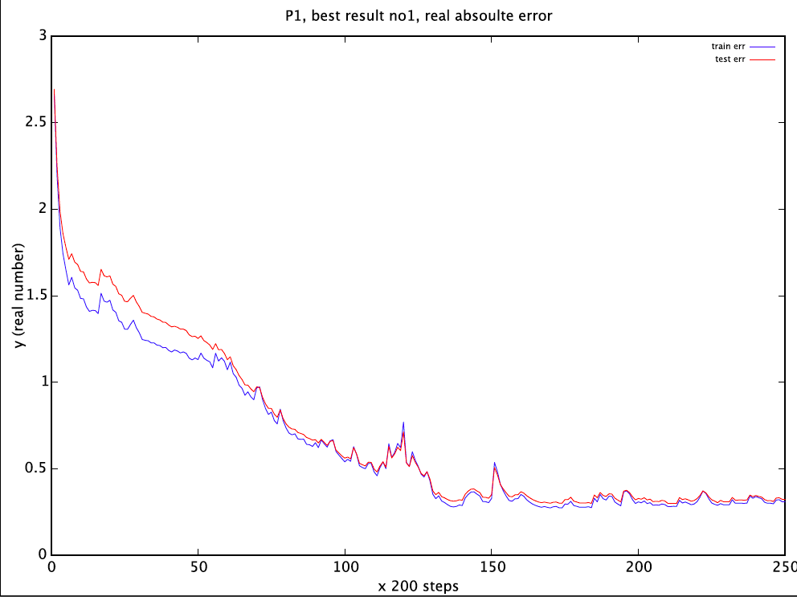

both the test error and train error are approaching 0.4. Therefore Error rate is about 0.4/(10-1)=4.44%

desired output VS calculated output is

results are not scaling back yet, but shapes are similar~

blue line is desired output, while red line is calculated output

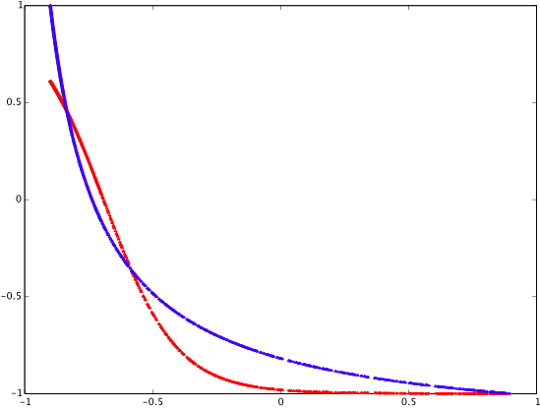

No2.

(a)

For own parameters, I use 0.05 as learn parameter, 1 as slope parameter, 15 hidden layers, 0.8 as momentum term constant, 200 as epoch size. Stopping criteria is “stop when 50,000 learning steps are performed”.

Initial weights are:

w =

Columns 1 through 9:

-0.0400000 -0.0900000 0.0100000 -0.0100000 -0.0200000 -0.0500000 -0.0200000 0.0500000 0.0400000

-0.0800000 0.0400000 -0.0800000 -0.0200000 0.0300000 -0.0400000 0.0900000 0.0100000 -0.0050000

Columns 10 through 14:

-0.0500000 0.0300000 0.1000000 0.0900000 0.0900000

-0.0300000 0.0100000 -0.0300000 -0.0300000 -0.0500000

v =

-0.010000

0.060000

0.070000

0.080000

-0.080000

0.040000

-0.090000

0.020000

-0.090000

0.090000

0.030000

-0.040000

0.020000

0.030000

-0.030000

(b)

Learn step Input vec Desired Actual ek

55000 -0.33059 -0.64458 -0.56816 -0.076426

10000 0.40975 -0.92784 -0.70333 -0.22451

15000 0.26529 -0.89669 -0.79353 -0.10316

20000 -0.44989 -0.53858 -0.38817 -0.15041

25000 -0.5593 -0.40024 -0.23664 -0.16359

30000 -0.3988 -0.58839 -0.48809 -0.10029

35000 -0.18729 -0.73527 -0.70888 -0.026388

40000 0.83638 -0.9927 -0.99027 -0.0024259

45000 -0.068562 -0.79132 -0.84028 0.048952

50000 0.78385 -0.9863 -0.99094 0.0046405

(c)

The error measurement is like this:

I use absolute error. The formula is to get sum of absolute value of every network’s output(200 samples for train data and 100 for test data) minus desired output. Then scaling back the sum by multiplying by 4.5, so that the error is real error treating y as range of [1, 10].

(Title wrong, it should be best result No2)

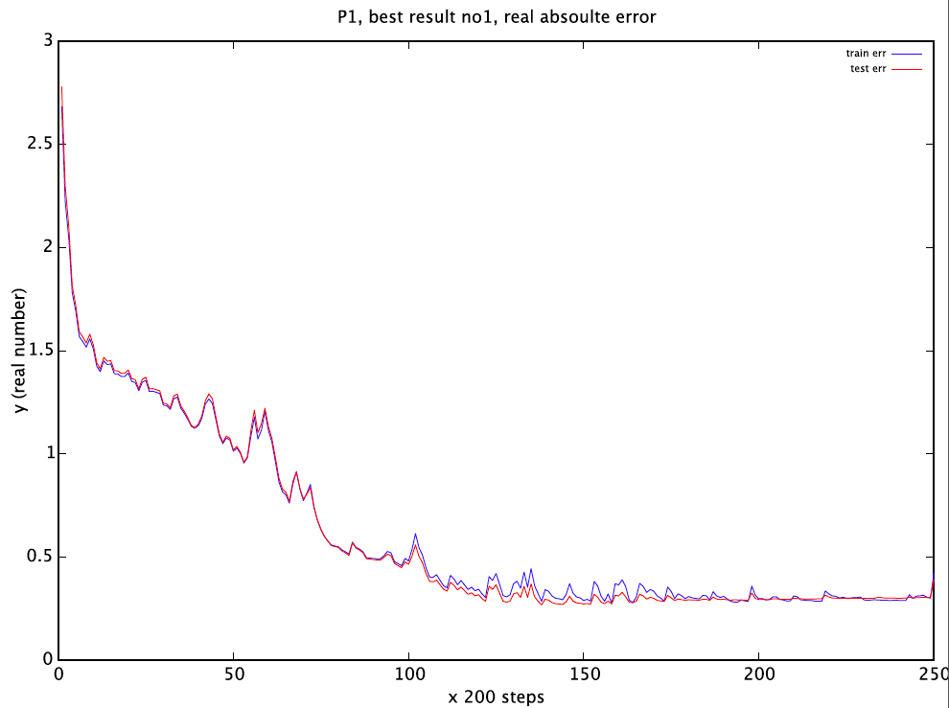

both the test error and train error are approaching 0.4. Therefore Error rate is about 0.4/(10-1)=4.44%. The test error and train error are more similar than No1. This is interesing~

desired output VS calculated output is

results are not scaling back yet, but shapes are similar~

blue line is desired output, while red line is calculated output

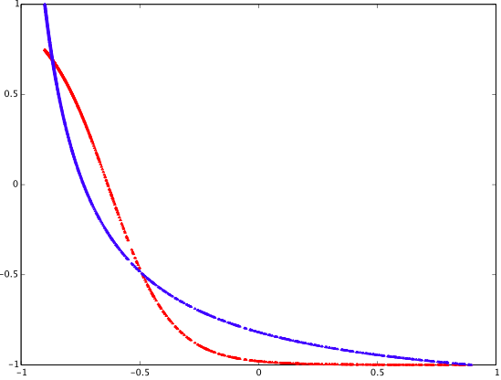

No3.

(a)

For own parameters, I use 0.05 as learn parameter, 1 as slope parameter, 10 hidden layers, 0.8 as momentum term constant, 200 as epoch size. Stopping criteria is “stop when 50,000 learning steps are performed”.

Initial weights are:

w =

0.0050000 -0.0100000 0.0100000 0.0500000 -0.0400000 0.0800000 -0.0100000 0.0800000 0.0050000

0.1000000 -0.0900000 0.0100000 0.0300000 0.0100000 0.0800000 -0.0200000 0.0100000 0.0700000

v =

-0.0100000

0.1000000

-0.0900000

0.0100000

-0.0400000

-0.0900000

0.0800000

0.0500000

0.0800000

-0.0050000

(b)

Learn step Input vec Desired Actual ek

5000 1 0.7139 -0.9772 -0.69972 -0.27748

10000 1 0.013675 -0.82314 -0.60667 -0.21647

15000 1 -0.0040455 -0.81669 -0.67072 -0.14597

20000 1 0.44367 -0.93431 -0.89957 -0.034738

25000 1 -0.76134 0.090151 -0.059618 0.14977

30000 1 0.11545 -0.85656 -0.86864 0.01208

35000 1 0.072002 -0.843 -0.86527 0.022265

40000 1 0.7565 -0.98282 -0.98465 0.0018287

45000 1 -0.09644 -0.77935 -0.8107 0.031346

50000 1 0.88091 -0.99786 -0.99135 -0.0065092

50000 1 0.42721 -0.9312 -0.97158 0.040372

(c)

The error measurement is like this:

I use absolute error. The formula is to get sum of absolute value of every network’s output(200 samples for train data and 100 for test data) minus desired output. Then scaling back the sum by multiplying by 4.5, so that the error is real error treating y as range of [1, 10].

Here is the plot

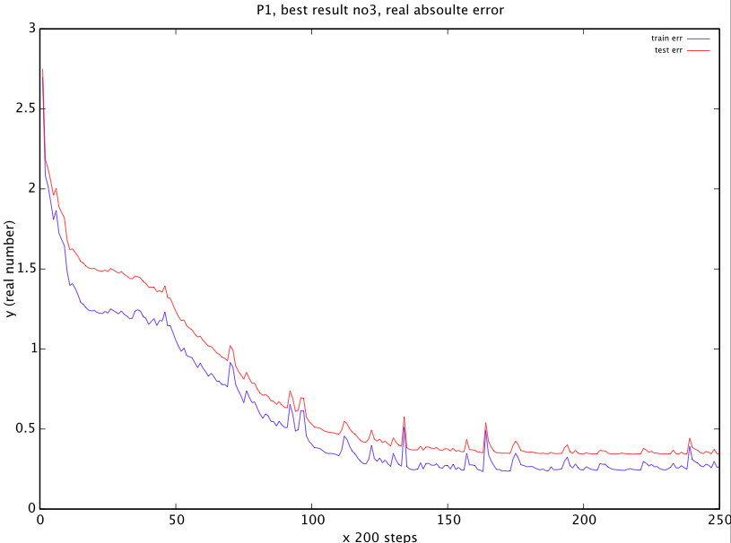

both the test error and train error are approaching 0.4. Therefore Error rate is about 0./(10-1)=5.56%

desired output VS calculated output is

results are not scaling back yet, but shapes are similar~

blue line is desired output, while red line is calculated output

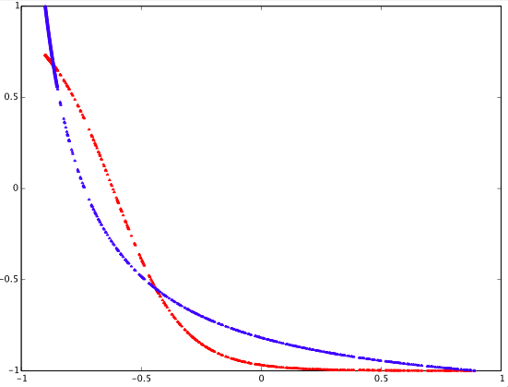

P2.

(a)

For own parameters, I use 0.05 as learn parameter, 1 as slope parameter, 10 hidden layers, 0.9 as momentum term constant, 200 as epoch size. Stopping criteria is “stop when 200,000 learning steps are performed”.

Initialized weights are:

w =

Columns 1 through 6:

0.0200000 -0.0300000 0.1000000 -0.0300000 0.0700000 -0.0700000

0.0050000 -0.0600000 0.0300000 0.0700000 -0.0900000 -0.0900000

-0.0900000 -0.0900000 0.0300000 0.0400000 0.0800000 -0.0400000

0.0200000 -0.0700000 0.0700000 -0.0600000 -0.0800000 -0.0400000

-0.0600000 0.0600000 -0.0400000 -0.0100000 -0.0700000 0.0050000

Columns 7 through 9:

0.0600000 0.0600000 0.1000000

0.0500000 -0.0700000 0.0800000

-0.0400000 -0.0400000 -0.0100000

0.0200000 0.0100000 0.0900000

0.0200000 0.0800000 0.0600000

v =

0.090000 0.070000 0.080000

-0.020000 0.100000 0.080000

0.020000 0.080000 -0.040000

-0.030000 -0.040000 0.020000

0.060000 0.030000 -0.010000

-0.070000 0.070000 0.100000

-0.010000 -0.080000 -0.090000

-0.050000 -0.050000 -0.090000

-0.070000 0.060000 -0.070000

0.020000 -0.050000 0.050000

(c)

The error measurement is like this:

I use absolute error. The formula is to get sum of absolute value of every network’s output(200 samples for train data and 100 for test data) minus desired output.

Here is the plot(error without scaling back). Moreover, I changed output 0s all to -1.

So output [0 0 1] now is [-1 -1 1]

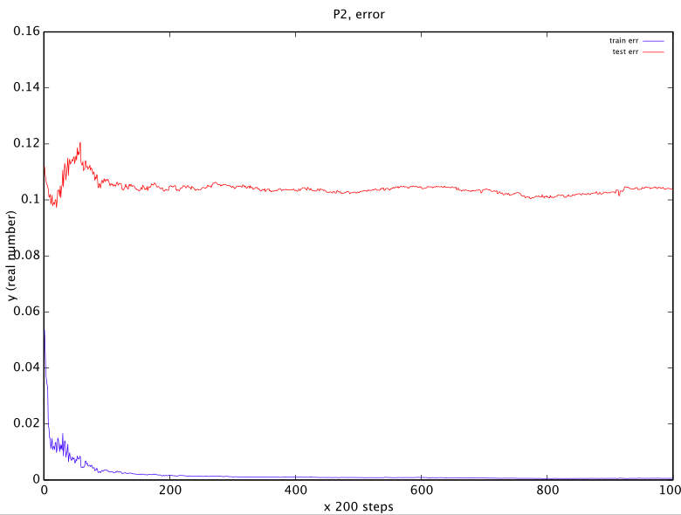

train data error is pretty small, nearly 0.001, but test data error is large, about 0.1, out of 2 total~which is about 5% error rate.

when I write my own program to use sign function(where f(x)=1 if x>0 and f(x)=-1if x<0) for network outputs, the result has no error with both test and train data. So the classification is correct after 200000 steps.