Xihao zhu

Comp502 Hw6

1

(1)

matlab code is [x,y,z]=princomp(zscore(testx)); where testx is input iris data set.

X corresponds to P, and z corresponds to eigenvalues.(zscore(testx) is to make input data preprocessed to have zero mean in each column).

eigenvector P is

[

0.5413 0.3309 0.6945 -0.3395

-0.1768 0.9434 -0.2428 0.1408

0.5863 -0.0237 -0.0507 0.8081

0.5762 0.0029 -0.6754 -0.4603

]

P*P’=

[

1.0000 -0.0000 -0.0000 0.0000

-0.0000 1.0000 0.0000 0.0000

-0.0000 0.0000 1.0000 0.0000

0.0000 0.0000 0.0000 1.0000

]

=I

checked.

eigenvalues are

[

2.8575

1.0160

0.1008

0.0257

]

(2)

GHA learning rate is 0.0005; number of iterations is 15000, initial weights are

|  |  |  |  |
| --- | --- | --- | --- |
| 1.5624 | 0.3965 | 2.2593 | 2.0700 |
|  |  |  |  |
| 2.2621 | 1.4600 | 2.4155 | 2.0735 |
|  |  |  |  |
| 0.3547 | 1.3625 | 2.0942 | 1.9528 |
|  |  |  |  |
| 2.1531 | 2.2582 | 2.2879 | 1.8847 |
|  |  |  |  |

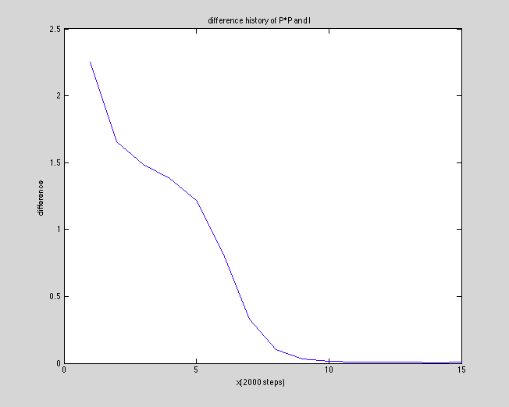

The method to calculate the difference of P*P’ and I is like this. Get the absolute value matrix of P*P’ –I. Then sum over this matrix to get difference.

myi=W*W’;

diff=myi-eye(4);

diff=sum(sum(abs(diff)));

Final Eigenvector P is

[

0.5416 -0.3311 -0.6950 0.3389

-0.1761 -0.9438 0.2428 -0.1413

0.5864 0.0236 0.0506 -0.8091

0.5764 -0.0030 0.6757 0.4600

]

The eigenvector from part 1 is

[

0.5413 0.3309 0.6945 -0.3395

-0.1768 0.9434 -0.2428 0.1408

0.5863 -0.0237 -0.0507 0.8081

0.5762 0.0029 -0.6754 -0.4603

]

So we can see they are pretty similar, except the some signs are reversed.

P(gha)*P(gha)’=

[

1.0007 0.0005 0.0005 -0.0005

0.0005 1.0007 0.0011 0.0004

0.0005 0.0011 1.0015 -0.0001

-0.0005 0.0004 -0.0001 1.0004

]

which is pretty much like I

[

1.0000 -0.0000 -0.0000 0.0000

-0.0000 1.0000 0.0000 0.0000

-0.0000 0.0000 1.0000 0.0000

0.0000 0.0000 0.0000 1.0000

]