COMP502-HW07

Xihao Zhu xz36

P1.

For my Kohonen SOM, I use 10000 steps and set learning rate as variable according to steps. Initial learning rate is as high as 0.6; while when steps approaches 10000 step, rate decreases uniformly to 0.01. Therefore the equation is like rate=init_rate -(init_rate –last_rate)*current#_step/(total#_step), where init_rate=0.6, last_rate=0.01, total#_step=10000.

Initial weight is set to random floats between 0 to 1.

Final weight vectors is like this:

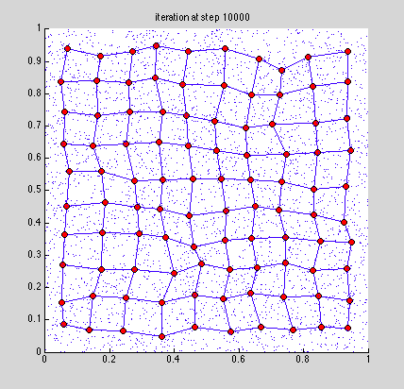

Since inputs are random floats spread in the whole plot above, the result weight is reasonable since it’s like a uniformly web that tries to cover all points.

Historical weight vectors at step 1, 10, 30, 50, 100, 500, 2000, 10000:

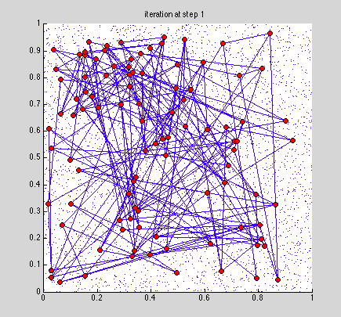

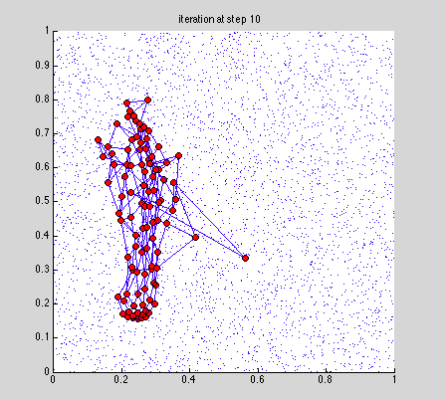

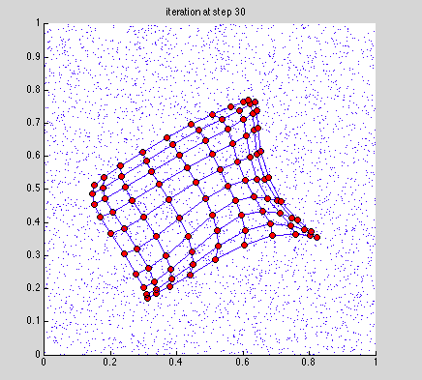

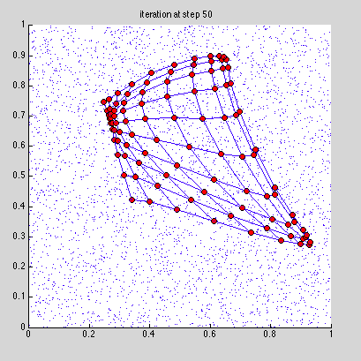

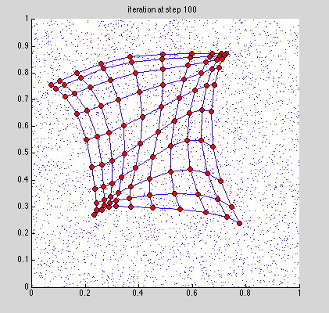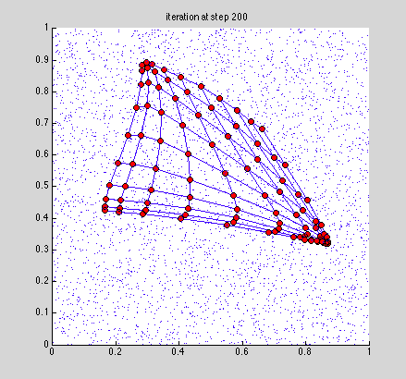

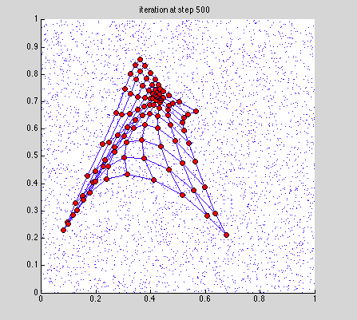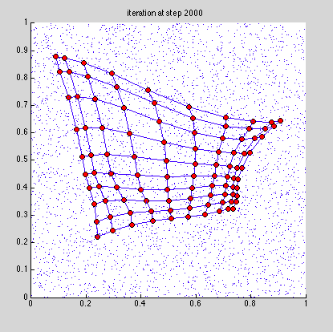

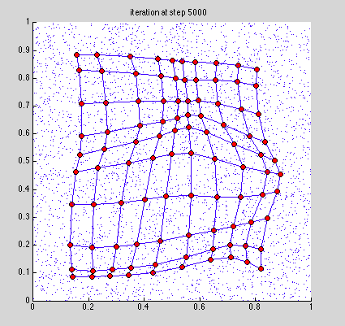

P2.

(a)

For this Kohonen SOM, I use 40000 steps and set learning rate as variable according to steps. Initial learning rate is as high as 0.05; while when steps approaches 40000 step, rate decreases uniformly to 0.005. Therefore the equation is like rate=init_rate -(init_rate –last_rate)*current#_step/(total#_step), where init_rate=0.05, last_rate=0.005, total#_step=40000.

Initial weight is set to random floats between 0 to 1.

Final weight vectors is like this:

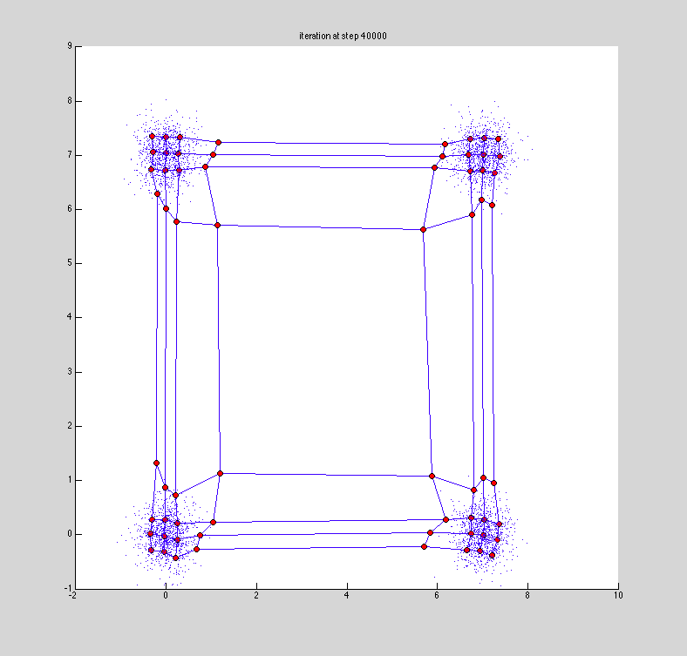

The resulting weights show the structure of 4 clusters, as we expected.

To get a first feel of PE’s input mapping number, I use following NN toolbox methods:

net=selforgmap([8 8])

net=train(net, x_rand)

plotsomhits(net,x_rand)

and get following figure:

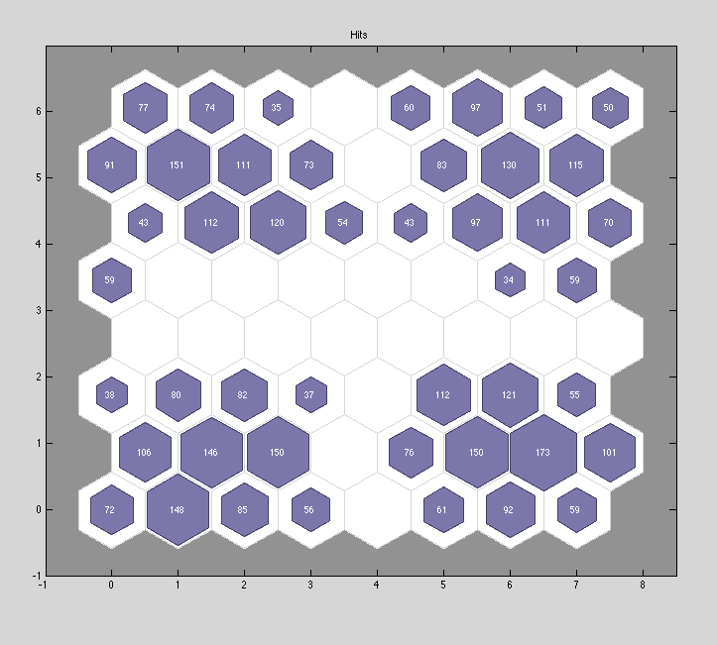

To get my own PE’s input mapping number visualization(if I understand the question correctly~), I use circles to denote how many mappings a PE has. The bigger the circle, the more mappings it has. The following is shown as my result

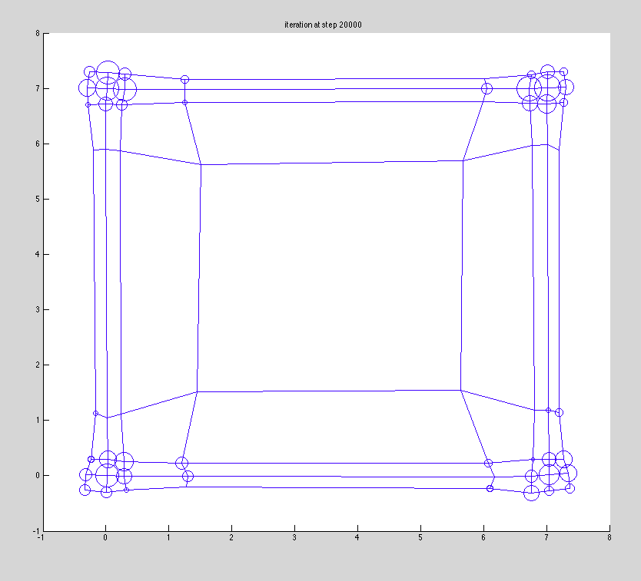

P3.

Neibour weight distance graph:

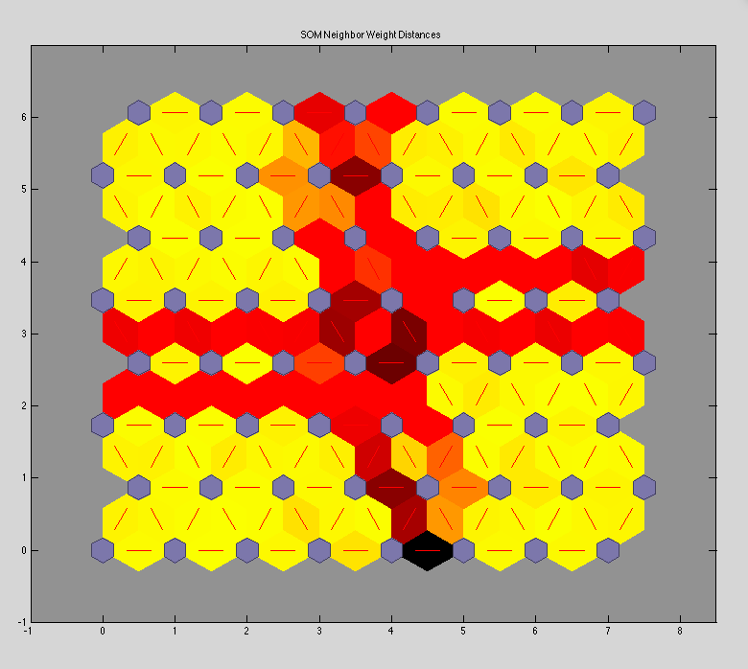

So we can see that there are majorly 4 big clusters, which have patterns that corresponds to weight visualization depicted above. The red zones are “dead ” zones where nearly no mappings to PEs here. Yellow zone shows there exist mappings to PEs in this area.