HW08

Xihao Zhu

Xz36

P1.

(a)

I use LVQ1 to perform the classification. I use LVQ-misc.m(with some modifications) to classifiy the training data. I use the following parameters: iteration to be 2500, number of neurons to be 50, learning rate to be 0.15.

The resulting image is

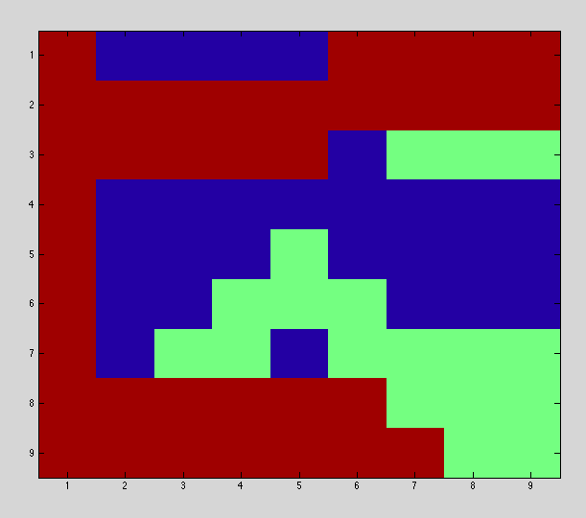

There are 3 misclassifications in the result. So the error rate is 3/81= 3.7%

(b)

Test image is as follow

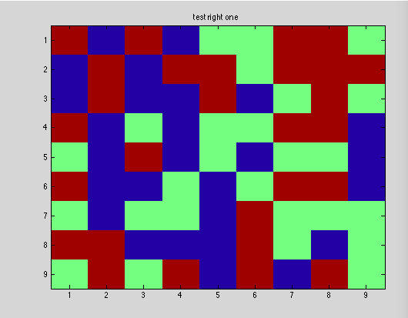

My classification result is as follow:

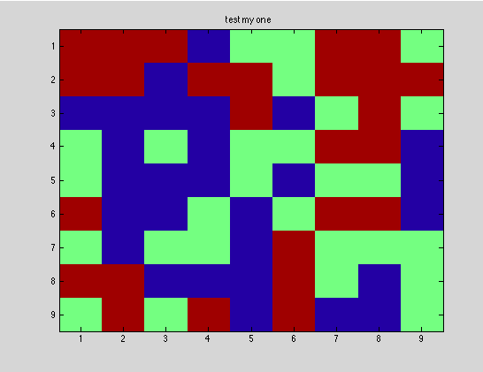

There are total 4 error out of 81. So the error rate is 4.94%.

P2.

I tired my own “modified U-matrix” method to visualize the cluster. I computed the Euclidean distance of each pair of weight vectors that belong to adjacent SOM PEs( adjacent means top, right, bottom, left neighbours). Since there are 10x10 PEs, I form 19x10 distance matrix to demonstrate the visualization. The distance matrix is formed by Horizontal distance matrix (neighbours in horizontal lines ) and vertical distance matrix( neighbours in horizontal lines). Since column size of PEs is 10, the column size for each horizontal distance vector is 9, but that for vertical line is 10. I fix this by making 10th element of horizontal distance vector to be a duplicate of its 9th element.

For my Kohonen SOM, I use 10000 steps and set learning rate as variable according to steps. Initial learning rate is as high as 0.6; while when steps approaches 10000 step, rate decreases uniformly to 0.01. Therefore the equation is like rate=init_rate -(init_rate –

last_rate)*current#_step/(total#_step), where init_rate=0.6, last_rate=0.01,

total#_step=10000. There are 10x10 PEs inside~. Training data is a composition of iris training data and test data.

Initial weight is set to random floats between 0 to 1.

The history of learning visualization is shown below:

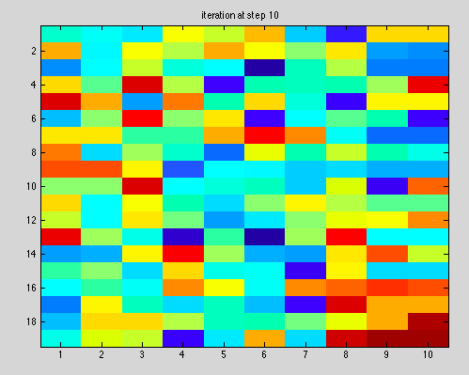

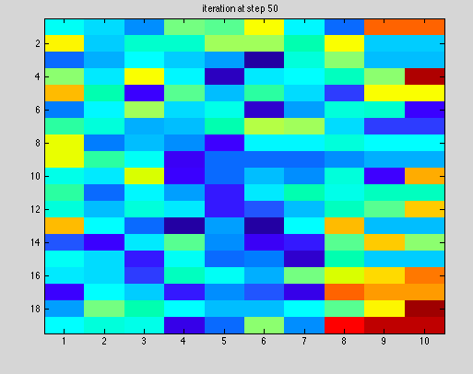

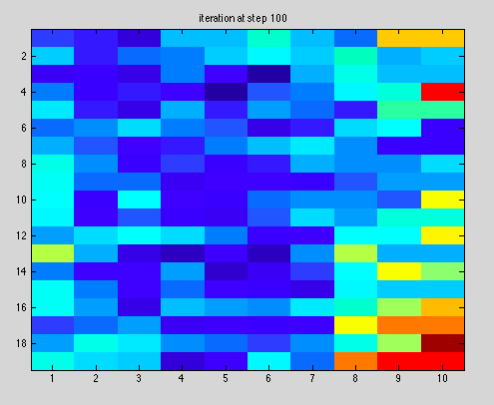

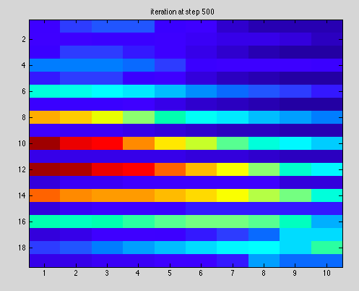

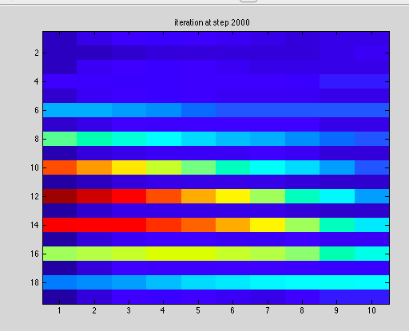

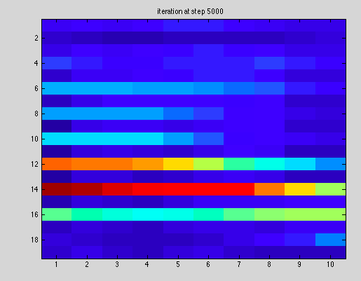

So brighter color means larger distance, darker color means smaller distance, and I see 3 clusters like this(it’s pretty hard to distinguish):

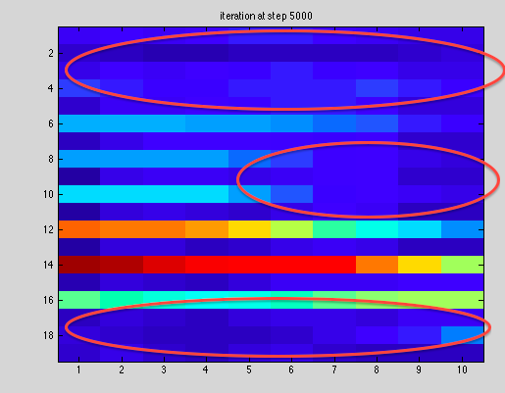

And my mappings of each cell look like. Red, green, and blue means 3 classes of iris dataset.

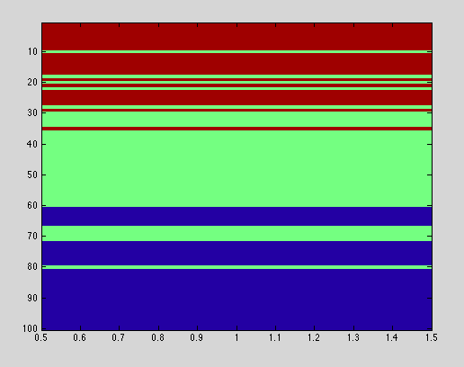

I think one reason why few samples were usually misclassified when we did supervised classification is that some classes horizontally overlap with other classes which make the classification very hard.