

**期末项目设计报告**

|  |  |  |  |
| --- | --- | --- | --- |
| 题 目 | 基于Oracle的网上售票的数据库设计 | | |
| 课程 | Oracle数据库应用 | | |
| 学 院 | 计算机学院 | | |
| 专 业 | 软件工程 | 年级 | 2018级 |
| 学生姓名 | 朱喜倩 | 学号 | 201810414205 |
| 指导教师 | 赵卫东 | 职称 | 副教授 |

|  |  |  |  |
| --- | --- | --- | --- |
| **评分项** | **评分标准** | **满分** | **得分** |
| 文档整体 | 文档内容详实、规范，美观大方 | 10 |  |
| 表设计 | 表，表空间设计合理，数据合理 | 20 |  |
| 用户管理 | 权限及用户分配方案设计正确 | 20 |  |
| PL/SQL设计 | 存储过程和函数设计正确 | 30 |  |
| 备份方案 | 备份方案设计正确 | 20 |  |
| **得分合计** | | |  |

2021 年 6 月 1 日

目录

期末项目设计报告 1

基于Oracle的网上售票管理系统数据库设计 3

实验要求 3

实验选题: 网上售票管理系统 3

实验内容 3

（一）自行设计一个信息系统的数据库项目，自拟 某项目 名称 3

1. 描述 3

2. E-R图设计 4

3. 类图设计 4

（二）设计项目涉及的表及表空间使用方案 6

1.设计数据表 6

2. 创建表空间 pdbtest_users1.dbf 与 pdbtest_users2.dbf 8

3. 创建用户YUKINO与DEEPSNOW 8

4. 创建表 9

5. 在数据库中建立一个程序包 25

（三）备份恢复 27

1. 备份./rman_level0.sh 27

2. 查看备份内容 27

3. 删除数据 27

4. 恢复备份 28

5. 恢复完成 28

实验总结 28

# 基于Oracle的网上售票管理系统数据库设计

# 实验要求

1. 自行设计一个信息系统的数据库项目，自拟 某项目 名称。

2. 设计项目涉及的表及表空间使用方案。至少5张表和5万条数据，两个表空间。

3. 设计权限及用户分配方案。至少两类角色，两个用户。

4. 在数据库中建立一个程序包，在包中用PL/SQL语言设计一些存储过程和函数，

5. 实现比较复杂的业务逻辑，用模拟数据进行执行计划分析。

6. 设计自动备份方案或则手工备份方案。

7. 设计容灾方案。使用两台主机，通过DataGuard实现数据库整体的异地备份(可选)。

# 实验选题: 网上售票管理系统

# 实验内容

## （一）自行设计一个信息系统的数据库项目，自拟 某项目 名称

### 描述

网上售票管理系统，用户能在该系统完成查询、订票、改票、退票等操作。实验部分信息：admin，manager，user，ManagerTicket，Ticket，TicketSystem，seat，orders，train，money。

### 2. E-R图设计

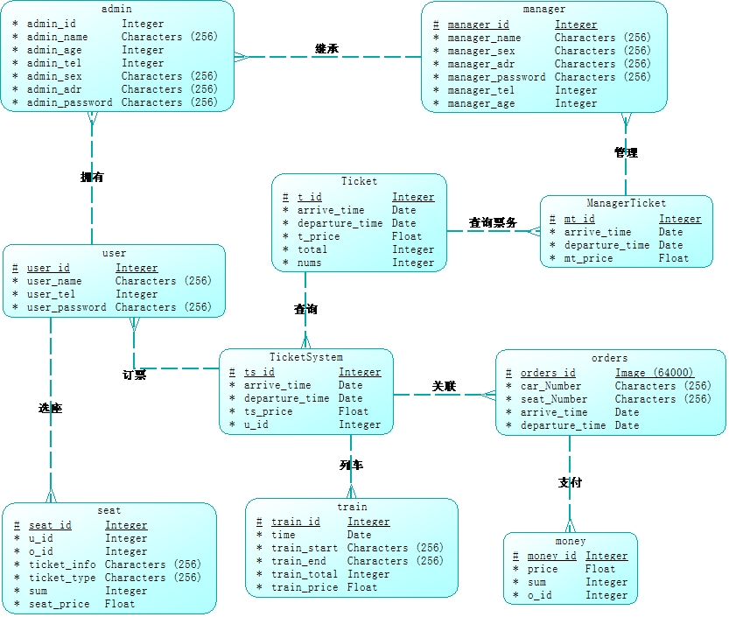

### 类图设计

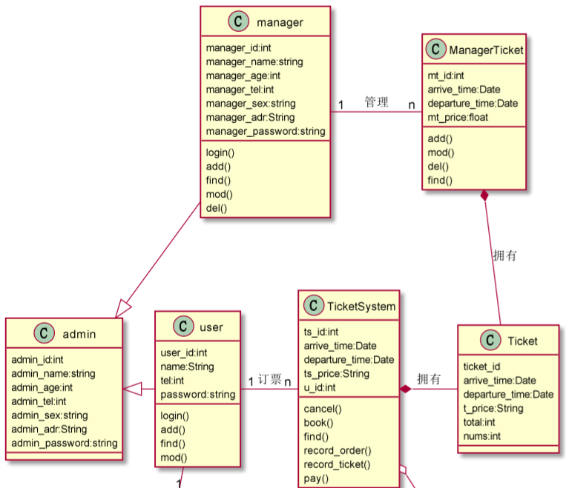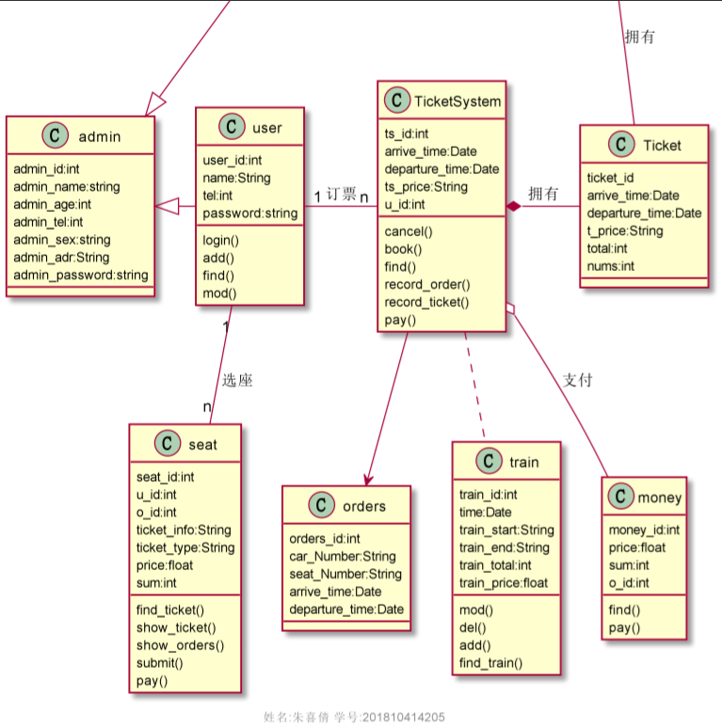

## （二）设计项目涉及的表及表空间使用方案

### 1.设计数据表

Admin

|  |  |  |  |
| --- | --- | --- | --- |
| **字段名** | **数据类型** | **可以为空** | **注释** |
| ADMIN_ID | NUMBER(6,0 | NO | adminID,主键 |
| ADMIN_NAME | VARCHAR2(40 BYTE) | NO | admin名称，非空 |
| ADMIN_AGE | NUMBER(6,0) | NO | admin年龄，非空 |
| ADMIN_TEL | NUMBER(13,0) | NO | admin电话，非空 |
| ADMIN_SEX | VARCHAR2(40 BYTE) | NO | admin性别，非空 |
| ADMIN_ADR | VARCHAR2(40 BYTE) | NO | admin地址，非空 |
| ADMIN_PASSWORD | VARCHAR2(40 BYTE) | NO | admin密码，非空 |

Manager

|  |  |  |  |
| --- | --- | --- | --- |
| **字段名** | **数据类型** | **可以为空** | **注释** |
| MANAGER_ID | NUMBER(6,0 | NO | 员工ID,主键 |
| MANAGER_MANE | VARCHAR2(40 BYTE) | NO | 员工名字,不能为空，创建不唯一B树索引 |
| MANAGER_AGE | NUMBER(6,0) | YES | 员工年龄 |
| MANAGER_TEL | NUMBER(13,0) | YES | 员工电话号码 |
| MANAGER_SEX | VARCHAR2(40 BYTE) | NO | 员工性别 |
| MANAGER_ADR | VARCHAR2(40 BYTE) | NO | 员工地址 |
| MANAGER_PASSWORD | VARCHAR2(40 BYTE) | NO | adminID |

User

|  |  |  |  |
| --- | --- | --- | --- |
| **字段名** | **数据类型** | **可以为空** | **注释** |
| USER_ID | NUMBER(6,0) | NO | 用户ID,主键 |
| USER_MANE | VARCHAR2(40 BYTE) | NO | 用户名字,不能为空，创建不唯一B树索引 |
| USER_AGE | NUMBER(6,0) | YES | 用户年龄 |
| USER_TEL | NUMBER(13,0) | YES | 用户电话号码 |
| USER_SEX | VARCHAR2(40 BYTE) | NO | 用户性别 |
| USER_ADR | VARCHAR2(40 BYTE) | NO | 用户地址 |
| USER_PASSWORD | VARCHAR2(40 BYTE) | NO | 用户密码 |

ManagerTicket

|  |  |  |  |
| --- | --- | --- | --- |
| **字段名** | **数据类型** | **可以为空** | **注释** |
| MANAGERTICKET_ID | NUMBER(6,0) | NO | 票务ID,主键 |
| MANAGERTICKET_arrive_time | VARCHAR2(40 BYTE) | NO | 列表到达时间 |
| MANAGERTICKET_departure_time | VARCHAR2(40 BYTE) | NO | 列车出发时间 |
| MANAGERTICKET_PRICE | NUMBER(13,0) | NO | 票务票价,主键 |

Ticket

|  |  |  |  |
| --- | --- | --- | --- |
| **字段名** | **数据类型** | **可以为空** | **注释** |
| TICKET_ID | NUMBER(6,0) | NO | 票务详情ID,主键 |
| TICKET_PRICE | VARCHAR2(40 BYTE) | NO | 票务价格 |
| ICKET_arrive_time | NUMBER(6,0) | YES | 列表到达时间 |
| TICKET_departure_time | NUMBER(13,0) | YES | 车出发时间 |
| TICKET_TOTAL | VARCHAR2(40 BYTE) | NO | 票务总数量 |
| TICKET_NUMS | NUMBER(8,2) | NO | 每类票务的数量 |

Orders

|  |  |  |  |
| --- | --- | --- | --- |
| **字段名** | **数据类型** | **可以为空** | **注释** |
| ORDER_ID | NUMBER(6,0) | NO | 订单ID,主键 |
| USER_NAME | VARCHAR2(40 BYTE) | NO | 用户名称，B数索引 |
| USER_TEL | NUMBER(6,0) | YES | 用户电话 |
| ORDER_DATE | DATE | YES | 车出发时间 |
| MANAGER_ID | VARCHAR2(40 BYTE) | NO | 订单经手人，员工表MANAGER的外键 |
| DISCOUNT | NUMBER(8,2) | NO | 订单整体优惠金额，默认为0 |
| TRADE_RECEIVABLE | Number(8,2) | YES | 订单应收货款，默认为0 |

Train

|  |  |  |  |
| --- | --- | --- | --- |
| **字段名** | **数据类型** | **可以为空** | **注释** |
| TRAIN_ID | NUMBER(6,0) | NO | 列车详情ID,主键 |
| TRAIN_TIME | DATE | NO | 列车每趟运行时长 |
| TRAIN_start | DATE | YES | 列车出发时间 |
| TRAIN_end | DATE | YES | 列车到达时间 |
| TRAIN_total | NUMBER(8,2) | NO | 每趟列车的总数量 |
| TRAIN_price | VARCHAR2(40 BYTE) | NO | 票价 |

Money

|  |  |  |  |
| --- | --- | --- | --- |
| **字段名** | **数据类型** | **可以为空** | **注释** |
| MONEY_ID | NUMBER(6,0) | NO | 支付详情ID,主键 |
| MONEY_PRICE | NUMBER(10,0) | NO | 每次支付的价格，用户购买的票的票价 |
| MONEY_SUM | NUMBER(10,0) | NO | 每次购买的票的数量 |
| ORDERS_ID | NUMBER(6,0) | NO | 订单的ID作为外键 |

### 创建表空间 pdbtest_users1.dbf 与 pdbtest_users2.dbf

    CREATE TABLESPACE Users2

    DATAFILE

    '/home/oracle/app/oracle/oradata/orcl/pdborcl/pdbtest_users1.dbf'

    SIZE 100M AUTOEXTEND ON NEXT 256M MAXSIZE UNLIMITED,

    '/home/oracle/app/oracle/oradata/orcl/pdborcl/pdbtest_users2.dbf'

    SIZE 100M AUTOEXTEND ON NEXT 256M MAXSIZE UNLIMITED

EXTENT MANAGEMENT LOCAL SEGMENT SPACE MANAGEMENT AUTO;

### 创建用户YUKINO与DEEPSNOW

分配表空间pdbtest_users1.dbf 与 pdbtest_users2.dbf的使用配额，再分配角色CONNECT和RESOURCE,便于用户可以连接到数据库来创建资源，最后再分配一个系统权限："CREATE VIEW"，便于用户可以创建视图

    --创建用户YUKINO

    CREATE USER YUKINO IDENTIFIED BY 123

    DEFAULT TABLESPACE "USERS"

    TEMPORARY TABLESPACE "TEMP";

    -- QUOTAS

    ALTER USER YUKINO QUOTA UNLIMITED ON USERS;

    ALTER USER YUKINO QUOTA UNLIMITED ON USERS02;

    -- ROLES

    GRANT "CONNECT" TO YUKINO WITH ADMIN OPTION;

    GRANT "RESOURCE" TO YUKINO WITH ADMIN OPTION;

    ALTER USER YUKINO DEFAULT ROLE "CONNECT","RESOURCE";

    -- SYSTEM PRIVILEGES

    GRANT CREATE VIEW TO YUKINO WITH ADMIN OPTION;

    --创建用户DEEPSNOW

    CREATE USER DEEPSNOW IDENTIFIED BY 123

    DEFAULT TABLESPACE "USERS"

    TEMPORARY TABLESPACE "TEMP";

    -- QUOTAS

    ALTER USER DEEPSNOW QUOTA UNLIMITED ON USERS;

    ALTER USER DEEPSNOW QUOTA UNLIMITED ON USERS02;

    -- ROLES

    GRANT "CONNECT" TO DEEPSNOW WITH ADMIN OPTION;

    GRANT "RESOURCE" TO DEEPSNOW WITH ADMIN OPTION;

    ALTER USER DEEPSNOW DEFAULT ROLE "CONNECT","RESOURCE";

    -- SYSTEM PRIVILEGES

    GRANT CREATE VIEW TO DEEPSNOW WITH ADMIN OPTION;

### 4. 创建表

创建ADMIN表

CREATE TABLE ADMIN

(

ADMIN_ID NUMBER(6, 0) NOT NULL

, ADMIN_NAME VARCHAR2(40 BYTE) NOT NULL

, CONSTRAINT ADMIN_PK PRIMARY KEY

(

ADMIN_ID

)

USING INDEX

(

CREATE UNIQUE INDEX DEPARTMENTS_PK ON ADMIN (DEPARTMENT_ID ASC)

NOLOGGING

TABLESPACE USERS

PCTFREE 10

INITRANS 2

STORAGE

(

INITIAL 65536

NEXT 1048576

MINEXTENTS 1

MAXEXTENTS UNLIMITED

BUFFER_POOL DEFAULT

)

NOPARALLEL

)

ENABLE

)

NOLOGGING

TABLESPACE USERS

PCTFREE 10

INITRANS 1

STORAGE

(

INITIAL 65536

NEXT 1048576

MINEXTENTS 1

MAXEXTENTS UNLIMITED

BUFFER_POOL DEFAULT

)

NOCOMPRESS NO INMEMORY NOPARALLEL;

创建MANAGER表

CREATE TABLE MANAGER

(

MANAGER_ID NUMBER(6, 0) NOT NULL

, NAME VARCHAR2(40 BYTE) NOT NULL

, EMAIL VARCHAR2(40 BYTE)

, PHONE_NUMBER VARCHAR2(40 BYTE)

, HIRE_DATE DATE NOT NULL

, SALARY NUMBER(8, 2)

, MANAGER_ID NUMBER(6, 0)

, MANAGER_ID NUMBER(6, 0)

, PHOTO BLOB

, CONSTRAINT MANAGER_PK PRIMARY KEY

(

EMPLOYEE_ID

)

USING INDEX

(

CREATE UNIQUE INDEX EMPLOYEES_PK ON EMPLOYEES (EMPLOYEE_ID ASC)

NOLOGGING

TABLESPACE USERS

PCTFREE 10

INITRANS 2

STORAGE

(

INITIAL 65536

NEXT 1048576

MINEXTENTS 1

MAXEXTENTS UNLIMITED

BUFFER_POOL DEFAULT

)

NOPARALLEL

)

ENABLE

)

NOLOGGING

TABLESPACE USERS

PCTFREE 10

INITRANS 1

STORAGE

(

INITIAL 65536

NEXT 1048576

MINEXTENTS 1

MAXEXTENTS UNLIMITED

BUFFER_POOL DEFAULT

)

NOCOMPRESS

NO INMEMORY

NOPARALLEL

LOB (PHOTO) STORE AS SYS_LOB0000092017C00009$$

(

ENABLE STORAGE IN ROW

CHUNK 8192

NOCACHE

NOLOGGING

TABLESPACE USERS

STORAGE

(

INITIAL 106496

NEXT 1048576

MINEXTENTS 1

MAXEXTENTS UNLIMITED

BUFFER_POOL DEFAULT

)

);

CREATE INDEX MANAGER_INDEX1_NAME ON MANAGER (NAME ASC)

NOLOGGING

TABLESPACE USERS

PCTFREE 10

INITRANS 2

STORAGE

(

INITIAL 65536

NEXT 1048576

MINEXTENTS 1

MAXEXTENTS UNLIMITED

BUFFER_POOL DEFAULT

)

NOPARALLEL;

ALTER TABLE MANAGER

ADD CONSTRAINT MANAGER_FK1 FOREIGN KEY

(

DEPARTMENT_ID

)

REFERENCES DEPARTMENTS

(

DEPARTMENT_ID

)

ENABLE;

ALTER TABLE MANAGER

ADD CONSTRAINT MANAGER_FK2 FOREIGN KEY

(

MANAGER_ID

)

REFERENCES MANAGER

(

EMPLOYEE_ID

)

ON DELETE SET NULL ENABLE;

ALTER TABLE MANAGER

ADD CONSTRAINT MANAGER_CHK1 CHECK

(SALARY>0)

ENABLE;

ALTER TABLE MANAGER

ADD CONSTRAINT MANAGER_CHK2 CHECK

(MANAGER_ID<>MANAGER_ID)

ENABLE;

ALTER TABLE MANAGER

ADD CONSTRAINT MANAGER_MANAGER_MANAGER_ID CHECK

(USER_ID<>MANAGER_ID)

ENABLE;

ALTER TABLE MANAGER

ADD CONSTRAINTMANAGER_SALARY CHECK

(SALARY>0)

ENABLE;

创建TICKET表

CREATE TABLE TICKET

(

TICKET_NAME VARCHAR2(40 BYTE) NOT NULL

, TICKET_TYPE VARCHAR2(40 BYTE) NOT NULL

, CONSTRAINT TICKET_PK PRIMARY KEY

(

TICKET_NAME

)

ENABLE

)

LOGGING

TABLESPACE "USERS"

PCTFREE 10

INITRANS 1

STORAGE

(

INITIAL 65536

NEXT 1048576

MINEXTENTS 1

MAXEXTENTS 2147483645

BUFFER_POOL DEFAULT

);

ALTER TABLE TICKET

ADD CONSTRAINT TICKET_CHK1 CHECK

(TICKET_TYPE IN ('食品', '饮料', '生活用品'))

ENABLE;

创建ORDERS表及相关表, 表空间：分区表：USERS,USERS02

CREATE GLOBAL TEMPORARY TABLE "ORDER_ID_TEMP"

("ORDER_ID" NUMBER(10,0) NOT NULL ENABLE,

CONSTRAINT "ORDER_ID_TEMP_PK" PRIMARY KEY ("ORDER_ID") ENABLE

) ON COMMIT DELETE ROWS ;

COMMENT ON TABLE "ORDER_ID_TEMP" IS '用于触发器存储临时ORDER_ID';

CREATE TABLE ORDERS

(

ORDER_ID NUMBER(10, 0) NOT NULL

, CUSTOMER_NAME VARCHAR2(40 BYTE) NOT NULL

, CUSTOMER_TEL VARCHAR2(40 BYTE) NOT NULL

, ORDER_DATE DATE NOT NULL

, EMPLOYEE_ID NUMBER(6, 0) NOT NULL

, DISCOUNT NUMBER(8, 2) DEFAULT 0

, TRADE_RECEIVABLE NUMBER(8, 2) DEFAULT 0

)

TABLESPACE USERS

PCTFREE 10

INITRANS 1

STORAGE

(

BUFFER_POOL DEFAULT

)

NOCOMPRESS

NOPARALLEL

PARTITION BY RANGE (ORDER_DATE)

(

PARTITION PARTITION_BEFORE_2016 VALUES LESS THAN (TO_DATE(' 2016-01-01 00:00:00', 'SYYYY-MM-DD HH24:MI:SS', 'NLS_CALENDAR=GREGORIAN'))

NOLOGGING

TABLESPACE USERS

PCTFREE 10

INITRANS 1

STORAGE

(

INITIAL 8388608

NEXT 1048576

MINEXTENTS 1

MAXEXTENTS UNLIMITED

BUFFER_POOL DEFAULT

)

NOCOMPRESS NO INMEMORY

, PARTITION PARTITION_BEFORE_2017 VALUES LESS THAN (TO_DATE(' 2017-01-01 00:00:00', 'SYYYY-MM-DD HH24:MI:SS', 'NLS_CALENDAR=GREGORIAN'))

NOLOGGING

TABLESPACE USERS02

PCTFREE 10

INITRANS 1

STORAGE

(

INITIAL 8388608

NEXT 1048576

MINEXTENTS 1

MAXEXTENTS UNLIMITED

BUFFER_POOL DEFAULT

)

NOCOMPRESS NO INMEMORY

);

--创建本地分区索引ORDERS_INDEX_DATE：

CREATE INDEX ORDERS_INDEX_DATE ON ORDERS (ORDER_DATE ASC)

LOCAL

(

PARTITION PARTITION_BEFORE_2016

TABLESPACE USERS

PCTFREE 10

INITRANS 2

STORAGE

(

INITIAL 8388608

NEXT 1048576

MINEXTENTS 1

MAXEXTENTS UNLIMITED

BUFFER_POOL DEFAULT

)

NOCOMPRESS

, PARTITION PARTITION_BEFORE_2017

TABLESPACE USERS02

PCTFREE 10

INITRANS 2

STORAGE

(

INITIAL 8388608

NEXT 1048576

MINEXTENTS 1

MAXEXTENTS UNLIMITED

BUFFER_POOL DEFAULT

)

NOCOMPRESS

)

STORAGE

(

BUFFER_POOL DEFAULT

)

NOPARALLEL;

CREATE INDEX ORDERS_INDEX_CUSTOMER_NAME ON ORDERS (CUSTOMER_NAME ASC)

NOLOGGING

TABLESPACE USERS

PCTFREE 10

INITRANS 2

STORAGE

(

INITIAL 65536

NEXT 1048576

MINEXTENTS 1

MAXEXTENTS UNLIMITED

BUFFER_POOL DEFAULT

)

NOPARALLEL;

CREATE UNIQUE INDEX ORDERS_PK ON ORDERS (ORDER_ID ASC)

GLOBAL PARTITION BY HASH (ORDER_ID)

(

PARTITION INDEX_PARTITION1 TABLESPACE USERS

NOCOMPRESS

, PARTITION INDEX_PARTITION2 TABLESPACE USERS02

NOCOMPRESS

)

NOLOGGING

TABLESPACE USERS

PCTFREE 10

INITRANS 2

STORAGE

(

INITIAL 65536

NEXT 1048576

MINEXTENTS 1

MAXEXTENTS UNLIMITED

BUFFER_POOL DEFAULT

)

NOPARALLEL;

ALTER TABLE ORDERS

ADD CONSTRAINT ORDERS_PK PRIMARY KEY

(

ORDER_ID

)

USING INDEX ORDERS_PK

ENABLE;

ALTER TABLE ORDERS

ADD CONSTRAINT ORDERS_FK1 FOREIGN KEY

(

EMPLOYEE_ID

)

REFERENCES EMPLOYEES

(

EMPLOYEE_ID

)

ENABLE;

CREATE TABLE MANAGERTICKET

(

ID NUMBER(10, 0) NOT NULL

, MANAGERTICKET_ID NUMBER(10, 0) NOT NULL

, MANAGERTICKET_NAME VARCHAR2(40 BYTE) NOT NULL

, MANAGERTICKET_NUM NUMBER(8, 2) NOT NULL

, MANAGERTICKET_PRICE NUMBER(8, 2) NOT NULL

, CONSTRAINT MANAGERTICKET _DETAILS_FK1 FOREIGN KEY

(

ORDER_ID

)

REFERENCES ORDERS

(

ORDER_ID

)

ENABLE

)

TABLESPACE USERS

PCTFREE 10

INITRANS 1

STORAGE

(

BUFFER_POOL DEFAULT

)

NOCOMPRESS

NOPARALLEL

PARTITION BY REFERENCE (ORDER_DETAILS_FK1)

(

PARTITION PARTITION_BEFORE_2016

NOLOGGING

TABLESPACE USERS

--必须指定表空间，否则会将分区存储在用户的默认表空间中

PCTFREE 10

INITRANS 1

STORAGE

(

INITIAL 8388608

NEXT 1048576

MINEXTENTS 1

MAXEXTENTS UNLIMITED

BUFFER_POOL DEFAULT

)

NOCOMPRESS NO INMEMORY,

PARTITION PARTITION_BEFORE_2017

NOLOGGING

TABLESPACE USERS02

PCTFREE 10

INITRANS 1

STORAGE

(

INITIAL 8388608

NEXT 1048576

MINEXTENTS 1

MAXEXTENTS UNLIMITED

BUFFER_POOL DEFAULT

)

NOCOMPRESS NO INMEMORY

)

;

CREATE UNIQUE INDEX ORDER_DETAILS_PK ON ORDER_DETAILS (ID ASC)

NOLOGGING

TABLESPACE USERS

PCTFREE 10

INITRANS 2

STORAGE

(

INITIAL 65536

NEXT 1048576

MINEXTENTS 1

MAXEXTENTS UNLIMITED

BUFFER_POOL DEFAULT

)

NOPARALLEL;

ALTER TABLE ORDER_DETAILS

ADD CONSTRAINT ORDER_DETAILS_PK PRIMARY KEY

(

ID

)

USING INDEX ORDER_DETAILS_PK

ENABLE;

--这个索引可以使整个订单的详单存放在一起

CREATE INDEX ORDER_DETAILS_ORDER_ID ON ORDER_DETAILS (ORDER_ID)

GLOBAL PARTITION BY HASH (ORDER_ID)

(

PARTITION INDEX_PARTITION1 TABLESPACE USERS

NOCOMPRESS

, PARTITION INDEX_PARTITION2 TABLESPACE USERS02

NOCOMPRESS

);

ALTER TABLE ORDER_DETAILS

ADD CONSTRAINT ORDER_DETAILS_PRODUCT_NUM CHECK

(Product_Num>0)

ENABLE;

创建3个触发器

CREATE OR REPLACE EDITIONABLE TRIGGER "ORDERS_TRIG_ROW_LEVEL"

BEFORE INSERT OR UPDATE OF DISCOUNT ON "ORDERS"

FOR EACH ROW --行级触发器

declare

m number(8,2);

BEGIN

if inserting then

:new.TRADE_RECEIVABLE := - :new.discount;

else

select sum(PRODUCT_NUM*PRODUCT_PRICE) into m from ORDER_DETAILS where ORDER_ID=:old.ORDER_ID;

if m is null then

m:=0;

end if;

:new.TRADE_RECEIVABLE := m - :new.discount;

end if;

END;

/

--批量插入订单数据之前，禁用触发器

ALTER TRIGGER "ORDERS_TRIG_ROW_LEVEL" DISABLE;

CREATE OR REPLACE EDITIONABLE TRIGGER "ORDER_DETAILS_ROW_TRIG"

AFTER DELETE OR INSERT OR UPDATE ON ORDER_DETAILS

FOR EACH ROW

BEGIN

--DBMS_OUTPUT.PUT_LINE(:NEW.ORDER_ID);

IF :NEW.ORDER_ID IS NOT NULL THEN

MERGE INTO ORDER_ID_TEMP A

USING (SELECT 1 FROM DUAL) B

ON (A.ORDER_ID=:NEW.ORDER_ID)

WHEN NOT MATCHED THEN

INSERT (ORDER_ID) VALUES(:NEW.ORDER_ID);

END IF;

IF :OLD.ORDER_ID IS NOT NULL THEN

MERGE INTO ORDER_ID_TEMP A

USING (SELECT 1 FROM DUAL) B

ON (A.ORDER_ID=:OLD.ORDER_ID)

WHEN NOT MATCHED THEN

INSERT (ORDER_ID) VALUES(:OLD.ORDER_ID);

END IF;

END;

/

ALTER TRIGGER "ORDER_DETAILS_ROW_TRIG" DISABLE;

CREATE OR REPLACE EDITIONABLE TRIGGER "ORDER_DETAILS_SNTNS_TRIG"

AFTER DELETE OR INSERT OR UPDATE ON ORDER_DETAILS

declare

m number(8,2);

BEGIN

FOR R IN (SELECT ORDER_ID FROM ORDER_ID_TEMP)

LOOP

--DBMS_OUTPUT.PUT_LINE(R.ORDER_ID);

select sum(PRODUCT_NUM*PRODUCT_PRICE) into m from ORDER_DETAILS

where ORDER_ID=R.ORDER_ID;

if m is null then

m:=0;

end if;

UPDATE ORDERS SET TRADE_RECEIVABLE = m - discount

WHERE ORDER_ID=R.ORDER_ID;

END LOOP;

--delete from ORDER_ID_TEMP;

END;

/

ALTER TRIGGER "ORDER_DETAILS_SNTNS_TRIG" DISABLE;

CREATE SEQUENCE "SEQ_ORDER_ID" MINVALUE 1 MAXVALUE 9999999999 INCREMENT BY 1 START WITH 1 CACHE 2000 ORDER NOCYCLE NOPARTITION ;

CREATE SEQUENCE "SEQ_ORDER_DETAILS_ID" MINVALUE 1 MAXVALUE 9999999999 INCREMENT BY 1 START WITH 1 CACHE 2000 ORDER NOCYCLE NOPARTITION ;

CREATE OR REPLACE FORCE EDITIONABLE VIEW "VIEW_ORDER_DETAILS" ("ID", "ORDER_ID", "CUSTOMER_NAME", "CUSTOMER_TEL", "ORDER_DATE", "PRODUCT_TYPE", "PRODUCT_NAME", "PRODUCT_NUM", "PRODUCT_PRICE") AS

SELECT

d.ID,

o.ORDER_ID,

o.CUSTOMER_NAME,o.CUSTOMER_TEL,o.ORDER_DATE,

p.PRODUCT_TYPE,

d.PRODUCT_NAME,

d.PRODUCT_NUM,

d.PRODUCT_PRICE

FROM ORDERS o,ORDER_DETAILS d,PRODUCTS p where d.ORDER_ID=o.ORDER_ID and d.PRODUCT_NAME=p.PRODUCT_NAME;

/

插入ADMIN，MANAGER数据

INSERT INTO DEPARTMENTS(DEPARTMENT_ID,DEPARTMENT_NAME) values (1,'总经办');

INSERT INTO EMPLOYEES(EMPLOYEE_ID,NAME,EMAIL,PHONE_NUMBER,HIRE_DATE,SALARY,MANAGER_ID,DEPARTMENT_ID)

VALUES (1,'阳董事长',NULL,NULL,to_date('2012-1-1','yyyy-mm-dd'),50000,NULL,1);

INSERT INTO DEPARTMENTS(DEPARTMENT_ID,DEPARTMENT_NAME) values (11,'销售部');

INSERT INTO EMPLOYEES(EMPLOYEE_ID,NAME,EMAIL,PHONE_NUMBER,HIRE_DATE,SALARY,MANAGER_ID,DEPARTMENT_ID)

VALUES (11,'张总',NULL,NULL,to_date('2012-1','yyyy-mm-dd'),50000,1,1);

INSERT INTO EMPLOYEES(EMPLOYEE_ID,NAME,EMAIL,PHONE_NUMBER,HIRE_DATE,SALARY,MANAGER_ID,DEPARTMENT_ID)

VALUES (111,'陈经理',NULL,NULL,to_date('2012-1','yyyy-mm-dd'),50000,11,11);

INSERT INTO EMPLOYEES(EMPLOYEE_ID,NAME,EMAIL,PHONE_NUMBER,HIRE_DATE,SALARY,MANAGER_ID,DEPARTMENT_ID)

VALUES (112,'刘经理',NULL,NULL,to_date('2012-1-1','yyyy-mm-dd'),50000,11,11);

INSERT INTO DEPARTMENTS(DEPARTMENT_ID,DEPARTMENT_NAME) values (12,'主管部');

INSERT INTO EMPLOYEES(EMPLOYEE_ID,NAME,EMAIL,PHONE_NUMBER,HIRE_DATE,SALARY,MANAGER_ID,DEPARTMENT_ID)

VALUES (12,'赵总',NULL,NULL,to_date('2012-1-1','yyyy-mm-dd'),50000,1,1);

INSERT INTO EMPLOYEES(EMPLOYEE_ID,NAME,EMAIL,PHONE_NUMBER,HIRE_DATE,SALARY,MANAGER_ID,DEPARTMENT_ID)

VALUES (121,'朱经理',NULL,NULL,to_date('2012-1-1','yyyy-mm-dd'),50000,12,12);

INSERT INTO EMPLOYEES(EMPLOYEE_ID,NAME,EMAIL,PHONE_NUMBER,HIRE_DATE,SALARY,MANAGER_ID,DEPARTMENT_ID)

VALUES (122,'李经理',NULL,NULL,to_date('2012-1-1','yyyy-mm-dd'),50000,12,12);

insert into TICKET (TICKET_name,TICKET_type) values ('food1','火车');

insert into TICKET (TICKET_name,TICKET_type) values ('food2','高铁');

insert into TICKET (TICKET_name,TICKET_type) values ('food3','飞机');

insert into TICKET (TICKET_name,TICKET_type) values ('drinks1','北京');

insert into TICKET (TICKET_name,TICKET_type) values ('drinks2','杭州');

insert into TICKET (TICKET_name,TICKET_type) values ('drinks3','深圳');

insert into TRAIN (TRAIN_name,TRAIN_type) values ('articles of daily use1','G111');

insert into products (TRAIN_name,TRAIN_type) values ('articles of daily use2','T111');

insert into products (TRAIN_name,TRAIN_type) values ('articles of daily use3','G111');

批量插入订单数据，注意ORDERS.TRADE_RECEIVABLE（订单应收款）的自动计算

declare

dt date;

m number(8,2);

V_EMPLOYEE_ID NUMBER(6);

v_order_id number(10);

v_name varchar2(100);

v_tel varchar2(100);

v number(10,2);

begin

for i in 1..50000

loop

if i mod 2 =0 then

dt:=to_date('2015-3-2','yyyy-mm-dd')+(i mod 60);

else

dt:=to_date('2016-3-2','yyyy-mm-dd')+(i mod 60);

end if;

V_EMPLOYEE_ID:=CASE I MOD 6 WHEN 0 THEN 11 WHEN 1 THEN 111 WHEN 2 THEN 112

WHEN 3 THEN 12 WHEN 4 THEN 121 ELSE 122 END;

--插入订单

v_order_id:=SEQ_ORDER_ID.nextval;

v_name := 'aa'|| 'aa';

v_name := 'Miku' || i;

v_tel := '138923483' || i;

insert /*+append*/ into ORDERS (ORDER_ID,CUSTOMER_NAME,CUSTOMER_TEL,ORDER_DATE,EMPLOYEE_ID,DISCOUNT)

values (v_order_id,v_name,v_tel,dt,V_EMPLOYEE_ID,dbms_random.value(100,0));

--插入订单y一个订单包括3个商品

v:=dbms_random.value(10000,4000);

v_name:='food'|| (i mod 3 + 1);

insert /*+append*/ into ORDER_DETAILS(ID,ORDER_ID,PRODUCT_NAME,PRODUCT_NUM,PRODUCT_PRICE)

values (SEQ_ORDER_DETAILS_ID.NEXTVAL,v_order_id,v_name,2,v);

v:=dbms_random.value(1000,50);

v_name:='drinks'|| (i mod 3 + 1);

insert /*+append*/ into ORDER_DETAILS(ID,ORDER_ID,PRODUCT_NAME,PRODUCT_NUM,PRODUCT_PRICE)

values (SEQ_ORDER_DETAILS_ID.NEXTVAL,v_order_id,v_name,3,v);

v:=dbms_random.value(9000,2000);

v_name:='articles of daily use'|| (i mod 3 + 1);

insert /*+append*/ into ORDER_DETAILS(ID,ORDER_ID,PRODUCT_NAME,PRODUCT_NUM,PRODUCT_PRICE)

values (SEQ_ORDER_DETAILS_ID.NEXTVAL,v_order_id,v_name,1,v);

select sum(PRODUCT_NUM*PRODUCT_PRICE) into m from ORDER_DETAILS where ORDER_ID=v_order_id;

if m is null then

m:=0;

end if;

UPDATE ORDERS SET TRADE_RECEIVABLE = m - discount WHERE ORDER_ID=v_order_id;

IF I MOD 1000 =0 THEN

commit;

END IF;

end loop;

end;

/

ALTER TRIGGER "ORDERS_TRIG_ROW_LEVEL" ENABLE;

ALTER TRIGGER "ORDER_DETAILS_SNTNS_TRIG" ENABLE;

ALTER TRIGGER "ORDER_DETAILS_ROW_TRIG" ENABLE;

最后动态增加一个PARTITION_BEFORE_2021分区：

ALTER TABLE ORDERS

ADD PARTITION PARTITION_BEFORE_2018 VALUES LESS THAN (TO_DATE(' 2021-01-01 00:00:00', 'SYYYY-MM-DD HH24:MI:SS', 'NLS_CALENDAR=GREGORIAN'));

ALTER INDEX ORDERS_INDEX_DATE

MODIFY PARTITION PARTITION_BEFORE_2018

NOCOMPRESS;

### 5. 在数据库中建立一个程序包

在包中用PL/SQL语言设计一些存储过程和函数，实现比较复杂的业务逻辑，用模拟数据进行执行计划分析。

create or replace PACKAGE SPM_Pack IS

/*

包SPM_Pack中有：

一个函数:Get_SaleAmount(V_DEPARTMENT_ID NUMBER)，

一个过程:Get_Employees(V_EMPLOYEE_ID NUMBER)

*/

FUNCTION Get_SaleAmount(V_DEPARTMENT_ID NUMBER) RETURN NUMBER;

PROCEDURE Get_Employees(V_EMPLOYEE_ID NUMBER);

END SPM_Pack;

/

create or replace PACKAGE BODY SPM_Pack IS

FUNCTION Get_SaleAmount(V_DEPARTMENT_ID NUMBER) RETURN NUMBER

AS

N NUMBER(20,2);

BEGIN

SELECT SUM(O.TRADE_RECEIVABLE) into N FROM ORDERS O,EMPLOYEES E

WHERE O.EMPLOYEE_ID=E.EMPLOYEE_ID AND E.DEPARTMENT_ID =V_DEPARTMENT_ID;

RETURN N;

END;

PROCEDURE GET_EMPLOYEES(V_EMPLOYEE_ID NUMBER)

AS

LEFTSPACE VARCHAR(2000);

begin

LEFTSPACE:=' ';

for v in

(SELECT LEVEL,EMPLOYEE_ID,NAME,MANAGER_ID FROM employees

START WITH EMPLOYEE_ID = V_EMPLOYEE_ID

CONNECT BY PRIOR EMPLOYEE_ID = MANAGER_ID)

LOOP

DBMS_OUTPUT.PUT_LINE(LPAD(LEFTSPACE,(V.LEVEL-1)*4,' ')||

V.EMPLOYEE_ID||' '||v.NAME);

END LOOP;

END;

END SPM_Pack;

/

## （三）备份恢复

### 1. 备份./rman_level0.sh

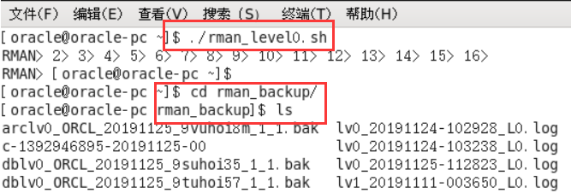

### 查看备份内容

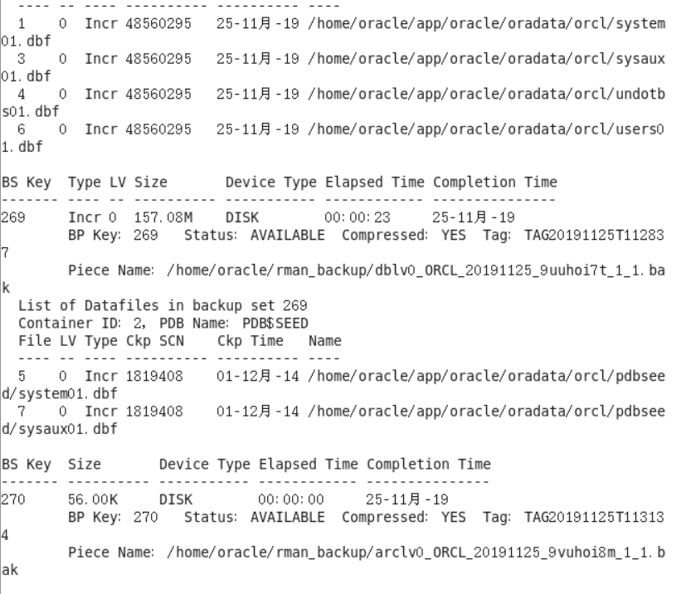

### 删除数据

pict15

### 恢复备份

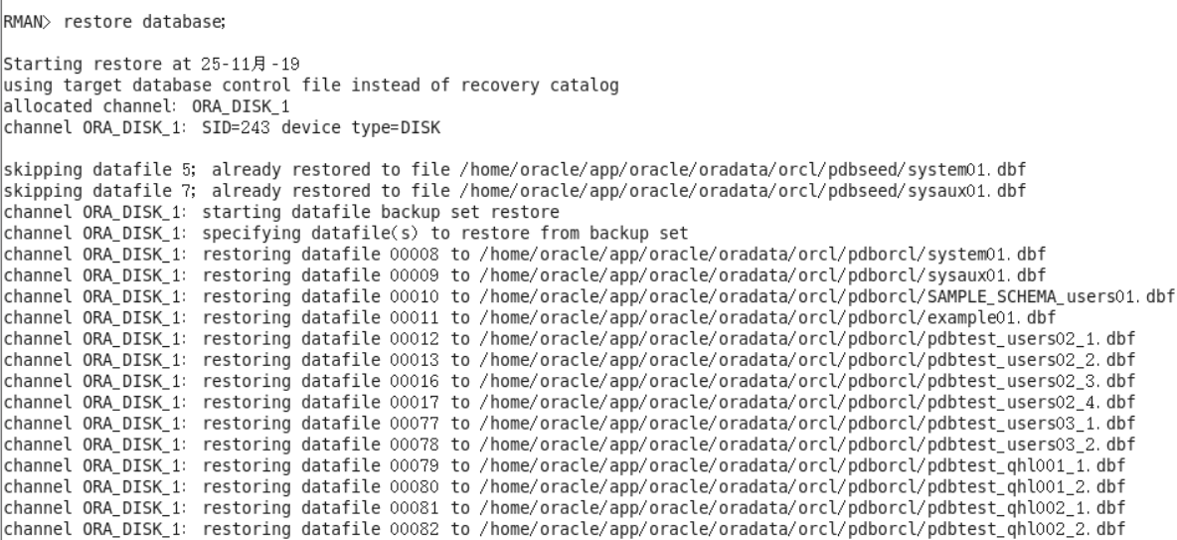

### 恢复完成

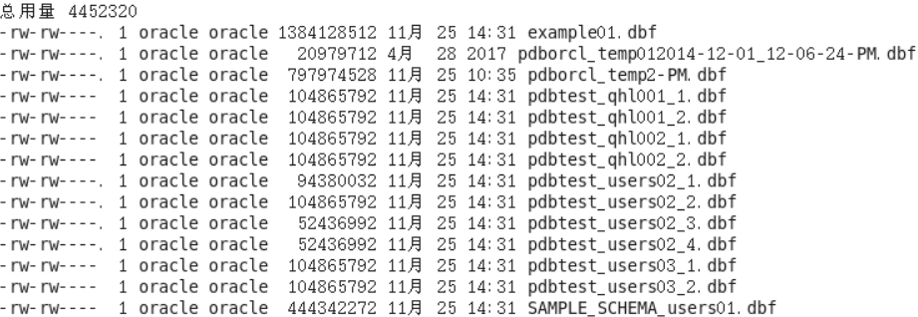

# 实验总结

通过本次实验，我学会了如何分区，知道了分区表的创建，查询等基本操作。也了解了对于分区对象的查询可以仅搜索自己关心的分区，提高检索速度，如果表的某个分区出现故障，表在其他分区的数据仍然可用，因此具有更好的查询性能和可用性。同时，我也掌握分区表的创建方法，并且也熟悉了各种分区方式的使用场景。我了解PL/SQL语言结构，还了解PL/SQL变量和常量的声明和使用方法。同时我也学习了条件语句的使用方法、分支语句的使用方法、循环语句的使用方法，也了解到了常用的PL/SQL函数，并且也对其有更了进一步的认识，通过这次实验的锻炼，我也学习了包，过程，函数的用法。在以后的学习中，要学会学以致用。