Cold Boot 2
Architectural initialization 2
Platform initialization 2
EL3 runtime services framework 3
测试case开发 7
1. 建立CA与TA之间的连接 7
2. CA发送数据到TA 8
3. TA回复数据到CA 8
4. 关闭CA与TA之间连接 12
5. 检测trusty fast/std服务是否能正常SMC指令转换。 12
6. Client 发送一个Unknow SMC指令。 15
PSCI（Power State Coordination Interface） 16

Cold Boot
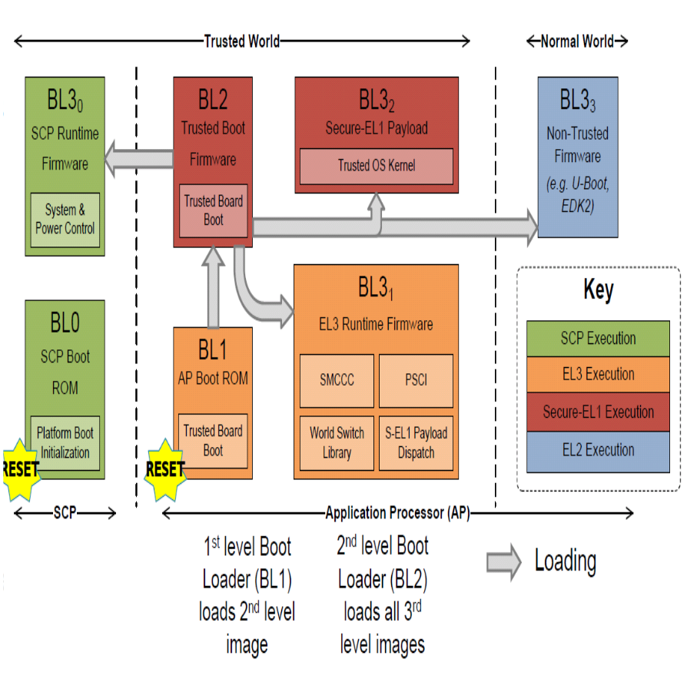

Sprd目前只使用BL31，其中包括以下功能。

Architectural initialization
  - 创建页表，初始化MMU
  - Set the exception vector

Platform initialization
  - GICv2 initialization
  - GICv3 initialization
  - Power management initialization
  - Runtime services initialization

EL3 runtime services framework
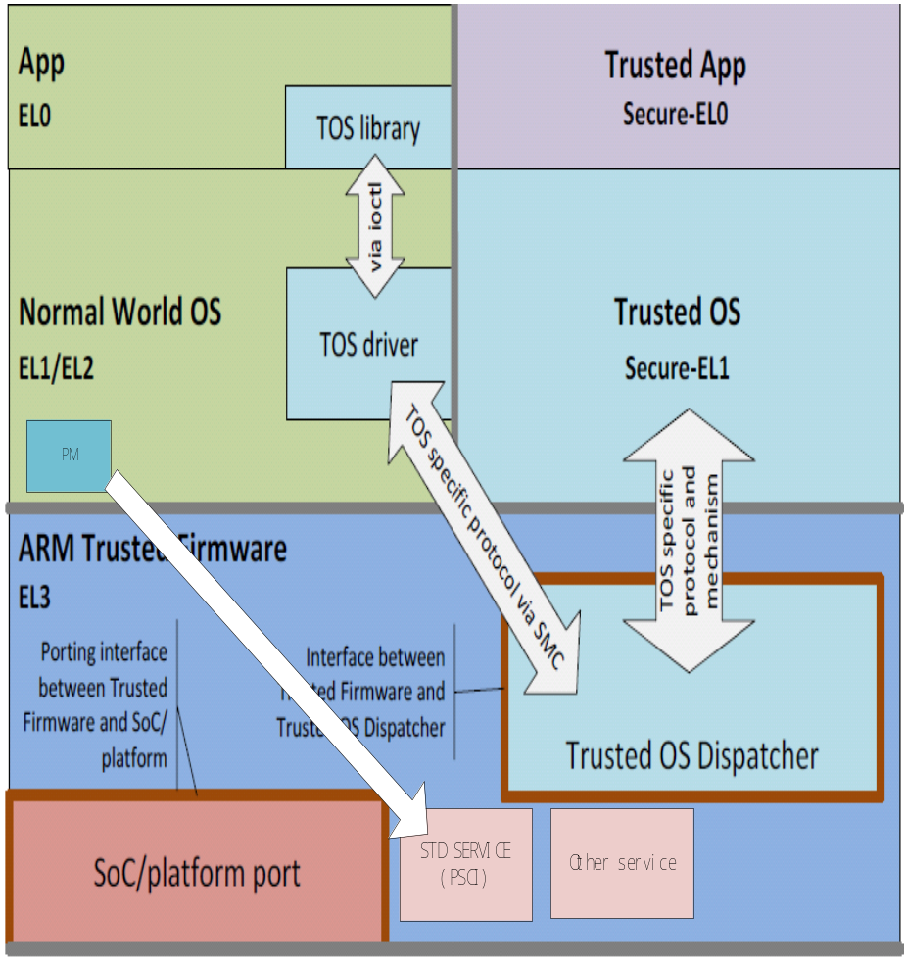
执行在non-secure状态和低于EL3的secure状态的软件，访问EL3 runtime services将通过Secure Monitor Call（SMC）指令。有关SMC相关规格文档见：
http://infocenter.arm.com/help/index.jsp?topic=/com.arm.doc.den0028b/index.html

EL3 runtime services framework使得不同厂家提供的服务，都可以容易的集成到最终的产品固件中。

以下是期望实现的runtime services。
- Standard Service Calls
此服务用于管理整个系统，The Power State Coordination Interface(PSCI)是ARM定义的第一组标准服务。
- Secure-EL1 Payload Dispatcher Service
如果一个系统运行着Trusted OS，则就在EL3需要一个Secure Monitor,用于在normal world(EL1/EL2)和Trusted world之间切换。Secure Monitor将使用SMC指令来完成normal和trusted world之间的切换。
- Cpu Implementation Service
这个服务将提供一个接口到CPU，用来实现具体的CPU服务。

服务的注册
使用DECLARE_RT_SVC宏来注册一个服务。
#define DECLARE_RT_SVC(_name, _start, _end, _type, _setup, _smch) \
static const rt_svc_desc_t __svc_desc_ ## _name \
__attribute__ ((section("rt_svc_descs"), used)) = { \
_start, \
_end, \
_type, \
#_name, \
_setup, \
_smch }
用来指定服务的名称，OEN的覆盖范围，服务的类型，初始化和服务的处理函数。
此宏定义实例化一个const struct rt_svc_desc结构，此结构被分配在一个”rt_svc_descs”的段中。当启动runtime framework的时候，会查找包含BL3-1中的所有服务描述符。

服务的初始化
  - 在runtime_svc.c中调用runtime_svc_init函数用来初始化runtime services framework。这一部分会在Cold Boot阶段作为BL3-1的初始化来执行。
在BL3-1的连接脚本（bl31.ld.S）中收集所有service描述符。
__RT_SVC_DESCS_START__ = .;
KEEP(*(rt_svc_descs))
__RT_SVC_DESCS_END__ = .;
会在runtime_svc.c中，会确认其service的大小。

#define RT_SVC_DESCS_START ((uint64_t) (&__RT_SVC_DESCS_START__))
#define RT_SVC_DESCS_END ((uint64_t) (&__RT_SVC_DESCS_END__))

/* If no runtime services are implemented then simply bail out */
rt_svc_descs_num = RT_SVC_DESCS_END - RT_SVC_DESCS_START;
rt_svc_descs_num /= sizeof(rt_svc_desc_t);
if (rt_svc_descs_num == 0)
return;

  - 通过函数validate_rt_svc_desc来检测服务是否有效。
if (desc == NULL)
return -EINVAL;
if (desc->start_oen > desc->end_oen)
return -EINVAL;
if (desc->end_oen >= OEN_LIMIT)
return -EINVAL;
if (desc->call_type != SMC_TYPE_FAST && desc->call_type != SMC_TYPE_STD)
return -EINVAL;
/* A runtime service having no init or handle function doesn't make sense */
if (desc->init == NULL && desc->handle == NULL)
return -EINVAL;
  - 当服务有效时，会调用服务的init回调处理函数，完成服务的初始化。
if (rt_svc_descs[index].init) {
rc = rt_svc_descs[index].init();
if (rc) {
ERROR("Error initializing runtime service %s\n",
rt_svc_descs[index].name);
continue;
}
}
  - 会根据服务的OEN（Owning Entity Number）和Call Type合成unique number,
最后map到rt_svc_descs_indices数组中，如下图：
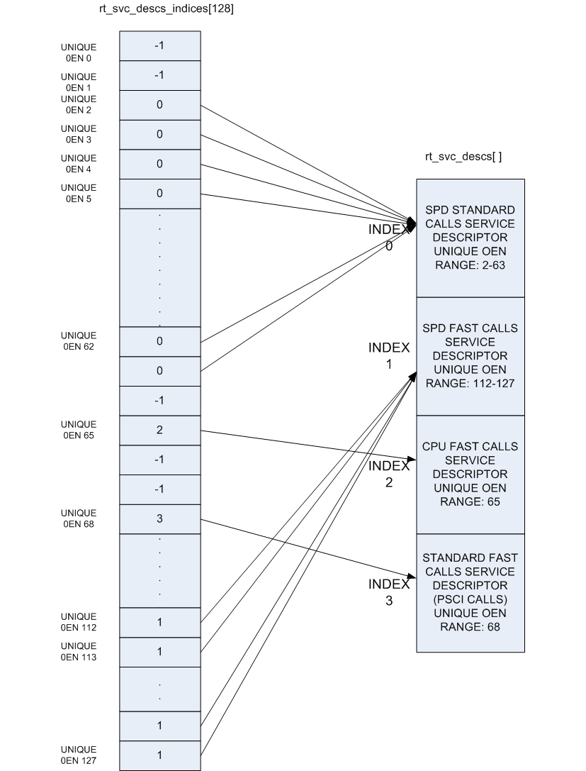

服务的处理
当EL3 runtime services framework接受到一个SMC(Secure Monitor Call)指令时，SMC函数处理ID在W0寄存器从EL2/EL1级别传入的。

通过在rt_svc_descs_indices数组中查找，如果查找不到表示没有处理程序的服务，在这种情况下，The runtime service framework也就会报告未知的SMC函数ID。否则通过rt_svc_descs数据进一步索引，以定位所需服务和处理程序。

服务的处理程序handle回调会提供五个SMC参数，其他的会保存在内存中。处理之前会设置返回值和保存上下文，设置执行函数堆栈，最后调用handle处理函数。

当从处理程序返回时，恢复堆栈和CPU状态并从SMC返回，返回值保存在X0-X3中。

以上的执行代码位于： ./bl31/aarch64/runtime_exceptions.S中

以下是SMC指令的构成格式。
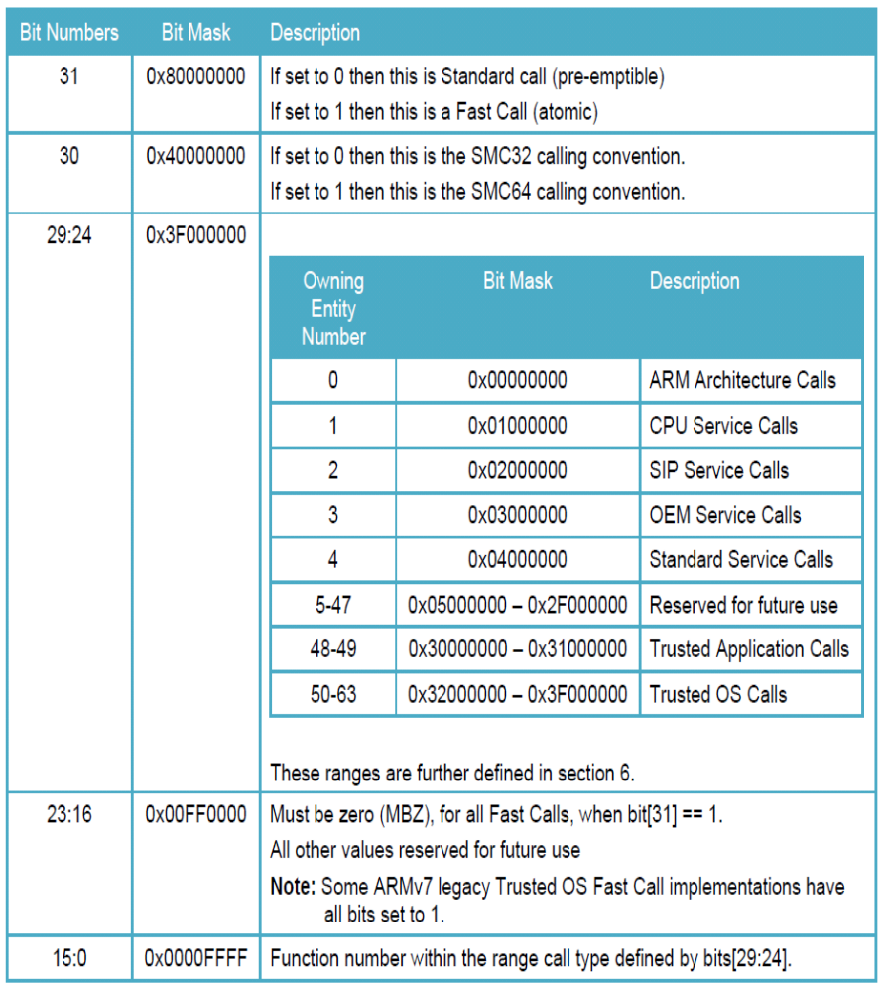

测试case开发

建立CA与TA之间的连接
检测CA和TA之间是否可以通路。
#include <string.h>
#include <stdlib.h>
#include <unistd.h>
#include <stdio.h>

#define TIPC_DEFAULT_DEVNAME "/dev/trusty-ipc-dev0"

static const char *srv_name = "com.android.trusty-test";
static int msgsz = 32;

int main(int argc, char **argv)
{
int ret;
int fd;
char tx_buf[msgsz];
char rx_buf[msgsz];

fd = tipc_connect(TIPC_DEFAULT_DEVNAME, srv_name);
if(fd < 0)
{
printf("tipc_connect ret is error!\n");
return -1;
}

memset(tx_buf, 0, msgsz);
memset(rx_buf, 0, msgsz);

memcpy(tx_buf, "Hello TA");
rc = write(fd, tx_buf, msgsz);

rc = read(fd, rx_buf, msgsz);
printf("rx_buf is %s\n", rx_buf);

tipc_close(fd);

retrun 0;
}

CA发送数据到TA
检测CA发送数据TA是否收到

TA回复数据到CA

#include <assert.h>
#include <err.h>
#include <stddef.h>
#include <stdio.h>
#include <stdlib.h>
#include <string.h>
#include <trusty_std.h>

#define MAX_ECHO_MSG_SIZE 64

#define MAX_PORT_BUF_SIZE 4096 /* max size of per port buffer */

static const char *srv_name = "com.android.trusty-test";
static uint8_t msg_buf[MAX_ECHO_MSG_SIZE];

/*
* Message handler
*/
static int handle_msg(handle_t chan)
{
int rc;
iovec_t iov;
ipc_msg_t msg;
ipc_msg_info_t msg_inf;

iov.base = msg_buf;
iov.len = sizeof(msg_buf);

msg.num_iov = 1;
msg.iov = &iov;
msg.num_handles = 0;
msg.handles = NULL;

/* get message info */
rc = get_msg(chan, &msg_inf);
if (rc == ERR_NO_MSG)
return NO_ERROR; /* no new messages */

if (rc != NO_ERROR) {
printf("failed (%d) to get_msg for chan (%d)\n",rc, chan);
return rc;
}

/* read msg content */
rc = read_msg(chan, msg_inf.id, 0, &msg);
if (rc < 0) {
printf("failed (%d) to read_msg for chan (%d)\n",rc, chan);
return rc;
}

/* update number of bytes received */
iov.len = (size_t) rc;

/* send message back to the caller */
rc = send_msg(chan, &msg);
if (rc < 0) {
printf("failed (%d) to send_msg for chan (%d)\n",rc, chan);
return rc;
}

/* retire message */
rc = put_msg(chan, msg_inf.id);
if ( rc != NO_ERROR) {
printf("failed (%d) to put_msg for chan (%d)\n",rc, chan);
return rc;
}

return NO_ERROR;
}

/*
* Channel event handler
*/
static void handle_channel_event(const uevent_t *ev)
{
int rc;

if (ev->event & IPC_HANDLE_POLL_MSG) {
rc = handle_msg(ev->handle);
if (rc != NO_ERROR) {
/* report an error and close channel */
printf("failed (%d) to handle event on channel %d\n",rc, ev->handle);
close(ev->handle);
}
return;
}
if (ev->event & IPC_HANDLE_POLL_HUP) {
/* closed by peer. */
close(ev->handle);
return;
}
}

/*
* Port event handler
*/
static void handle_port_event(const uevent_t *ev)
{
uuid_t peer_uuid;

if ((ev->event & IPC_HANDLE_POLL_ERROR) ||
(ev->event & IPC_HANDLE_POLL_HUP) ||
(ev->event & IPC_HANDLE_POLL_MSG) ||
(ev->event & IPC_HANDLE_POLL_SEND_UNBLOCKED)) {
/* should never happen with port handles */
printf("error event (0x%x) for port (%d)\n",ev->event, ev->handle);
return;
}

if (ev->event & IPC_HANDLE_POLL_READY) {
/* incoming connection: accept it */
int rc = accept(ev->handle, &peer_uuid);
if (rc < 0) {
printf("failed (%d) to accept on port %d\n",rc, ev->handle);
return;
}
}
}

int main(void)
{
int rc;
handle_t port;

/* create port */
rc = port_create(srv_name, 1, MAX_PORT_BUF_SIZE, IPC_PORT_ALLOW_NS_CONNECT);
if (rc < 0)
{
printf("create port error!\n");
return rc;
}

port = (handle_t)rc;

for (;;)
{
uevent_t ev;
ev.handle = INVALID_IPC_HANDLE;
ev.event = 0;
ev.cookie = NULL;

int rc = wait_any(&ev, -1);

if (rc == NO_ERROR)
{
if(ev.handle == port)
{
handle_port_event(&ev);
}
else
{
handle_channel_event(&ev);
}
}

if (rc < 0)
break;
}

return rc;
}
通过TA回复数据到CA，可以检测数据通路

关闭CA与TA之间连接
关闭之间的连接

5. 检测trusty fast/std服务是否能正常SMC指令转换。
通过发送一个SMC_FC_GET_VERSION_STR命令，去获取当前的VERSION信息。如果成功获取，说明SMC服务可以正常工作。

代码：
#include <linux/module.h>
#include <linux/kernel.h>
#include <linux/init.h>
#include <linux/platform_device.h>
#include <linux/trusty/smcall.h>
#include <linux/trusty/sm_err.h>
#include <linux/trusty/trusty.h>
#include <asm/compiler.h>

static struct platform_device *trusty_test_pdev;

#ifdef CONFIG_ARM64
#define SMC_ARG0 "x0"
#define SMC_ARG1 "x1"
#define SMC_ARG2 "x2"
#define SMC_ARG3 "x3"
#define SMC_ARCH_EXTENSION ""
#define SMC_REGISTERS_TRASHED "x4","x5","x6","x7","x8","x9","x10","x11", \
"x12","x13","x14","x15","x16","x17"
#else
#define SMC_ARG0 "r0"
#define SMC_ARG1 "r1"
#define SMC_ARG2 "r2"
#define SMC_ARG3 "r3"
#define SMC_ARCH_EXTENSION ".arch_extension sec\n"
#define SMC_REGISTERS_TRASHED "ip"
#endif
static inline ulong smc(ulong r0, ulong r1, ulong r2, ulong r3)
{
register ulong _r0 asm(SMC_ARG0) = r0;
register ulong _r1 asm(SMC_ARG1) = r1;
register ulong _r2 asm(SMC_ARG2) = r2;
register ulong _r3 asm(SMC_ARG3) = r3;

asm volatile(
__asmeq("%0", SMC_ARG0)
__asmeq("%1", SMC_ARG1)
__asmeq("%2", SMC_ARG2)
__asmeq("%3", SMC_ARG3)
__asmeq("%4", SMC_ARG0)
__asmeq("%5", SMC_ARG1)
__asmeq("%6", SMC_ARG2)
__asmeq("%7", SMC_ARG3)
SMC_ARCH_EXTENSION
"smc #0" /* switch to secure world */
: "=r" (_r0), "=r" (_r1), "=r" (_r2), "=r" (_r3)
: "r" (_r0), "r" (_r1), "r" (_r2), "r" (_r3)
: SMC_REGISTERS_TRASHED);
return _r0;
}

static ssize_t trusty_test_show(struct device *d, struct device_attribute *attr, char *buf)
{
int ret;
int version_str_len;
char buf[64];
int i;

printk(KERN_EMERG "trusty_test: trusty_test_show!\n");

ret = smc(SMC_FC_GET_VERSION_STR, -1, 0, 0);
version_str_len = ret;

for(i = 0; i < version_str_len; i++)
{
ret = smc(SMC_FC_GET_VERSION_STR, i, 0, 0);
buf[i] = ret;
}

printf("get API Version: %s\n", buf);

return 0;
}

static ssize_t trusty_test_store(struct device *d, struct device_attribute *attr,const char *buf, size_t count)
{
printk(KERN_EMERG "trusty_test: trusty_test_store!\n");
return 1;
}

static DEVICE_ATTR_RW(trusty_test);

static int trsty_test_driver_probe(struct platform_device *pdev)
{
int ret;
printk(KERN_EMERG "trusty_test: trsty_test_driver_probe!\n");

ret = device_create_file(&pdev->dev, &dev_attr_trusty_test);

return 0;
}

static struct platform_driver trsty_test_driver = {
.probe = trsty_test_driver_probe,
.driver = {
.name = "trusty_test",
.owner = THIS_MODULE,
},
};

static int __init trusty_test_init(void)
{

printk(KERN_EMERG "trusty_test: trusty_test_init!\n");
trusty_test_pdev = platform_device_alloc("trusty_test", -1);
platform_device_add(trusty_test_pdev);

platform_driver_register(&trsty_test_driver);

return 0;
}

static void __exit trusty_test_exit(void)
{
printk(KERN_EMERG "trusty_test: trusty_test_exit!\n");
platform_driver_unregister(&trsty_test_driver);
platform_device_unregister(trusty_test_pdev);
}

module_init(trusty_test_init);
module_exit(trusty_test_exit);
MODULE_LICENSE("GPL");

6. Client 发送一个Unknow SMC指令。
当Client发送一个没有定义的指令时， 会返回一个Unknow SMC的指令。

代码：

static ssize_t trusty_test_show(struct device *d, struct device_attribute *attr, char *buf)
{
int ret;
int version_str_len;
char buf[64];
int i;

printk(KERN_EMERG "trusty_test: trusty_test_show!\n");

ret = smc(SMC_FC_FOR_TEST, 0, 0, 0);

printf("get ret: 0x%x\n", ret);

return 0;
}

PSCI（Power State Coordination Interface）
ATF另外一个主要的功能，提供芯片相关的电压管理接口，将cpu相关的底层操作抽象出来给kernel调用，主要包括cpu idle/cpu boot/cpu off/system off/system rest以及预留的cpu migrate相关的接口。kernel通过smc来调用sml api。

主要是通过struct psci_operations psci_ops结构来操作完成。

主要功能有：
Cpu_suspend | psci_cpu_suspend | suspend
cpu_off | psci_cpu_off | 断电
cpu_on | psci_cpu_on | 上电
migrate | psci_migrate | cpu迁移
affinity_info | psci_affinity_info | Cpu 依附信息
migrate_info_type | psci_migrate_info_type | 迁移信息的类型
arm_pm_restart | psci_sys_reset | 系统reset
pm_power_off | psci_sys_poweroff | 系统power off
Get API Version | psci_get_version | 获取PSCI的版本

代码：
static noinline int smc(u64 r0, u64 r1, u64 r2,u64 r3)
{

register ulong _r0 asm(SMC_ARG0) = r0;
register ulong _r1 asm(SMC_ARG1) = r1;
register ulong _r2 asm(SMC_ARG2) = r2;
register ulong _r3 asm(SMC_ARG3) = r3;

asm volatile(
__asmeq("%0", SMC_ARG0)
__asmeq("%1", SMC_ARG1)
__asmeq("%2", SMC_ARG2)
__asmeq("%3", SMC_ARG3)
"smc #0\n"
: "+r" (_r0)
: "r" (_r1), "r" (_r2), "r" (_r3));

return _r0;
}

static ssize_t trusty_test_show(struct device *d, struct device_attribute *attr, char *buf)
{
int ret;

printk(KERN_EMERG "trusty_test: trusty_test_show!\n");
ret = smc(PSCI_0_2_FN_PSCI_VERSION, 0, 0, 0);
printk(KERN_EMERG "trusty: get API Version: %d\n", ret);

printk(KERN_EMERG "trusty: major version=%d\n", PSCI_VERSION_MAJOR(ret));
printk(KERN_EMERG "trusty: minor version=%d\n", PSCI_VERSION_MINOR(ret));

smc(PSCI_0_2_FN_SYSTEM_OFF, 0, 0, 0);
smc(PSCI_0_2_FN_SYSTEM_RESET, 0, 0, 0);

for(i=0; i < 8; i++)
{
ret = smc(PSCI_0_2_FN64_AFFINITY_INFO, i, 0, 0);
printk(KERN_EMERG "trusty: affinity info:%d\n",ret);
}

return 0;
}

