An Qing
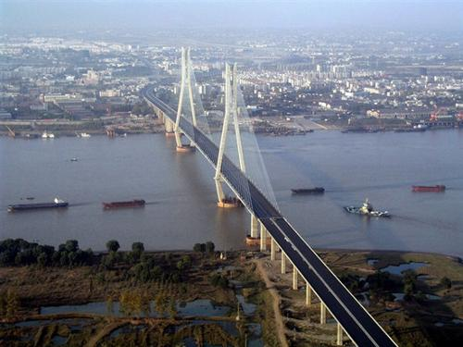
Figure1 Anqing picture

https://baike.baidu.com/item/%E5%AE%89%E5%BA%86/350307?fr=aladdin

student ID :2030024069
Chinese name: 葛宇
English name: Ellene

Content
1.Introduction 3
1.1 Location: 3
1.2 Name: 3
2.History Story 3
3.Special Culture：Huang Mei opera 3
4.Famous people 4
4.1 Chen Duxiu 4
4.2Han Zaifen 4
4.3Yan Fengying 4
5.Scenic spots: 4
5.1Tian Zhu Mountain 4
5.2 Zhenfeng Tower 5
6.Me——Living in this city 5
Bibliography

1.Introduction

1.1 Location:
Anqing is located in the central part of China, in the southeast of Anhui Province. Located south of the Huaihe River, north of the Yangtze River in east China.

1.2 Name:
Anqing was the seat of the ancient country during the Eastern Zhou Dynasty, and Anhui Province is referred to simply as "Yu" from there. Southern Song Shaoxing 17 years (1147) changed Shuzhou Deqing Army for Shuzhou Anqing Army, "Anqing" has since been named. Anqing City was founded in the Southern Song Dynasty Jiading ten years (1217), has nearly 800 years of history. Dongjin poet Guo Wei once called "this place Yicheng", so Anqing also alias "Yicheng".[]

2.History Story

Anqing has a long history, a collection of humanities, is the country's historical and cultural city. Neolithic cultural sites such as Xue Jiagang and Zhang Shixuan have witnessed an ancestor of Anqing that has flourished in this beautiful and rich land since ancient times.During the Eastern Zhou Dynasty, Anqing was the seat of the ancient country, and Anhui Province was referred to simply as "Yu" from there.

3.Special Culture：Huang Mei opera
Huang Mei opera is one of Anqing's unique cultures. In 2006, Huang Mei opera was selected as one of the first national intangible cultural heritage representative projects list. Tea-picking in Huangmei County, Hubei Province, at the end of the Qing, was transferred to adjacent Areas such as Huaining County, Anhui Province, combined with local folk art, and sang and read in the Anqing dialect, gradually developing into a new type of opera, then known as nostalgia or nostalgia, which was 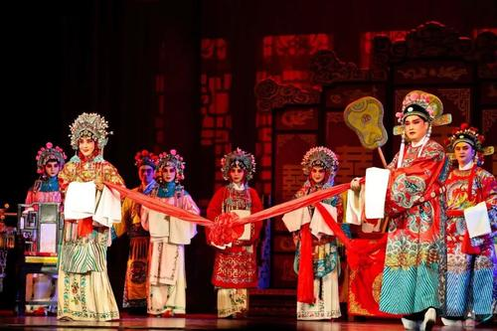
Figure 2 Huang Mei Opera

the early Huangmei opera. Later, Huang Mei opera learned from the absorption of Qingyang cavity and emblem music, performances and plays, began to perform "the play." After Anqing as the center, after more than a hundred years of development, Huangmei opera has become the main local opera in Anhui and the country's well-known drama species.

4.Famous people

4.1 Chen Duxiu
Chen Duxiu (1879-1942), formerly named Chen Qingtong, Chen Qiansheng, Shifu, Anhui Anqing, advocate, promoter and main flag bearer of the New Culture Movement, "Commander-in-Chief of the May Fourth Movement", one of the main founders of the Communist Party of China and the early major leaders of the Party.[]

4.2Han Zaifen
Han Zaifen, born in February 1968 in Anqing City, Anhui Province, Chinese Huangmei opera performance artist, actor at the national level, representative inheriter of the national intangible cultural heritage project, enjoy the State Council "special government allowance."[]

4.3Yan Fengying
Yan Fengying (1930-1968), formerly Yan Hongxian, Anqing, Anhui Province. Female, a member of the Communist Party of China, an outstanding performance artist of Huang Mei Opera, one of the founders of Huangmei Opera in China, the shaper of the "Seven Fairies", an important pioneer and contributor to the heritage and development of Huangmei Opera in China.[]
Name | Gender | Birth year | Job | Famous event
Chen Duxiu | Male | 1879 | revolutionist | advocate "Commander-in-Chief of the May Fourth Movement"
Han Zaifen | Female | 1986 | Theater actress | 《Nu fu ma》
Yan Fengying | Female | 1930 | Theater actress | 《Goddess Marriage》
Table1 Famous peopele

5.Scenic spots:

5.1Tian Zhu Mountain
In ancient times, because the column of heaven deep in the mountains, a peak towering, thousands of rocks, far and near the size, not around the arch worship. Therefore, when Qin and Han, the mountain is called "Hoshan". The main peak of Tianzhu Mountain is 1489.8 meters above sea level, high, straight into the clouds, such as the column of the sky, so there is the name of the column of heaven, and because it is hidden in the mountains (also: dive, ancient for the dragonfly, shaped "tip" also, righteous and Tianzhu mountain is mostly sharp, so the mountain is also known as the submersion mountain, and has a single tip, the tip of the shoots of the name. There is also the same name as The Submarine Mountain and Wanshan. The name of Wanshan also said that because of Hanfeng Nanyue, it is also known as Long live mountain. "The county is named after the mountain, the mountain is under the name of the subliminal" (the old "Submarine Mountain City Journal"). In the spring and autumn, the Zhou Dynasty placed the country here, sealed the uncle's rule, Tianzhu Mountain belongs to the weibo sealed land, so the mountain is also known as the lushan. In order to celebrate Dr. Erbo's rule, Qingming and Dezheng, also known as Gonggongshan. As a result, Yan also became short for Anhui Province.

5.2 Zhenfeng Tower
Zhenfeng Tower, located in Anqing City, Anhui Province, Yingjiang Temple, the original name of wanfu Tower, also known as Yingjiang Temple Tower, after the name "Zhenfeng", there is "To Zhenwen Feng" meaning. Zhenfeng Tower is located in Anqing City, Anhui Province, Yingjiang District along the north side of Jiangdong Road, on the edge of the Yangtze River. The Anqing Zhenfeng Tower was built in mingmu Zonglongqing two years (1568) and built in Minglongqing four years (1570), which is one of the ancient towers along the Yangtze River. In addition to the function of the tower, the tower also has the function of navigating extradition.

6.Me——Living in this city
My hometown is a beautiful city which is located on the edge of the Yang Zi River. Since I was born, have lived in this city for 18 years. Most time I lived with my parents, and sometimes my grandparents look after me in my childhood. In my memory, the most impressed and happy experience is every time I go to the park with my parents and cousins. When I go to the park, I always full of energy and expectation and my favourite activity is bungee jumping. It’s really a place full of memory for me.

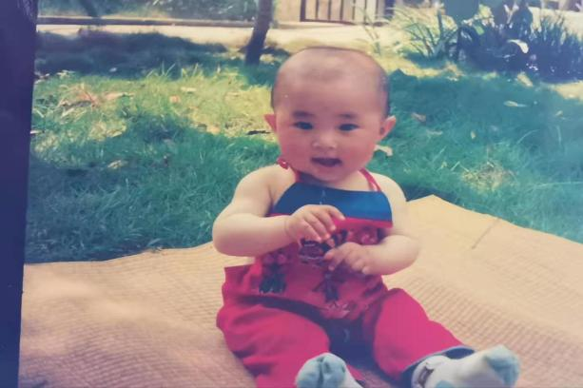

Figure 3Little Me

Bibliography

[] Anqing introduction from website https://baike.baidu.com/item/%E5%AE%89%E5%BA%86/350307?fr=aladdin
[] Chen Duxiu introduction from website https://baike.baidu.com/item/%E9%99%88%E7%8B%AC%E7%A7%80/114833?fr=aladdin
[]Han Zaifen introduction from website https://baike.baidu.com/item/%E9%9F%A9%E5%86%8D%E8%8A%AC/529200?fr=aladdin
[] Mei Yanfang introduction from website https://baike.baidu.com/item/%E4%B8%A5%E5%87%A4%E8%8B%B1/5344

