**IT FOR SUCCESS OF EVERYDAY LIFE AND WORK**

**Assignment 2**

## Deadline: 9th May, 2021 before 23:59 This is an individual assignment.

**You are required to build a website about your hometown.**

You are allowed to design *your web pages* in *your own style* but it must contain at least the following pages. The suggested web site hierarchy is shown below for your reference.

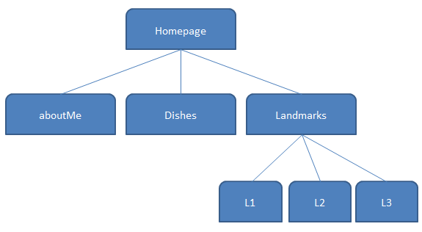

**Figure 1 Website Hierarchy**

## The *minimum* requirements of web pages are specified below.

* **Home Page (index.html):**
  + Introduction of your hometown
  + At least one large picture which can represent your hometown.
  + Navigation and Links to your website pages
  + Logo

# About Me (aboutMe.html):

* + A picture of yourself
  + Something interesting about you and/or why you like your town
  + Personal details – UIC email, zodiac, telephone number, etc
  + Link to your favorite website – (*use of external link*)

# List of 3 recommended dishes from your province (dishes.html):

* + Use a visible table to display information about the dishes.
  + Display in the top row(merged) the title “Dishes of the Province”
  + Display a photograph of each individual dish in one column.
  + Display title and description of the dish in another column.
  + Display the average price of the dish (doesn’t need to be accurate, but realistic)
  + Ensure all images are the same size using CSS.

# Landmarks (landmark.html):

* + Create one web page with 3 landmarks of your choice from your hometown/province
  + Use an invisible table to display information about the landmarks.
  + Information of each landmark should include:
    - name of the landmark
    - exactly one picture of the landmark
    - a brief description of the landmark
    - three interesting points about the landmark (use unordered list)
  + Every picture should link to an external page (L1, L2 or L3) related to its landmark information.
    - do **not** develop the 3 pages of the landmarks
    - only create links to pages, which have more details about the landmark

# Logo:

* + This should be the logo of your province or a made up logo.
  + It should be displayed in the same position on **each** website page.

# Navigation Bar

* + Display the navigation bar on **each** page.
  + Links to homepage, aboutMe page, dishes page and landmark page.
  + *Example of navigation bar can be found on the top left corner of iSpace course sites.*

# CSS

All general styling for the website should be defined in the external file **my_style.css**.

* + The CSS file provides your website with consistent appearance.
  + Feature(s) of the course with list and different font size, font color, and font.
  + Use my_style.css **external** CSS.

# Submission

✓Make sure the links and the navigation bar function.

✓You should upload the pages and images to iSpace in a compresses file

✓Name your file qxxxxxxxxx_A2.zip

# Attentions

*Your deliverable will be viewed in Google Chrome or Firefox browsers for grading. You must check your deliverables on Chrome and Firefox for consistency with your expected outcomes before submission.*

*To create the website, you may use a text editor (Notepad/Notepad++/etc.) or web development tool (Dreamweaver, Amaya, etc.). You are NOT allowed to copy a whole web site from any other source or use a webpage generator (we will check your source code to verify).*

*What you’ve learned from the lab exercises is enough to do a good job in this assignment.*

# Appendix: Hint on steps to submit your assignment 2

## Step 1:

Create your html pages with a text editor, and use the same css file (my_style.css) for use in all your pages

## Step 2:

Test using a **Chrome** browser with the address

## Step 3:

Compress all your files (including images) with a .zip extension format Name your fie 2xxxxxxxxx_A2.zip

# Notes:

1. File names should **NOT** contain spaces or Chinese characters.
2. ONE external CSS only.
3. If you have any questions, try to find the answer using a search engine(Google/Baidu/etc) first.
   * Before asking in the Forum, check if your question has already been asked.